
Date:
Employee Name:
Employee Code:

Confirmation Letter

Dear Employee Name,
Congratulations!
Consequent to the review of your performance during your probation period, we have the pleasure in informing you that your services are being as Designation with effect from DD-MM-YYYY.
All the other terms and conditions as detailed in your appointment letter remain unchanged.
As an organization, we look forward to your valuable contributions and long term association with Netbounce Placements LLP.
We wish you all the very best for a rewarding career with Netbounce Placements LLP.
Your Sincerely,
For Netbounce Placements LLP
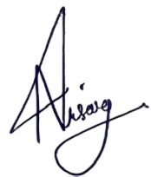

Nisarg Patel
Chief Executive Officer

