**Steps to setup environment for running the POC**

**Prerequisites:**

1. Install NodeJs – 4.x or above

2. Git Command line

3. Install Java – 1.6 or above

4. Install Maven – 3.x

**Environmental Variables:**

1. JAVA_HOME: C:\Program Files\Java\jdk1.7** (path of jdk wherever installed)

2. M2_HOME: D:\apache-maven-3.** (path of maven wherever installed)

3. PATH: %JAVA_HOME%\bin;%M2_HOME%;C:\Program Files\Git\cmd;C:\Users\{user-name}\AppData\Roaming\npm

**After the above steps:**

Open NodeJS cmd propmt: StartMenu > Node.js > Node.js command prompt

1. In NodeJS cmd: npm install -g grunt-cli bower yo

2. Download and Extract the generators from generators.zip to a folder.

3. With generator-jhipster-usm-server as your current directory, run “npm install” and then run “npm link”.

4. With generator-jhipster-usm-ui as your current directory, run “npm install” and then run “npm link”.

**Creating end server project:**

1. Unzip “end-server.zip” into a folder.

2. Import the project into workspace and run it using “mvn jetty:run -DskipTests”.

3. Your server will be up and running on port 8083. To check it, use any rest client to hit the url.

4. Here is the screen shot for the setting to be made in Postman to check the url.

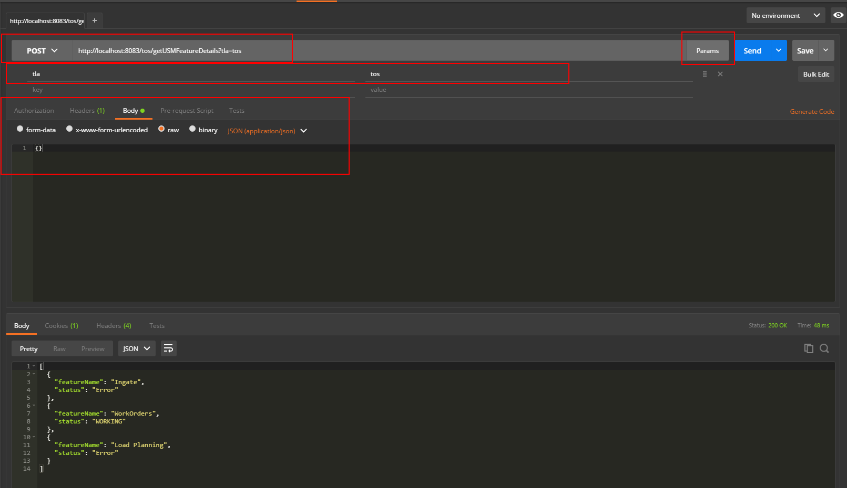

**Creating server project:**

1. Create a folder where you want to install the Server Project.

2. In the “generator-jhipster-usm-server”, there is a “sample-config.yml” file. Copy that and paste into the folder you created. Rename it to “config.yml”.

3. It will read the file and show all the properties that it has read. Hit “Y” and the project will be created.

8. You can see that the project is created, import it into eclipse and run, “mvn clean install -DskipTests=true” and “mvn jetty:run -DskipTests=true -Duprr.implementation.environment=dev”.

9. The server will be up and running on port 8081.

10. Here is the screen shot for the setting to be made in Postman to check the url.(Check the port, it is different in the screen shot from what it actually is)

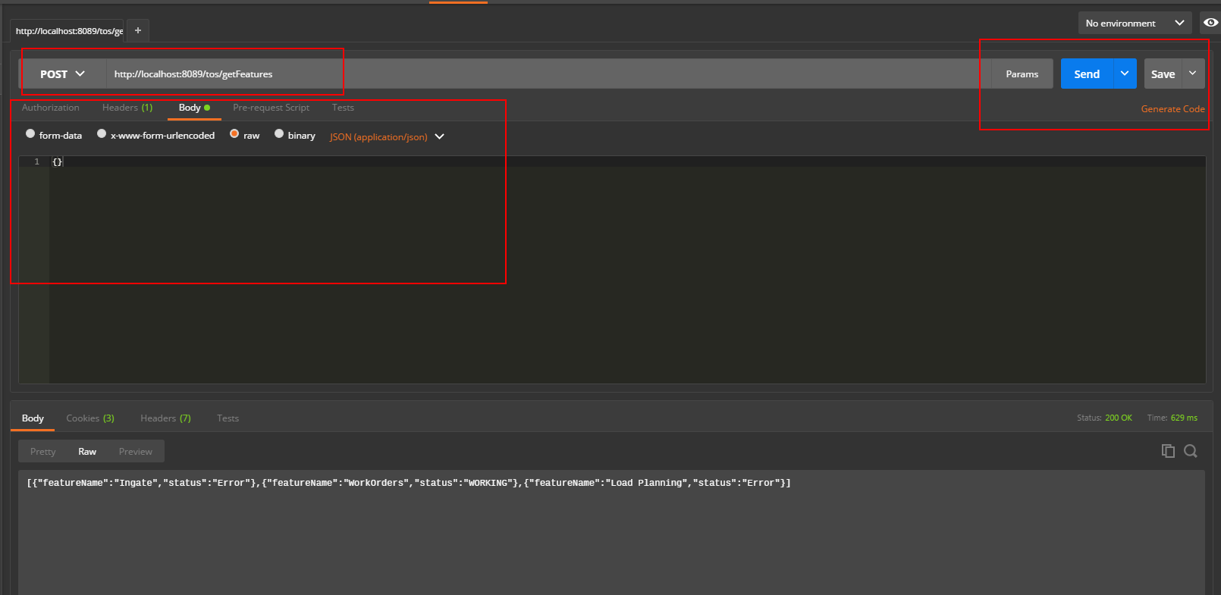

**Creating ui project (runs only on UP machines as it needs a node dependency of Ricola3 ):**

1. Create a folder where you want to install the UI Project.

2. Run “yo jhipster-usm-ui”. It would take some time to start the process.

3. Hit enter for all the options.

4. After installing, run “npm install” and “bower install”. Just to make sure everything is good to go.

5. Run “grunt serve”. Screen will be loaded and will display the default values.