1. **Introduction**

This introduction is to explain the technology in which the site works and how to employ it to design a simplified website for sale online (eCommerce), I used HTML to provides the basic structure of sites, which is enhanced and modified by CSS and JavaScript, CSS to control presentation, formatting, and layout, JavaScript is used to control the behavior of different elements used in the website.

1. **HTML.**

HTML is used in the website to add the different elements used in the website such as pages and tags as headers and labels and the products placeholders and images, ... etc.

HTML is also used to specify what kind of information each item on a webpage contains — for instance, the “p” HTML element indicates a paragraph. As of this my website is built for ecommerce purpose, marking the caption of an image with the product element and enclosing the image and its caption in the “figure” meta element helps a search engine understand that these two pieces of content are related and that the caption describes the associated image.

Examples:

* Search Bar:

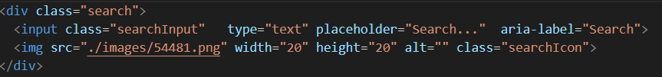

HTML role here is to only display the search bar with input tag to allow the user enter the search item and the image of the search button. The action will be taken care off by JavaScript functions.

* Cart Icon

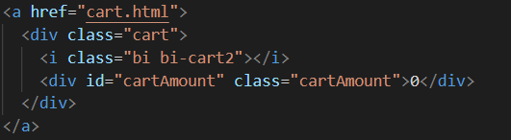

HTML here will display the cart icon “<i>” which is also wrapped by an <a> to allow the user to click on to go to cart page.

1. CSS.

### I used CSS in website to enhance the looking of the pages, by using one file to set the looking and properties for each element type in the website instead of defining a style property for each element, this will of course provide a Easy Formatting Changes and Quicker Development Time.

### Examples:

### Search Bar Style:

### 

### The CSS file here add the propertied for each element in HTML like font size, height, width, …

### JavaScript.

### I used JavaScript in the website for several purposes, the most important of which are:

### Execute the search process and display all results that meet the research criteria.

### Include the information to be displayed for each product.

### Adding each product selected by the customer to the basket and handle the extract process of the product quantity.

### Handle all the actions applied by the customer by clicking and buttons or links which of course can be handles by html only.

### Examples :

### When the user selects an item and click on the + icon the cart will get incremented by one, this done by the following JavaScript code:

### 

### 

### Displaying data of each item done by listing all of them in data.js file and calling this file from index.html page by the following statement:

### 

### and the data looks like this in the file :

### 

### In the cart page when the user click on the “X” icon, this will execute the following line :

<div class="buttons">

              <i onclick="decrement(${id})" class="bi bi-dash-lg"></i>

              <div id=${id} class="quantity">${item}</div>

              <i onclick="increment(${id})" class="bi bi-plus-lg"></i>

          </div>

### This will decrease the total number selected by one each time the button clicked.

### This will be executed by running the remove item function :

### 