

Inventory & Stock Management System

Made by Shayan Muhammad Faisal| 2312259 | BSCS 5D

Introduction 2
Objective 2
Technology Stack 2
System Modules 2
Database Design 4
System Flow 4
Advantages 5
Conclusion 5

Introduction
The Inventory Management System is a web-based application developed using PHP and MySQL. The main objective of this project is to simplify the process of managing products, purchases, and retailers for small businesses. The system provides an organized way to track inventory levels, handle retailer information, and manage purchase orders through a single dashboard interface. It ensures that the inventory is automatically updated after every purchase, maintaining real-time accuracy.

Objective
The project aims to create an easy-to-use web platform that automates manual business processes, reduces human error, and ensures that all product and purchase records are stored securely in a database. It allows administrators to monitor stock, prevent overselling, and generate accurate purchase information without requiring external tools.

Technology Stack
The system is developed using core PHP for backend processing and MySQL as the relational database. The frontend interface uses HTML and CSS for simplicity and responsiveness. The application runs on an Apache server environment such as XAMPP or LAMP. The combination of these technologies ensures a lightweight and efficient solution suitable for small-scale deployment.

System Modules
The system is divided into multiple modules.
Dashboard (index.php)
This is the main interface for the administrator. The dashboard provides summarized business data including total products, retailers, and purchase orders. It helps the admin quickly assess the overall status of inventory and sales operations.
Database Configuration (db.php)
This file manages the connection between PHP and MySQL. It defines essential parameters like database host, username, password, and database name. Every other PHP file includes this configuration file to maintain a single database connection, improving maintainability and reducing repetitive code.
Product Management (product.php, add_product.php, product_detail.php, product_listing.php)
This module enables the administrator to add, view, and manage product details such as name, price, and stock quantity. When a new product is added, it’s stored in the Products table. Upon creation of a purchase order, the system automatically deducts the sold quantity from stock to maintain real-time inventory control.
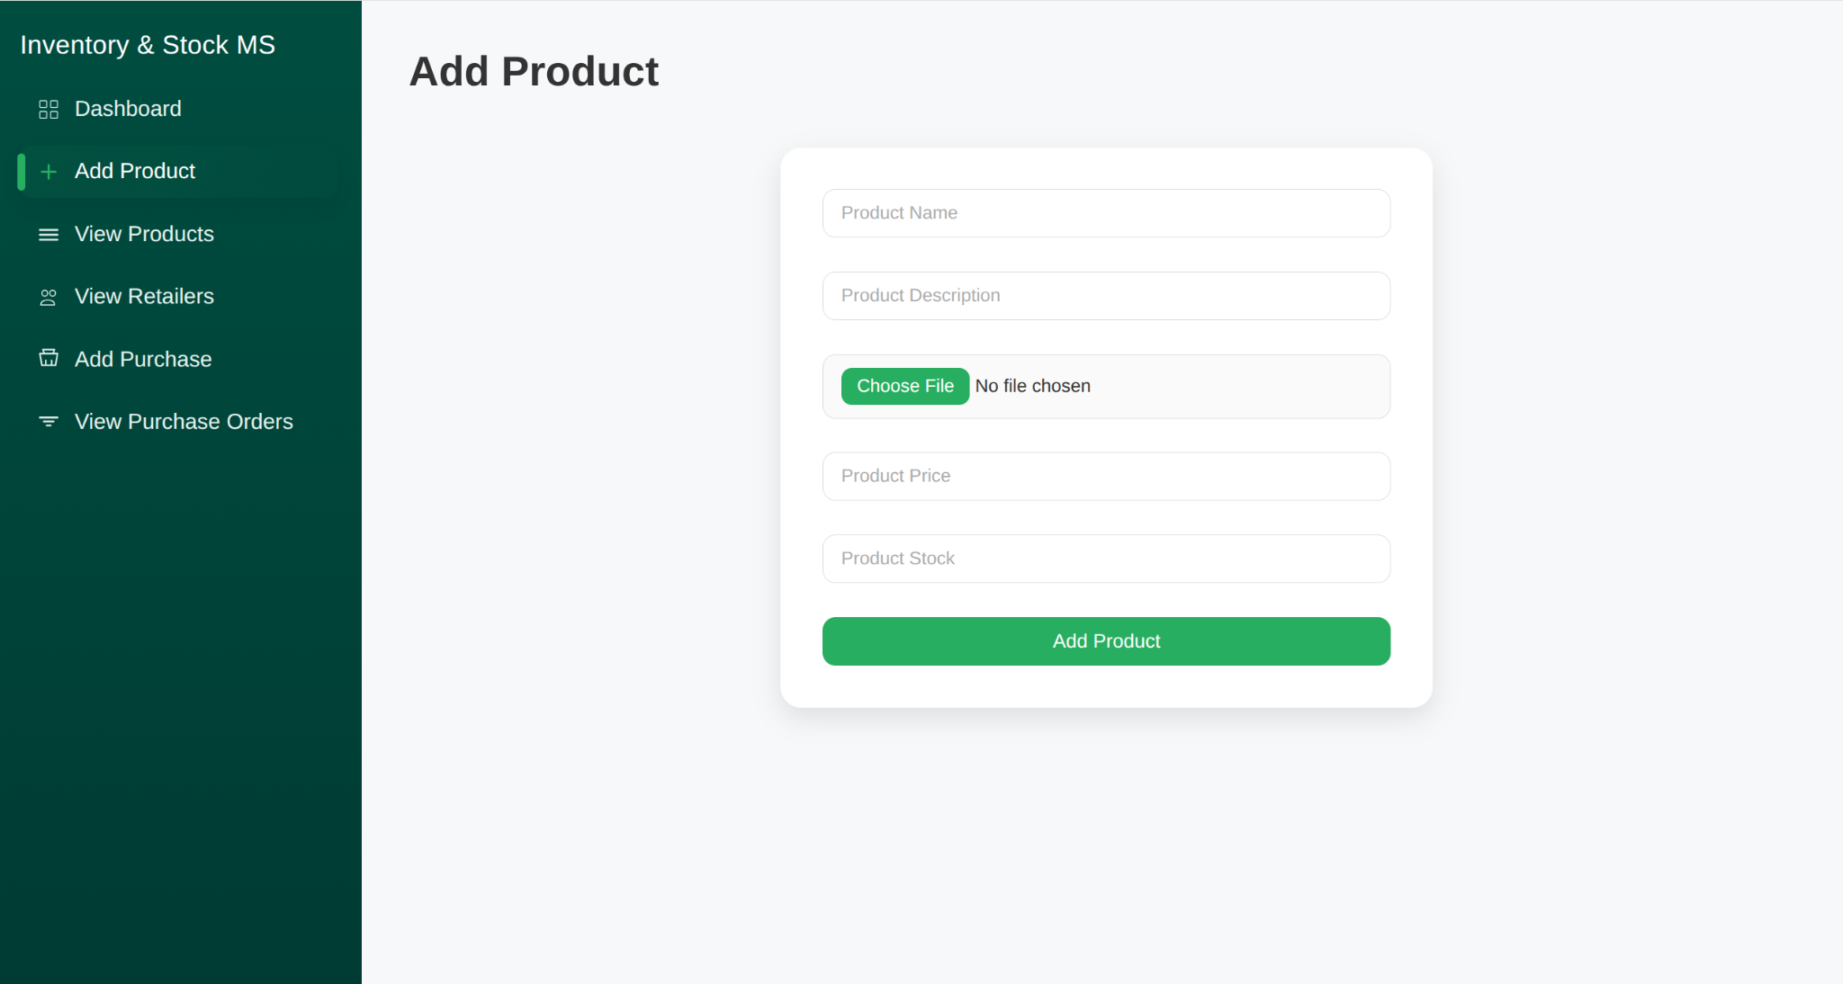
Retailer Management (retailers.php)
This module allows the admin to store and manage retailer information such as name, contact number, and address. During purchase creation, the retailer is selected from a dropdown list, linking every order to its corresponding retailer for proper tracking and history management.
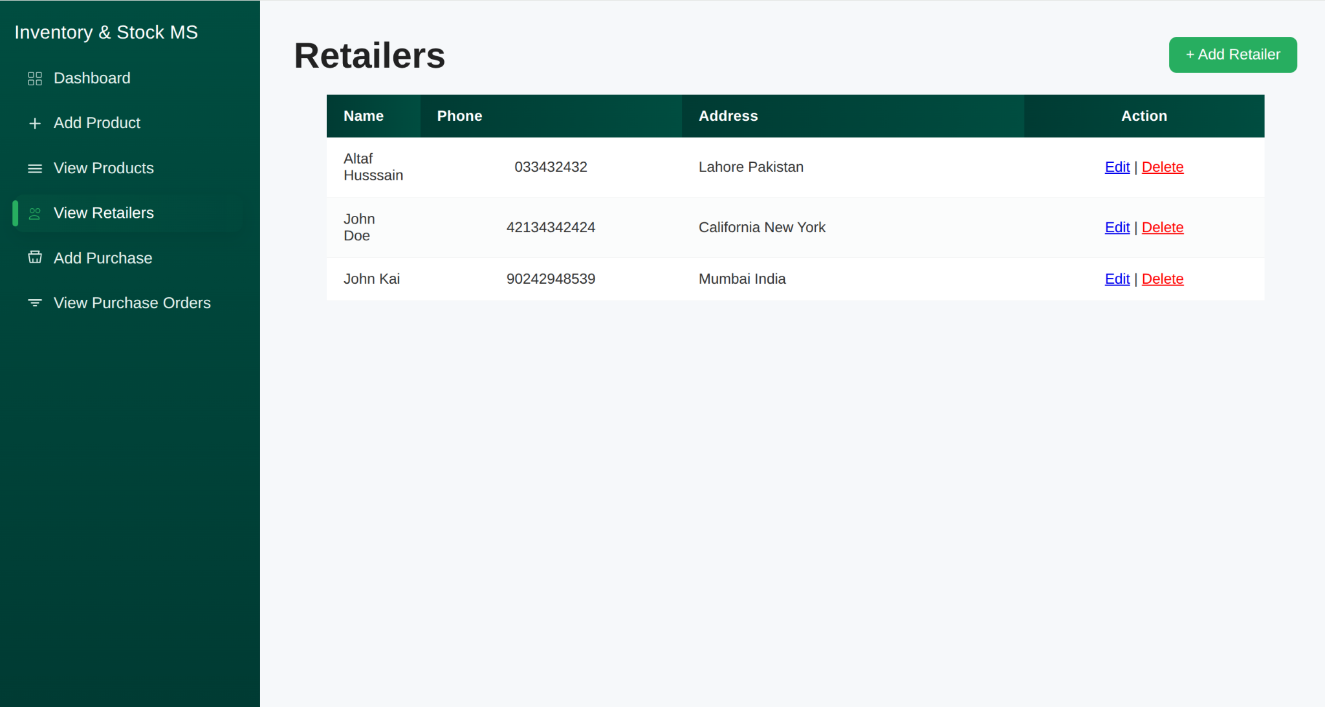
Purchase Order Management (add_purchase.php, purchase_order_listing.php)
This module manages all purchase transactions. The admin selects a retailer and a product, and the system automatically fetches the product’s price and available stock. The total amount is calculated using the formula “price × quantity.” If the requested quantity exceeds the available stock, the system prevents order creation. Once the order is successfully created, it updates the product’s stock automatically. The purchase order listing page displays all previous purchase orders with details such as product, retailer, quantity, unit price, and total amount.
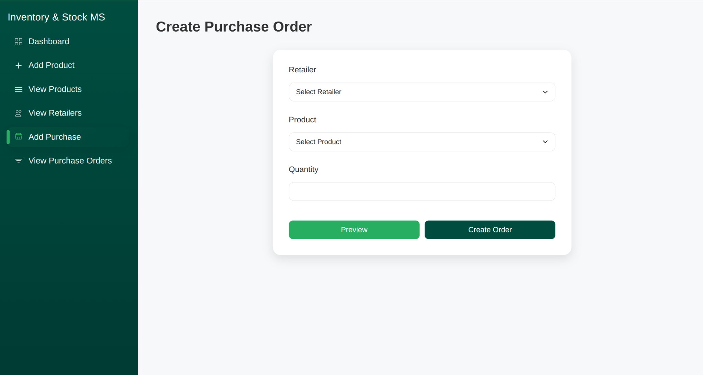

Database Design
The system uses three main tables: Products, Retailers, and PurchaseOrders.
- The Products table stores product details such as name, price, and stock.
- The Retailers table stores retailer details like name, phone, and address.
- The PurchaseOrders table connects both tables using foreign keys to maintain relational integrity. Each purchase record references both the product and the retailer, ensuring accurate linkage and traceability.

System Flow
The admin logs into the system and accesses the dashboard to view key statistics. The admin can add new products and retailers as needed. When creating a purchase order, the system fetches the required data, validates stock levels, and updates inventory upon successful order creation. The admin can later view all orders through the purchase listing module. All data operations are handled dynamically by PHP scripts interacting with the MySQL database.

Advantages
The system reduces manual record-keeping by digitizing inventory data. It maintains accurate stock levels and prevents human error. It also enhances efficiency by providing real-time insights into product availability and purchase activity. The design is modular, scalable, and can easily be expanded to include more advanced features like supplier management or detailed reporting.

Conclusion
The PHP-Based Inventory Management System is a practical and efficient solution for small businesses to manage inventory and purchasing operations. It combines a simple interface with functional automation to ensure accuracy and efficiency. The project effectively demonstrates the use of PHP and MySQL for real-world business applications. Future improvements can include authentication systems, downloadable reports, and analytical dashboards. Overall, it achieves its goal of providing a reliable, user-friendly, and scalable inventory management solution.

