Instructions:
- You are going to collaborate with a robot to “install a solar panel” in a simulated environment. The robot is going to operate as your collaborative partner. Therefore, some of the tasks are going to be done by the robot, and some other tasks will be done by you.
- All the tasks are implemented with labeled pegs. You and the robot are going to pick up and place these pegs on the predefined spots on the shared table-top in front of you.
- Pegs that are properly placed in the predefined spots are considered to be successfully completed tasks.
- Pegs are provided in two colors. Red pegs represent the robot's tasks and blue pegs represent your tasks.
- The predefined spots on the board are labeled with tasks and are colored to match the corresponding pegs.
- The robot is supposed to place its own pegs on the red spots.
- You should place your own blue pegs only in the corresponding blue spots, i.e., if you have a blue peg labeled A (representing a task called A that you are responsible for), there will be a blue spot on the shared board labeled A (see the figure below).
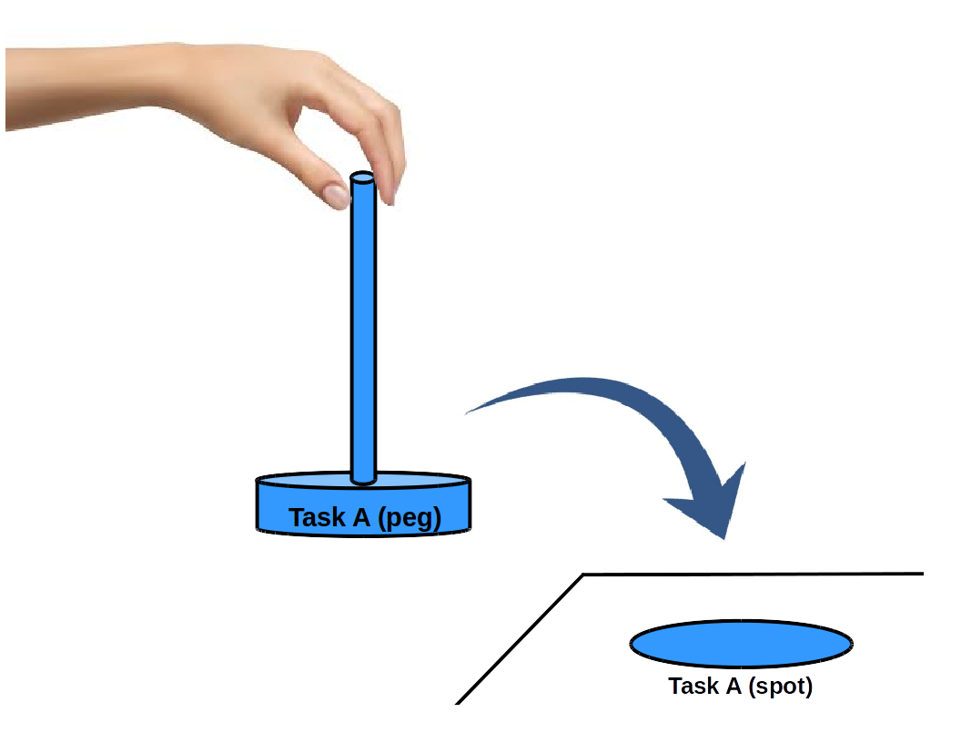

Success and Failure of Achieving a Task:

- Picking up and placing a peg on the right spot of the shared board means that particular task has been successfully achieved.
- Task failures are simulated using magnets: a task fails when the magnet in the board does not let the peg's settle fully into its spot (see the following figure).

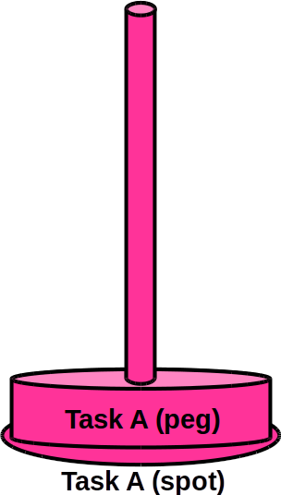 | 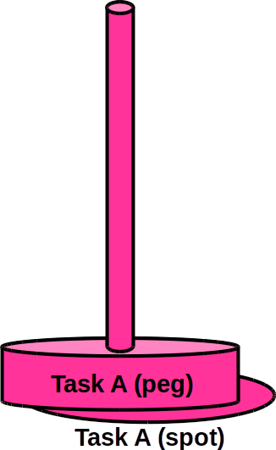  NOTE: A little bit off is okay. | 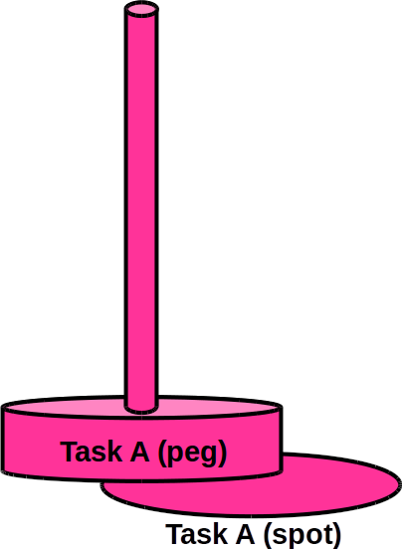
  Successful Task | Successful Task |   Failed Task

Order of Doing Tasks:
The numerical labels on the shared board under each spot provide the correct order of the task completion.

Your Objectives:

a) Successful completion of “installing the solar panel”,
b) Expressing yourself to the robot through the interface provided on the screen.
c) Timely completion of the overall task (e.g., if there is a failure that requires the robot's supervisor, the extra time will be counted against you).
d) Ensuring overall satisfaction of the robot during collaboration.
e) Avoiding impasse; where there is a failure and the robot supervisor has to come in, you will lose points unless you are already working on a different task suggested by the robot.

Note 1: The winner's prize will be sent by e-mail the week after the study finishes.
Note 2: Your overall score will be calculated based on these objectives.

Playing Rules:

1. You should not touch the robot under any circumstance.
2. You are responsible for removing a failed the task peg (the robot's or your own) from the shared board.
3. You should wait for the robot to inform you that it is your turn through voice and/or the visual interface (see the figure below – the visual interface will change from what you see in the left to the right condition).
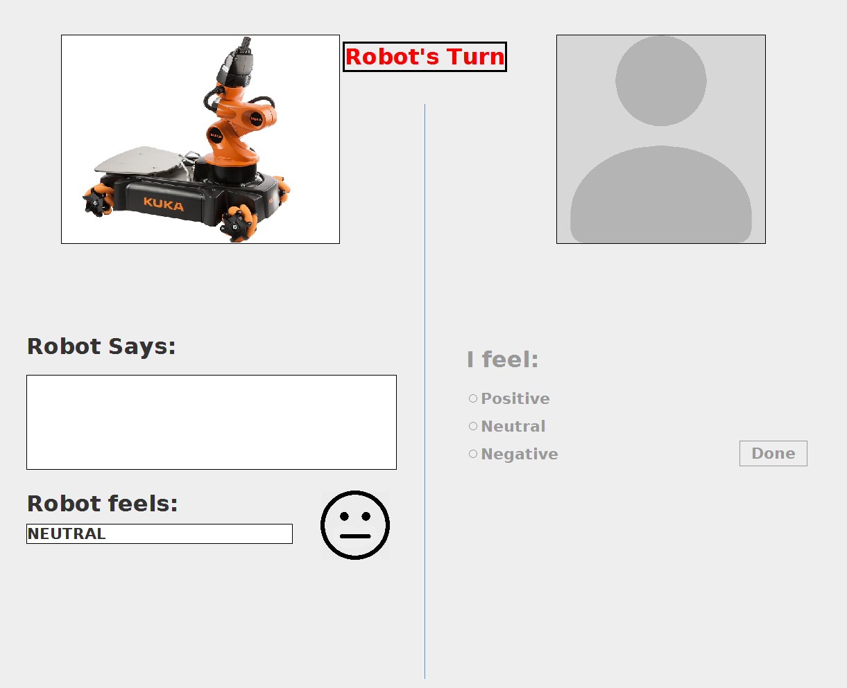 | 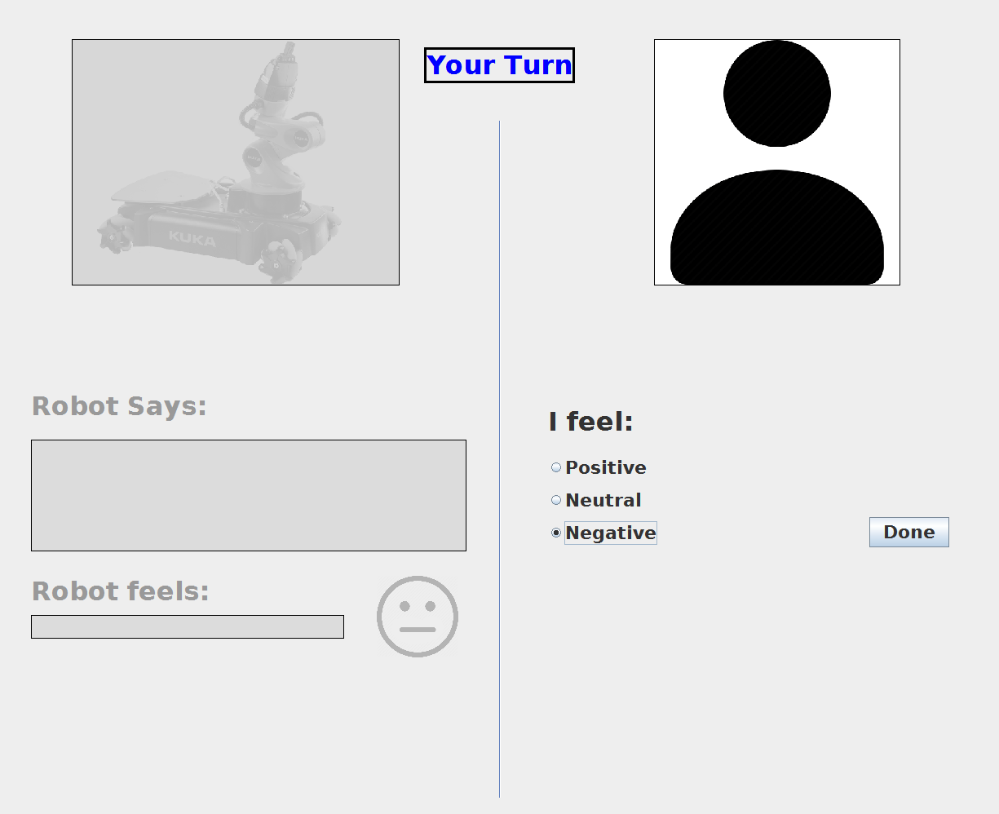

4. When it is your turn to do your own task, you should strictly obey the following:

4.1) Move ONLY one of your pegs according to the current numerical label of your task, e.g., if the robot's last move was task 8, you should do task 9 if you are responsible for it (see the following figure).

4.2) Based on the failure or success of your task, choose how you feel (i.e., Positive, Neutral, Negative) about the outcome of your task on the interface provided on the screen (see the following figure).

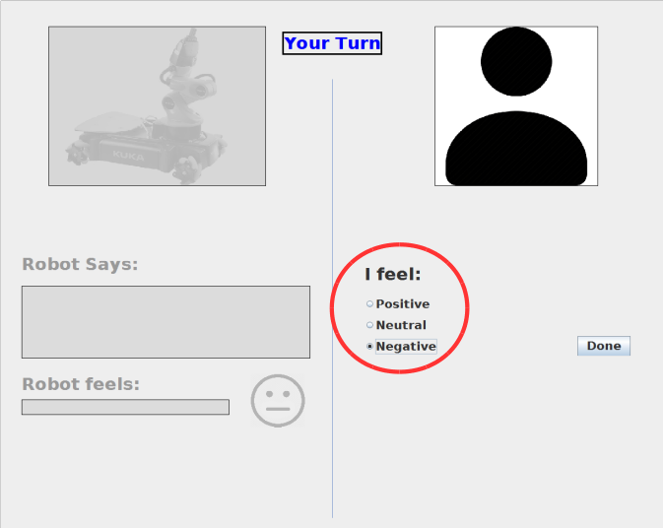

4.3) Press the “Done” button to give the turn back to the robot (see the following figure).

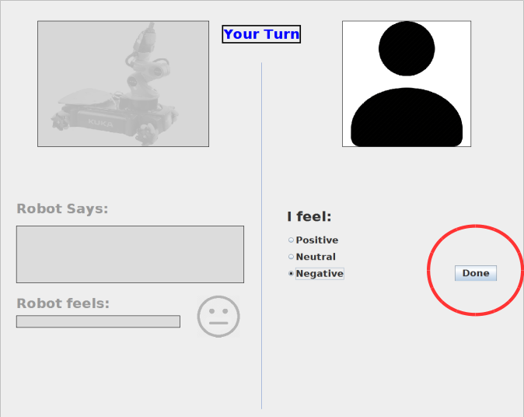

5. You must not remove any peg from the board unless it is a clear case of a failure caused by the magnetic field.
6. It is okay to change the order of the tasks ONLY if the robot makes such a decision and announces it to you.
7. Do not touch your pegs until it is your turn again.
8. The robot might ask its supervisor to come and help if there is a task failure that causes an impasse during your collaboration.
9. The robot might want to help you with its own pegs; if so, the robot will place a peg in the “Handoff Area” for use during your next turn.

