You are preparing for hiking. You are supposed to make two different snacks, a peanut butter and jelly sandwich and a simple boiled egg sandwich, together with Mary. The peanut butter and jelly sandwich MUST be prepared using peanut butter and strawberry jam. The egg sandwich MUST be prepared using two boiled eggs, salt and some pickles. All required ingredients are available to you and Mary, including:

a) a jar of peanut butter,
b) a jar of strawberry jam,
c) whole wheat bread,
d) two eggs,
e) pickles, and
f) salt.

First Sandwich:

To prepare peanut butter and jelly sandwich the following steps MUST be taken in the following order (as shown in the picture):

Spread some peanut butter on one slice of bread. Spread some strawberry jam on another slice of bread. Press two slices together, and pass the sandwich to Mary. Mary uses a knife to cut the sandwich in half. Mary will take a zip lock bag, and puts the sandwich in the bag.

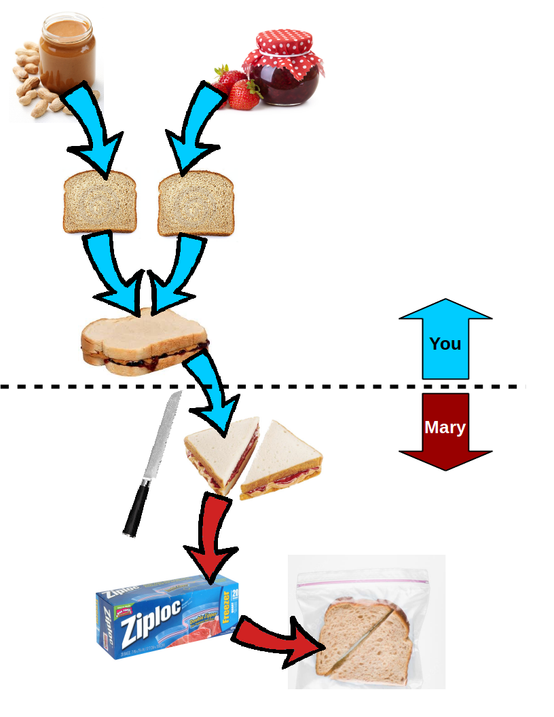
Second Sandwich:

To prepare boiled egg sandwich the following steps MUST be taken in the following order (as shown in the picture):

Boil the water in a pot, and put two eggs in the pot when the water is boiling. Remove the eggs from the pot after 5 minutes. Peel the boiled eggs and slice them into a few pieces. Shake some salt on the eggs. Put the sliced eggs on bread. Wait for Mary to put some pickles on top of the eggs. Press another slice of bread on top. Grab a zip lock bag and put your sandwich inside of the zip lock bag.

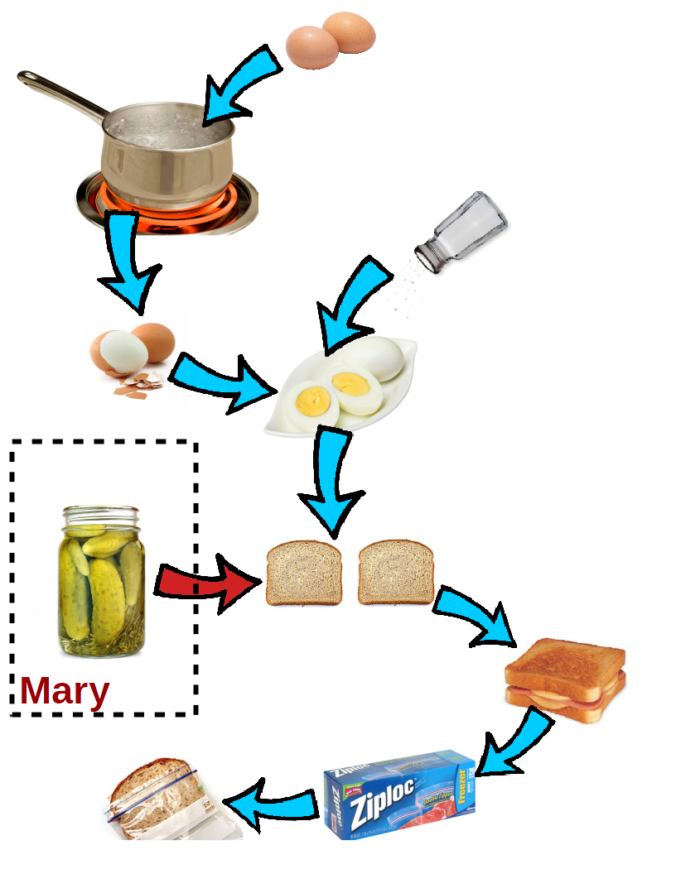
In this questionnaire, there are 10 questions about different situations while you are preparing two sandwiches together with Mary (as mentioned above). Each question provides three different options to answer. All questions ask about which one of the first two conditions is relevant to what you want/need in a particular situation, or whether they are equally relevant.

A situation or an event is relevant if it requires your attention because of its positive or negative effect, since it can impact your state or what you want. For example, if you need Mary to take the peanut butter sandwich you made, cut it in half and put it in a zip lock for you (see the picture above), how do you think it is relevant if she cuts your sandwich in half and puts it in a small paper bag for you?

Now, please answer the following questions:

1. Imagine you have just pressed two slices of bread after spreading peanut butter and jelly on them. Which of the following two actions is more relevant? [Belief Saliency – Focus]

A. Mary takes your sandwich and cuts it in half.

B. Mary looks for a jar of pickles for your second sandwich.

C. Equally relevant.

2. Imagine you want to make the peanut butter sandwich. Which of the following two actions is more relevant? [Belief Strength - Responsibility]

A. You trying to find the jar of peanut butter.

B. Mary wants to figure out which knife to use to cut the sandwich you make.

C. Equally relevant.

3. Imagine you have made the peanut butter sandwich and passed it to Mary to cut it in half. You begin to boil some water in the pot for the eggs. Which of the following two actions is more relevant? [Belief Recency]

A. Mary has cut the peanut butter sandwich and put it in a zip lock bag.

B. Mary asks you whether you have found the jar of peanut butter.

C. Equally relevant.

4. Imagine Mary cuts your given peanut butter sandwich in half. Which of the following two actions is more expected? [Most_Expected – Most_Unexpected]

A. Mary takes a zip lock bag and put the sandwich inside of the bag.

B. Mary leaves the apartment to but some energy drink.

C. Equally expected.

5. Imagine you have pressed the two slices of bread (one covered with strawberry jam and one covered with peanut butter) together and passed it to Mary. Which of the following two actions is more expected? [Most_Expected – Unexpected]

A. Mary puts the given sandwich into a zip lock bag after cutting it in half.

B. Mary puts some pickles on another slice of bread.

C. Equally expected.

6. Imagine you have pressed the two slices of bread (one covered with strawberry jam and one covered with peanut butter) together and passed it to Mary. Which of the following two actions is more expected? [Most_Unexpected – Unexpected]

A. Mary puts some pickles on another slice of bread.

B. Mary begins to cook some chicken for you.

C. Equally expected.

7. Imagine you have pressed the two slices of bread (one covered with strawberry jam and one covered with peanut butter) together and passed it to Mary. Which of the following two actions is more expected? [Expected – Expected]

A. Mary puts the given sandwich into a zip lock bag after cutting it in half.

B. You go ahead and begin to boil the water in a pot, since Mary doesn't need your help anymore.

C. Equally expected.

8. Imagine you are spreading strawberry jam onto the second slice of bread. Which of the following two actions is more expected? [Unexpected – Unexpected]

A. Mary wants to cut the one slice of bread which is already covered by peanut butter.

B. Mary puts some pickles on another slice of bread.

C. Equally expected.

9. Which of the following two actions is more expected? [Most_Expected – Most_Expected]

A. Imagine you have pressed the two slices of bread (one covered with strawberry jam and one covered with peanut butter) together and passed it to Mary. Mary puts the given sandwich into a zip lock bag after cutting it in half.

B. Imagine you have shaken salt on the slices of the boiled eggs on the bread. Mary puts some pickles on another slice of bread.

C. Equally expected.

10. Imagine you have peeled the boiled eggs and sliced them into some pieces. Which of the following two actions is more expected? [Most_Unexpected – Most_Unexpected]

A. Mary leaves the apartment to but some energy drink.

B. Mary begins to cook some chicken for you.

C. Equally expected.

