You are preparing for hiking. You are supposed to make **two** different snacks, a peanut butter and jelly sandwich and a simple boiled egg sandwich, **together with Mary**. The peanut butter and jelly sandwich MUST be prepared using peanut butter and strawberry jam. The egg sandwich MUST be prepared using two boiled eggs, salt and some pickles. All required ingredients are available to **you and Mary**, including:

a) a jar of peanut butter,

b) a jar of strawberry jam,

c) whole wheat bread,

d) two eggs,

e) pickles, and

f) salt.

**First Sandwich:**

To prepare the **peanut butter and jelly** sandwich the following **steps** MUST be taken in the following **order** (as shown in the picture):

Spread some peanut butter on one slice of bread. Spread some strawberry jam on another slice of bread. Press the two slices together, and pass the sandwich to Mary. Mary uses a knife to cut the sandwich in half. Mary takes a zip lock bag, and puts the sandwich in the bag.

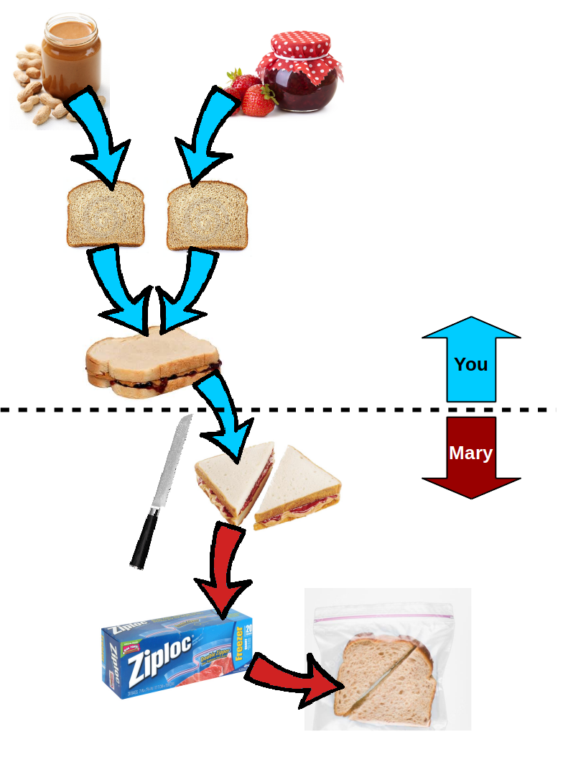

**Second Sandwich:**

To prepare the **boiled egg** sandwich the following **steps** MUST be taken in the following **order** (as shown in the picture):

Boil the water in a pot, and put two eggs in the pot when the water is boiling. Remove the eggs from the pot after 5 minutes. Peel the boiled eggs and slice them into a few pieces. Shake some salt on the eggs. Put the sliced eggs on bread. Wait for Mary to put some pickles on top of the eggs. Press another slice of bread on top. Grab a zip lock bag and put your sandwich inside of the zip lock bag.

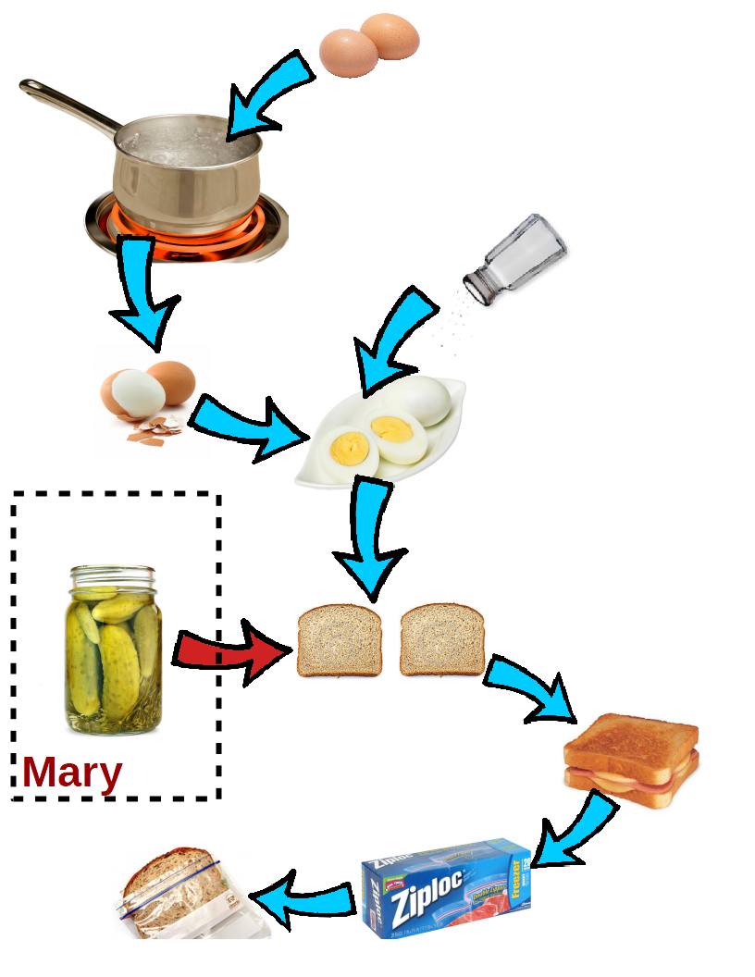

In this questionnaire, there are 10 questions about different situations while you are preparing two sandwiches **together with Mary** (as mentioned above). Each question provides three possible answers regarding how controllable the situations are.

**Controllability** is about whether the outcome of an event can be changed under your or your collaborator's control. For example, boiling the eggs is more controllable for you since you have the eggs and the pot and you know how to turn on the oven, but putting pickles on the sliced eggs is not controllable for you since your hands are dirty and you should not open the lid on the pickle jar with your dirty hands.

Now, please answer the following questions:

1. Imagine you want to quickly make a peanut butter sandwich. You know that you are supposed to press two slices of bread together that are covered by peanut butter and strawberry jam, and pass it to Mary to cut it in half. Which of the following two actions is **more controllable**? [Agency – Internal Motive]

**A. You spread the peanut butter on one slice of bread and strawberry jam on the other slice of bread to prepare the sandwich.**

B. Mary asks you whether you know how to make your own homemade bread for your sandwich.

C. Equally controllable.

2. Imagine you want to quickly make a peanut butter sandwich. Which of the following two actions is **more controllable**? [Autonomy - Contributers]

A**. You spread the peanut butter on one slice of bread and strawberry jam on the second slice of bread. You do not need Mary to cut the sandwich in half. You press the two slices together and put it in a zip lock bag.**

B. You spread the peanut butter on one slice of bread and strawberry jam on the second slice of bread. You **need** to pass the sandwich to Mary to cut it in half and put it in a zip lock bag.

C. Equally controllable.

3. Imagine you want to quickly make a peanut butter sandwich. Which of the following two actions is **more controllable**? [Autonomy - Predecessors]

**A. You can spread the peanut butter on one slice of bread and strawberry jam on the second slice of bread.**

B. You can spread the peanut butter on one slice of bread and you need Mary to spread strawberry jam on the second slice of bread.

C. Equally controllable.

4. Imagine you want to quickly make a hard boiled egg sandwich. Which of the following two actions is **more controllable**? [Succeeded Predecessors Ratio]

**A. You want to put the sandwich into a zip lock bag. You check the sandwich. It is made the way you wanted.**

B. You put the sandwich into a zip lock bag. You check the sandwich. You find out the eggs are not boiled enough in a way you wanted.

C. Equally controllable.

5. Imagine you want to quickly make a peanut butter sandwich. Which of the following two actions is **more controllable**? [Available Inputs]

**A. You have a jar of peanut butter and a jar of strawberry jam opened and ready to use.**

B. You cannot find the jar of peanut butter, and Mary tells you that you ran out of bread.

C. Equally controllable.

6. Imagine you want to quickly make a peanut butter sandwich. You know that you are supposed to press two slices of bread together that are covered by peanut butter and strawberry jam, and pass it to Mary to cut it in half. Which of the following two actions is **more controllable**? [Agency – Internal Motive]

A. You spread the peanut butter on one slice of bread and strawberry jam on the other slice of bread to prepare the sandwich.

**B. You have two slices of bread one covered with peanut butter and one covered with strawberry jam. You press them together before passing the sandwich to Mary.**

C. Equally controllable.

7. Which of the following two actions is **more controllable**? [Autonomy - Contributers]

A. Imagine you want to quickly make a peanut butter sandwich. You spread the peanut butter on one slice of bread and strawberry jam on the second slice of bread. You **do not need** Mary to cut the sandwich in half. You press two slices together and put it in a zip lock bag.

B. Imagine you want to quickly make a hard boiled egg sandwich. You have boiled and peeled the eggs. You **do not need** Mary to put some pickles on your eggs.

**C. Equally controllable.**

8. Which of the following two actions is **more controllable**? [Autonomy - Predecessors]

A. Imagine you want to quickly make a peanut butter sandwich. You can spread the peanut butter on one slice of bread and strawberry jam on the second slice of bread.

**B. Imagine you want to quickly make a hard boiled egg sandwich. You can boil the eggs, peel them, put them on bread and add some pickles on top without getting any help from Mary.**

C. Equally controllable.

9. Which of the following two actions is **more controllable**? [Succeeded Predecessors Ratio]

A. Imagine you want to quickly make a hard boiled egg sandwich. You want to put the sandwich into a zip lock bag. You check the sandwich. It is made the way you wanted.

B. Imagine you want to quickly make a peanut butter sandwich. You want to put the sandwich into a zip lock bag. You check the sandwich. It has more strawberry jam than you wanted.

C. Equally controllable.

10. Which of the following two actions is **more controllable**? [Available Inputs]

A. Imagine you want to quickly make a peanut butter sandwich. You have a jar of peanut butter and a jar of strawberry jam opened ready to use.

B. Imagine you want to quickly make a hard boiled egg sandwich. You have two eggs, and a boiling pot on the stove.

**C. Equally controllable.**