You are preparing for hiking. You are supposed to make **two** different snacks, a peanut butter and jelly sandwich and a simple boiled egg sandwich, **together with Mary**. The peanut butter and jelly sandwich MUST be prepared using peanut butter and strawberry jam. The egg sandwich MUST be prepared using two boiled eggs, salt and some pickles. All required ingredients are available to **you and Mary**, including:

a) a jar of peanut butter,

b) a jar of strawberry jam,

c) whole wheat bread,

d) two eggs,

e) pickles, and

f) salt.

**First Sandwich:**

To prepare **peanut butter and jelly** sandwich the following **steps** MUST be taken in the following **order** (as shown in the picture):

Spread some peanut butter on one slice of bread. Spread some strawberry jam on another slice of bread. Press two slices together, and pass the sandwich to Mary. Mary uses a knife to cut the sandwich in half. Mary will take a zip lock bag, and puts the sandwich in the bag.

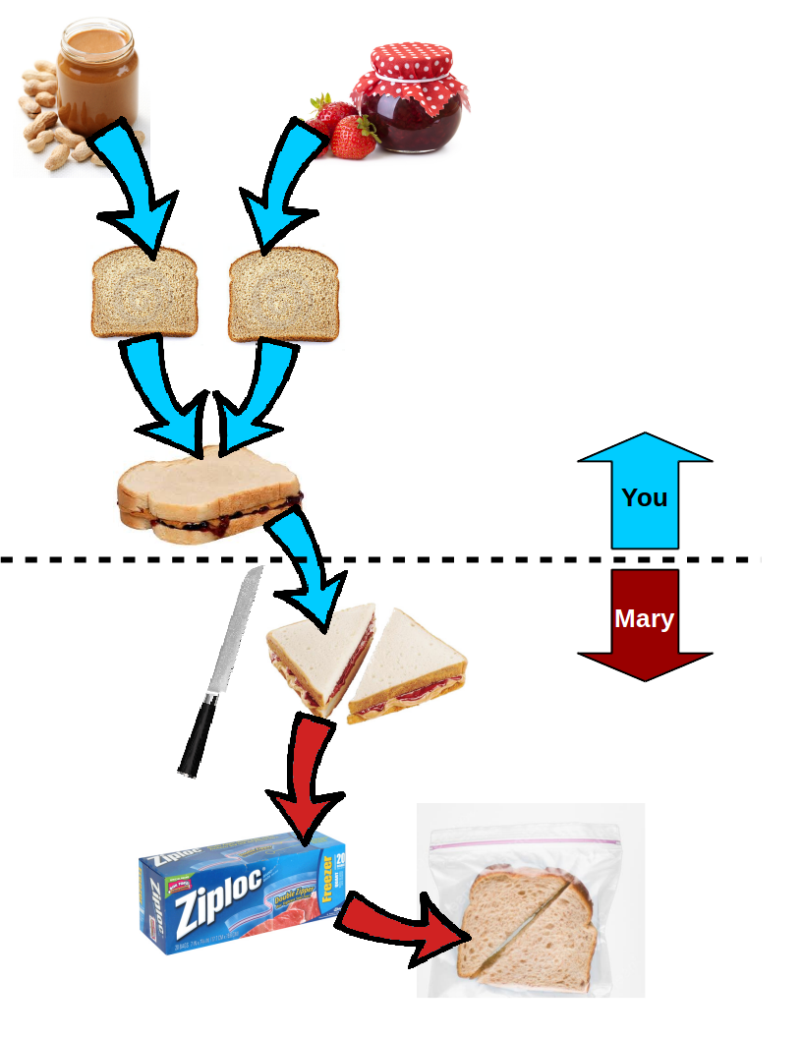

**Second Sandwich:**

To prepare **boiled egg** sandwich the following **steps** MUST be taken in the following **order** (as shown in the picture):

Boil the water in a pot, and put two eggs in the pot when the water is boiling. Remove the eggs from the pot after 5 minutes. Peel the boiled eggs and slice them into a few pieces. Shake some salt on the eggs. Put the sliced eggs on bread. Wait for Mary to put some pickles on top of the eggs. Press another slice of bread on top. Grab a zip lock bag and put your sandwich inside of the zip lock bag.

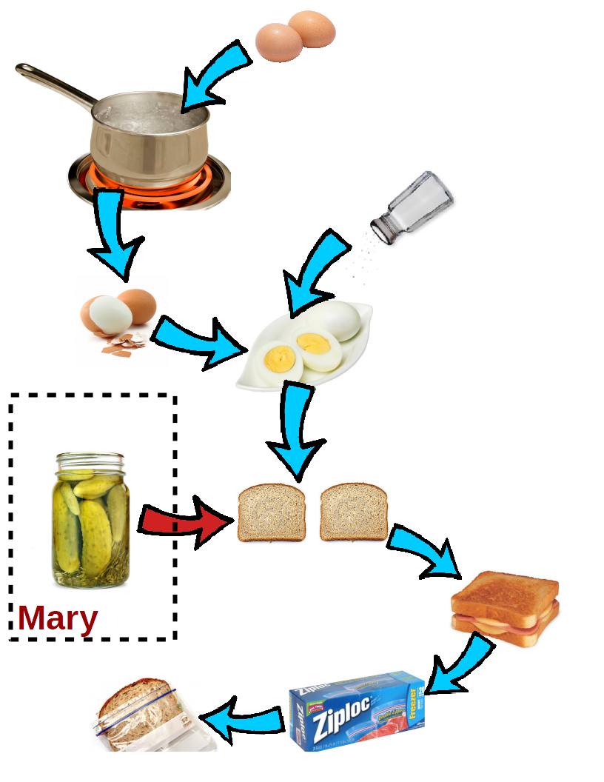

In this questionnaire, there are 12 questions about different situations while you are preparing two sandwiches **together with Mary** (as mentioned above). Each question provides three possible answers regarding the desirability of certain circumstances.

**Desirability** is a measure of the value of an event or action. Desirability can be positive if an event facilitates a positive value for you, and it can be negative it inhibits a positive value for you. For example, if you know Mary is supposed to add some pickles to the top of your sliced boiled eggs (see the picture above), how desirable do you think it is if she adds another garnish to your sandwich that you do not like?

Now, please answer the following questions:

1. Imagine you want to make one peanut butter and one hard boiled egg sandwich for your hike. Which of the following two actions is **more desirable**? [Top Level Goal is Failed]

A. Mary tells you the peanut butter and eggs you used in your sandwiches are spoiled and out dated.

**B. Your peanut butter sandwich is done and ready. Mary tell you to wait for her to cut the egg sandwich in half and put it in a zip lock bag for you.**

C. Equally desirable.

2. Imagine you want to make one peanut butter and one hard boiled egg sandwich for your hike. Which of the following two actions is **more desirable**? [Top Level Goal is Achieved]

**A. You have both sandwiches ready to go.**

B. Your peanut butter sandwich is done and ready. Mary tells you to wait for her to cut the egg sandwich in half and put it in a zip lock bag for you.

C. Equally desirable.

3. Imagine you want to make the egg sandwich. You have sliced the eggs, put them on one slice of bread, salted them, and are waiting for Mary to put some pickles on your eggs. Which of the following two actions is **more desirable**? [Predecessors OR preconditions of the top level goal]

A. Mary tells you there are no more pickles left in the jar to put on your sandwich.

**B. Mary finds the pickle jar to put some pickles on your eggs.**

C. Equally desirable.

4. Imagine you pressed two slices of bread together with peanut butter and strawberry jam on them, and passed them to Mary. Which of the following two actions is **more desirable**? [Focus is Achieved]

**A. Mary cuts the peanut butter sandwich in half and put it in a zip lock bag.**

B. Mary can not find a knife to cut the sandwich in half.

C. Equally desirable.

5. Imagine you have put two eggs in a boiling pot. Which of the following two actions is **more desirable**? [Focus is Failed]

A. You go back to the pot to remove the eggs from the pot, but the egg shells are broken and the eggs are mixed with water.

**B. You decide to wait for two more minutes for the eggs to boil.**

C. Equally desirable.

6. Imagine you want to make the egg sandwich. You have put eggs in the pot to boil. Which of the following two actions is **more desirable**? [Predecessors OR preconditions of the focus]

A. You come back to the pot and you see that you have forgotten to turn on the oven.

**B. You come back to the pot and eggs are boiling, and ready to be removed from the pot.**

C. Equally desirable.

7. Imagine you have pressed the two slices of bread together (one covered with strawberry jam and one covered with peanut butter) together and passed it to Mary. Which of the following two actions is **more desirable**? [Pending or Inprogress focus]

A. Mary puts two pieces of the sandwich into a zip lock bag after cutting the sandwich in half.

B. You go ahead and begin to boil the water to make the boiled egg sandwich.

**C. Equally desirable.**

8. Imagine you want to make one peanut butter and one hard boiled egg sandwich for your hike. Which of the following two actions is **more desirable**? [Top Level Goal is Failed]

A. Mary tells you the peanut butter and eggs you used in your sandwiches are spoiled and out dated.

B. Mary finds some mold on the bread in both sandwiches.

**C. Equally desirable.**

9. Imagine you want to make the egg sandwich. You have sliced the eggs, put them on one slice of bread, salted them, and are waiting for Mary to put some pickles on your eggs. Which of the following two actions is **more desirable**? [Predecessors OR preconditions of the top level goal]

A. Mary tells you there are no more pickles left in the jar to put on your sandwich.

B. Mary finds the pickles are out dated and not edible.

**C. Equally desirable.**

10. Which of the following two actions is **more desirable**? [Focus is Achieved]

A. Imagine you pressed two slices of bread together with peanut butter and strawberry jam on them, and passed them to Mary. Mary cuts the peanut butter sandwich in half and puts them in the zip lock bag.

B. Imagine you want to make the egg sandwich. You have sliced the eggs, put them on one slice of bread, salted them, and waiting for Mary to put some pickles on your eggs. Mary puts some pickles on your eggs.

**C. Equally desirable.**

11. Imagine you have put two eggs in a pot to boil. Which of the following two actions is **more desirable**? [Focus is Failed]

A. You go back to the pot to remove the eggs from the pot, but the egg shells are broken and eggs are mixed with water and are not edible any more.

B. You go back to the pot to remove the eggs from the pot, but you find out somebody has removed the eggs before you and eaten them.

**C. Equally desirable.**

12. Which of the following two actions is **more desirable**? [Predecessors OR preconditions of the focus]

A. Imagine you want to make the egg sandwich, but you cannot find the eggs.

B. Imagine you want to make the peanut butter sandwich, but you find the peanut butter jar empty.

**C. Equally desirable.**