You are preparing for hiking. You are supposed to make **two** different snacks, a peanut butter and jelly sandwich and a simple boiled egg sandwich, **together with Mary**. The peanut butter and jelly sandwich MUST be prepared using peanut butter and strawberry jam. The egg sandwich MUST be prepared using two boiled eggs, salt and some pickles. All required ingredients are available to **you and Mary**, including:

a) a jar of peanut butter,

b) a jar of strawberry jam,

c) whole wheat bread,

d) two eggs,

e) pickles, and

f) salt.

**First Sandwich:**

To prepare **peanut butter and jelly** sandwich the following **steps** MUST be taken in the following **order** (as shown in the picture):

Spread some peanut butter on one slice of bread. Spread some strawberry jam on another slice of bread. Press two slices together, and pass the sandwich to Mary. Mary uses a knife to cut the sandwich in half. Mary will take a zip lock bag, and puts the sandwich in the bag.

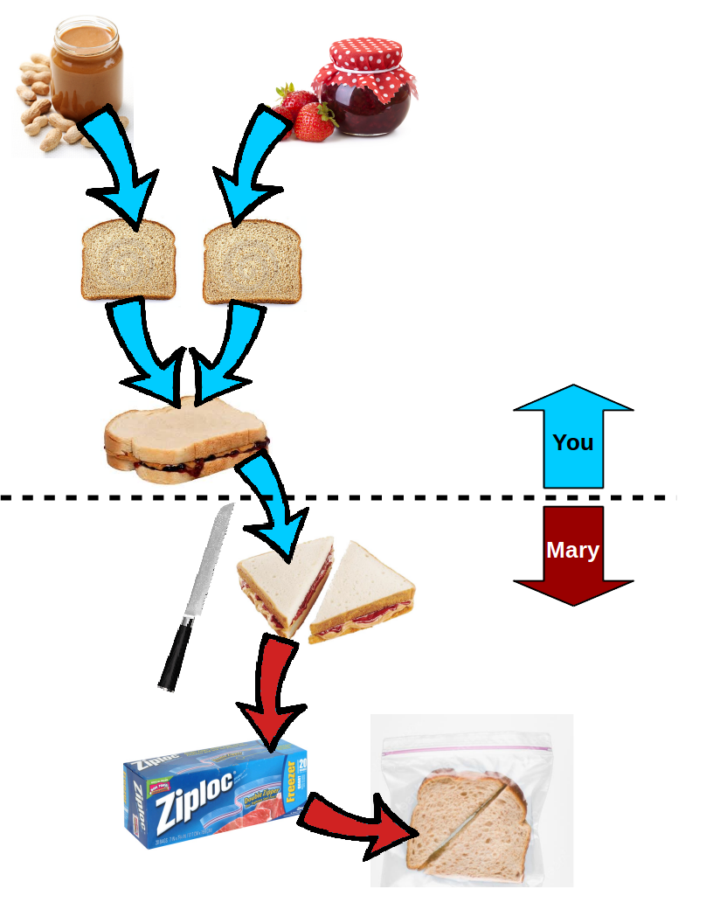

**Second Sandwich:**

To prepare **boiled egg** sandwich the following **steps** MUST be taken in the following **order** (as shown in the picture):

Boil the water in a pot, and put two eggs in the pot when the water is boiling. Remove the eggs from the pot after 5 minutes. Peel the boiled eggs and slice them into a few pieces. Shake some salt on the eggs. Put the sliced eggs on bread. Wait for Mary to put some pickles on top of the eggs. Press another slice of bread on top. Grab a zip lock bag and put your sandwich inside of the zip lock bag.

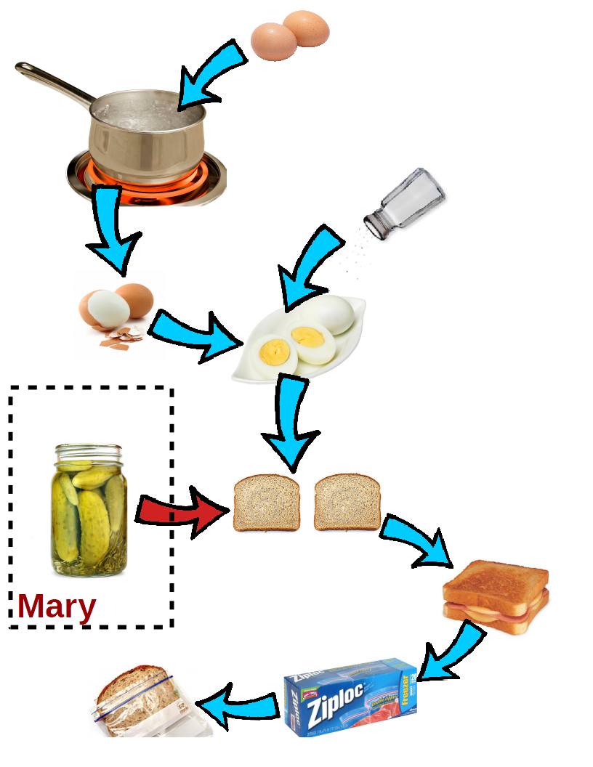

In this questionnaire, there are 10 questions about different situations while you are preparing two sandwiches **together with Mary** (as mentioned above). Each question provides three possible answers regarding how expected the possible situations are.

**Expectedness** is the extent to which a situation or an event could be predicted from your past knowledge. For example, if you know Mary is supposed to add some pickles to the top of your sliced boiled eggs (see the picture above), how expected do you think it is if she does something completely different in comparison with what you and she planned for?

Now, please answer the following questions:

1. Imagine you have just pressed two slices of bread together after spreading peanut butter and strawberry jam on them. Which of the following two actions is **more expected**? [Expected vs. Most_Expected]

**A. Mary takes your sandwich and cuts it in half.**

B. You begin to put the water in the pot without passing the peanut butter sandwich to Mary.

C. Equally expected.

2. Imagine you have just pressed the two slices of bread together after spreading peanut butter and strawberry jam on them, and passed it to Mary. Which of the following two actions is **more expected**? [Expected – Most_Unexpected]

**A. Mary takes your sandwich and cuts it in half.**

B. Mary takes a bite of the given sandwich.

C. Equally expected.

3. Imagine you are spreading peanut butter onto one slice of bread. Which of the following two actions is **more expected**? [Expected – Unexpected]

**A. Mary waits for you to prepare the sandwich and pass it to her.**

B. Mary puts some pickles on another slice of bread.

C. Equally expected.

4. Imagine Mary cuts your given peanut butter sandwich in half. Which of the following two actions is **more expected**? [Most_Expected – Most_Unexpected]

**A. Mary takes a zip lock bag and put the sandwich inside of the bag**.

B. Mary leaves the apartment to but an energy drink.

C. Equally expected.

5. Imagine you have pressed the two slices of bread (one covered with strawberry jam and one covered with peanut butter) together and passed it to Mary. Which of the following two actions is **more expected**? [Most_Expected – Unexpected]

**A. Mary puts the given sandwich into a zip lock bag after cutting it in half.**

B. Mary puts some pickles on another slice of bread.

C. Equally expected.

6. Imagine you have pressed the two slices of bread (one covered with strawberry jam and one covered with peanut butter) together and passed it to Mary. Which of the following two actions is **more expected**? [Most_Unexpected – Unexpected]

**A. Mary puts some pickles on another slice of bread.**

B. Mary begins to cook some chicken for you.

C. Equally expected.

7. Imagine you have pressed the two slices of bread (one covered with strawberry jam and one covered with peanut butter) together and passed it to Mary. Which of the following two actions is **more expected**? [Expected – Expected]

A. Mary puts the given sandwich into a zip lock bag after cutting it in half.

B. You go ahead and begin to boil the water in a pot, since Mary doesn't need your help anymore.

**C. Equally expected.**

8. Imagine you are spreading strawberry jam onto the second slice of bread. Which of the following two actions is **more expected**? [Unexpected – Unexpected]

A. Mary wants to cut the one slice of bread which is already covered by peanut butter.

B. Mary puts some pickles on another slice of bread.

**C. Equally expected.**

9. Which of the following two actions is **more expected**? [Most_Expected – Most_Expected]

A. Imagine you have pressed the two slices of bread (one covered with strawberry jam and one covered with peanut butter) together and passed it to Mary. Mary puts the given sandwich into a zip lock bag after cutting it in half.

B. Imagine you have shaken salt on the slices of the boiled eggs on the bread. Mary puts some pickles on another slice of bread.

**C. Equally expected.**

10. Imagine you have peeled the boiled eggs and sliced them into some pieces. Which of the following two actions is **more expected**? [Most_Unexpected – Most_Unexpected]

A. Mary leaves the apartment to but an energy drink.

B. Mary begins to cook some chicken for you.

**C. Equally expected.**