You are preparing for hiking. You are supposed to make **two** different snacks, a peanut butter and jelly sandwich and a simple boiled egg sandwich, **together with Mary**. The peanut butter and jelly sandwich MUST be prepared using peanut butter and strawberry jam. The egg sandwich MUST be prepared using two boiled eggs, salt and some pickles. All required ingredients are available to **you and Mary**, including:

a) a jar of peanut butter,

b) a jar of strawberry jam,

c) whole wheat bread,

d) two eggs,

e) pickles, and

f) salt.

**First Sandwich:**

To prepare **peanut butter and jelly** sandwich the following **steps** MUST be taken in the following **order** (as shown in the picture):

Spread some peanut butter on one slice of bread. Spread some strawberry jam on another slice of bread. Press two slices together, and pass the sandwich to Mary. Mary uses a knife to cut the sandwich in half. Mary takes a zip lock bag, and puts the sandwich in the bag.

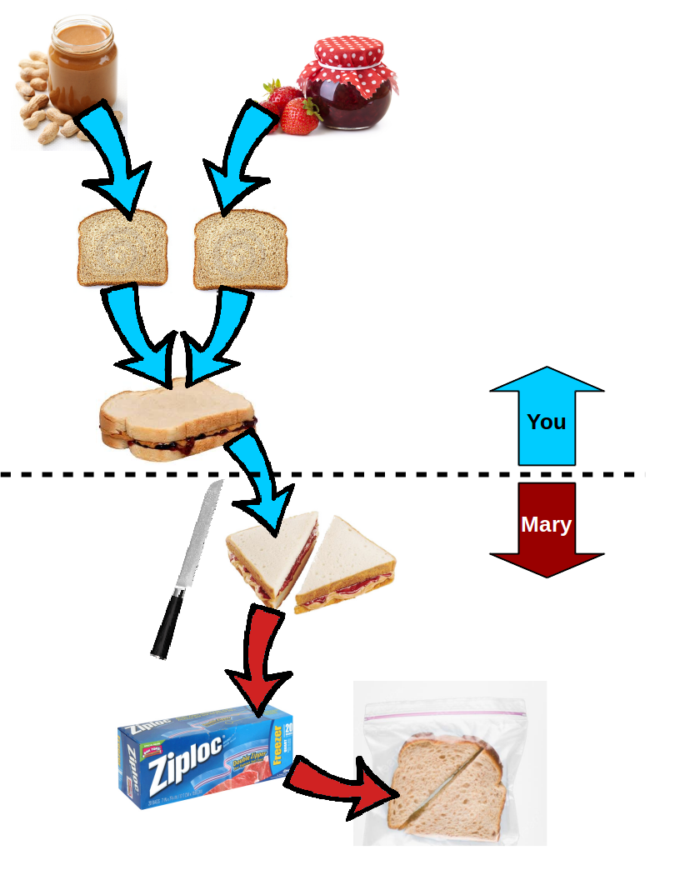

**Second Sandwich:**

To prepare **boiled egg** sandwich the following **steps** MUST be taken in the following **order** (as shown in the picture):

Boil the water in a pot, and put two eggs in the pot when the water is boiling. Remove the eggs from the pot after 5 minutes. Peel the boiled eggs and slice them into a few pieces. Shake some salt on the eggs. Put the sliced eggs on bread. Wait for Mary to put some pickles on top of the eggs. Press another slice of bread on top. Grab a zip lock bag and put your sandwich inside of the zip lock bag.

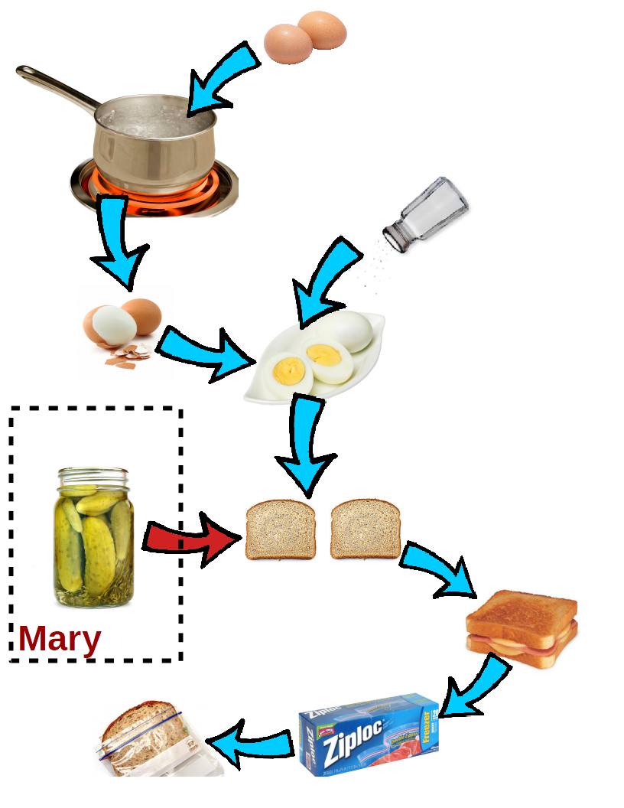

In this questionnaire, there are 19 questions about different situations while you are preparing the two sandwiches **together with Mary** (as mentioned above). Each question provides three Possible answers regarding the relevancy of various situations to the goal of preparing the sandwiches.

A situation or an event is **relevant** if it requires your attention because of its positive or negative effect, since it can impact your state or what you want. For example, if you need Mary to take the peanut butter sandwich you made, cut it in half and put it in a zip lock for you (see the picture on the previous page), how **relevant** do you think it is if she cuts your sandwich in half and puts it in a small paper bag for you?

Now, please answer the following questions:

1. Imagine you have just pressed two slices of bread together after spreading peanut butter and jelly on them. Which of the following two actions is **more relevant**? [Belief Saliency – Focus]

**A. Mary takes your sandwich and cuts it in half.**

B. Mary looks for a jar of pickles for your second sandwich.

C. Equally relevant.

2. Imagine you want to make the peanut butter sandwich. Which of the following two actions is **more relevant**? [Belief Strength - Responsibility]

A. You trying to find the jar of peanut butter.

B. Mary wants to figure out which knife to use to cut the sandwich you make.

**C. Equally relevant.**

3. Imagine you have made the peanut butter sandwich and passed it to Mary to cut it in half. You begin to boil some water in the pot for the eggs. Which of the following two actions is **more relevant**? [Belief Recency]

**A. Mary has cut the peanut butter sandwich and put it in a zip lock bag.**

B. Mary asks you whether you have found the jar of peanut butter.

C. Equally relevant.

4. Imagine you have spread peanut butter on one slice of bread and you have just spread the strawberry jam on the second slice of bread. Now you want to press them together and pass the sandwich to Mary to cut it in half. Which of the following two actions is **more relevant**? [Motive Insistence – ordered successor]

**A. Mary asks you to pass the sandwich to her**.

B. Mary asks you whether the eggs are done.

C. Equally relevant.

5. Imagine you want to make a hard boiled egg sandwich. Which of the following two actions is **more relevant**? [Motive Urgency – Demand on something with pressing necessity]

A. Mary tells you that you have run out of eggs.

B. Mary tells you that you have run out of pickles.

**C. Equally relevant.**

6. Imagine you and Mary want to make the hard boiled egg sandwich. Which of the following two actions is **more relevant**? [Motive Intensity – Failure or blockage of a demanding task]

A. Mary tells you that you can not boil the eggs since the stove is broken.

**B. Mary tells you that she is going to grab a knife to cut the sandwich in half.**

C. Equally relevant.

7. Imagine you want to make the peanut butter sandwich. You open the lid on both jars of peanut butter and strawberry jam. Which of the following two actions is **more relevant**? [Goal Proximity – Distance from current goal]

**A. You pick a slice of bread to spread peanut butter onto it.**

B. You ask Mary whether she has a zip lock bag to put the sandwich inside.

C. Equally relevant.

8. Imagine you and Mary are going to make a peanut butter and a hard boiled egg sandwich for your hiking trip. Which of the following two actions is **more relevant**? [Goal Specificity]

**A. You take two eggs and put them in a pot with boiling water.**

B. You think of making a snack for your hiking trip.

C. Equally relevant.

9. Which of the following two actions is **more relevant**? [Belief Saliency – Focus]

A. Pressing two slices of bread after spreading peanut butter and jelly on them.

B. Pressing two slices of bread after after putting slices of boiled egg, and adding some salt and pickles.

**C. Equally relevant.**

10. Imagine you want to make the peanut butter sandwich. Which of the following two actions is **more relevant**? [Belief Strength - Responsibility]

A. Spreading peanut butter on one slice of bread.

B. Spreading strawberry jam on another slice of bread.

**C. Equally relevant.**

11. Imagine you have made the peanut butter sandwich and passed it to Mary to cut it in half. You begin to boil some water in the pot for the eggs. Which of the following two actions is **more relevant**? [Belief Recency]

A. Mary has cut the peanut butter sandwich and put it in a zip lock bag.

B. You put the eggs in the boiling water.

**C. Equally relevant.**

12. Which of the following two actions is **more relevant**? [Motive Insistence – ordered successor]

A. You want to press two slices of bread together after spreading peanut butter and strawberry jam on them.

B. You want to spread strawberry jam on another slice of bread after spreading peanut butter on one slice of the bread.

**C. Equally relevant.**

13. Which of the following two actions is **more relevant**? [Motive Urgency – Demand on something with pressing necessity]

A. Mary tells you that you have run out of eggs when you wanted to make a hard boiled egg sandwich.

B. Mary tells you that you have run out of peanut butter when you wanted to make a peanut butter sandwich.

**C. Equally relevant.**

14. Which of the following two actions is **more relevant**? [Motive Intensity – Failure or blockage of a demanding task]

A. You try to find a pot to boil the eggs since you want to make the hard boiled egg sandwich.

B. You look for the jar of peanut butter since you want to make peanut butter sandwich .

**C. Equally relevant.**

15. Which of the following two actions is **more relevant**? [Goal Proximity – Distance from current goal]

A. You open the lid on both jars of peanut butter and strawberry jam since you want to make the peanut butter sandwich.

**B. Mary opens the lid on jar of pickles since she wants to add some pickles to the top of your sliced boiled eggs.**

C. Equally relevant.

16. Which of the following two actions is **more relevant**? [Goal Specificity]

A. You take two eggs and put them in a pot with boiling water, since you want to make a hard boiled egg sandwich.

B. You open the lid on both jars of peanut butter and strawberry jam since you want to make the peanut butter sandwich.

**C. Equally relevant.**

17. Imagine you have made the peanut butter sandwich and passed it to Mary to cut it in half. Which of the following two actions is **more relevant**? [Belief Saliency – Focus]

**A. Mary starts crying since she cut her finger with a knife.**

B. You begin to boil the water to boil the eggs for your second sandwich.

C. Equally relevant.

18. Imagine you have spread peanut butter on one slice of bread and you just spread the strawberry jam on the second slice of bread. Now you want to press them together and pass the sandwich to Mary to cut it in half. Which of the following two actions is **more relevant**? [Motive Insistence – ordered successor]

A. Mary asks you to pass the sandwich to her.

B. You realize Mary becomes so angry and begins yelling at you. You want to know what happened!

**C. Equally relevant.**

19. Imagine you want to make the peanut butter sandwich. You open the lid on both jars of peanut butter and strawberry jam. Which of the following two actions is **more relevant**? [Goal Proximity – Distance from current goal]

A. Mary begins to laugh so hard. She can't say anything, but is pointing at you. You keep asking her what happened!

B. You pick a slice of bread to spread peanut butter onto it.

**C. Equally relevant.**