Computational Linear Algebra: Module 2  
Maya Shende  
Due: January 31st, 2018

1. Proof: Let n be an even number. Then n = 2x for some integer x. So, $\sqrt{n}=\sqrt{2x}=y$, and thus $2x=y^{2}$. Now, by way of contradiction, suppose y is odd. So, by definition $y=2z+1$ for some integer z. So,

$$n=\left(2z+1\right)\left(2z+1\right)$$

$$=4z^{2}+4z+1$$

$$=2\left(2z^{2}+2z\right)+1$$

which is odd. But we know that n is even, so y must also be even. □

1. Proof: Let $x=\frac{p}{q}$ and $y=\frac{r}{s}$ be two rational numbers with x < y. Then, we will find the midpoint of these two numbers and show that it is also a rational number. Let z be the midpoint of x and y, defined as $z=\frac{\frac{p}{q}+\frac{r}{s}}{2}=\frac{ps+qr}{2qs}$ where ps+qr is an integer and 2qs is an integer, thus making z a rational number. So, we have found a rational number z such that x < z < y. □
2. Yes, there is a real-world physical length corresponding to sqrt(2) – the hypotenuse of an isosceles triangle with side length 1.
3. If the coefficients are rational, we can simply get rid of the denominators using the LCD to get integer coefficients. If we apply any of the standard arithmetic operators to two algebraic numbers, the result is always algebraic because algebraic numbers are closed under these operators. One example of an irrational algebraic number is sqrt(2), which is the root of

$x^{2}-2=0$.

$f(x)=\left\{\begin{aligned}\frac{x}{2}, x\text{ even} \\ \frac{-(x-1)}{2}, &x \text{odd}\end{aligned}\right.$

1. Rationals have the same size as the integers – we can use Cantor’s Diagonalization to prove this
2. The cardinality of [0,1] = cardinality of **R** and the cardinality of [a,b] = cardinality of **R**. Therefore the cardinality of [0,1] = cardinality of [a,b] for any [a,b].
3. Cardinality of the plane is the same as the line. We can find a one-to-one mapping from every point in a plane (call the point (x,y)) to some point z that lies along an edge of the plane. We can find this point by taking alternating digits from x and y and using them to form z. This means that each point maps to a unique z and each z decomposes to a unique point (x,y). Thus, the cardinalities are the same since we found such a one-to-one mapping.
4. 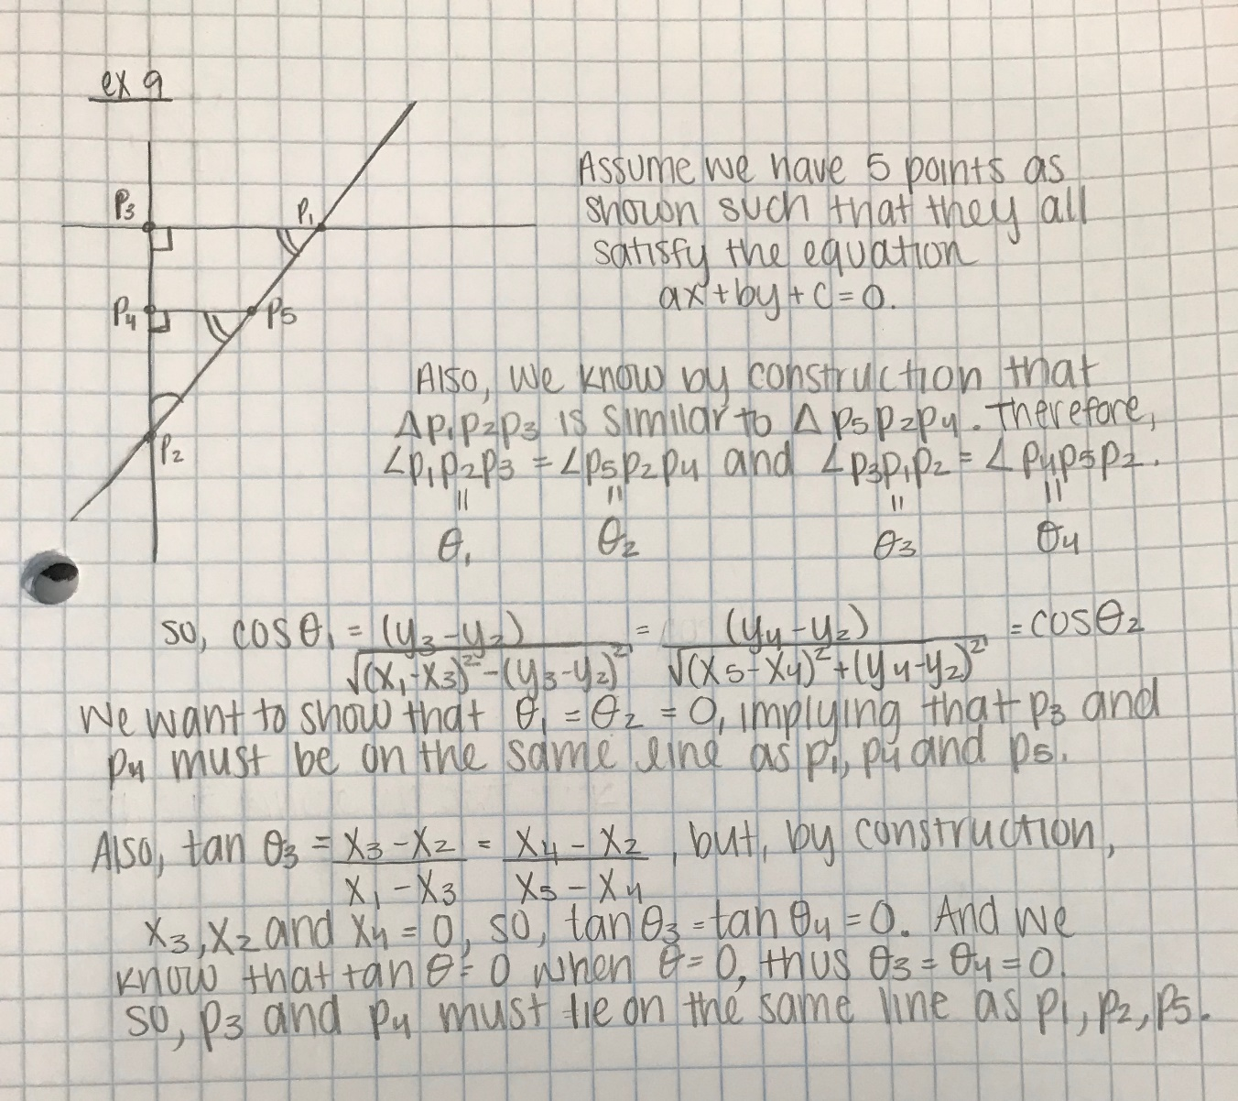
5. ${(x+y)}^{n}=\left(x+y\right)\left(x+y\right)…(x+y)$. In other words, for each term, we are **choosing** either x or y, and then multiplying these choices together. In total there are $\left({n \atop k}\right)$ ways to pick x’s. each term of the expansion is then $x^{k}y^{n-k}$, and $\left({n \atop k}\right)$ tells us how many ways there are to do this.
6. If we take this formula and multiply it out, we easily see that it is a polynomial.
7. Sin(x) is defined on all real numbers, so we can define its value. They are defined as real numbers. The function repeats 3 times in the range
8. Smaller ω means the curve oscillates at a smaller frequency.
9. $sin⁡\left(2πt+\frac{π}{2}\right)$ shifts the sine wave so that it now looks like a normal cosine wave. $cos⁡\left(2πt+\frac{π}{2}\right)$ shifts the cosine wave so that it now looks like a negative sine wave.
10. All we are changing is the amplitude, not the frequency, so that period will remain the same.