Kubernetes HA Lab
Complete Build & Operations Guide
VMware ESXi · pfSense · 3-Master K8s v1.30.14 · Calico · MetalLB · Kafka
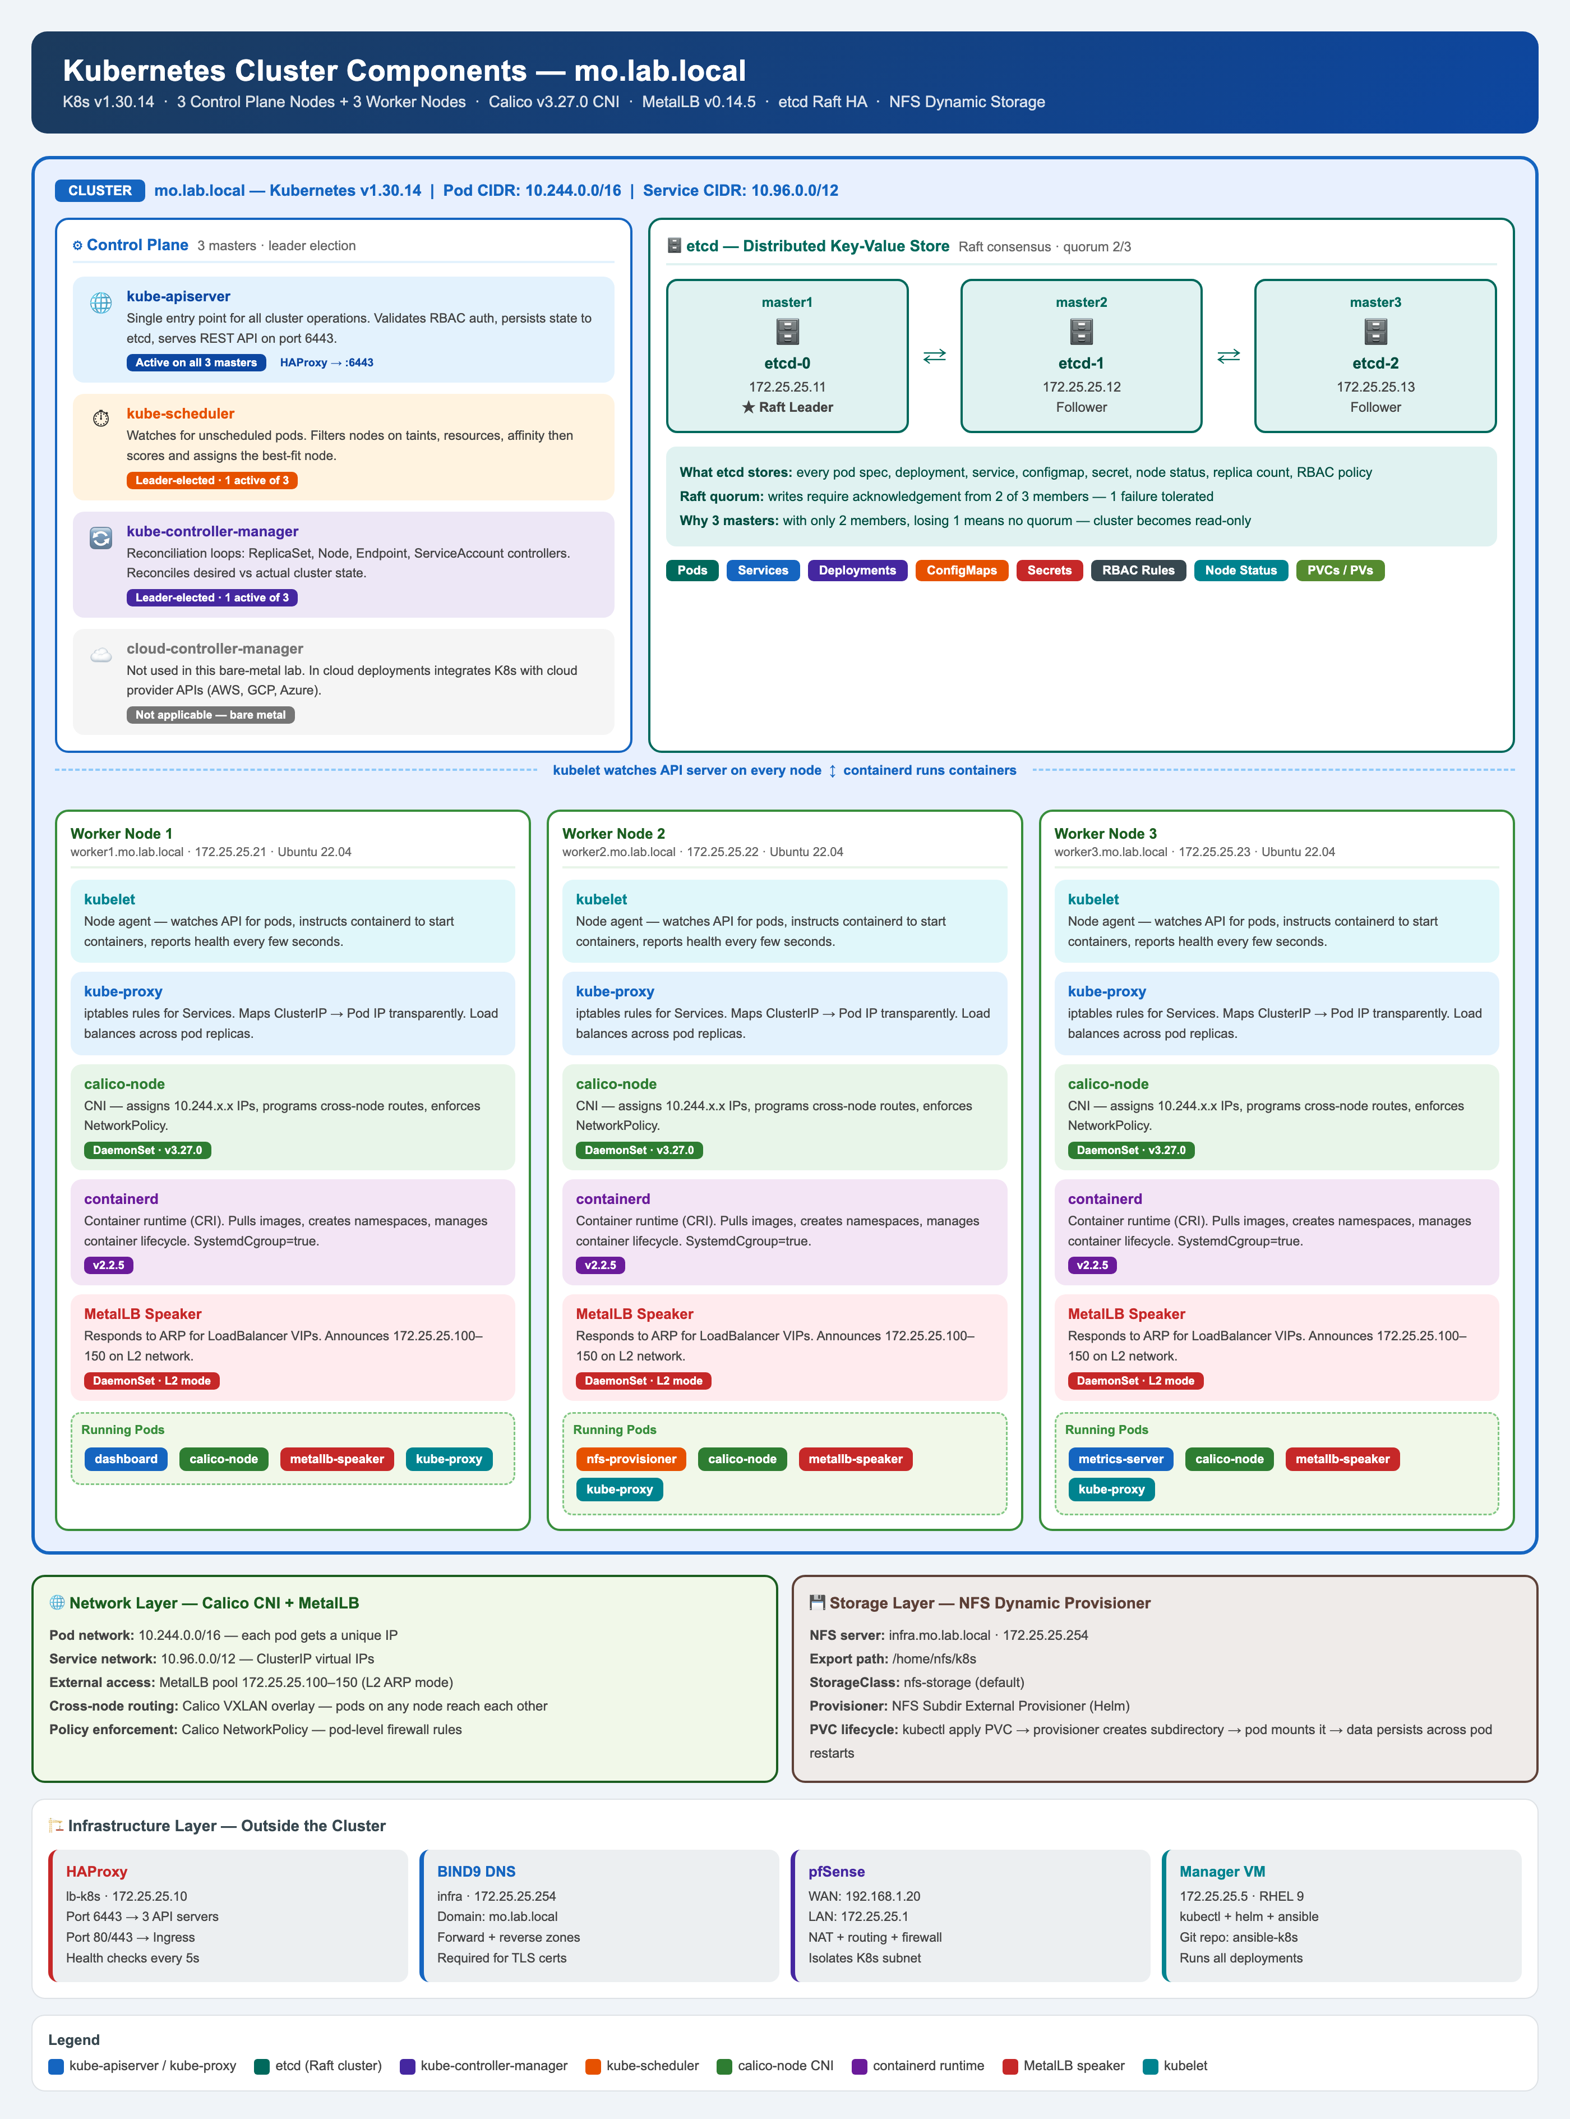
Kubernetes Cluster Components

Table of Contents

1. Architecture Overview

This lab implements a production-grade Kubernetes HA cluster on VMware ESXi using pfSense as the network gateway and firewall. Three control-plane nodes run stacked etcd using Raft consensus, while three worker nodes host application workloads. HAProxy load-balances the Kubernetes API across all three masters.

Node Inventory
Host | IP / OS / Role
infra.mo.lab.local | 172.25.25.254 · RHEL 9 · BIND9 DNS + NFS server
manager.mo.lab.local | 172.25.25.5 · RHEL 9 · Ansible control node + Helm + kubectl
lb-k8s.mo.lab.local | 172.25.25.10 · RHEL 9 · HAProxy 2.8.14 load balancer
master1-k8s.mo.lab.local | 172.25.25.11 · Ubuntu 22.04 · K8s control plane + etcd
master2-k8s.mo.lab.local | 172.25.25.12 · Ubuntu 22.04 · K8s control plane + etcd
master3-k8s.mo.lab.local | 172.25.25.13 · Ubuntu 22.04 · K8s control plane + etcd
worker1-k8s.mo.lab.local | 172.25.25.21 · Ubuntu 22.04 · K8s worker node
worker2-k8s.mo.lab.local | 172.25.25.22 · Ubuntu 22.04 · K8s worker node
worker3-k8s.mo.lab.local | 172.25.25.23 · Ubuntu 22.04 · K8s worker node

Network Layout
Network | Description
vSwitch0 192.168.1.0/24 | Home LAN — vmnic0, pfSense WAN 192.168.1.20
vSwitch1 172.25.25.0/24 | K8s lab network — vmnic1, pfSense LAN 172.25.25.1
MetalLB pool | 172.25.25.100 – 172.25.25.150 (L2 mode)
Pod CIDR | 10.244.0.0/16 (Calico)
Domain | mo.lab.local (BIND9 on infra)

2. pfSense 2.8.1 Installation & Configuration

pfSense acts as NAT gateway, firewall, and router between the home LAN (192.168.1.0/24) and the isolated K8s lab network (172.25.25.0/24).

ESXi VM Configuration
- vCPU: 2, RAM: 2 GB, Disk: 8 GB
- Network Adapter 1: vSwitch0 (vmnic0) → WAN interface em0
- Network Adapter 2: vSwitch1 k8s-net-lab (vmnic1) → LAN interface em1

Initial Interface Assignment
On first boot pfSense prompts for interface assignment:
WAN → em0 (192.168.1.20/24, gateway 192.168.1.1)
LAN → em1 (172.25.25.1/24)

NAT — Outbound Rule
Firewall → NAT → Outbound → Manual Outbound NAT:
- Interface: WAN
- Source: 172.25.25.0/24
- Translation: Interface Address

Static Route on Mac
Add a persistent route on your Mac so you can reach 172.25.25.x from the home LAN:
sudo route add -net 172.25.25.0/24 192.168.1.20
Note: This route is lost on reboot. Add it to /etc/rc.local or a LaunchDaemon for persistence.

3. BIND9 DNS Server (infra — 172.25.25.254)

Install
# On infra VM
dnf install -y bind bind-utils
systemctl enable --now named

/etc/named.conf (key settings)
options {
listen-on port 53 { 127.0.0.1; 172.25.25.254; };
directory "/var/named";
allow-query { localhost; 172.25.25.0/24; };
recursion yes;
forwarders { 8.8.8.8; 8.8.4.4; };
dnssec-enable no;
dnssec-validation no;
};

/etc/named/named.conf.local
zone "mo.lab.local" {
type master;
file "/etc/named/zones/db.mo.lab.local";
};
zone "25.25.172.in-addr.arpa" {
type master;
file "/etc/named/zones/db.172.25.25.rev";
};

Forward Zone — db.mo.lab.local
$TTL 86400
@ IN SOA infra.mo.lab.local. admin.mo.lab.local. (2024010101 3600 1800 604800 86400)
@ IN NS infra.mo.lab.local.
infra IN A 172.25.25.254
manager IN A 172.25.25.5
lb-k8s IN A 172.25.25.10
master1-k8s IN A 172.25.25.11
master2-k8s IN A 172.25.25.12
master3-k8s IN A 172.25.25.13
worker1-k8s IN A 172.25.25.21
worker2-k8s IN A 172.25.25.22
worker3-k8s IN A 172.25.25.23
dashboard-k8s IN A 172.25.25.100

Verify DNS
dig @172.25.25.254 master1-k8s.mo.lab.local
# Expected: 172.25.25.11 in ANSWER section
dig @172.25.25.254 -x 172.25.25.11
# Expected: master1-k8s.mo.lab.local in ANSWER section

4. NFS Server (infra — 172.25.25.254)

# On infra VM
dnf install -y nfs-utils
mkdir -p /home/nfs/k8s
chmod 777 /home/nfs/k8s
echo "/home/nfs/k8s 172.25.25.0/24(rw,sync,no_subtree_check,no_root_squash)" >> /etc/exports
exportfs -rav
systemctl enable --now nfs-server

# Verify from any worker
showmount -e 172.25.25.254
# Expected: /home/nfs/k8s 172.25.25.0/24

5. HAProxy 2.8.14 Load Balancer (lb-k8s — 172.25.25.10)

Install
# On lb-k8s VM
dnf install -y haproxy
systemctl enable --now haproxy

/etc/haproxy/haproxy.cfg
global
log /dev/log local0
chroot /var/lib/haproxy
stats socket /run/haproxy/admin.sock mode 660 level admin
user haproxy
group haproxy
daemon

defaults
log global
mode tcp
option tcplog
timeout connect 5000
timeout client 50000
timeout server 50000

frontend kubernetes-api
bind *:6443
mode tcp
default_backend kubernetes-masters

backend kubernetes-masters
mode tcp
balance roundrobin
option tcp-check
server master1 172.25.25.11:6443 check fall 3 rise 2
server master2 172.25.25.12:6443 check fall 3 rise 2
server master3 172.25.25.13:6443 check fall 3 rise 2

frontend http-ingress
bind *:80
mode tcp
default_backend http-workers

backend http-workers
mode tcp
balance roundrobin
server worker1 172.25.25.21:80 check fall 3 rise 2
server worker2 172.25.25.22:80 check fall 3 rise 2
server worker3 172.25.25.23:80 check fall 3 rise 2

frontend https-ingress
bind *:443
mode tcp
default_backend https-workers

backend https-workers
mode tcp
balance roundrobin
server worker1 172.25.25.21:443 check fall 3 rise 2
server worker2 172.25.25.22:443 check fall 3 rise 2
server worker3 172.25.25.23:443 check fall 3 rise 2

listen stats
bind *:9000
mode http
stats enable
stats uri /
stats refresh 10s

Verify
haproxy -c -f /etc/haproxy/haproxy.cfg # config check
systemctl restart haproxy
curl http://172.25.25.10:9000/ # stats page

6. Ansible Setup (manager — 172.25.25.5)

# On manager VM
dnf install -y ansible-core git

# Generate SSH key and copy to all nodes
ssh-keygen -t rsa -b 4096 -f ~/.ssh/id_rsa -N ""
for host in 172.25.25.11 172.25.25.12 172.25.25.13 172.25.25.21 172.25.25.22 172.25.25.23; do
ssh-copy-id msalah@$host
done

# Clone the repo
git clone https://github.com/mshgayar/k8s-pfsense-esxi.git /root/ansible-k8s
cd /root/ansible-k8s

Ansible Inventory — hosts
[masters]
master1-k8s ansible_host=172.25.25.11
master2-k8s ansible_host=172.25.25.12
master3-k8s ansible_host=172.25.25.13

[workers]
worker1-k8s ansible_host=172.25.25.21 ansible_user=worker1-k8s
worker2-k8s ansible_host=172.25.25.22 ansible_user=worker2-k8s
worker3-k8s ansible_host=172.25.25.23 ansible_user=worker3-k8s

[k8s:children]
masters
workers

[k8s:vars]
ansible_user=msalah
ansible_become=yes
ansible_become_method=sudo

Test Connectivity
ansible all -i hosts -m ping
# All 6 nodes should return SUCCESS

7. Kubernetes Stack

7.1 Prepare All Nodes via Ansible
The prepare-k8s-nodes.yml playbook configures all 6 K8s nodes: disables swap, loads kernel modules, configures sysctl, installs containerd, and installs kubeadm/kubelet/kubectl v1.30.
# On manager VM
cd /root/ansible-k8s
ansible-playbook -i hosts prepare-k8s-nodes.yml
Key tasks performed on every node:
- apt update/upgrade — latest security patches
- Disable swap permanently (swapoff -a + /etc/fstab edit)
- Load overlay and br_netfilter kernel modules
- sysctl: net.bridge.bridge-nf-call-iptables=1, net.ipv4.ip_forward=1
- Install containerd.io from Docker repository with SystemdCgroup=true in config.toml
- Disable UFW firewall
- Install kubelet kubeadm kubectl v1.30 and hold package versions
- Enable kubelet service

7.2 Initialize Cluster on master1
# On master1 (172.25.25.11)
kubeadm init \
--control-plane-endpoint "172.25.25.10:6443" \
--upload-certs \
--pod-network-cidr=10.244.0.0/16 \
--apiserver-advertise-address=172.25.25.11
After init completes, set up kubeconfig:
mkdir -p $HOME/.kube
cp /etc/kubernetes/admin.conf $HOME/.kube/config
chown $(id -u):$(id -g) $HOME/.kube/config
Save the join commands output — you will need them for the control-plane and worker joins.
Note: The --certificate-key value expires after 2 hours. Regenerate with: kubeadm init phase upload-certs --upload-certs on master1.

7.3 Join master2 and master3
# On master2 and master3 — use the control-plane join command from kubeadm init output
kubeadm join 172.25.25.10:6443 \
--token <token> \
--discovery-token-ca-cert-hash sha256:<hash> \
--control-plane \
--certificate-key <cert-key> \
--apiserver-advertise-address=172.25.25.12 # (or .13 for master3)
If a join fails and leaves a stale etcd member, clean it up before retrying:
# On master1 — list and remove stale etcd member
etcdctl --endpoints=https://127.0.0.1:2379 \
--cacert=/etc/kubernetes/pki/etcd/ca.crt \
--cert=/etc/kubernetes/pki/etcd/healthcheck-client.crt \
--key=/etc/kubernetes/pki/etcd/healthcheck-client.key \
member list

etcdctl ... member remove <STALE_ID>

# On master2/master3 — clean before retry
kubeadm reset -f && rm -rf /etc/kubernetes /var/lib/etcd

7.4 Join Worker Nodes
# On worker1, worker2, worker3 — use the worker join command
kubeadm join 172.25.25.10:6443 \
--token <token> \
--discovery-token-ca-cert-hash sha256:<hash>

# Verify on master1 — nodes will be NotReady until CNI is installed
kubectl get nodes

7.5 Install Calico CNI
Note: Flannel v0.28.5 requires /opt/bin which is not present on Ubuntu 22.04. Use Calico v3.27.0 instead.
# On master1
kubectl apply -f https://raw.githubusercontent.com/projectcalico/calico/v3.27.0/manifests/calico.yaml

# Watch nodes become Ready (takes ~60 seconds)
kubectl get nodes -w

# Expected output:
NAME STATUS ROLES AGE VERSION
master1-k8s Ready control-plane 5m v1.30.14
master2-k8s Ready control-plane 4m v1.30.14
master3-k8s Ready control-plane 3m v1.30.14
worker1-k8s Ready <none> 2m v1.30.14
worker2-k8s Ready <none> 2m v1.30.14
worker3-k8s Ready <none> 1m v1.30.14

7.6 Install MetalLB
# Apply MetalLB manifest
kubectl apply -f https://raw.githubusercontent.com/metallb/metallb/v0.14.5/config/manifests/metallb-native.yaml

# Wait for controller to be ready
kubectl wait -n metallb-system deployment/controller --for=condition=Available --timeout=120s

# Apply IP pool configuration
kubectl apply -f metallb-config.yaml
metallb-config.yaml:
apiVersion: metallb.io/v1beta1
kind: IPAddressPool
metadata:
name: k8s-ip-pool
namespace: metallb-system
spec:
addresses:
- 172.25.25.100-172.25.25.150
---
apiVersion: metallb.io/v1beta1
kind: L2Advertisement
metadata:
name: k8s-l2-advert
namespace: metallb-system
spec:
ipAddressPools:
- k8s-ip-pool

7.7 Install Kubernetes Dashboard
kubectl apply -f https://raw.githubusercontent.com/kubernetes/dashboard/v2.7.0/aio/deploy/recommended.yaml

# Change service type to LoadBalancer
kubectl -n kubernetes-dashboard patch svc kubernetes-dashboard \
-p '{"spec":{"type":"LoadBalancer"}}'

# Verify MetalLB assigned IP 172.25.25.100
kubectl -n kubernetes-dashboard get svc

# Create admin service account and cluster role binding
kubectl create serviceaccount dashboard-admin -n kubernetes-dashboard
kubectl create clusterrolebinding dashboard-admin \
--clusterrole=cluster-admin \
--serviceaccount=kubernetes-dashboard:dashboard-admin

# Generate login token
kubectl create token dashboard-admin -n kubernetes-dashboard --duration=87600h
Note: Access at https://172.25.25.100 — paste the token to log in.

7.8 Install Metrics Server
kubectl apply -f https://github.com/kubernetes-sigs/metrics-server/releases/latest/download/components.yaml

# Patch for insecure TLS (required in lab — no valid certs on kubelets)
kubectl patch deployment metrics-server -n kube-system \
--type json \
-p '[{"op":"add","path":"/spec/template/spec/containers/0/args/-","value":"--kubelet-insecure-tls"}]'

# Verify
kubectl top nodes

7.9 Install NFS Dynamic Provisioner
# Install nfs-common on all worker nodes (required for NFS mounts)
ansible workers -i hosts -m apt -a "name=nfs-common state=present" --become

# Add Helm repo and install provisioner
helm repo add nfs-subdir-external-provisioner \
https://kubernetes-sigs.github.io/nfs-subdir-external-provisioner/
helm repo update

helm install nfs-subdir-external-provisioner \
nfs-subdir-external-provisioner/nfs-subdir-external-provisioner \
--set nfs.server=172.25.25.254 \
--set nfs.path=/home/nfs/k8s \
--set storageClass.name=nfs-storage \
--set storageClass.defaultClass=true

# Test dynamic provisioning
kubectl apply -f test-pvc.yaml
kubectl apply -f test-pod-dynamic-storage.yaml
kubectl get pvc # Should be Bound

7.10 Kubernetes Traffic Flow Diagram
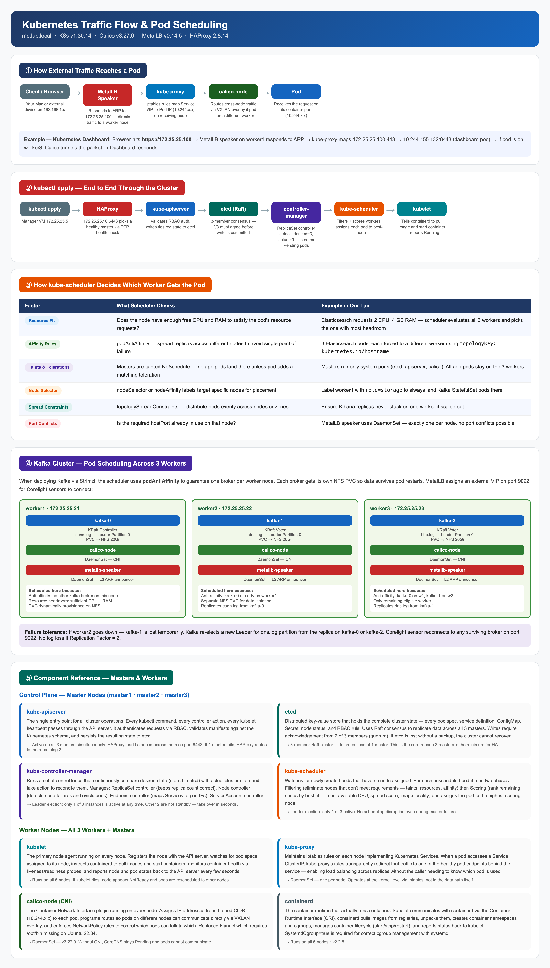
Kubernetes Traffic Flow & Pod Scheduling

8. Kafka Cluster for Corelight / Zeek Logs

After the Kubernetes cluster is operational, a Kafka cluster will be deployed using the Strimzi operator in KRaft mode (no Zookeeper). The Corelight network sensor will forward Zeek log events to Kafka topics for downstream consumption by a SIEM or analytics platform.
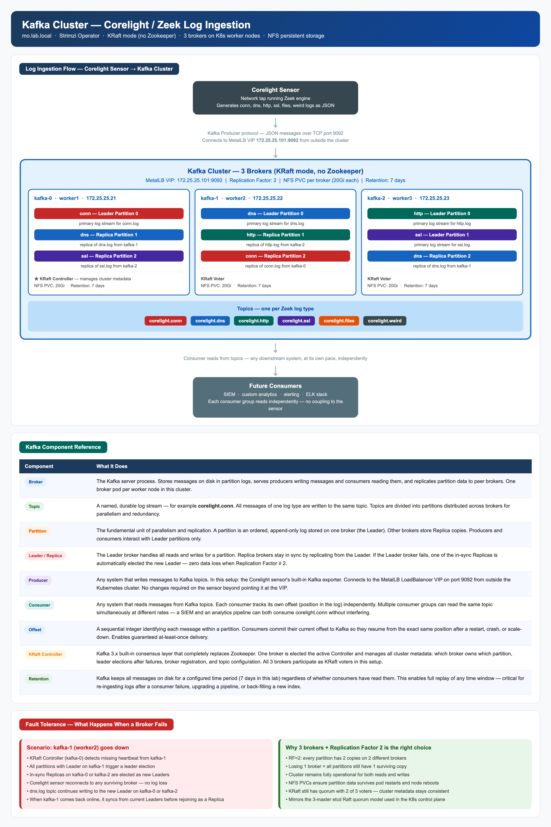
Kafka Cluster Architecture — Corelight Log Ingestion

Design
- 3 broker pods — one per worker node, NFS PVCs (20Gi each) for durability
- KRaft mode — no Zookeeper dependency
- Replication Factor 2 — survives single broker failure
- MetalLB LoadBalancer VIP: 172.25.25.101:9092
- Topics: corelight.conn, corelight.dns, corelight.http, corelight.ssl, corelight.files, corelight.weird
- Retention: 7 days — supports full replay after consumer failure

9. Troubleshooting

Issue | Root Cause & Fix
etcd not healthy on join | Stale member from failed join → etcdctl member remove <ID> on master1, then kubeadm reset on the joining node
NumCPU preflight error | 1 vCPU configured → power off VM, Edit Settings in ESXi, set 2 vCPU minimum
Flannel CrashLoopBackOff | Flannel requires /opt/bin absent on Ubuntu 22.04 → use Calico v3.27.0
NFS mount bad option | nfs-common missing on workers → ansible workers -m apt -a "name=nfs-common state=present"
Certificate key expired | kubeadm cert key expires after 2 hours → kubeadm init phase upload-certs --upload-certs on master1
HAProxy forwardfor error | option forwardfor incompatible with TCP mode → remove forwardfor lines from haproxy.cfg
BIND9 REFUSED queries | DNSSEC validation rejecting responses → set dnssec-validation no in named.conf
MetalLB controller crash | Stale pod after node restart → kubectl delete pod -n metallb-system <pod>
Dashboard no graphs | Metrics Server not installed → follow Step 7.8
NFS provisioner crash | nfs-common missing on workers → install then rollout restart deployment
pfSense routing loop | Wrong default gateway → System → Routing → Gateways, disable incorrect entry

10. Quick Reference

Access Endpoints
Service | URL / Address
Kubernetes Dashboard | https://172.25.25.100 (Bearer Token login)
HAProxy Stats | http://172.25.25.10:9000
Kubernetes API | https://172.25.25.10:6443 (via HAProxy)
pfSense Web UI | https://192.168.1.20 (home LAN only)
DNS Server | 172.25.25.254:53 (BIND9, mo.lab.local)
NFS Export | 172.25.25.254:/home/nfs/k8s
Kafka (planned) | 172.25.25.101:9092 (MetalLB VIP)

Component Versions
Component | Version
pfSense | 2.8.1
HAProxy | 2.8.14
Kubernetes | v1.30.14
containerd | v2.2.5
Calico CNI | v3.27.0
MetalLB | v0.14.5
Kubernetes Dashboard | v2.7.0
Strimzi (Kafka) | latest (KRaft mode)

Key Commands Cheatsheet
# Cluster health
kubectl get nodes -o wide
kubectl get pods -A
kubectl get svc -A
kubectl top nodes

# etcd health
etcdctl --endpoints=https://127.0.0.1:2379 \
--cacert=/etc/kubernetes/pki/etcd/ca.crt \
--cert=/etc/kubernetes/pki/etcd/healthcheck-client.crt \
--key=/etc/kubernetes/pki/etcd/healthcheck-client.key \
endpoint health --cluster

# Regenerate dashboard token
kubectl create token dashboard-admin -n kubernetes-dashboard --duration=87600h

# Regenerate kubeadm cert key (for new control-plane joins)
kubeadm init phase upload-certs --upload-certs

# Run Ansible on all K8s nodes
ansible k8s -i hosts -m command -a "uptime"

