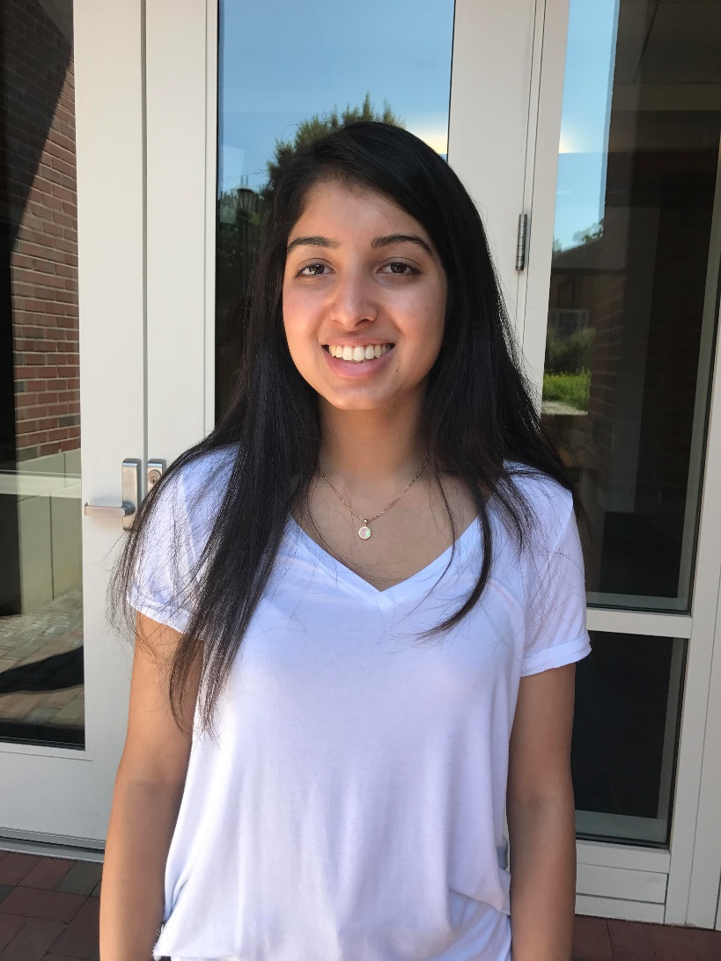

**Manali Shirsekar**

* Senior in High School
* I created an Ubbi Dubbi translator, pirate madlib, personality quiz, and Raleigh restaurant finder alongside Kiran and Elizabeth in Girls who Code
* I hope to attend either NCSU or UNC Chapel Hill
* I will be pursuing a degree in either engineering, computer science, or statistics
* With the help of my teammates I learned the basics of HTML, CSS, and JavaScript
* My advice to girls pursuing a career in tech is to have confidence in themselves, and not be afraid of making mistakes and asking for help along the way.

**Woman In Tech Spotlight:**