Mangrove calc

Mohammad Shamim Hasan Mandal

2022-11-12

Note :

1. Open this file inside the project
2. Then run the code chucks line by line

## Required packages

# install the packages; only first time  
# install.packages("geodata")  
# install.packages("terra")  
  
library(geodata) # for data  
library(terra) # for image (raster) and vector (shpaefile)

## Directory management

We will create separate folders for “data” and “results”

dir.create("data")  
dir.create("result")

## Data download

We need internet connection to download the data set for the first time. After downloading for next time on wards no need.

How to get help: we will use geodata package, it have few functions. One of them is gadm(), using that we can download vector (shapefile) for country(countries).

# load the help file for the gadm() function from the geodata package  
# help(gadm, geodata)

First, download a vector (shapefile) for Bangladesh.

bd= geodata::gadm(  
 country = "Bangladesh",  
 level = 1, # level 1 of administrative sub-division  
 path = "./data", # save to data folder  
 version = "latest", # version 4.1  
 resolution = 1 # high resolution  
 )

View the data. To see the vector that we have gave the name “bd”, just type it in the console. The terra package have a SpatVector class. So, the bd object is of SpatVector. Remember this, this is important.

# print the vector information  
bd  
  
# using head print first six rows  
head(bd)  
  
# using head get detailed information.  
str(bd)

Now make a map. Using the “bd” SpatVector, we can use plot() function to make a map

plot(bd,  
 axes=T,  
 main="Map of Bangladesh",  
 xlab="Longitude",  
 ylab="Latitude",  
 col="gray"  
 )

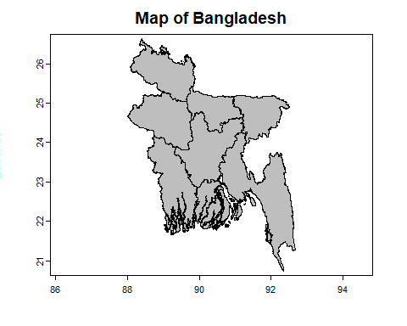

## Get the extent of our study area (meaning whole Bangladesh)

terra::ext(bd)

## Get satellite image

We need to download satelite image from the

# we will use the package luna for this. First we need to download this: only first time  
# install.packages('luna', repos='https://rspatial.r-universe.dev')  
library(luna)  
  
# help document on Modis data download  
# help("getModis")

## Get modis

We will download MODIS MOD09A1 Terra Surface Reflectance 8-Day Version 061 1. Data on Google Earth Engine [MOD09A1](https://developers.google.com/earth-engine/datasets/catalog/MODIS_061_MOD09A1) 2. [LPDAAC](https://lpdaac.usgs.gov/products/mod09a1v006/)

#   
# mod09a1 <- getModis(  
# product = "MOD09A",  
# start_date = "2015-01-01",  
# end_date = "2016-01-01",  
# aoi =   
# )

Reading:

1. Where to get [data/(<https://gisgeography.com/free-satellite-imagery-data-list/>)
2. See luna pakcage code in github [getModis](%22https://github.com/rspatial/luna/blob/master/R/getMODIS.R%22) function.
3. Read more on [rspatial.org](https://rspatial.org/)