**Testing of Website**

1. Need to move the line of content one step up.



1. **SHOP NOW** button does not work.



1. **SHOP NOW** button does not work.



1. **SUBSCRIBE** button let back to home page of GOOGLE.



1. No items can able to search.

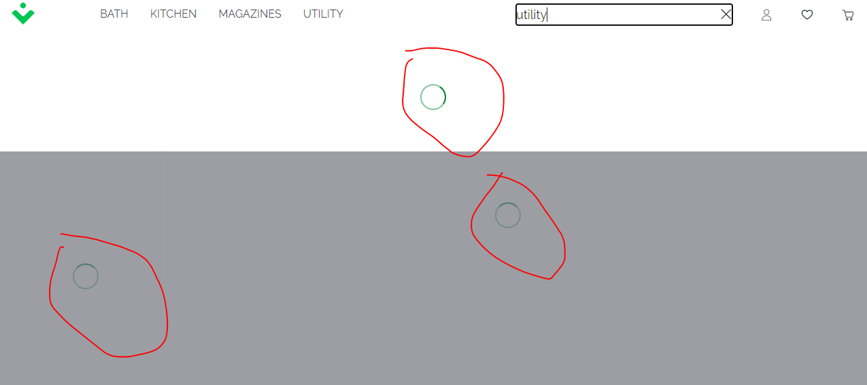

1. These items not work while clicking.

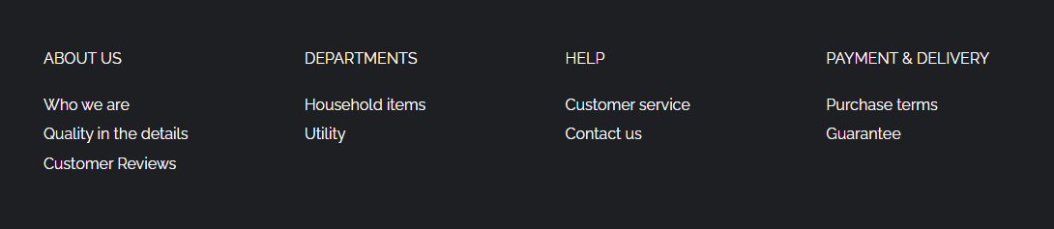

1. Header options are not working properly.

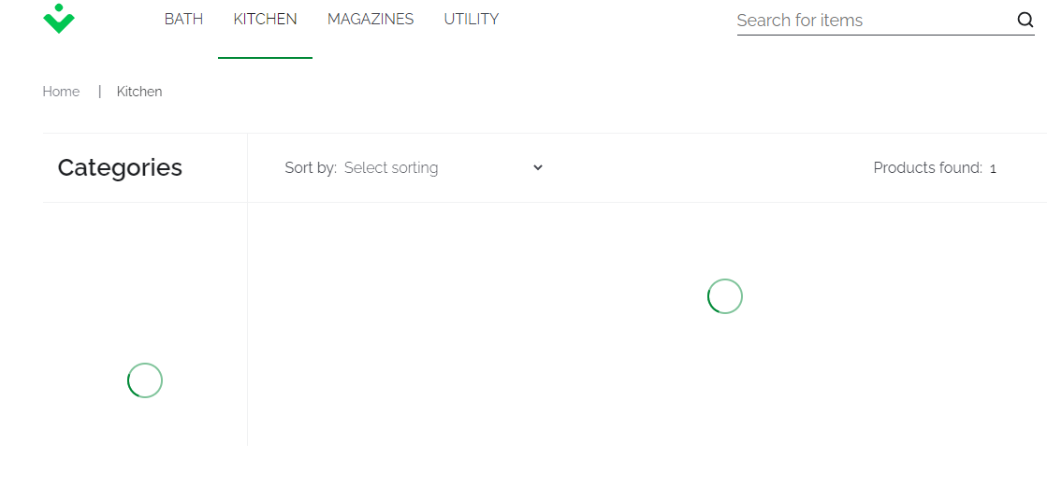

**WhatsApp Features**

* Voice Calling
* Video Calling
* Text Messages
* Voice Messages
* Emoji’s Text
* GIF Chatting
* Video/MMS Sharing
* Creating Groups
* Group Calling
* Group Chatting
* Group Privacies
* Live Location Sharing
* Images Sharing
* Status uploading
* Creating Profile
* Updating Profile
* Wallpaper Updating
* WhatsApp Linked with WhatsApp Web
* Profile Pictures Privacies
* Status Sharing Privacies