Data Management & Databases Tutorial Project 2026
Assignment 1 Service Description

1. Project name and team
Project name: Skill Track Employee Performance & Development Tracker
Team members:
- Mabhuda Sbahle
- Mcolisi Austine Shongwe

2. Functionality description
SkillTrack is a web application that helps small and medium-sized businesses manage employee performance and identify skills gaps across their workforce. Employees and managers each have a profile in the system. Managers conduct periodic performance reviews of the employees on their team, recording goals met and overall ratings. Alongside standard performance reviews, managers (or HR staff) can carry out a skills gap assessment for an employee, comparing the skill levels required for their role against the employee's current proficiency in each relevant skill.
From the employee's perspective, the system provides a personal dashboard showing past reviews, current skill ratings, and any identified skill gaps, along with recommended training or development actions. From the manager's perspective, the system provides an overview of their team, allows scheduling and recording of reviews, and aggregates skills-gap data across the team or department helping the business decide where training investment or new hiring is needed. The system also groups employees into departments, so gaps can be analysed at the department level rather than only per individual.

3. ER diagram of the miniworld
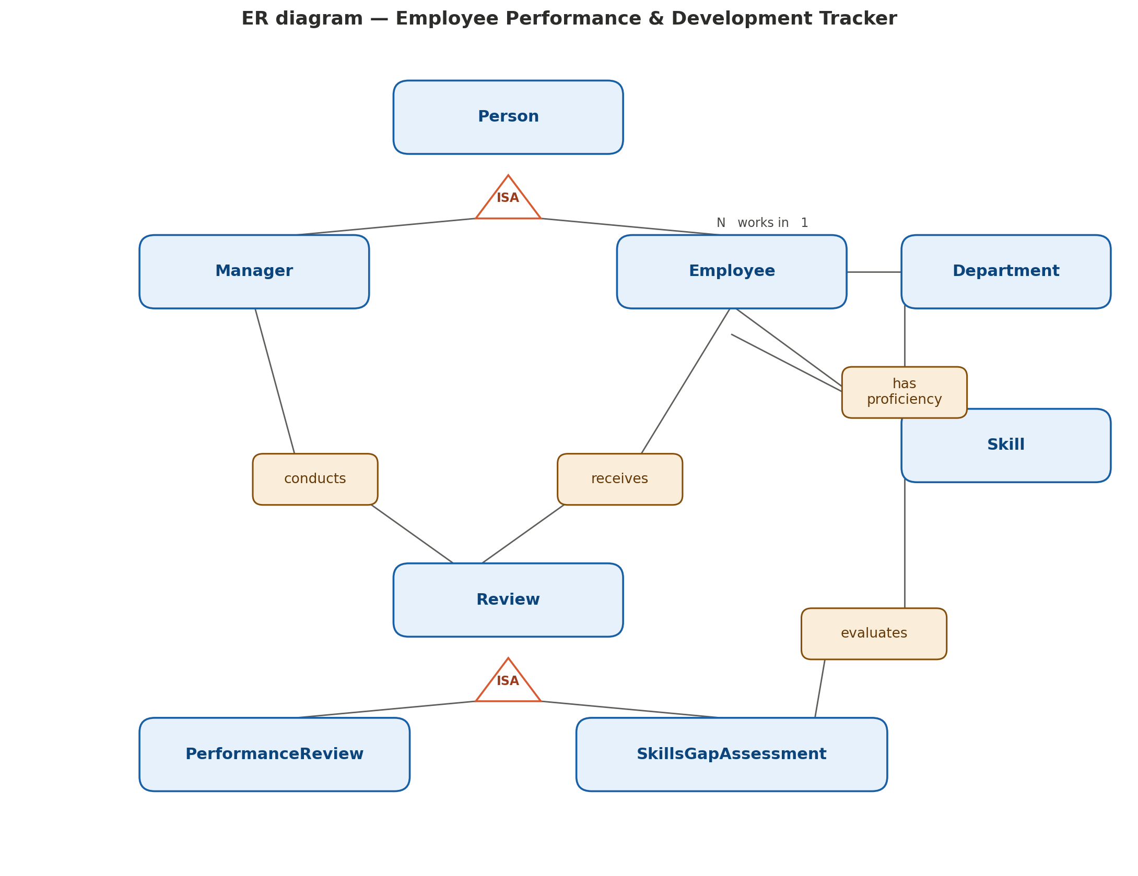
This diagram contains two ISA hierarchies, matching the team size of two: (1) Person specializes into Manager and Employee, and (2) Review specializes into Performance Review and Skills Gap Assessment. Supporting entities Department and Skill connect to Employee through the works in and has proficiency relationships, and to Skills Gap Assessment through the evaluates relationship.

4. User interactions
General user actions available in the system:
- Log in / log out of the system with a role (employee or manager).
- Employee: view own profile, past reviews, and current skill ratings.
- Employee: view identified skill gaps and recommended development actions.
- Manager: view list of employees in their team or department.
- Manager: create and submit a performance review for an employee.
- Manager: create and submit a skills gap assessment for an employee, selecting the skills being evaluated.
- Manager: view aggregated skill-gap statistics across a department.
- Admin/HR: add or remove employees, managers, departments, and skills from the system.
Illegal or invalid actions are rejected by the system with a clear error message for example: an employee attempting to create a review for themselves or another employee, a manager attempting to submit a review with an incomplete rating, or an attempt to assign a skill that does not exist in the system's skill catalogue.
Submission: project git repository on the teaching VM.

