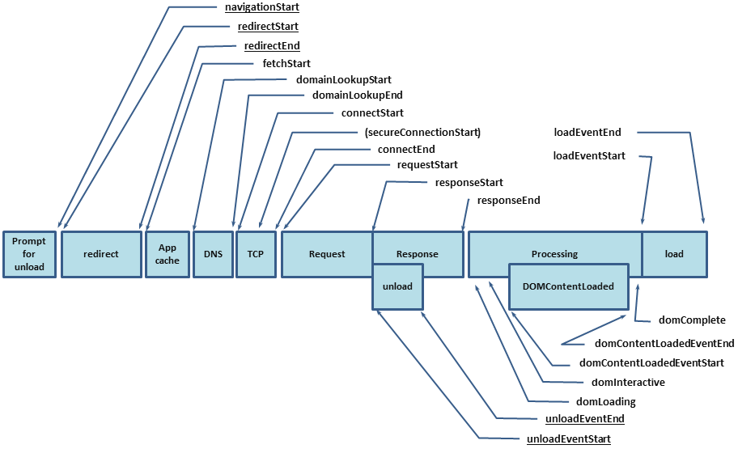1: Total time from start to load: performance.timing.loadEventEnd - performance.timing.fetchStart

2: Time consumed preparing the new page: performance.timing.fetchStart - performance.timing.navigationStart

3: Time spent during redirection: performance.timing.redirectEnd - performance.timing.redirectStart

4: AppCache: performance.timing.domainLookupStart - performance.timing.fetchStart

5: DNS query time: performance.timing.domainLookupEnd - performance.timing.domainLookupStart

6: TCP connection time: performance.timing.connectEnd - performance.timing.connectStart

7: Time spent during the request: performance.timing.responseEnd - performance.timing.requestStart

8: Time spent unloading documents: performance.timing.unloadEventEnd - performance.timing.unloadEventStart

9: Time spent in DOMContentLoaded:

performance.timing.domContentLoadedEventEnd - performance.timing.domContentLoadedEventStart

10: Time spent constructing the DOM tree: performance.timing.domComplete - performance.timing.domInteractive

11: Processing and loading time: performance.timing.loadEventEnd - performance.timing.responseEnd

12: Request to completion of the DOM loading: performance.timing.domInteractive - performance.timing.responseEnd

13: Load event time: performance.timing.loadEventEnd - performance.timing.loadEventStart

14: Processing Time: performance.timing.domComplete - performance.timing.domLoading

15: Painting time: performance.timing.domContentLoadedEventStart - performance.timing.domLoading