**SHUTTLE**

A Basic Web Server

Kyle Nickel

Daman Camara

Matthew Shortall

Zachary Sorenson

University of Maryland University College

Dr. Duchon

CMSC-495

Table of Contents

1 Project Plan 5

1.1 Introduction 5

1.1.1 Purpose 5

1.1.2 Scope 5

1.2 Definitions 6

1.3 Skills Required 6

1.4 Environment 6

1.5 Milestones 7

1.5.1 Overview and Assignments 7

1.5.2 Daemon 7

1.5.3 Logger 7

1.5.4 Cacher 8

1.5.5 RequestHandler 8

1.6 Testing 8

1.6.1 Unit Testing 8

1.6.2 Application Testing 8

1.6.3 Test Site 9

2 User’s Guide 9

2.1 Introduction 9

2.1.1 Purpose 9

2.1.2 Scope 9

2.2 Starting the daemon 9

2.3 Command line options 9

2.4 Configuration file 10

3 Test Plan 10

3.1 Introduction 10

3.1.1 Purpose 10

3.1.2 Scope 11

3.2 Application testing 11

3.2.1 Manual testing 11

3.2.2 Automatic testing 12

3.3 Daemon testing 12

3.4 RequestHandler testing 13

3.4.1 Test Case 1 – Returns Page to User 13

3.4.2 Test Case 2 – Querying the Cacher 13

3.4.3 Test Case 3 – Read Requested File when Cacher Faults 13

3.4.4 Test Case 4 – RequestHandler Provides Cacher with Data after Successful Fault 14

3.5 Cacher testing 14

3.5.1 Test Case 1 – Cacher Returns Cached Data 14

3.5.2 Test Case 2 – Cacher Returns a Fault when Data doesn’t Exist 15

3.5.3 Test Case 3 – Cacher Implements a Least Recently Used Algorithm for Storage 15

3.6 Logger testing 15

3.6.1 Test Case 1 – Logger Logs to Appropriate File 15

3.6.2 Test Case 2 – Logger Logs Debug Statements 15

3.6.3 Test Case 3 – Logger Suppresses Debug Statements when not in Debug Mode 16

3.7 Site Generator 16

3.7.1 Language and Dependencies 16

3.7.2 Design 16

3.7.3 Running the Script 17

4 Shuttle design 17

4.1 Introduction 17

4.1.1 Purpose 17

4.1.2 Scope 17

4.2 Overall architecture 17

4.2.1 Description 17

4.2.2 Overview diagram 18

4.2.3 Flow diagram 19

4.3 Daemon architecture 21

4.3.1 Daemon description 21

4.3.2 Daemon UML Diagram 21

4.3.3 Daemon flow of processes 23

4.4 Cacher architecture 24

4.4.1 Cacher description 24

4.4.2 Cacher UML Diagram 24

4.4.3 Cacher flow of processes 26

4.5 RequestHandler architecture 26

4.5.1 RequestHandler description 26

4.5.2 RequestHandler UML Diagram 27

4.5.3 RequestHandler flow of processes 29

4.6 Logger architecture 29

4.6.1 Logger description 29

4.6.2 Logger UML Diagram 30

4.6.3 Logger flow of processes 31

5 Shuttle Phase I 32

5.1.1 Shuttle Phase I Overview 32

5.1.2 Shuttle Phase Schedule 32

5.1.3 Shuttle Phase Notes 32

5.1.4 Completed Tasks 32

5.1.5 Upcoming Tasks 33

5.2 Daemon Phase I (Kyle Nickel) 33

5.2.1 Daemon Phase I Overview 33

5.2.2 Daemon Phase Schedule 34

5.2.3 Daemon Phase Notes 34

5.3 Cacher Phase I (Matthew Shortall) 34

5.3.1 Cacher Phase I Overview 34

5.3.2 Cacher Phase Schedule 35

5.3.3 Cacher Phase I Notes 35

5.4 RequestHandler Phase I (Daman Camara) 35

5.4.1 RequestHandler Phase I Overview 35

5.4.2 RequestHandler Phase Schedule 36

5.4.3 RequestHandler Phase Notes 36

5.5 Logger Phase I (Zachary Sorenson) 36

5.5.1 Logger Phase I Overview 36

5.5.2 Logger Phase Schedule 37

5.5.3 Logger Phase Notes 37

6 Shuttle Phase II 37

6.1.1 Shuttle Phase II Overview 37

6.1.2 Shuttle Phase Schedule 38

6.1.3 Shuttle Phase Notes 38

6.1.4 Completed Tasks 38

6.1.5 Upcoming Tasks 39

6.2 Daemon Phase II (Kyle Nickel) 39

6.2.1 Daemon Phase II Overview 39

6.2.2 Daemon Phase Schedule 40

6.2.3 Daemon Phase Notes 40

6.3 Cacher Phase II (Matthew Shortall) 40

6.3.1 Cacher Phase II Overview 40

6.3.2 Cacher Phase Schedule 41

6.3.3 Cacher Phase Notes 41

6.4 RequestHandler Phase II (Daman Camara) 41

6.4.1 RequestHandler Phase II Overview 41

6.4.2 RequestHandler Phase Schedule 42

6.4.3 RequestHandler Phase Notes 42

6.5 Logger Phase II (Zachary Sorenson) 42

6.5.1 Logger Phase II Overview 42

6.5.2 Logger Phase Schedule 43

6.5.3 Logger Phase Notes 43

7 Shuttle Phase III 43

7.1.1 Shuttle Phase III Overview 43

7.1.2 Shuttle Phase Schedule 44

7.1.3 Shuttle Phase Notes 44

7.1.4 Completed Tasks 44

7.2 Daemon Phase III (Kyle Nickel) 45

7.2.1 Daemon Phase III Overview 45

7.2.2 Daemon Phase Schedule 45

7.2.3 Daemon Phase Notes 45

7.3 Cacher Phase III (Matthew Shortall) 46

7.3.1 Cacher Phase III Overview 46

7.3.2 Cacher Phase Schedule 46

7.3.3 Cacher Phase Notes 46

7.4 RequestHandler Phase III (Daman Camara) 46

7.4.1 RequestHandler Phase III Overview 46

7.4.2 RequestHandler Phase Schedule 47

7.4.3 RequestHandler Phase Notes 47

7.5 Logger Phase III (Zachary Sorenson) 47

7.5.1 Logger Phase III Overview 47

7.5.2 Logger Phase Schedule 47

7.5.3 Logger Phase Notes 48

# 1 Project Plan

## 1.1 Introduction

### 1.1.1 Purpose

The Shuttle web server project is designed to be a basic web server that responds to HTTP GET requests. It will be able to handle multiple concurrent connections utilizing Java threading. Shuttle will also cache the most recent hits to increase the speed of returning requests.

### 1.1.2 Scope

Shuttle is not meant to be on the same scale as Apache HTTPD, but instead a small basic server. It will provide concurrency for multiple connections and respond to HTTP GET requests with parsing of parameters. Additionally, it will log all connections and served pages.

Shuttle will also implement a basic caching system to quickly return recently requested pages.

This document shall outline the components of the Shuttle web server to include the Daemon, Logger, Cacher and RequestHandler. The document has been written with language intended for use by system architects, designers and developers.

## 1.2 Definitions

|  |  |
| --- | --- |
| **Term** | **Definition** |
| GET | A HTTP request providing parameters in the URL. |
| Caching | Keeping resources in memory for fast access. |
| Unit Testing | Testing on a method level for each class. |
| Git | A source code manager. |
| GitHub | A web service allowing for collaboration with Git. |
| Daemon | A master process that runs without user intervention. |

## 1.3 Skills Required

Java

Socket Programming (Java)

Unit Testing

Application Testing

Caching Algorithms

File I/O

Git

## 1.4 Environment

Development of the Shuttle web server shall be performed on a personal laptop, in conjunction with a university supplied Unix server. For this development, the Unix server will likely be UMUC’s Nova. Hardware and Software availability within Nova will be managed by the system administrators. Personal laptops may utilize Windows, Apple OSX, or a Unix/Linux build, with the OS system noted during development and testing documentation.

Shuttle shall utilize Java 7 (currently update 45), or the most recent up to date security release for the main development environment. This will allow Shuttle to run on a wide variety of platforms while mitigating development architecture conflicts. During the development phase, developers shall utilize either Eclipse or Netbeans IDE. The codebase will be stored in a Git repository on GitHub.com at <https://github.com/nickelkr/shuttle>. Each participant should fork this repository and any changes committed back to this master branch.

Shuttle will be configured to utilize Transmission Control Protocol (TCP) network connectivity. TCP will handle Internet Protocol requests between the user’s browser and Shuttle. With that, the NetServer shall be configured to utilize TCP/IP.

For testing purposes, the Shuttle project will be using the JUnit test framework. This framework is well documented and widely used for Java unit tests. For validation during application testing, Firefox v25.0, Internet Explorer v10, and Google Chrome v30 will be used. Additional browser versions shall be utilized when appropriate and documented in follow-on design and testing documentation.

## 1.5 Milestones

### 1.5.1 Overview and Assignments

The Shuttle project is made up of the following components:

|  |  |
| --- | --- |
| **Component** | **Assigned To** |
| Daemon | Kyle |
| Logger | Zack |
| Cacher | Matt |
| RequestHandler | Daman |
| Unit Tests | Everyone (Lead – Daman) |
| Sample Web Site | Kyle |
| Application Test | Daman |

### 1.5.2 Daemon

The Shuttle daemon is the master process. This part of the application provides the user with the ability to start the application and provide options like port number.

It will also be the class handling the incoming connections. As Shuttle receives a connection request, it will be in charge of creating a new thread and handling the request with a RequestHandler instance.

This daemon will also be in charge of managing all sub-processes for RequestHandler, Logger and Caching instances.

When the user kills the Shuttle daemon he or she is stopping the server entirely.

### 1.5.3 Logger

The Logger is in charge of ensuring all major processes are documented and saved to the file system.

Any connections made to Shuttle should be documented with the corresponding IP address. It should also log any pages that are sent out to such IP addresses.

Changes to the state of the Shuttle daemon should also be logged: starting, stopping.

The Logger should provide an API for each component of Shuttle to provide logging information. The Logger itself should handle time stamping and naming of each log line to differentiate component logging.

### 1.5.4 Cacher

The Cacher is responsible for keeping recently requested pages in memory. As pages are requested by outside systems, the RequestHandler should first look to the Cacher to see if Shuttle currently has the page in memory. If the page is stored in memory, Shuttle can serve the page without performing slower I/O operations. Otherwise, the RequestHandler should retrieve the page and provide the Cacher with the served page.

The Cacher should implement a Least Recently Used algorithm, LRU. It will be responsible for swapping pages in and out of memory, and also responding to page requests from the RequestHandler returning either the page requested or a fault.

### 1.5.5 RequestHandler

The RequestHandler is responsible for handling a single HTTP GET request per instance. The Shuttle daemon will create an instance of the RequestHandler and pass the request in.

The RequestHandler should parse the request, along with any parameters, and then return the requested page from either the cache or the file system. If the page is not found, or another error occurs, the RequestHandler is responsible for conveying the issue with standard HTTP codes.

## 1.6 Testing

### 1.6.1 Unit Testing

Each team member shall write unit tests for each method in the class that they are responsible for developing.

The tests shall be written using the JUnit testing framework. Before committing any work to the production branch, all tests should pass JUnit testing. Additionally, all tests should meet any specific pass/fail criteria specified in separate documentation.

### 1.6.2 Application Testing

A small program is required to test Shuttle as a whole. This program shall use threading to create multiple connections and request many pages in quick succession. This will demonstrate the ability to concurrently handle connections, as well as test the caching system and page retrieval.

### 1.6.3 Test Site

To fully test Shuttle, a test web site will need to be created. This web site shall consist of no less than 1000 synthetically generated web pages. Page templates shall be created and utilized to automatically populate the test web site. The data and/or information on these pages will not be of great significance. Rather, these pages will represent a large web site and help to sufficiently test the capabilities and performance of the Shuttle web server. The java code for the test web site shall not be included in core Shuttle web server, however, it will be documented and saved in a repository.

# 2 User’s Guide

## 2.1 Introduction

### 2.1.1 Purpose

The purpose of this section is to provide the users all option available with the Shuttle web server.

### 2.1.2 Scope

This section is written for the users of the Shuttle web server. It does not include the inner workings of options or functions, but provides information about the available options to users and how to utilize them.

It will also cover the configuration file for the Shuttle web server and provide an example of such a configuration file. In this respect, this section also intends to guide the Shuttle server development and the following guides within this document.

## 2.2 Starting the daemon

To start the Shuttle daemon, the user should run the following:

java –jar shuttle {options}

This will begin the Shuttle web server and {options} should be the options provided by the user.

## 2.3 Command line options

The following is a list of options. If providing a configuration file, no other options besides the –c option are required. All other provided options will override those in the configuration file.

|  |  |
| --- | --- |
| **Option** | **Description** |
| -c | Accepts a path to a valid configuration file. |
| -m | Mode setting: debug or production |
| -p | Specifies the port Shuttle will listen on |
| -l | Path to where Shuttle should log |

## 2.4 Configuration file

To have a constant configuration used, it is possible to define a key value pair configuration file to Shuttle. Shuttle will read this file and set the appropriate parameters when starting. The following is the structure:

mode: {debug | production (defaults to production)}

port: {port number to listen on}

directory: {top level directory to be served}

log_file: {file where Shuttle should log}

The following is an example:

mode: debug

port: 80

log_file: /var/log/shuttle.log

The keys for the configuration file do not need to be in any particular order and are not case-sensitive.

The path to this file should be provided to Shuttle when starting with ‘-c’ an example follows:

java –jar shuttle –c /etc/shuttle.config

# 3 Test Plan

## 3.1 Introduction

### 3.1.1 Purpose

This section is designed to provide developers and testers required information to ensure that the development and release of the Shuttle web server performs as expected.

### 3.1.2 Scope

This section will cover application testing and the overall testing of Shuttle’s major components. It will provide testing guidelines with expected outcomes for a passing test all other outcomes should be considered failing.

This section will not cover unit testing. Unit tests shall be created by the programmer early and be granular. Unit tests are out of the scope of this section.

## 3.2 Application testing

To test the Shuttle web server, manual testing for browser support and automatic testing utilizing a script will be required.

### 3.2.1 Manual testing

The manual testing included in sections 3.2.1.1 thru 3.2.1.4 shall be performed on each of the three most widely used web browsers: Google Chrome, Mozilla FireFox, and Microsoft Internet Explorer. Specifics about browser versions can be found as stated in section 1.4 of the Project Plan, noted previously in this document

#### 3.2.1.1 Test Case 1 – Index page

Purpose: To test that Shuttle returns the index.html page when no page is specified.  
  
Pre-test requirement: Start the web server listening on port 80.

Operation: Enter 127.0.0.1, or IP address where Shuttle is running.

Expected output: The index.html page is returned to the browser with links to each of the subpages and Shuttle returns a 200 status code.

#### 3.2.1.2 Test Case 2 – Subpages

Purpose: To test that Shuttle returns subpages deeper in the file system.

Pre-test requirement: Start Shuttle listening on port 80.

Operation: Select and follow links from the index.html page and then continue to traverse links into the file system.

Expected output: When each displayed link is clicked, the page title shown in the link shall be returned to the user’s browser and Shuttle returns a 200 status code.

#### 3.2.1.3 Test Case 3 – Missing Page

Purpose: To test that Shuttle returns a not found error, 404, when a web page that doesn’t exist is requested.

Pre-test requirement: Start Shuttle on port 80.

Operation: Enter 127.0.0.1/nopage.html

Expected output: Shuttle should respond with “404 – Page Not Found”.

#### 3.2.1.4 Test Case 4 – Forbidden

Purpose: To ensure Shuttle does not return a page that does not have public access.

Pre-test requirement: Start Shuttle on port 80. Create a directory that should not be publicly visible (ie. /etc/passwd).

Operation: Enter “127.0.0.1/etc/passwd” into the browser.

Expected output: Shuttle should respond with “403 – Forbidden Request”.

### 3.2.2 Automatic testing

The automatic testing shall be performed with a small Java application. This application shall request the index page from the server and then perform a random walk of the file system.

This application shall be threaded to ensure Shuttle can handle multiple concurrent connections.

The testing application shall record results including failures and response times. The statistics shall be printed to the screen in the following format:

Shuttle Test Run:  
 Total Time:

# of Pages Requested:

# of Pages Returned:

# of Failures:

## 3.3 Daemon testing

To test the daemon, the User should start Shuttle via the command line with (on a Linux / Unix system):

nohup java –jar shuttle –c config.config &

Once Shuttle is started, the automatic testing and manual testing shall be performed. During this testing, the Shuttle will continue to run and be responsive.

## 3.4 RequestHandler testing

The RequestHandler shall be tested for the following basic features: querying the Cacher, reading requested file if faulted, return requested file to user, and provide Cacher with data.

### 3.4.1 Test Case 1 – Returns Page to User

Purpose: To ensure the RequestHandler returns requested pages to the requesting user.

Pre-test requirement: Start Shuttle on port 80.

Operation: Request a known to exist page via the address bar of a web browser.

Expected output: The requested page is returned to the user.

### 3.4.2 Test Case 2 – Querying the Cacher

Purpose: To ensure the RequestHandler queries the Cacher to utilize cached data when a request is processed.

Pre-test requirement: Start Shuttle on port 80.

Operation: Request a known to exist page via the address bar of the web browser, this page should also exist in cache.

Expected output: The RequestHandler initiates page request to the Cacher and returns the cached data to the user.

### 3.4.3 Test Case 3 – Read Requested File when Cacher Faults

Purpose: To ensure that the RequestHandler appropriately reads and returns the requested data when the Cacher returns a fault.

Pre-test requirement: Start Shuttle on port 80.

Operation: Request a known to exist page via the address bar of the web browser, this page should not exist in cache.

Expected output: The RequestHandler initiates a page request to the Cacher that returns a fault. The RequestHandler should then read the requested page and return the data to the user.

### 3.4.4 Test Case 4 – RequestHandler Provides Cacher with Data after Successful Fault

Purpose: To ensure that the RequestHandler returns the requested user data to the Cacher for caching after a successful fault.

Pre-test requirement: Start Shuttle on port 80.

Operation: Request a known to exist page via the address bar of the web browser, this page should not exist in cache.

Expected output: The RequestHandler initiates a page request to the Cacher that returns a fault. The RequestHandler should then read the requested page and return the data to the Cacher for caching.

## 3.5 Cacher testing

The Cacher shall be tested to ensure that when a page is requested, it returns the requested page or a fault. It shall also store any pages provided by a RequestHandler using a least recently used algorithm.

### 3.5.1 Test Case 1 – Cacher Returns Cached Data

Purpose: To ensure that if the Cacher has the requested data cached, it is returned to the RequestHandler.

Pre-test requirement: Start Shuttle on port 80.

Operation: Request a known to exist page via the address bar of the web browser, this page should exist in cache.

Expected output: The Cacher shall check its cache data structure, find the requested data and return it to the RequestHandler.

### 3.5.2 Test Case 2 – Cacher Returns a Fault when Data doesn’t Exist

Purpose: To ensure that if the Cacher does not have the requested data it returns a fault.

Pre-test requirement: Start Shuttle on port 80.

Operation: Request a known to exist page via the address bar of the web browser, this page should not exist in cache.

Expected output: The Cacher shall check its cache data structure. When it does not find the requested data it should return a fault to the appropriate RequestHandler.

### 3.5.3 Test Case 3 – Cacher Implements a Least Recently Used Algorithm for Storage

Purpose: To ensure that the Cacher implements the least recently used, LRU, algorithm for caching.

Pre-test requirement: Start Shuttle on port 80.

Operation: Request a known to exist page via the address bar of the web browser, this page should not exist in cache.

Expected output: When the RequestHandler requests a cache of previously faulted data the Cacher shall replace the least recently used data with the provided.

## 3.6 Logger testing

The Logger shall be tested to ensure it is logging appropriate messages.

### 3.6.1 Test Case 1 – Logger Logs to Appropriate File

Purpose: To ensure that the Logger writes all logging statements to the log file specified in the configuration file.

Operation: Start Shuttle on port 80. Select random links from index.html.

Expected output: The logging statements should be written to the file specified in the configuration file associated with the “log_file” key.

### 3.6.2 Test Case 2 – Logger Logs Debug Statements

Purpose: When Shuttle is in “debug” mode all debug statements are logged to the log file.

Pre-test requirement: Start Shuttle with “mode” set to debug.

Operation: Observe log file.

Expected output: The log file should show more verbose, debugging, statements.

### 3.6.3 Test Case 3 – Logger Suppresses Debug Statements when not in Debug Mode

Purpose: To ensure if Shuttle is not in debug mode it does not log debug statements.

Pre-test requirement: Start Shuttle with “mode” set to production.

Operation: Observe log file.

Expected output: No “debug” statements are logged.

## 3.7 Site Generator

The Site Generator is a script designed to build a large sample web site to be used in testing Shuttle.

### 3.7.1 Language and Dependencies

This script shall be written in Ruby 1.9.2.

To fill out text sections of web pages, the Lorem Ipsum module of the Faker gem shall be used. This will allow random text to be entered into sections of the web page body.

### 3.7.2 Design

The script will take three arguments: number of files to be generated, number of directories to be used, the top-level directory.

The script will then iterate, creating a sample document that will be filled with a random number of paragraphs and links. The links will be filled with page links to pages that already exist.

For ease of design, the script will utilize a class that we will create providing the necessary data structures and randomization.

The index.html file will be created last and filled with links to all of the files that have been generated.

### 3.7.3 Running the Script

The script should be run by using the follow command on a Unix / Linux system:

ruby site_generator.rb –p 1500 –d 50 –s /var/www/html

-p : the option for setting the number of pages to be generated

-d : the option for setting the number of directories to be created

-s : the starting directory (top level directory)

# 4 Shuttle design

## 4.1 Introduction

### 4.1.1 Purpose

The design section of this document is written for developers and architects. It has been developed to show the inner workings of the Shuttle Web Server.

### 4.1.2 Scope

This section contains detailed information about how the Shuttle Daemon works. It will cover the general architecture and also the architecture of each individual component in depth. Developers should be able to understand, extend, and develop the Shuttle Web Server with the contained information.

## 4.2 Overall architecture

### 4.2.1 Description

The Shuttle Web Server is comprised of four major components: Daemon, RequestHandler, Cacher, and Logger.

The Daemon is responsible for receiving incoming requests, via HTTP, and distributing these requests to individual RequestHandler objects. It is also responsible for creating instances of each of the other components and parsing the configuration file or user given options.

The RequestHandler is responsible for handling one HTTP request per instance of the RequestHandler. It shall parse the given request parameters, check with the Cacher for stored data, and retrieve any uncached requested resource. After the data has been retrieved the RequestHandler then returns the resource to the requestor and supplies the Cacher with the resource if it resulted in a cache miss.

The Cacher is responsible for ensuring any recently used resources are stored for quick access if requested again. It will respond to requests from the RequestHandler and return with the resource data or a miss response. If a cache miss occurs the Cacher is also responsible for storing data that the requesting RequestHandler provides.

The Logger is responsible for writing critical debugging and production level status updates from all components of Shuttle. The Logger will receive information from each component with log level (debug, info, warn, error), the component name, and the log string. It will then format the data, apply a time stamp, and write the information to disc.

### 4.2.2 Overview diagram

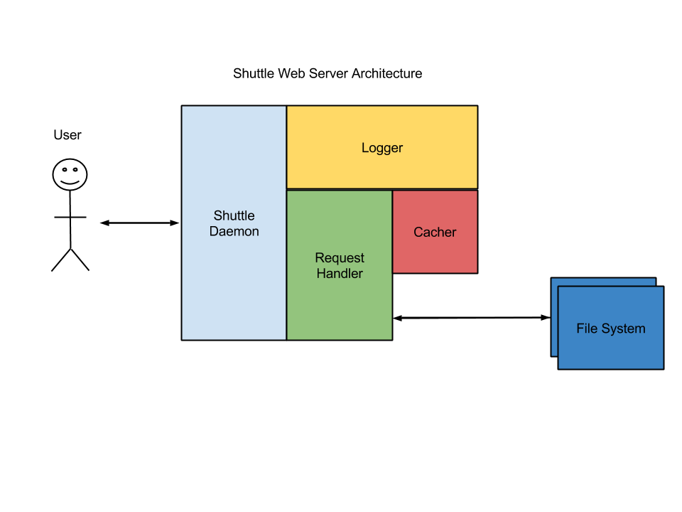

The above diagram shows the associations for all of the components in the Shuttle Web Server.

While the Daemon creates all processes it does not communicate with all components after creation. As is shown about the Daemon will communicate with RequestHandler and Logger objects after the system has been started.

The Logger is required to communicate with all components at all times. It will need to be available to facilitate many concurrent-logging requests by all components.

The RequestHandler will communicate with the Cacher. It will request cached resources and provide resources that it reads from the file system, when a cache miss occurs. It will also provide it’s own logging strings to the Logger.

The Cacher will only communicate with the RequestHandler and the Logger. It will need to search its cache for resources that are requested from the RequestHandler. It will also be required to store any resources that a RequestHandler requests to be cached.

The file system is not apart of the actual web server.

### 4.2.3 Flow diagram

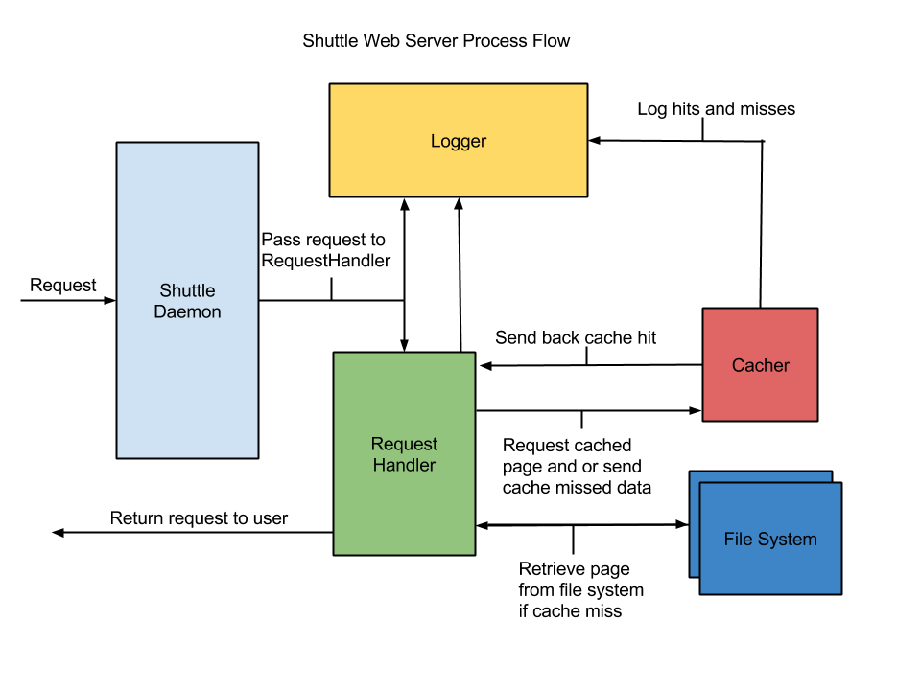

The above diagram demonstrates the process flow of the Shuttle Web Server at a high-level view.

When a user makes a request through their web browser via HTTP on port 80 the Daemon receives the connection and then spawns a new RequestHandler object.

The Daemon passes the socket and request to the newly created RequestHandler and logs the action.

The RequestHandler then parses the request. After determining the requested resource the RequestHandler then utilizes the Cacher’s API and requests the resource from the Cacher. If the Cacher has the data in cache it returns the data, if not it returns null.

If the data is cached it is immediately returned to the requestor and all transactions are logged.

If the data is not cached the Cacher returns null and then RequestHandler reads the resource from the file system. It then returns the resource to the requestor and asks the Cacher to store the data in its cache.

When a RequestHandler process requests data from the cache the Cacher will check its cache structure. If it finds the requested resource it will return the data. If it does not find the resource it returns null.

If the Cacher previously returned null, a cache miss, then it receives a later request to cache data. The Cacher stores the data in its caching structure. Each cache hit, miss, and storage is logged.

During all of the system interactions logging strings are passed to the Logger. The logger receives the log level which is one of the following: debug, info, warn, and error. It also receives the name of the component that is sending the log request and the string to be logged. It formats this data, applies a time stamp, and writes it to disc.

## 4.3 Daemon architecture

### 4.3.1 Daemon description

The Shuttle Daemon is in charge of creating all the sub-process components: Logger, Cacher, and RequestHandler. It handles are incoming requests while listening on port 80 for HTTP GET requests and spawns a new RequestHandler object to handle each incoming request.

The Daemon also facilitates the passing of static objects for logging and caching to each required component.

When a user specifies a configuration file the Daemon parses the file and inserts user specified options into the options data structure. If commands are passed via the command line these options are parsed and inserted into the options data structure.

### 4.3.2 Daemon UML Diagram

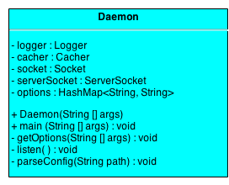

The Daemon is composed of the following data structures:

|  |  |  |
| --- | --- | --- |
| **Variable** | **Type** | **Description** |
| logger | Logger | A static instance of the Logger component to be passed to other objects and be used by all objects. |
| cacher | Cacher | A static instance to cache, retrieve, and store resources. |
| socket | Socket | A socket for facilitating communications to the user’s browser. |
| serverSocket | ServerSocket | A socket that listens on port 80 for incoming requests. |
| options | HashMap<String, String> | A HashMap to store user or configuration defined options. |

The Daemon has the following methods:

|  |  |
| --- | --- |
| **Signature** | **Description** |
| Daemon (String [] args) | Default constructor for the Shuttle Daemon. |
| main (String [] args) | The main method that initializes the Daemon object. |
| getOptions (String [] args) | The method to parse command line options that are passed by the user and stores the values. |
| listen ( ) | The method containing the loop listening for incoming connections on port 80. |
| parseConfig (String path) | When a configuration file is used this method parses the information and stores it. |

### 4.3.3 Daemon flow of processes

**Start up:**

The user starts the Shuttle Web Server on the command line providing designated options.

The main method is run and creates the Daemon object passing the ‘args’ string array.

The Daemon starts the Logger and the Cacher and then calls the getOptions method.

**Configuration**:

The getOptions method is passed a string array that is parsed. When each option is encountered the option is saved as the key and the user provided value as the value.

If the user provides a configuration file it is then passed to the parseConfig method. The parseConfig method reads the file and iterates through each line of key value pairs storing each in the options data structure.

If an option is provided on both the command line and in the configuration file the command line option takes precedence.

**Incoming connections:**

The listen method is then called. Inside the listen method a loop continually runs listening for a request on port 80.

When a connection request is made on port 80 the Daemon spawns a new RequestHandler and passes the new object a socket for the client, a static Cacher object, and a Logger object.

The Daemon then continues to listen for more requests, repeating the process for each request.

**Logging requirements:**

The Daemon is required to log the starting process, each requested connection, and spawning of all RequestHandler processes.

## 4.4 Cacher architecture

### 4.4.1 Cacher description

The Shuttle Cacher is responsible for adding file system objects to the cache. A LinkedHashMap instance of the Map interface is utilized for the cache. It handles incoming requests from the Daemon process to initialize. Once initialized, the Cacher interacts with the RequestHandler to return objects contained within the cache, render null objects when objects are not contained within the cache, and add objects to the cache when appropriate.

The Cacher follows a least recently used (LRU) paging algorithm to maintain the cache. Pages are added to the cache until all physical frames contain a page in memory. Once this has occurred, the algorithm replaces the least recently used page in a physical frame with that of the requested cache page addition.

The Cacher also interacts with the Logger to ensure valuable data is kept while interacting with the RequestHandler.

### 4.4.2 Cacher UML Diagram

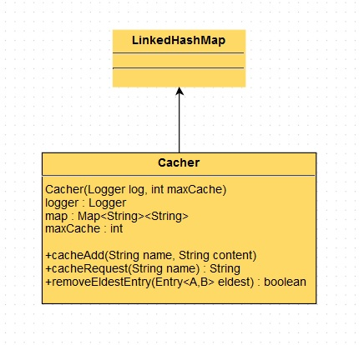

The Cacher is composed of the following data structures:

|  |  |  |
| --- | --- | --- |
| **Variable** | **Type** | **Description** |
| logger | Logger | A static instance of the Logger component passed by the Daemon, and used by the Cacher to write cache request hits and misses. |
| map | Map<String><String> | An instance of Map used to facilitate the cache in a key/value relationship. |
| maxCache | int | A variable passed to the constructor by the Daemon, and specifies the size of the cache. |

The Cacher has the following methods:

|  |  |
| --- | --- |
| **Signature** | **Description** |
| Cacher (Logger log, int maxCache) | Default constructor for the Shuttle Cacher. |
| cacheAdd(String name, String content) | The method to add a file system object to the LinkedHashMap cache for faster retrieval. |
| cacheRequest(String name) | The method call to search the cache for a specific file system object. This method returns the String object if found, or null if the object is not in cache. |
| removeEldestEntry(Entry<A,B> eldest) | This method is called when an object is added to the cache, and removes the eldest entry in the cache following an LRU algorithm. |

### 4.4.3 Cacher flow of processes

**Start up:**

The Cacher is started by the Daemon processes. The Daemon calls the Default Constructor for the Cacher class and passes the location in memory of the Cacher object to the RequestHandler.

The Cacher does not have a main method, and therefore is reliant upon incoming connections for actions to be taken.

**Incoming connections:**

The Cacher receives incoming connections from the RequestHandler. The RequestHandler calls upon the Cacher to request an object stored in cache. This is achieved by calling upon the cacheRequest method and supplying the name of the object requested. If the name requested correlates to a key contained within the cache, the Cacher shall return the value for the key/name match. This represents a successful Cacher Hit. If the name requested cannot be matched to a key contained within the cache, the Cacher will return a null value to the RequestHandler, signifying that the object is not contained within the cache. This response represents a Cacher Miss.

**Logging requirements:**

The Cacher shall be required to log each Hit and Miss, for each cacheRequest called by each RequestHandler thread. Each log entry shall maintain appropriate formatting to detail the supplied Cacher response. For successful logging, the Cacher requires the Daemon supply the spawned Logger object, for outgoing communications.

## 4.5 RequestHandler architecture

### 4.5.1 RequestHandler description

For efficiency reasons, each user request for a web resource will be executed in a different Thread. Therefore the RequestHandler will implement the Runnable interface and override the run() method. To make the design more effective and modular, some of the original functionalities of the RequestHandler class have been extracted to the Request and Response Classes. These classes are used to encapsulate information usually associated with user requests, and server responses to the clients.

The RequestHandler’s responsibilities will be:

* To parse each user request, consult the cache to determine if there is a cached version of the requested web resource in order to avoid unnecessary file operations.
* Retrieve and send a byte stream form of the requested resource with appropriate headers information.

Some of the other tasks performed by the RequestHandler class are to log messages relevant to the Server’s operational status, and determine the type and set the type of the resource being requested based on the file extension.

The RequestHandler class is dependent on the Daemon class which listens for incoming user requests, and spawns a RequestHandler instance to service each request.

### 4.5.2 RequestHandler UML Diagram

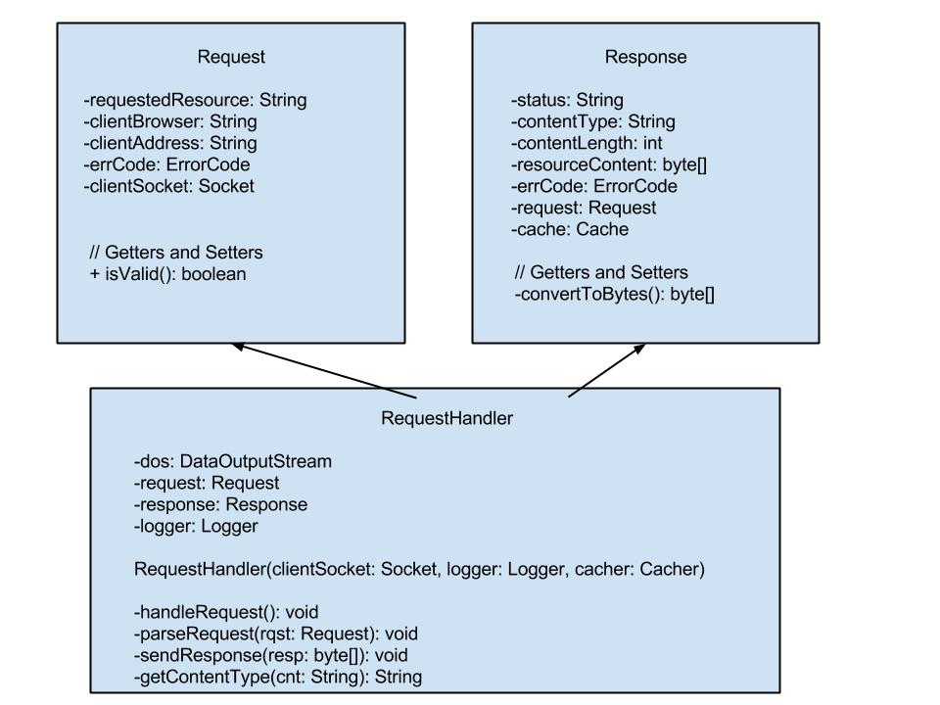

The RequestHandler is composed of the following data structures:

|  |  |  |
| --- | --- | --- |
| **Variable** | **Type** | **Description** |
| logger | Logger | A static instance of the Logger component passed by the Daemon, and used by the RequestHandler to log relevant events during the Server’s operation. |
| Dos | DataOutputStream | An instance of the DataOutputStream class used to send a byte stream form of the response to the client. |
| Request | Request | Abstract Data Type encapsulating information relevant to a Request such as the client address and name of the resource being requested. |
| Response | Response | An ADT encapsulating information relevant to a Response such as the HTML status code, a byte array representation of the requested resource. |

The RequestHandler has the following methods:

|  |  |
| --- | --- |
| **Signature** | **Description** |
| RequestHandler (Socket sock, Logger log, Cacher cache) | Constructor for the Shuttle RequestHandler. |
| handleRequest() | The method used to handle user requests. It parses the request, then takes actions depending on the status of the request which is indicated by an error code. |
| parseRequest(Request rqst) | The method used to parse each incoming request. It extracts information from the user request such as the client address and requested resource name. |
| sendResponse(byte[] resp) | The method used to send a response back to the client. It relies on the DataOutputStream instance of the class to carry out this feature. |
| getContentType(String cnt) | The method determines the content type being requested by examining the file extension. It returns a String indicating the type of resource being requested. |

### 4.5.3 RequestHandler flow of processes

**Start up:**

The RequestHandler is started by the Daemon process. The Daemon calls the Constructor for the RequestHandler class and passes the client socket, and static instances of the Logger and Cacher classes.

The RequestHandler does not have a main method, and instead depends on the Daemon class to spawn new instances as user requests arrive.

**Incoming connections:**

As users continue to request resources on the web server, a new instance of the RequestHandler class is created to serve the requests. The Daemon process will also be required to call the start() method on each RequestHandler instance created in order for the Thread to run to completion.

**Logging requirements:**

The RequestHandler class will contain an instance of the Logger class, and therefore will be able to log relevant events during the course of the Server’s operation.

## 4.6 Logger architecture

### 4.6.1 Logger description

The Logger exists to record the activities of the various components of the Shuttle webserver. Regardless of subcomponent, there will be a unified format for log information.

The Logger needs to handle concurrent log requests, without bottlenecking the other components. To accomplish this, the Logger is derived from a static super class which actually records data to file. A Logger subclass records data concurrently into temporary data structures before waiting in line to record to file. This wait is independent of the subcomponents of Shuttle that use Logger.

The super class will periodically, and prior to close, sort the log file in order to maintain a chronological record in spite of race conditions.

### 4.6.2 Logger UML Diagram

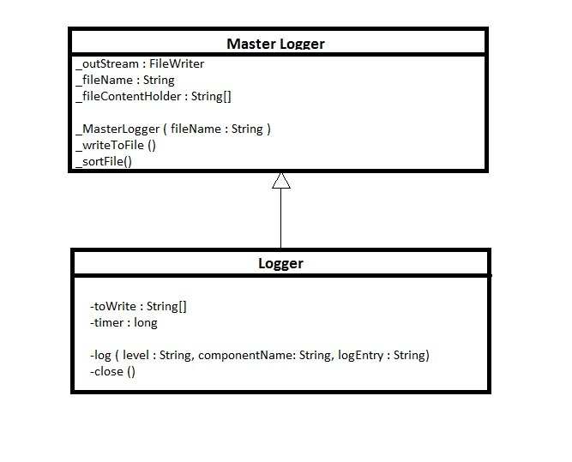

+

+

+Logger()

The MasterLogger is composed of the following data structures:

|  |  |  |
| --- | --- | --- |
| **Variable** | **Type** | **Description** |
| outStream | FileWriter | A basic file stream to write data to file. |
| fileName | String | A file name to be specified by whichever process initializes the logger. |
| fileContentHolder | String[] | An array that holds each log entry, or line, for file sorting purposes. |

The MasterLogger has the following methods:

|  |  |
| --- | --- |
| **Signature** | **Description** |
| MasterLogger (String fileName) | Default constructor for the Shuttle MasterLogger, static called by main method, passed output file name. |
| sortFile() | This method sorts the file chronologically by line. |

The Logger is composed of the following data structures:

|  |  |  |
| --- | --- | --- |
| **Variable** | **Type** | **Description** |
| toWrite | String[] | Records log information line by line to be passed to writeToFile(String[]) method. |
| timer | long | Records system time at instance of log request in order to mark the time of that requrest. |

The Logger has the following methods:

|  |  |
| --- | --- |
| **Signature** | **Description** |
| Logger() | This constructs an instance of Logger, which starts a new thread. |
| log(string level, string subcomponent, string entry) | This is passed the debug level, the component of shuttle making the log request, and the entry to be recorded in the log. This data, along with time, is recorded in a temporary data structure owned by the Logger instance. |
| close() | This method tells this Logger instance to wait in line to record its data to the log file. |

### 4.6.3 Logger flow of processes

**Start up:**

The MasterLogger is first initialized by the main() method in the Daemon. This creates a FileWriter.

Each subcomponent that would like to use the Logger then initializes an instance of Logger each.

**Log Process:**

The Logger then logs data with each log() method called for each instance. Each instance is its own thread, so it can log data without bottlenecking other processes.

When the subcomponent thread shuts down, it should call the close() method on its Logger instance. This tells the Logger to start waiting in line to write its data to the log file.

Every 5 seconds without write activity, the MasterLogger will sort its file. When the last thread shuts down, it will do the same before closing. This way the file is always sorted.

**Error Handling:**

If the Logger is passed log information deemed incorrect format, it will still make a log entry but not the discrepancy.

# 5 Shuttle Phase I

### 5.1.1 Shuttle Phase I Overview

At the Phase I milestone the Shuttle Web Server is on schedule. Overall basic functionality has been completed and a working prototype developed.

### 5.1.2 Shuttle Phase Schedule

|  |  |  |
| --- | --- | --- |
| Phase | Requirement(s) | Date |
| Phase I | Code Dev Complete | Compilation | High-Level Testing | 11/24/2013 |
| Phase II | Component Debug | Component Unit Testing | Shuttle Compilation | Refactoring | 12/01/2013 |
| Phase III | Shuttle Integration and Application Testing | 12/08/2013 |
| Phase IV | Shuttle Hardening Phase | Final Packaging | 12/15/2013 |

### 5.1.3 Shuttle Phase Notes

With the majority of the codebase having been developed and functional, Phase I is complete. In Phase 2 unit testing will commence and any required refactoring will be performed.

### 5.1.4 Completed Tasks

|  |  |  |
| --- | --- | --- |
| **Task** | **Responsibility** | **Status** |
| Daemon – Listening | Kyle Nickel | Complete |
| Daemon – Creation of required objects | Kyle Nickel | Complete |
| Daemon – Basic testing | Kyle Nickel | Complete |
| Cacher – Allow for cache requests | Matthew Shortall | Complete |
| Cacher – Basic testing | Matthew Shortall | Complete |
| Cacher – Implement LRU | Matthew Shortall | Complete |
| RequestHandler – Parse user Requests | Daman Camara | Complete |
| RequestHandler – Determine Request status (200, 403, 404) | Daman Camara | Complete |
| RequestHandler – Send Response to Client | Daman Camara | Complete |
| RequestHandler – Consult Cache for cached pages | Daman Camara | Complete |
| RequestHandler – Provide default Web Page if Unspecified in URL | Daman Camara | Complete |
| Logger – Log strings | Zachary Sorenson | Complete |
| Logger – Log using debug level | Zachary Sorenson | Complete |
| Logger – Concurrent writes | Zachary Sorenson | Complete |

### 5.1.5 Upcoming Tasks

|  |  |  |
| --- | --- | --- |
| **Task** |  | **Status** |
| Daemon – Unit testing | Kyle Nickel | Incomplete |
| Daemon – Configuration modification | Kyle Nickel | Incomplete |
| Web Generation Script – Development | Kyle Nickel | Incomplete |
| Web Generateion Script – Testing | Kyle Nickel | Incomplete |
| Cacher – Unit testing | Matthew Shortall | Incomplete |
| Shuttle – Integration | Team Effort | Continuing |
| Shuttle – Application testing | Team Effort | Incomplete |
| RequestHandler – Log pages served | Daman Camara | Incomplete |
| RequestHandler – Ensure case-insensitivity in URL | Daman Camara | Incomplete |
| Shuttle – Provide global access to configuration Object (which contains Information such as the location of the default Web Root) | Daman Camara / Kyle Nickel | Continuing |
| Logger – File selection | Zachary Sorenson | Incomplete |
| Logger – Debugging features | Zachary Sorenson | Incomplete |
| Logger – Statement sorting | Zachary Sorenson | Incomplete |

## 5.2 Daemon Phase I (Kyle Nickel)

### 5.2.1 Daemon Phase I Overview

The Shuttle Daemon’s basic functionality has been completed. It is currently creating all necessary objects and passing the correct arguments. The Daemon currently conforms to section 1.5.2.

The Daemon is in the same package as the RequestHandler and related classes. This is due to their close relationship and inter-workings. The Daemon is handling multiple incoming connections and spinning up new RequestHandler threads.

### 5.2.2 Daemon Phase Schedule

|  |  |  |
| --- | --- | --- |
| Phase | Requirement(s) | Date |
| Phase I | Code Dev Complete | Compilation | High-Level Testing | 11/24/2013 |
| Phase II | Daemon Debug | Daemon Unit Testing | Shuttle Compilation | Refactoring | 12/01/2013 |
| Phase III | Shuttle Integration and Application Testing | 12/08/2013 |
| Phase IV | Shuttle Hardening Phase | Final Packaging | 12/15/2013 |

### 5.2.3 Daemon Phase Notes

With the Daemon currently in a functioning state Unit testing will begin during the next phase cycle. The Daemon also will require some refactoring and minor adjustments.

The Daemon is following object-oriented practices and is instantiated as a single object that then acts as the master process to the other sub processes. This code needs to be refactored to exclude any older non object-oriented code.

The configuration options still need to be implemented to provide better user functionality.

## 5.3 Cacher Phase I (Matthew Shortall)

### 5.3.1 Cacher Phase I Overview

During Phase I of the Shuttle Web Server project plan, Casher code development begun. Initial elements of the development were tied to specific requirements as noted in section 1.5 & 1.6 of the Project Plan. Additional element decisions were correlated to testing requirements as noted in section 3.5, and design requirements specified in section 4.4 of the Design Document. Once all specified requirements could be mapped, initial coding of Phase I began.

A Cacher package was created to allow for ease of portability and allow for additional classes to be included, should follow-on requirements dictate such. A Cacher class was also created to house the cacher in its entirety. A default constructor was created for use by the controlling Daemon which specifies the size of the cache. Additionally, two methods were implemented for interaction with the RequestHandler; cacheRequest and cacheAdd. The cacheRequest method call returns the value in a key/value pair if the requested page was found to be contained within the cache. If a match cannot be made, the method call was developed to return a null array. Each of these responses are intended for handling by the RequestHandler. The cacheAdd method adds a key/value element to the synchronized LinkedHashMap.

During Phase I, the Least-Recently-Used algorithm was also implemented by overriding the removeEldestEntry method of the LinkedHashMap class. This method will identify the least recently used element of the map and remove it if the map size is greater than the allowed cache size specified by the Daemon. Initial testing of the LRU algorithm implementation was conducted, with additional follow-on testing required.

Following Phase I of the Shuttle Web Server Project Plan, the Cacher implementation compiles correctly with initial testing efforts showing successful results.

### 5.3.2 Cacher Phase Schedule

|  |  |  |
| --- | --- | --- |
| Phase | Requirement(s) | Date |
| Phase I | Code Dev Complete | Compilation | High-Level Testing | 11/24/2013 |
| Phase II | Cacher Debug | Cacher Unit Testing | Shuttle Compilation | Refactoring | 12/01/2013 |
| Phase III | Shuttle Integration and Application Testing | 12/08/2013 |
| Phase IV | Shuttle Hardening Phase | Final Packaging | 12/15/2013 |

**Status**: Phase I Complete and On Schedule.

### 5.3.3 Cacher Phase I Notes

During Phase I of the Shuttle Web Server Project Plan, initial implementations of the Cacher class utilized an array of String values within the LinkedHashMap. Following initial group testing and review, it was found that better performance and I/O could be achieved if byte[] array values were utilized. This change was implemented during Phase I and slated for additional unit testing.

Additional changes were implemented in the Cacher class during Phase I to correct run-time errors encountered while calling the default constructor. It was found that the declaration of the LinkedHashMap as wrapped by a Collection of syncrhonizedMap needed to be declared within the default constructor. These changes were also implemented and successfully tested during Phase I.

## 5.4 RequestHandler Phase I (Daman Camara)

### 5.4.1 RequestHandler Phase I Overview

The Shuttle RequestHandler’s basic functionality has been completed. As it stands, the request handler parses each user request, and reacts accordingly if it is able to successfully parse the request. While parsing, the RequestHandler checks to see if the User’s request contains the name of a default webpage such as index.html, if not then index.html will be selected as the default web page to display.

The RequestHandler also is able to react to the different types of Erroneous conditions. For instance, if the user tries to access a directory for which he or she does not have the proper permission, the user will be greeted with a 403 – Request Forbidden Web Page. There is also a similar behavior for a Bad Request that could be the result of a forged HTTP request.

### 5.4.2 RequestHandler Phase Schedule

|  |  |  |
| --- | --- | --- |
| Phase | Requirement(s) | Date |
| Phase I | Code Dev Complete | Compilation | High-Level Testing | 11/24/2013 |
| Phase II | RequestHandler Debug | RequestHandler Unit Testing | Shuttle Compilation | Refactoring | 12/01/2013 |
| Phase III | Shuttle Integration and Application Testing | 12/08/2013 |
| Phase IV | Shuttle Hardening Phase | Final Packaging | 12/15/2013 |

### 5.4.3 RequestHandler Phase Notes

Currently the RequestHandler class has most of the necessary functionalities required. However, more work needs to be done to refactor the code, and thoroughly test the Class, as the algorithm in the parseRequest() method does not appear to be very convincing. Another area that needs to be addressed relates to the default page displayed to users if they do not specify one. For instance, if the user types the following address: <http://localhost:3000/> on their browser, the user will be greeted with an index.html page. This behavior is likely to be altered to accommodate other types of files such as index.htm.

The RequestHandler will most likely require the Cacher class to provide a getter to its Logger instance.

## 5.5 Logger Phase I (Zachary Sorenson)

### 5.5.1 Logger Phase I Overview

The Shuttle Logger is currently able to handle multiple concurrent log statement requests. It works first by instantiating a MasterLogger object when the Daemon starts. The other components then use a Logger object that provides them with methods write and close.

The component then calls write with a string and close to ensure that the MasterLogger object writes the log statements. The MasterLogger object handles the write requests and queues them accordingly allowing the components to continue processing without having to block for naturally slow write calls.

### 5.5.2 Logger Phase Schedule

|  |  |  |
| --- | --- | --- |
| Phase | Requirement(s) | Date |
| Phase I | Code Dev | Compilation | High-Level Testing | 11/24/2013 |
| Phase II | Logger Added Features | Logger Debug | Logger Unit Testing | Shuttle Compilation | Refactoring | 12/01/2013 |
| Phase III | Shuttle Integration and Application Testing | 12/08/2013 |
| Phase IV | Shuttle Hardening Phase | Final Packaging | 12/15/2013 |

### 5.5.3 Logger Phase Notes

The core Logger development has been split between Phase I and Phase II. Phase II will introduce more features to the Logger. These features include the ability to handle file selection by the call component.

Phase II development will also support the sort functionality. This is required to ensure that all log lines are representing according to their chronological order that could be skewed due to the concurrent nature.

Concurrency tests will be run during Phase II by all of the calling components as well as unit tests. The Logger is currently on schedule.

# 6 Shuttle Phase II

### 6.1.1 Shuttle Phase II Overview

Phase 2 focused on unit testing the individual components and implementing finer grain features.

The unit tests for the Daemon, RequestHandler, and Cacher are complete and passing. The JUnit4 framework was utilized for testing the Daemon and RequestHandler. This allowed for easy integration of the tests and the ability to run them through the Eclipse IDE.

The RequestHandler is utilizing the Selenium browser test framework. This was decided when unit testing using the JUnit framework was not successful due to certain states that the RequestHandler requires to run properly.

All tests are currently passing.

The Logger’s API was finalized and implemented in all classes this week. With the

Logger now allowing for log level modes and passed in a passed in log file path it is ready to undergo extensive testing in Phase 3.

The Daemon now accepts both command line and configuration file options. This allows the environment to be customized by the user at run time and also for static or default configuration settings.

All components have been refactored and unnecessary or complex code removed.

The Shuttle project is on time and ready for full integration and application testing in Phase 3.

### 6.1.2 Shuttle Phase Schedule

|  |  |  |
| --- | --- | --- |
| Phase | Requirement(s) | Date |
| Phase I | Code Dev Complete | Compilation | High-Level Testing | 11/24/2013 |
| Phase II | Component Debug | Component Unit Testing | Shuttle Compilation | Refactoring | 12/01/2013 |
| Phase III | Shuttle Integration and Application Testing | 12/08/2013 |
| Phase IV | Shuttle Hardening Phase | Final Packaging | 12/15/2013 |

### 6.1.3 Shuttle Phase Notes

Due to the nature of the RequestHandler it was required to use another testing framework besides JUnit. The Selenium testing framework allows for browser testing and is required to running as well as the Shuttle application for the testing to work. This will allow the simulation of user clicks in the browser.

All components are working well with each other with some minor changes need in this phase for proper operation. These changes were not critical but instead necessary for some of the finer grain features.

### 6.1.4 Completed Tasks

|  |  |  |
| --- | --- | --- |
| **Task** | **Responsibility** | **Status** |
| Daemon – Listening | Kyle Nickel | Complete |
| Daemon – Creation of required objects | Kyle Nickel | Complete |
| Daemon – Basic testing | Kyle Nickel | Complete |
| Cacher – Allow for cache requests | Matthew Shortall | Complete |
| Cacher – Basic testing | Matthew Shortall | Complete |
| Cacher – Implement LRU | Matthew Shortall | Complete |
| RequestHandler – Parse user Requests | Daman Camara | Complete |
| RequestHandler – Determine Request status (200, 403, 404) | Daman Camara | Complete |
| RequestHandler – Send Response to Client | Daman Camara | Complete |
| RequestHandler – Consult Cache for cached pages | Daman Camara | Complete |
| RequestHandler – Provide default Web Page if Unspecified in URL | Daman Camara | Complete |
| Logger – Log strings | Zachary Sorenson | Complete |
| Logger – Log using debug level | Zachary Sorenson | Complete |
| Logger – Concurrent writes | Zachary Sorenson | Complete |
| Daemon – Unit testing | Kyle Nickel | Complete |
| Daemon – Configuration modification | Kyle Nickel | Complete |
| Cacher – Unit testing | Matthew Shortall | Complete |
| RequestHandler – Log pages served | Daman Camara | Complete |
| RequestHandler – Ensure case-insensitivity in URL | Daman Camara | Complete |
| Logger – File selection | Zachary Sorenson | Complete |
| Logger – Debugging features | Zachary Sorenson | Complete |
| Logger – Statement sorting | Zachary Sorenson | Complete |

### 6.1.5 Upcoming Tasks

|  |  |  |
| --- | --- | --- |
| **Task** |  | **Status** |
| Web Generation Script – Development | Kyle Nickel | Incomplete |
| Web Generateion Script – Testing | Kyle Nickel | Incomplete |
| Shuttle – Integration | Team Effort | Continuing |
| Shuttle – Application testing | Team Effort | Incomplete |
| Shuttle – Provide global access to configuration Object (which contains Information such as the location of the default Web Root) | Daman Camara / Kyle Nickel | Continuing |
| Logger – Unit Testing | Zachary Sorenson | Incomplete |

## 6.2 Daemon Phase II (Kyle Nickel)

### 6.2.1 Daemon Phase II Overview

At the end of Phase 2 the Daemon now accepts command line options and can parse them from a configuration file. The command line options passed by the starting entity take precedence over the configuration file settings.

The unit tests for the Daemon have been completed and are currently passing. These tests ensure that all passed values, on the command line, are set accordingly and can be used both long and short hand. Unit tests also ensure that the configuration file settings are parsed and set.

### 6.2.2 Daemon Phase Schedule

|  |  |  |
| --- | --- | --- |
| Phase | Requirement(s) | Date |
| Phase I | Code Dev Complete | Compilation | High-Level Testing | 11/24/2013 |
| Phase II | Daemon Debug | Daemon Unit Testing | Shuttle Compilation | Refactoring | 12/01/2013 |
| Phase III | Shuttle Integration and Application Testing | 12/08/2013 |
| Phase IV | Shuttle Hardening Phase | Final Packaging | 12/15/2013 |

### 6.2.3 Daemon Phase Notes

Command line options and the configuration file are optional and default values are assigned if none are provided by the starting entity.

The configuration file follows a key value pair structure:  
key:value

It reads line-by-line and only sets the value if it hasn’t already been set from a command line option.

With Phase 2 complete the Daemon has been refactored and all major features implemented. The unit tests ensure that the Daemon’s methods are working according to the plan.

In the upcoming Phase 3 integration testing will begin. During Phase 3, any changes that are required for the Daemon to properly work with the other components will be changed and tested.

## 6.3 Cacher Phase II (Matthew Shortall)

### 6.3.1 Cacher Phase II Overview

During Phase 2 of the project, the Cacher milestone completed was unit testing. To facilitate this level of testing, the JUnit 4 framework was utilized to compile unit tests. For the Cacher, it was important to test the two available methods within the class; cacheAdd and cacheRequest. To test the cacheAdd method, it needed to be combined with the cache Request because the response to the assertation cannot be void. For this reason, unit testing included a unit test with expected pass results for a known object, as well as a test for expected fail results for an object known to be missing from cache. To date, all JUnit testing has concluded with passing results.

Additional work was performed during Phase 2 to implement Logging requirements. Initial logging was written within the source code to note required Cacher logging. With the Logger API now finalized, initial component integrations were performed in preparation for Phase 3 of the project. Initial tests show successful results as well.

### 6.3.2 Cacher Phase Schedule

|  |  |  |
| --- | --- | --- |
| Phase | Requirement(s) | Date |
| Phase I | Code Dev Complete | Compilation | High-Level Testing | 11/24/2013 |
| Phase II | Cacher Debug | Cacher Unit Testing | Shuttle Compilation | Refactoring | 12/01/2013 |
| Phase III | Shuttle Integration and Application Testing | 12/08/2013 |
| Phase IV | Shuttle Hardening Phase | Final Packaging | 12/15/2013 |

### 6.3.3 Cacher Phase Notes

During Phase 2, it was observed that the Cacher contained methods that were outside of scope for some classes not contained within the Cacher package. To rectify these scope issues, some methods within the Cacher package were modified to be “public”, opening the methods up to additional class files within the Shuttle project. The alternative approach was to import the Cacher package to other components within the project, but the team felt that this would not be the best resolution.

Initial attempts to create JUnit tests for the cacheAdd method were not successful. These tests failed to run at compile time with Void errors. It was observed that because the cacheAdd method was Void, it could not be tested with the implemented assertation. This JUnit test was modified to run appropriately.

JUnit 3 framework tests were also created during this phase. They will not be utilized for this project, but were utilized during the creation of JUnit tests.

At this time, the Cacher component of the Shuttle project remains on-schedule with no integration issues expected during Phase 3.

## 6.4 RequestHandler Phase II (Daman Camara)

### 6.4.1 RequestHandler Phase II Overview

The bulk of the code written for the RequestHandler during phase II dealt with Unit Testing. The Unit Testing is performed using Selenium which is browser automation software that facilitates the testing of web-based software. It does this by allowing the user to automatically interact with the web by opening a web browser, click on links, fetch content, etc… In order to run the tests, both the Selenium server and the shuttle Server need to be running as a pre-requisite.

The tests are implemented by opening the web browser and fetching a web page several times, and comparing the duration (in milliseconds) of the fetch times. Since file operations are time-consuming, web page retrievals from the cache are expected to take much less time than web page retrievals using file Input/Output.

At the end of phase II, the RequestHandler class behaves as expected. It is able to serve pages nested in directories, provide various messages as necessary based on the validity of the request.

### 6.4.2 RequestHandler Phase Schedule

|  |  |  |
| --- | --- | --- |
| Phase | Requirement(s) | Date |
| Phase I | Code Dev Complete | Compilation | High-Level Testing | 11/24/2013 |
| Phase II | RequestHandler Debug | RequestHandler Unit Testing | Shuttle Compilation | Refactoring | 12/01/2013 |
| Phase III | Shuttle Integration and Application Testing | 12/08/2013 |
| Phase IV | Shuttle Hardening Phase | Final Packaging | 12/15/2013 |

### 6.4.3 RequestHandler Phase Notes

The various classes associated with RequestHandler functionalities (most notably the RequestHandler class) have been refactored by removing redundant or unnecessary code.

Changes have been made to the Cacher class to provide the Response object with public access to its members, and allow the RequestHandler object access to the Logger instance.

The Unit Testing methodology used is Black-box testing, meaning that it is ignorant of the internal workings of the application. White-box testing was attempted with little to no success because of problems with keeping track of important program counters.

The parseRequest() method in the RequestHandler class has been modified to not address the scenario where the user omits the name of the page in the URL, until a better solution is found.

## 6.5 Logger Phase II (Zachary Sorenson)

### 6.5.1 Logger Phase II Overview

The Shuttle Logger now has all planned features implemented. The format of the log entries has been formalized with the time stamp at the front for sorting purposes.

Debug is now highlighted in the log entries when subcomponents call for it. Debug log entries will stand out compared to standard entries. A standard entry must be passed “NORM” or “norm” in order to not display a debug status.

The file sorts automatically by chronological order of log entries. Depending on testing status, additional sort considerations may be implemented.

### 6.5.2 Logger Phase Schedule

|  |  |  |
| --- | --- | --- |
| Phase | Requirement(s) | Date |
| Phase I | Code Dev | Compilation | High-Level Testing | 11/24/2013 |
| Phase II | Logger Added Features | Logger Debug | Logger Unit Testing | Shuttle Compilation | Refactoring | 12/01/2013 |
| Phase III | Shuttle Integration and Application Testing | 12/08/2013 |
| Phase IV | Shuttle Hardening Phase | Final Packaging | 12/15/2013 |

### 6.5.3 Logger Phase Notes

During Phase II additional features were added to the Logger. Primarily, a sort was added so that the log entries in the output file would be sorted chronologically despite concurrency issues. Additionally, the format of the log entries was formalized, and a debug feature was added.

Phase II was going to implement a file select feature, but it was decided that this was something that should be left transparent to the user. The main method of the WebServer passes a file name to the Logger master static object.

Other components of the server have already integrated the core Logger functionality, so the Phase II features should integrate seamlessly. The Logger is now ready for extensive testing, which is the purpose of Phase III. The Logger is currently on schedule.

# 7 Shuttle Phase III

### 7.1.1 Shuttle Phase III Overview

Phase 3 focused on integration and application testing. Using curl, Daman, constructed a testing application that allowed the user to specify the number of requests to be made and also traverse directories.

A Ruby script was developed to generate a fake website. This script will generate the provided number of pages and spread them across the provided number of directories.

All components completed integration and application testing has been conducted successfully.

### 7.1.2 Shuttle Phase Schedule

|  |  |  |
| --- | --- | --- |
| Phase | Requirement(s) | Date |
| Phase I | Code Dev Complete | Compilation | High-Level Testing | 11/24/2013 |
| Phase II | Component Debug | Component Unit Testing | Shuttle Compilation | Refactoring | 12/01/2013 |
| Phase III | Shuttle Integration and Application Testing | 12/08/2013 |
| Phase IV | Shuttle Hardening Phase | Final Packaging | 12/15/2013 |

### 7.1.3 Shuttle Phase Notes

Utilizing the application testing script testing was completed. Multiple runs were made to test the speed and results of the fully integrated Shuttle web server. These results will be presented in the final presentation.

The application testing scripts uses a required application, curl and the website generator requires Ruby and the Faker gem.

All components have been finalized and integrated, duplicate files removed, and classes moved to better directory locations.

### 7.1.4 Completed Tasks

|  |  |  |
| --- | --- | --- |
| **Task** | **Responsibility** | **Status** |
| Daemon – Listening | Kyle Nickel | Complete |
| Daemon – Creation of required objects | Kyle Nickel | Complete |
| Daemon – Basic testing | Kyle Nickel | Complete |
| Cacher – Allow for cache requests | Matthew Shortall | Complete |
| Cacher – Basic testing | Matthew Shortall | Complete |
| Cacher – Implement LRU | Matthew Shortall | Complete |
| RequestHandler – Parse user Requests | Daman Camara | Complete |
| RequestHandler – Determine Request status (200, 403, 404) | Daman Camara | Complete |
| RequestHandler – Send Response to Client | Daman Camara | Complete |
| RequestHandler – Consult Cache for cached pages | Daman Camara | Complete |
| RequestHandler – Provide default Web Page if Unspecified in URL | Daman Camara | Complete |
| Logger – Log strings | Zachary Sorenson | Complete |
| Logger – Log using debug level | Zachary Sorenson | Complete |
| Logger – Concurrent writes | Zachary Sorenson | Complete |
| Daemon – Unit testing | Kyle Nickel | Complete |
| Daemon – Configuration modification | Kyle Nickel | Complete |
| Cacher – Unit testing | Matthew Shortall | Complete |
| RequestHandler – Log pages served | Daman Camara | Complete |
| RequestHandler – Ensure case-insensitivity in URL | Daman Camara | Complete |
| Logger – File selection | Zachary Sorenson | Complete |
| Logger – Debugging features | Zachary Sorenson | Complete |
| Logger – Statement sorting | Zachary Sorenson | Complete |
| Web Generation Script – Development | Kyle Nickel | Complete |
| Web Generateion Script – Testing | Kyle Nickel | Complete |
| Shuttle – Integration | Team Effort | Complete |
| Shuttle – Application testing | Team Effort | Complete |
| Shuttle – Provide global access to configuration Object (which contains Information such as the location of the default Web Root) | Daman Camara / Kyle Nickel | Complete |
| Logger – Unit Testing | Zachary Sorenson | Complete |

## 7.2 Daemon Phase III (Kyle Nickel)

### 7.2.1 Daemon Phase III Overview

The daemon has been completed. During the third phase only minor changes occurred in the daemon this week.

Some changes to the logger use in the daemon occurred. There was a missed close() statement which initiates the command to the MasterLogger to write the log statements to disk.

### 7.2.2 Daemon Phase Schedule

|  |  |  |
| --- | --- | --- |
| Phase | Requirement(s) | Date |
| Phase I | Code Dev Complete | Compilation | High-Level Testing | 11/24/2013 |
| Phase II | Daemon Debug | Daemon Unit Testing | Shuttle Compilation | Refactoring | 12/01/2013 |
| Phase III | Shuttle Integration and Application Testing | 12/08/2013 |
| Phase IV | Shuttle Hardening Phase | Final Packaging | 12/15/2013 |

### 7.2.3 Daemon Phase Notes

The daemon’s functionality has remained the same between the second and third phases. Only minor code changes have been made, none of which effect the operation of the class itself and are not visible to the other components or users.

The daemon is complete and application testing complete. It has been fully integrated into the system and correctly uses all other system classes.

## 7.3 Cacher Phase III (Matthew Shortall)

### 7.3.1 Cacher Phase III Overview

Phase III for the Cacher brought about additional unit testing and integration testing within the Shuttle web server. The Cacher has been fully integrated within Shuttle. Initial unit testing was successful during Phase II of the project, however, follow-on unit testing showed room for improvement. Phase III also validated application testing efforts for the Cacher’s integration within Shuttle. These tests were successful, and following a code review, will be marked complete and entering hardening.

### 7.3.2 Cacher Phase Schedule

|  |  |  |
| --- | --- | --- |
| Phase | Requirement(s) | Date |
| Phase I | Code Dev Complete | Compilation | High-Level Testing | 11/24/2013 |
| Phase II | Cacher Debug | Cacher Unit Testing | Shuttle Compilation | Refactoring | 12/01/2013 |
| Phase III | Shuttle Integration and Application Testing | 12/08/2013 |
| Phase IV | Shuttle Hardening Phase | Final Packaging | 12/15/2013 |

### 7.3.3 Cacher Phase Notes

During this Phase of the project, not many changes were required for the Cacher. As noted in Section 7.3.1, integration testing identified necessary improvements for unit testing of the Cacher class. Unit tests were found to be compiling and returning, though results were not as expected. These tests were re-written and will be validated prior to hardening.

Phase III also identified an issue with the Cacher integrating with the Logger class. Initial attempts to integrate with the Logger API were successful, however, follow-on changes to the API required changes within the Cacher class. These changes were made and validated during follow-on testing.

No additional modifications were found to be required for the Cacher.

## 7.4 RequestHandler Phase III (Daman Camara)

### 7.4.1 RequestHandler Phase III Overview

Since the RequestHandler met the requirements set forth in the beginning of the project, it did not require many changes during Phase 3. Most of the changes made during phase three involved integrating the various components of the application, and ensuring that they are interacting properly. For instance, the RequestHandler class was modified to switch from using a Stub for the Logger class to an actual Thread-safe and secure implementation.

### 7.4.2 RequestHandler Phase Schedule

|  |  |  |
| --- | --- | --- |
| Phase | Requirement(s) | Date |
| Phase I | Code Dev Complete | Compilation | High-Level Testing | 11/24/2013 |
| Phase II | RequestHandler Debug | RequestHandler Unit Testing | Shuttle Compilation | Refactoring | 12/01/2013 |
| Phase III | Shuttle Integration and Application Testing | 12/08/2013 |
| Phase IV | Shuttle Hardening Phase | Final Packaging | 12/15/2013 |

### 7.4.3 RequestHandler Phase Notes

Only one significant change was made to the RequestHandler during phase 3, which focused on testing.

There was an attempt to convert the current Cacher Test to a Unit Test.

While running the Application Testing class, it is assumed that the webroot is a folder called website.

## 7.5 Logger Phase III (Zachary Sorenson)

### 7.5.1 Logger Phase III Overview

The main purpose of Phase III was testing. A shell program was written to test the logger with concurrency. Delays were built in so that the sorting function would also be tested.

Also, a formal API was finalized so other components can properly implement the logger with deterministic results.

Finally, logger was integrated with the other components and testing of the overall application has begun.

### 7.5.2 Logger Phase Schedule

|  |  |  |
| --- | --- | --- |
| Phase | Requirement(s) | Date |
| Phase I | Code Dev | Compilation | High-Level Testing | 11/24/2013 |
| Phase II | Logger Added Features | Logger Debug | Logger Unit Testing | Shuttle Compilation | Refactoring | 12/01/2013 |
| Phase III | Shuttle Integration and Application Testing | 12/08/2013 |
| Phase IV | Shuttle Hardening Phase | Final Packaging | 12/15/2013 |

### 7.5.3 Logger Phase Notes

The following API guide was developed to help team members in use of the logger as they integrated it into their respective subcomponents:

Logger Classes:

MasterLogger  
Logger (child of MasterLogger)

General Description:

MasterLogger contains static variables which manage file operations. Any program using logger must build a MasterLogger object in order to initialize these static variables, to include giving the desired file name for the output file. MasterLogger sorts the data in the file continuously as it is accessed by child objects.

Logger maintains a dynamic array of log entries accessed directly from program subcomponents. A close method must be called when the subcomponent is finished logging so that the Logger object can access the MasterLogger methods to write its data to file. This process is thread-safe due to the existence of a static semaphore in the MasterLogger class.

Usage and Methods:

* To use the logger, first a MasterLogger object must be initialized, preferably in the main method, and before any logging is to take place. The object must be passed a String object containing the desired file name for the output file.

MasterLogger *name* = new MasterLogger(*String object: file name*);

* Each individual sub component of the program that is to log actual entries must create a Logger object.

Logger *name* = new Logger();

* In order to log an entry, the log() method must be used. It must be passed three String objects: the debug status, the name of the sub component using the logger, and the log entry text.

*loggerObject*.log(*String: debug status*, *String: subcomponent, String: log entry*);

* The debug status will be displayed directly at the end of each log entry unless the status is normal. “NORM” or “norm” must be passed as the debug status for this to occur.
* When the subcomponent is finished logging, or after the thread using the logger is closed, the specific Logger object must be closed in order for the data to be written to file.

*loggerObject*.close();

* This writes data to file, and sorts the file in chronological order

Output:

Normal –

YYYYMMDD_HHMMSS : *subcomponent* : *logEntry*

Debug status-

YYYYMMDD_HHMMSS : *subcomponent* : *logEntry* - [Debug Status - *debugText* ]

Example -

20131130_175746 : requestHandler : Request Made By 12345

The test program successfully generated a log file with both concurrency and delays. Below is a sample of the output of that test file:

…

20131130_175746 : testLog : 6part1 - [Debug Status - Test ]  
20131130_175746 : testLog : 6part2 - [Debug Status - Test ]  
20131130_175747 : testLog : 10part0 - [Debug Status - Test ]  
20131130_175747 : testLog : 10part1 - [Debug Status - Test ]  
20131130_175747 : testLog : 10part2 - [Debug Status - Test ]

…