[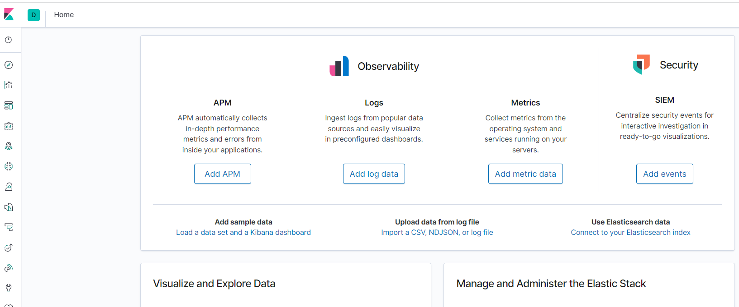](project%20screenshots%2015th%20june.docx)