**Networks and Communication**

**Lab Assignment - 2**

Shreya Maheshwari

18BCE0167

Q1. Write TCP Socket program to transfer the contents of a file from the client program by reading from an existing file and write the contents to a new file in the server program.

**Code:**

**SERVER SIDE: server_file.py**

import socket

port = 60071

s = socket.socket()

host = socket.gethostname()

s.bind((host, port))

s.listen(5)

print 'Server listening....'

while True:

conn, addr = s.accept()

print 'Got connection from', conn,addr

data = conn.recv(1024)

print('Server received', repr(data))

filename='mytext.txt'

f = open(filename,'rb')

l = f.read(1024)

while (l):

conn.send(l)

print('Sent ',repr(l))

l = f.read(1024)

f.close()

print('Done sending')

conn.send('Thank you for connecting')

conn.close()

**CLIENT SIDE: client_file.py**

import socket

port = 60071

s = socket.socket()

host = socket.gethostname()

s.bind((host, port))

s.listen(5)

print 'Server listening....'

while True:

conn, addr = s.accept()

print 'Got connection from', conn,addr

data = conn.recv(1024)

print('Server received', repr(data))

filename='mytext.txt'

f = open(filename,'rb')

l = f.read(1024)

while (l):

conn.send(l)

print('Sent ',repr(l))

l = f.read(1024)

f.close()

print('Done sending')

conn.send('Thank you for connecting')

conn.close()

**Output:**

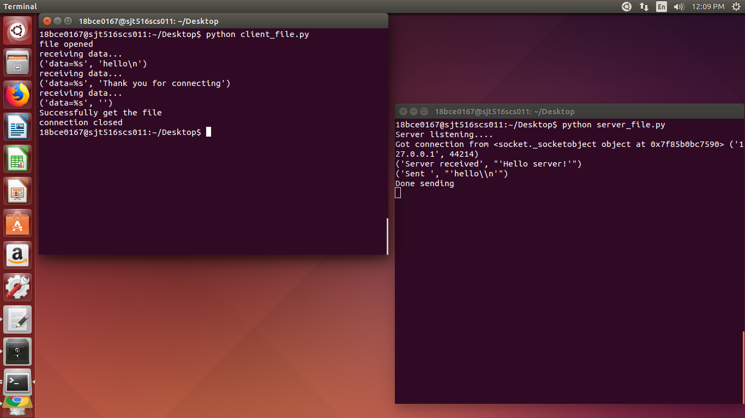

Q2. Write a TCP socket program for calculating the factorial of a number in the server program which is sent by the client program.

**Code:**

**SERVER SIDE: server2.py**

import socket

print("This is the server for question 2")

# factorial function

def factorial(n):

fact = 1

for i in range(1, n+1):

fact = fact*i

return fact

# establishing connection

s=socket.socket()

host=socket.gethostname()

port=12347

s.bind((host,port))

s.listen(5)

c,addr=s.accept()

# processing for incoming data

rec_word = c.recv(1024).decode()

data = int(rec_word);

fact = factorial(int(data))

c.send(str(fact).encode())

**CLIENT SIDE: client2.py**

import socket

s=socket.socket()

host=socket.gethostname()

port=12347

s.connect((host,port))

# can include or remove print statements

data = int(input("Enter the number you want to calculate the factorial of : "))

s.send(str(data).encode())

print("Data sent to server")

print("Received the calculated factorial value ")

str=s.recv(1024)

str1=str.decode()

print(str1)

s.close

**Output:**

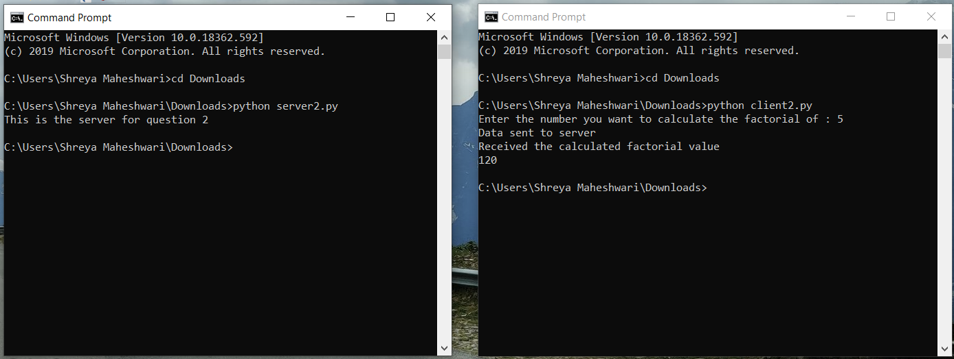

Q3. Write a TCP socket program for user authentication by using the user [] and password [] arrays in the server program.

**Code:**

**SERVER SIDE: server3.py**

import socket

print("This is the server for question 3")

# establishing connection

s=socket.socket()

host=socket.gethostname()

port=12384

s.bind((host,port))

s.listen(5)

c,addr=s.accept()

#processing for recived data

username_reg = ["shreya"]

password_reg = ["shreya123"]

while True:

data = c.recv(1024).decode()

print("Recv message : ", data.split('~'))

cred_list = data.split('~')

flag = True;

for i in range(0, len(username_reg)):

if (username_reg[i] == cred_list[0]):

if password_reg[i] == cred_list[1]:

c.send("Authentication Sucessful".encode())

flag = False

else:

c.send("Authentication Failed".encode())

flag = False

if(flag):

c.send("Username not found".encode())

**CLIENT SIDE: client3.py**

import socket

s=socket.socket()

host=socket.gethostname()

port=12384

s.connect((host,port))

# can include or remove print statements

while True:

user = input("Enter username : ")

pw = input("Enter password : ")

cred = user + "~" + pw

s.send(bytes(cred, 'UTF-8'))

# printing the received response from server

res=s.recv(1024)

str1=res.decode()

print(str1)

**Output:**

