Dear reviewers,

I hope all is well with you during these unprecedented times and thank you for quickly reviewing this manuscript. We incorporated your suggestions into our manuscript, and our responses to your feedback in this letter are colored green. If a change is simple and does not necessitate a response, we simply respond with “done”.

The biggest change to this manuscript is an addition of a new figure. We expanded the scope of this study by including the geographic distribution of curtains, with an accompanying discussion of the longitudinal distribution of curtains and the expected signature for drifting curtains.

We made one additional important change. In the introduction we included a high level overview of two general mechanisms that could create the observed curtain fine structure. We mentioned that the fine curtain structure can be due to either drifting remnants of a gyroresonant wave-particle scattering (such as the Blake and O’Brien 2016 hypothesis), or a stable mechanism that is capable of continuously transporting electrons in pitch angle while both AC6 units pass through the active region’s footprint. We hope that this paragraph gives more context and clarity to the reader.

Sincerely,

Mike Shumko

___________________________________________________________________________________

Reviewer #1 (Formal Review for Authors (shown to authors)):

Overview

This paper presents a statistical analysis of precipitation "curtains", which are defined as narrow regions of electron precipitation that persist for many seconds but are narrowly constrained in latitude or L-shell. A dataset of over 1600 curtains is analyzed for their spatial, temporal, and geographic properties. The study finds that these events are narrow in latitude (mostly < 20 km), occur at outer radiation belt L-shells and pre-midnight MLT, and occur more frequently with increasing AE index. Moreover, the study calls into question the previous attribution of these events to drifting electrons, and provides an analysis suggesting a mechanism driven by parallel electric fields, thereby associating curtains with inverted-V discrete aurora. However, the paper rightly points out that a clear connection between the two will require a more comprehensive data set that includes energy resolution.

Impression

This is a nice study that improves on our knowledge of these precipitation events, which are relatively new and poorly understood. The study is an important contribution to the field of energetic particle precipitation. The paper calls into question the previous association of curtains with drift loss cone electrons, and I think that association does indeed require more data and analysis, so it is important to highlight; I will expand on this below. I see nothing in this paper to prevent its eventual publication in JGR, but there are some comments below that should be addressed. In particular, the paper requires some further analysis to make the argument for or against the curtain mechanism.

Major Comments

I have a couple of "major" comments here, but they are major only in that I think they are especially important; the actual effort required to revise the paper should not be cumbersome.

1. The term "curtains" is problematic. It has been established and so is likely to stick, but it's worth considering the term and its implications. Blake and O'Brien [2016] estimate the longitudinal extent of their events to be >= 60 km based solely on the drift time between the passes of the two spacecraft (and Earth rotation? it is not mentioned.). That still assumes the electrons are drifting, which may or may not be the defining signature of these events. The precipitation may have been scattered locally, and AC6 is actually measuring electrons in the local BLC. The fact that the event persists simply means the scattering mechanism persists, as mentioned later in the paper. There are a few comments below on this question; the paper needs to be very careful about what conclusions can really be drawn from this data.

Thank you for pointing out this potentially misleading nomenclature. In the introduction section of this revision, we carefully pointed out that the curtain nomenclature comes directly from the unproven drifting electron hypotheses, and the reader should consider other possible realities.

2. Are these really radiation belt electrons? The paper points to this fact, though it does not overemphasize it. But the L-shell locations and energies suggest something more related to auroral precipitation, as the authors go on to suggest in Section 5.3. The connection with radiation belts in the motivation, introduction, and earlier parts of the paper should be revisited. I say more about this in the comments below.

This is a valid concern and unfortunately the AC6 instrumentation does not allow us to determine the curtain source population. Due to the ~ 30 keV dos1 energy threshold, it is difficult to classify curtains as part of the outer radiation belt, ring current, or the aurora. For reference, we included a plot of the dos1 energy response from O’Brien et al., 2019 (and also cited in the manuscript) that shows that dos1 is more sensitive to radiation belt electrons. However, the observed counts strongly depend on the energy spectrum and that is a big unknown.

We revised the L shell extent of curtains and where curtains originate from in section 4.2.

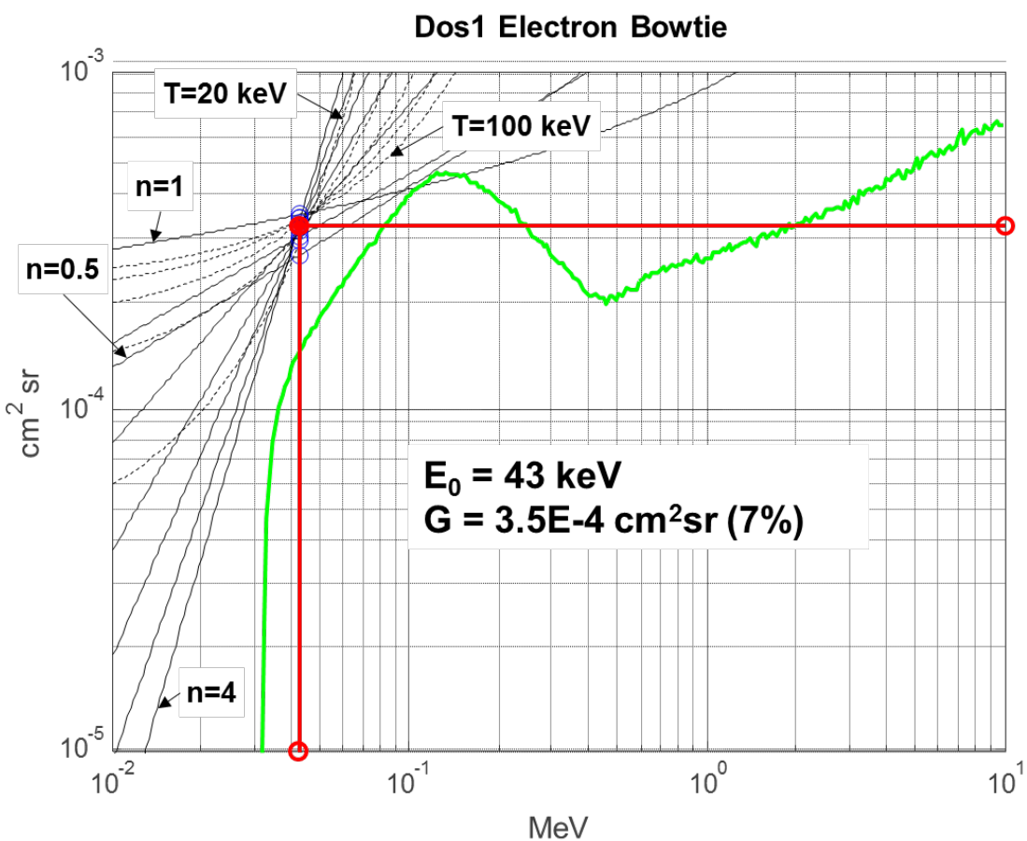

3. I also say more about this below, but the event distribution in MLT (Figure 3) requires more discussion. Alone, the MLT distribution is interesting and a valuable piece of information, but I am not sure it is being analyzed accurately. The fact that these events are constrained to specified MLT regions is indicative of a specific source mechanism occurring at those locations in geospace; the paper does not say much about this. But it also argues against the "curtain" hypothesis. If the spacecraft were indeed measuring drifting curtains, one would expect the distribution in MLT to be roughly uniform, because the spacecraft would be measuring the curtains irrespective of whether or not the source region is "overhead". On the other hand, the distribution in geographic longitude would be much more interesting. Drifting curtains would be observed increasingly as one progressed eastward from SAA, after which the events would disappear (since they all precipitated there). But this idea has not been investigated.

One could argue that such analysis could be left for future work. However, because the paper works hard to assess the curtain mechanism, I think this more analysis is important. As it is, the paper does not present a strong argument one way or another, for or against the curtain mechanism.

CHECK PAPER IF WE PICK A SIDE ANYWHERE!

Thank you for your suggestion and as we pointed out earlier in this letter, we added a new figure that shows the geographic distribution of curtains. It appears that the distribution of curtains in longitude, shown in Fig. 4c, does not show an obviously increasing trend eastward of the SAA. Thus, this analysis suggest that curtains are not drifting.

We did not comment on the MLT distribution in the manuscript because it is very murky. The MLT location of the SAA (tied to the time of day) strongly influences the MLT distribution. We attempted to address this by applying various time of day filters to the MLT distributions, to pin down the SAA location. Unfortunately, this filtering decimated the data set to the point where statistical inference was impossible. Furthermore, the observed MLT distribution will not be uniform because the drifting curtain electrons disperse and become less prominent and therefore less detectable. Lastly, this is compounded by other drift loss cone precipitation that will bury curtains along their drift path.

Minor Comments

Line 30-31: because there is no evidence for the parallel electric field mechanism, I suggest rewording to something like: "we investigate the possibility that this precipitation is driven by parallel electric fields and show that this mechanism is consistent with observed signatures."

Done

Line 35-36: "remaining unchanged for seconds to a minute" - is there evidence for an upper limit on their duration? We really don't know, do we? The lower limit is given by the spacecraft separation, but they could persist for much longer; we don't have data to say when the event ends. One could look at the subsequent orbit, but the next orbit crossing likely happens at a different MLT and/or geographic longitude. I suggest rewording to note that any estimated durations are a lower limit.

You are correct. Do not know how long curtains last for, and we mentioned that AC6 observed them to be stationary for AC6 separations as long as a minute.

Line 51: the introduction talks about radiation belts, but are these really radiation belt electrons? The L-shells observed (figure 3, L = 5-9) are consistent with the outer belt but tending towards the outer edge and the auroral region. AC6 data are likely dominated by the lower energies (30-100 keV). Most would not strictly categorize these as radiation belt electrons.

As we mentioned earlier, 30 keV is the lower energy regime of the radiation belts, and the upper energy regime of the ring current, the aurora, and the plasma sheet. On its own, AC6 can not definitively differentiate between these populations so in the introduction we changed “radiation belts” to “magnetosphere” to be more general.

Line 57: define "stationary" - in time, space, or both?

Done

Line 58: see my major comment above about curtains and their longitudinal extent.

We left this line as is because the cautionary sentence is at the end of the introduction section. Please let us know if you believe that there is a possibility of a reader being mislead.

Same paragraph: Is there any evidence in the literature of similar "curtains" in FIREBIRD data?

There is no evidence of curtains observed by FIREBIRD-II in the literature yet, but the FIREBIRD science team plans to look for them in the future. There are a handful of caveats with the data that has prevented us from doing a thorough analysis. In theory these caveats are addressable, so we specifically targeted data downlinks from both CubeSats during the same radiation belt passes.

Line 99: what is the spatial extent of bands / spikes referred to in this paragraph? This paragraph should also differentiate between bands / spikes and the curtains under study here. Are you saying they might be the same thing?

We removed the mention of the hypothetical connection between curtains and precipitation bands from the beginning of the paragraph to avoid priming the reader to assume that they are the same thing. We now point out their possible connection at the end of the paragraph---carefully noting that the energy difference between the most recently reported band observations with SAMPEX and CSSWE are for relativistic electrons energies: a very different energy regime than AC6. Therefore curtains and bands could be related, but there is not enough observational evidence to make that connection.

Line 167: It's great that the authors identify the bias inherent in their windowing method. One possible solution to this could be to filter with multiple windows of different duration; perhaps a comment could be added on this or other methods to investigate / eliminate the bias. However, given the distribution in Figure 2, I don't think the bias is a major concern.

Done.

Line 171: Elaborate on the "visual inspection". Visual inspection / classification can be very unreliable. How was the visual inspection method controlled?

We filtered out candidate events with the criteria mentioned in the text and we did the manual inspection blindly. In other words, we did the inspection without knowing the results---we did not go back and adjust our inspection criteria after the first pass.

Line 183: Again, I do not see strong evidence that these curtain events are "drifting" at all; it's likely but there isn't evidence, unless I am missing something?

So far this is our conclusion as well. We hope that the new plot of the longitudinal distribution clarifies these results.

Line 246: I would argue that the distribution in L-shell from Figure 3 is more like L = 6-9, possibly even L = 5-10 on the night side. The large number of events at L > 7 suggests this is a signature occurring largely outside the radiation belts.

While we were addressing your major point #2, we addressed this point as well.

Suggestion: one way to look at this in more detail would be a joint distribution in L-shell and geomagnetic activity (such as AE index).

We made a box plot of the curtain distribution in L shell vs AE. The AE bins are 100 nT wide and each box is horizontally centered on the lower edge of each AE bin. The horizontal yellow line inside each box is the median value of the distribution, while the top and bottom box edges show the interquartile range. Most of the probability density is spread out over a few L shells, but the tails of the distributions are very wide.

Because the L-AE trend is not statistically significant, we are not going to add this to the manuscript.

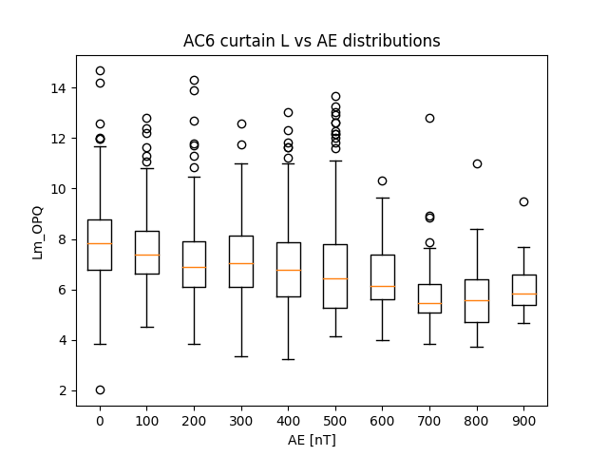

Figure 3: The clear regions of higher observations in MLT are interesting, given the argument that these curtains are drifting electrons. If the signatures are primarily drifting electrons, wouldn't we expect to see near uniformity in MLT? The events would be created at preferential locations, but would be observed just about everywhere due to the drift. Could the authors comment on this, and its consistency with the observed MLT dependence?

In a similar vein, if these are curtains of drifting electrons, then we would expect a clear dependence with geographic longitude; in particular, we'd see the occurrence rate near zero just east of the SAA, and increasing linearly around the globe to a maximum just before the SAA. This dependence should show up regardless of where the events are created in MLT, thanks to statistics (i.e. random combination of MLT and geographic longitude at any given time).

On the other hand, if the events are being observed where they are created, the geographic dependence would be roughly uniform (random) in longitude, while the MLT dependence would show some preference (as in Figure 3).

Thank you for your detailed thoughts on this matter---your description helped us significantly improve the results of this manuscript. We believe that our response to your 3rd major comment also addressed this comment.

Line 248: Authors should explain why they chose AE index as a potential correlator with these events. Are there other indices that could be relevant, such as Kp or Dst?

We chose AE because it is commonly used in other wave and precipitation studies such as the work by Wen Li, Emma Douma, and Nigel Merdeith. We mentioned this in the manuscript.

Line 272: This section is left hanging without any conclusion; I suggest a few sentences to explain the findings and implications of what is seen in Figure 5. The statement at the beginning of the section says the goal is to determine if the electrons are drifting or locally precipitating, but the conclusions based on Figure 5 are not clear.

Showing events in the SAA (conjugate) region does not really give any insight. As mentioned above, it is the distribution of events geographically which will really answer the question posed in this section.

We added a sentence at the end of the section to remind the reader that in this region any particles observed by AC6, regardless of their pitch angle, will precipitate within a bounce.

Line 290: outer radiation belt → really the outer edge of the outer radiation belt, or just outside.

Done

Figure 5: I suggest showing the AC6 trajectories on this figure, as line segments or arrows, showing where the spacecraft are going.

Done. We added the 1 minute trajectory and the direction of travel arrow.

Line 301-302: It is not clear how the events on Figure 5 "call into question" the hypothesis of B&O 2016. It is simply luck that those particular events were created right above the SAA and will immediately precipitate. Other events (almost 1600) that were not observed over the SAA can still drift.

What we are saying here is the drifting microburst hypothesis can not explain these curtains because these electrons could not sustain bounce motion. There must be something else going on. We rewrote the beginning of section 5.3 to be more clear.

Line 313: May I suggest starting a new subsection here? The subsection 5.3 heading doesn't really make sense for the rest of this subsection.

Done

Line 336: what altitude is chosen for B_f? Sea level? In actuality, electrons with mirror points just above 100 km would not have to be scattered that far; lowering the mirror point to ~90 km would probably be sufficient to precipitate them. (Marshall and Bortnik 2018 show that the loss cone altitude is reasonably sharp.) In that scenario, wouldn't this process require a much lower potential, just a few hundred volts? The conclusion that is drawn of a 1-4 kV potential is largely dependent on those assumptions of initial and final mirroring altitudes, which are not known.

We chose B_f to be the magnetic field at AC6’s location when the BLC curtains were observed. In the conjugate hemisphere in the SAA, the equivalent mirror point altitude will be at or below sea level. While the minimum potential necessary to precipitate electrons could be smaller, we were mainly focused on explaining the observations: the minimum required potential to lower the electron’s mirror point to AC6’s altitude so they can be observed.

Paragraphs starting at line 341: Does this reasoning suggest that curtains are the source of inverted-V discrete aurora? Making this connection solely on the basis of the potential seems spurious at best.

We agree that the evidence connecting the curtain and inverted-V phenomena is weak; that is why we state that AC6 alone can’t connect the two. One possible path forward is to use AC6 in conjunction with other ground- and space-based sensors to understand what causes curtains. We are starting exploratory studies looking for curtain precipitation in conjunction with lightning, aurora, and wave-particle interactions observed by The Van Allen Probes.

Line 368: just to reiterate that the duration may in fact be much longer than seconds; we would need a true "string of pearls", with >> 2 satellites, to determine the true duration!

We’re also hopeful that future missions will include more than 2 satellites to thoroughly study this precipitation and its duration. We modified the last conclusion point, now the 4th main point, to reiterate the duration limitation.

Figure A1: caption says "kilometers" but I think you mean "seconds"

You are correct and we fixed the caption.

Figure B1: for the 3rd and 5th event: how do you distinguish between individual curtains and clusters / groups of curtains shown here? Are they counted individually, or is a cluster considered a single event?

They’re are typically counted individually, but not always. Below is a thorough explanation.

First, the peak finding algorithm identifies the time intervals when the two dos1 count rates are highly correlated and prominently peaked. Often intervals contain one prominent peak, but sometimes more than one peak is inside the time interval. For studies such O’Brien et al. 2004 and Greeley et al., 2019 this is not a problem because they were summing the microburst flux. But for this study, since we’re identifying individual curtains, this approach will substantially overestimate the number of curtains. Therefore, for each continuous time interval that satisfied the above two criteria, the curtain saved was time tagged at the highest count rate observed by AC6-A.

___________________________________________________________________________________Reviewer #2 (Formal Review for Authors (shown to authors)):

Summary:

The manuscript further qualifies and characterizes a newly identified form of electron precipitation reported by Blake and O'Brien (2016) called curtains. The authors use the AC-6 dual CubeSat observations to identify over 1000 curtains defined as electron precipitation that is stationary with spatial structure that is on the order of seconds. The precipitation is identified using the dosimeter >30keV integral count rate data such that there are prominent peaks with high spatial correlation. The findings of this work show curtains are narrow in width latitudinal wise with 90% narrower than 20km. Curtains are observed by AC-6 predominately in the pre-midnight MLT region during active geomagnetic times.

The manuscript is well organized and well written. The comments I have are minor comments. The authors do a good job to build upon the work from Blake and O'Brien (2106) to further characterize this newly described precipitation that previously could not be identified by single spacecraft or balloon observations. The study does not try to do more than seems reasonable drawing conclusions which stay within the bounds of what can be concluded from the data. Very nice paper!

Comments:

1. The authors describe the instrument energy sensitivity as > 30keV. Blake and O'Brien report the instrument > 35keV. Perhaps the authors can use a consistent value for the instrument or describe why they are reporting a slightly different number.

The reason we used 30 keV is because it is dos1’s electronic energy threshold shown in O’Brien et al., 2019. We decided to be consistent with the previous study and changed the energy threshold to 35 keV.

2. Blake and O'Brien show curtains that occur in back to back orbits. How many identified curtains occur in back to back orbits and are those events counted individually or as one continuous event?

In this study curtains are counted individually and we have not looked at the curtain occurrence in back-to-back orbits. Blake and O'Brien (2106) did look at curtains observed on adjacent orbits and found that the “...in a little less than 2 h, the precipitation structures of >35 keV electrons at the same local times have evolved significantly although fine structure remained.” Therefore, it looks like Blake and O'Brien (2106) did not find individual curtains that persisted for subsequent orbits, but that question has not been thoroughly investigated.

3. The authors do not mention the study by Anderson et al., 2017 which utilizes balloon observations from BARREL in conjunction with FIREBIRD II and AC-6. The Anderson study suggests curtains can occur along with microburst activity and could be caused by similar phenomena. This paper does not address the Anderson study though reports microburst activity can be hard to distinguish from curtains. The manuscript gave me the impression that one could be mistaken for the other but didn't necessarily occur at the same time or was a separate type of precipitation. This understanding might be driven by the fact the events presented in the paper are all separated in time as shown in Figure 1 with time stamps in April, May, and October of 2015 and January of 2017. The event shown in Blake and O'Brien (2016) show time evolution with curtain observations over sequential orbit passes. It seems to me there is a temporal development of these events that is not captured in this study with a focus purely on the spatial structure. It seems coincident balloon observations would be valuable to gain temporal information for these events. Even though peaks align with high correlation it is clear that the lagging spacecraft observes lower counts/s which also seems like a temporal feature (Figure 1d). I recommend include the Anderson study in the introduction.

Anderson, B. R., S. Shekhar,R. M. Millan, A. B. Crew, H. E. Spence,D. M. Klumpar, J. B. Blake, T. P. O'Brien, and D. L. Turner (2017), Spatial scale and duration of one microburst region on 13 August 2015, J. Geophys. Res. Space Physics, 122, 5949-5964,doi:10.1002/2016JA023752

Thank you for mentioning the Anderson et al., 2017 study. We included their contribution to microburst and curtain observations in the introduction section. To constrain the scope of this study, we only focused on the micro physics of individual curtains. We believe that considering the curtain temporal evolution, and looking for conjunctions with balloons and other satellites is a natural follow-on study. As for which AC6 spacecraft observes higher curtain counts, we found no clear trend.

The plot below shows our study that quantified the AC6 leader vs. follower curtain counts, integrated over 0.5 second (this is before we had a refined width estimate), and with the instruments looking within 10 degrees of each other in pitch angle when the curtain was observed. The left panel shows the follower vs leader count scatter plot with a line with a slope=1 shown by the black dashed line. The scatter plot colors represent the in-track lag. The scatter is roughly uniformly distributed about the slope=1 line, but other trends are not obvious.

To help visualize the ratio, the middle panel shows the ratio of the leader/follower counts vs the leader counts. The right panel is the histogram version of the middle panel with a few statistical values indicated with horizontal lines. The observed median ratio is not at the median (or mean), but is within the interquartile range of the ratio distribution. We argue that the difference is not statistically significant and systematic factors such as instrument cross-calibration can account for the asymmetric distribution.

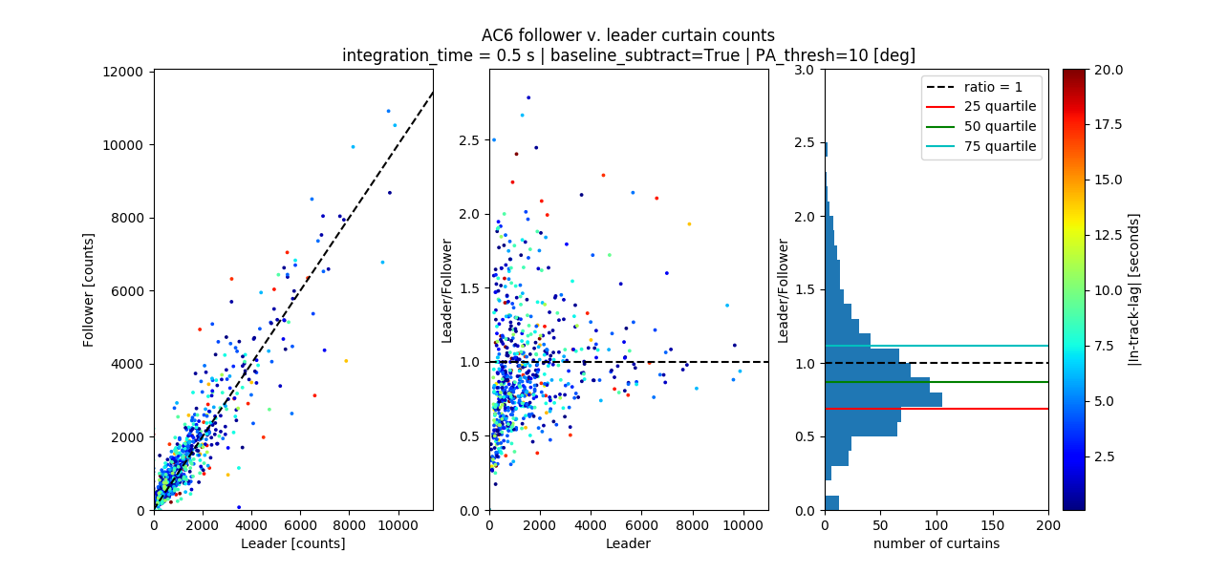

4. The authors draw conclusions about the correlation of curtains with geomagnetic activity using AE index. I did not see any reference to the data source for these values in the acknowledgments. Please include the data source for AE index.

Done

5. The statement on line 294 about curtains near midnight MLT is rather suggestive for the paper, with language like "hints" and "possibly". I would encourage the author to make a more concrete statement here. I'm not sure L of 10 on the night side with a stretched tail during geomagnetic times would qualify as outside the outer radiation belts.

We removed the “Nevertheless, Fig. 3b hints…” statement completely. Instead, we mentioned that curtains could originate from the outer belt or the plasma sheet.

6. Line 335 states the authors used the IRBEM-Lib again for analysis pertaining to curtains in the bounce loss cone. I find it more valuable to state the magnetic field model used in the study verses the tool used to run the model.

Done

7. The authors report that curtains occur predominantly in the pre-midnight local time sector though figure 3 shows that the AC-6 mission does not cover all local times with a sizeable gap post-midnight to 6 MLT and low statistics in the dayside dusk MLT sector. I agree that the data shows a preference for pre-midnight but that is based on the AC-6 orbit and should be qualified as such.

Thank you for pointing this out and we mentioned this limitation in the discussion section. We also rewrote the 2nd conclusion point to remind the reader of the limited MLT sampling distribution.