AC-6 Microburst Scale Size Project

Removing Noisy Detections with Correlations

Mykhaylo Shumko

Montana State University

Last Modified: 2018-09-10

**Background**

The transmitters on the AC-6 CubeSats are not only used to communicate with the handful of Air Force ground stations, but also with each other. As described in the AC-6 Data README (v3.0), AC-6 has a high/low rate transition crosslink. This was intended to test if one CubeSat can command other CubeSats around it. As a consequence, the dosimeters experience non-physical counts, example of which is shown in Fig. 1

Due to a similar time signature of these transmissions to microbursts, my wavelet detector flags these as detections. Paul has attempted to flag these times in the data, which are well documented in the README document. In Fig. 1, a flag = 5 translates to a binary bitmap values of 1 and 4 which correspond to: transmitter is on for ground contact, and the attitude is interpolated. Unfortunately, it does not appear that all noise of this nature is flagged in the public data. Thus John and I through of using an auto-correlation to remove detections that had an artificial periodicity.

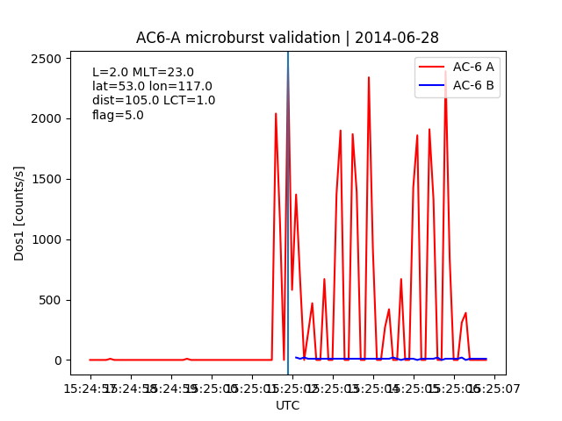  
Figure 1: example of transmitter noise. Looks like unit A commanded unit B to go into 10 Hz mode.

**Methodology**

For each detection, I use np.correlate() with mode=’same’ to calculate the autocorrelation of the signal. The width of the auto-correlation window was 1 second (10 data points). Since auto-correlation is symmetric about lag=0, I only plot the positive lags. Fig. 2 shows one example of the auto-correlation on A’s signal. Top panel of Fig. 2 shows the two dos1rates, similar to Fig. 1.

Middle panel shows the auto-correlation. I’ve used scipy.signal.find_peaks() to identify peaks that have a topological prominence > 0.05. I’ve also used the find_peaks() function to mark the peak prominence in orange.

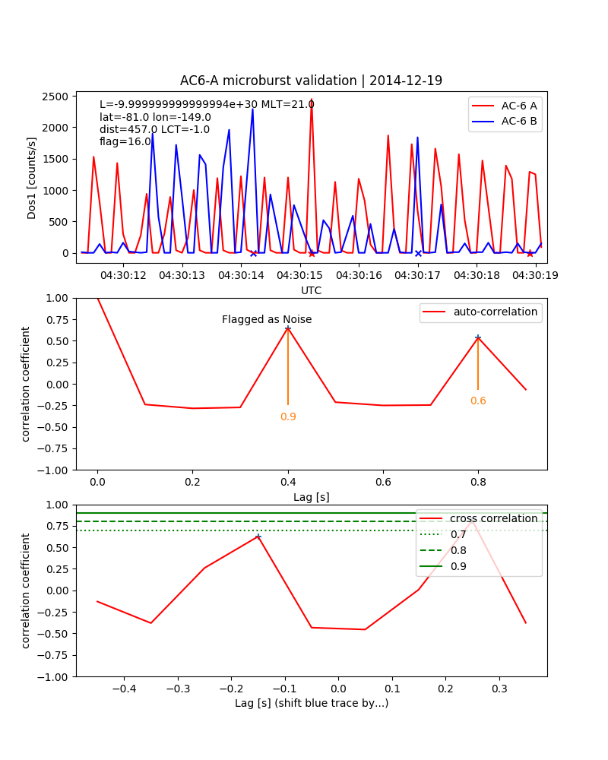  
Figure 2: Example of AC6 noise that was not flagged as transmitter noise (flag = 16 means dos3 is affected by "northern hemisphere high latitude" noise"). Middle panel shows the auto-correlation with a window of width 1 s. Bottom panel shows the cross-correlation with a width of 1 s (centered at lag = 0).

These plots are automatically generated for the entire microburst database, and it is my goal to A) provide good microburst catalogs from each spacecraft separately, and B) use a cross-correlation to generate a robust catalog of coincident microbursts for future studies.

Fig.3 shows an example where the cross-correlation between the two spacecraft’s dos1rate’s are very correlated due to noise, but the auto-correlation correctly flagged this as noise with a simple criteria of a peak with a prominence > 0.05 found at a lag < 0.5 s.

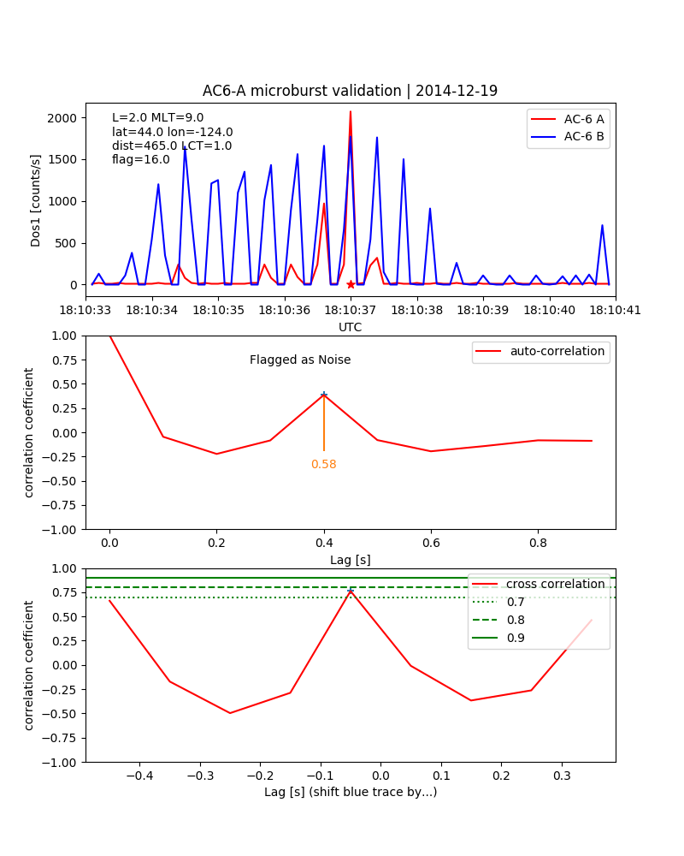  
Figure 3: Same as Fig. 2

Now the following pages show examples where this code incorrectly flags trains of microbursts, so this criteria is not as robust as one would like. Careful tuning of the peak criteria may help, or use some other auto-correlation criteria.

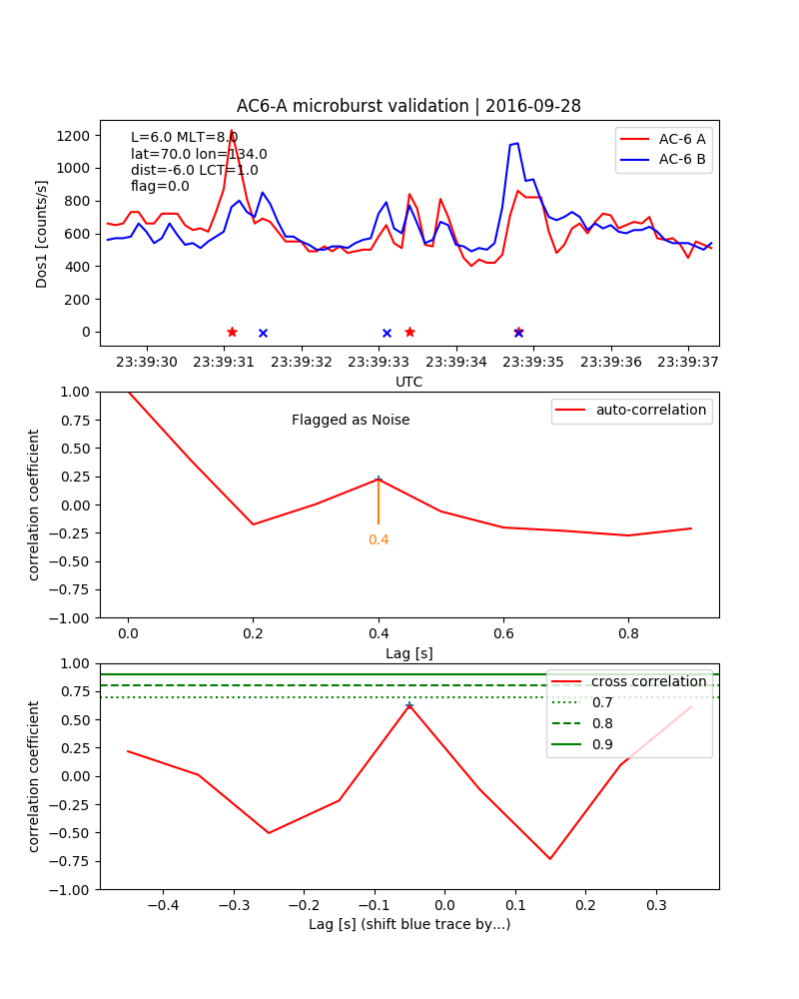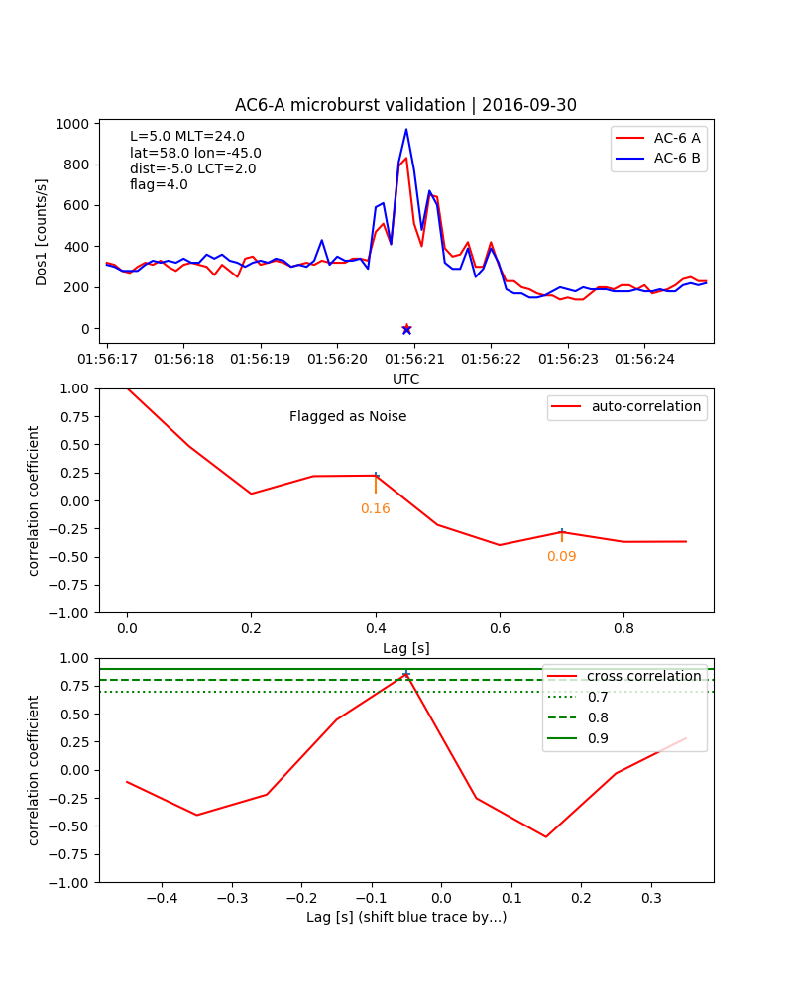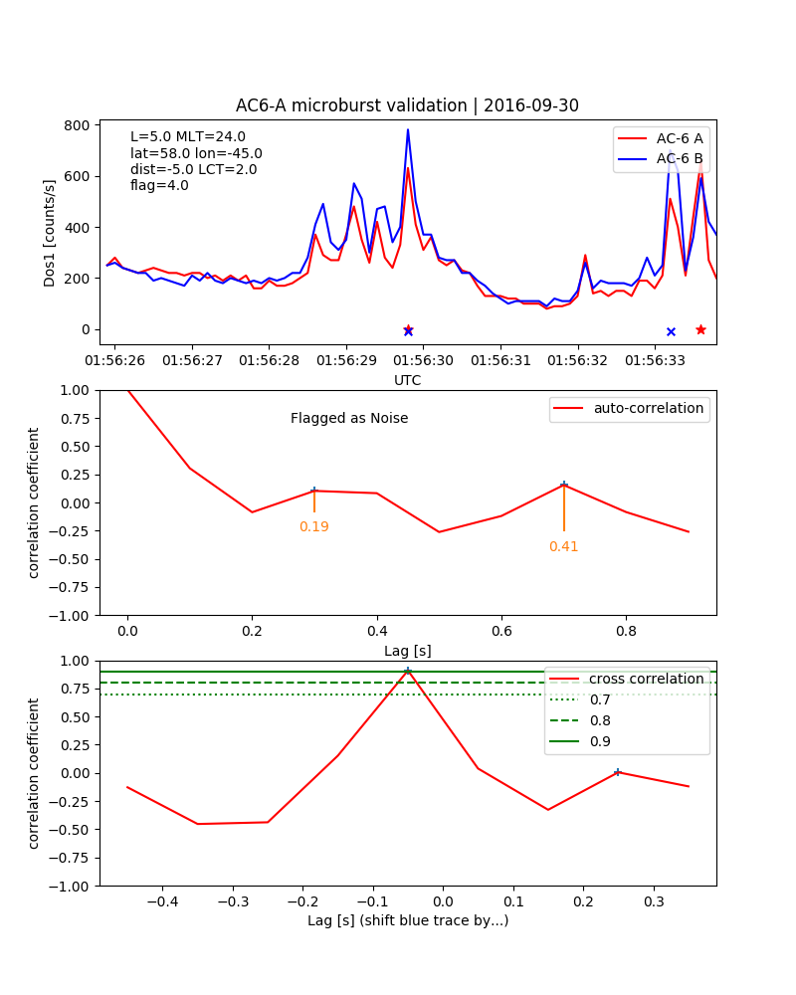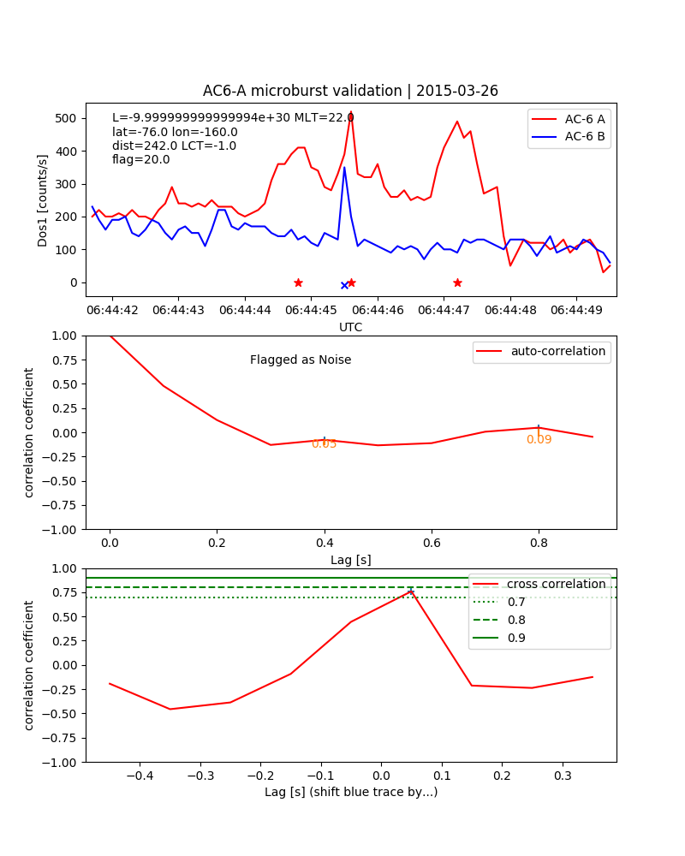

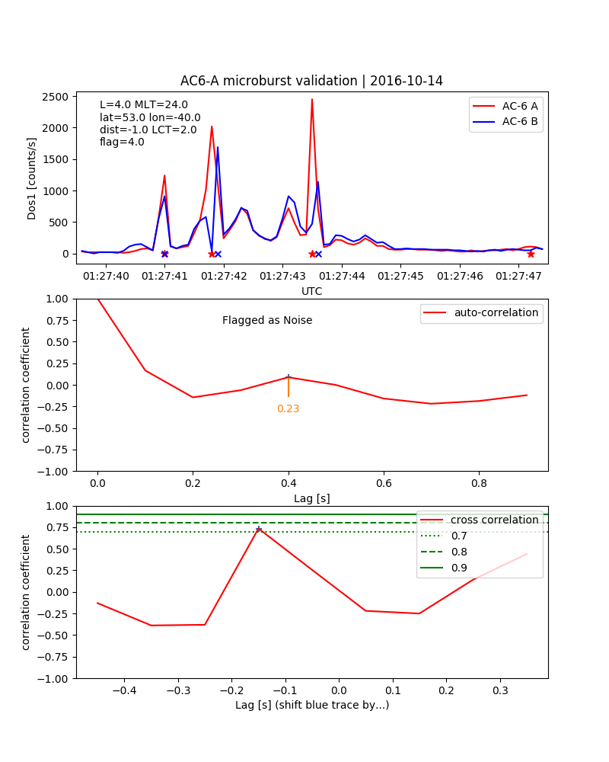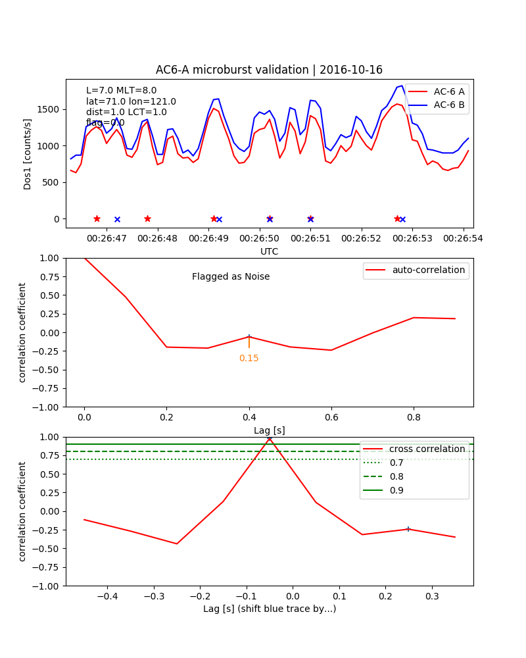

Now here are examples of true detections that appear to be noise.

