Dear reviewers,

I hope all is well with you during these unprecedented times and thank you for quickly reviewing this manuscript. We incorporated your suggestions into the manuscript and made numerous minor grammatical improvements. Our responses to your feedback in this letter are colored green. If a change is simple and does not necessitate a response, we simply respond with “done”. We tracked changes for substantial edits, but we did not track minor grammar improvements.

Sincerely,

Mike Shumko

Reviewer #1 Evaluations:  
Science Category (Required): Science Category 2  
Presentation Category: Presentation Category B  
Key Points (Required): Yes  
  
Reviewer #1 (Comments to Author (shown to authors):  
  
This paper uses the SAMPEX HILT (for >1 MeV electron detection) data to quantify microburst duration as a function of activity level and L, MLT. Microbursts are fit with a combination of a Gaussian profile and a linear fit (to account for slope in baseline), and care is taken to remove bad fits caused by overlapping microbursts. Results are important towards further establishing the connection between microbursts and their likely cause - chorus waves. This paper shows that microburst duration spatial and activity-dependent variability is similar to that of chorus, as previously reported.  
  
I don't have any major issues with the results, but a number of minor changes are needed before this paper can be published. These include the presentation of results, explanation of methodology and results, etc.  
  
  
Main comments regarding data presentation:  
  
I think there should be some changes in how the results are presented.  
Figure 3 presents L,MLT duration distributions separated into percentiles. Not sure I understand the reason for dividing into percentiles here since the distribution in 2a has a smooth (Gaussian) functional form. Maybe if it showed distinct populations (bump on tail) then you'd want to separately analyze the different populations. However, it just seems to be a continuously varying population. As such, I would expect a,b,c in Fig3 to be very similar, and they are. I think it should be enough to just show the L/MLT distribution of all the microbursts and mention that there is little variation based on FWHM duration.

Out initial intention with plotting the 25th, 50th, and 75th percentiles was to identify any asymmetries, such as the bump on tail that you refer to. We agree with your suggestion. Given the smooth distribution in Fig. 2 and the redundancy in Fig. 3a-c, we removed the two panels showing the 25th and 75th percentile distributions.  
  
Figure 4 would likely benefit from a plot showing L slices at various MLTs in order to see the "subtle" duration trend discussed around L225. Currently, these subtle trends are very difficult to see in Fig 4 (as the paper points out)

We experimented with plotting the distribution in other ways, and we ran into difficulties highlighting the subtle trends. Since this trend appears inconsequential to our overall conclusions, we left the text as is.  
  
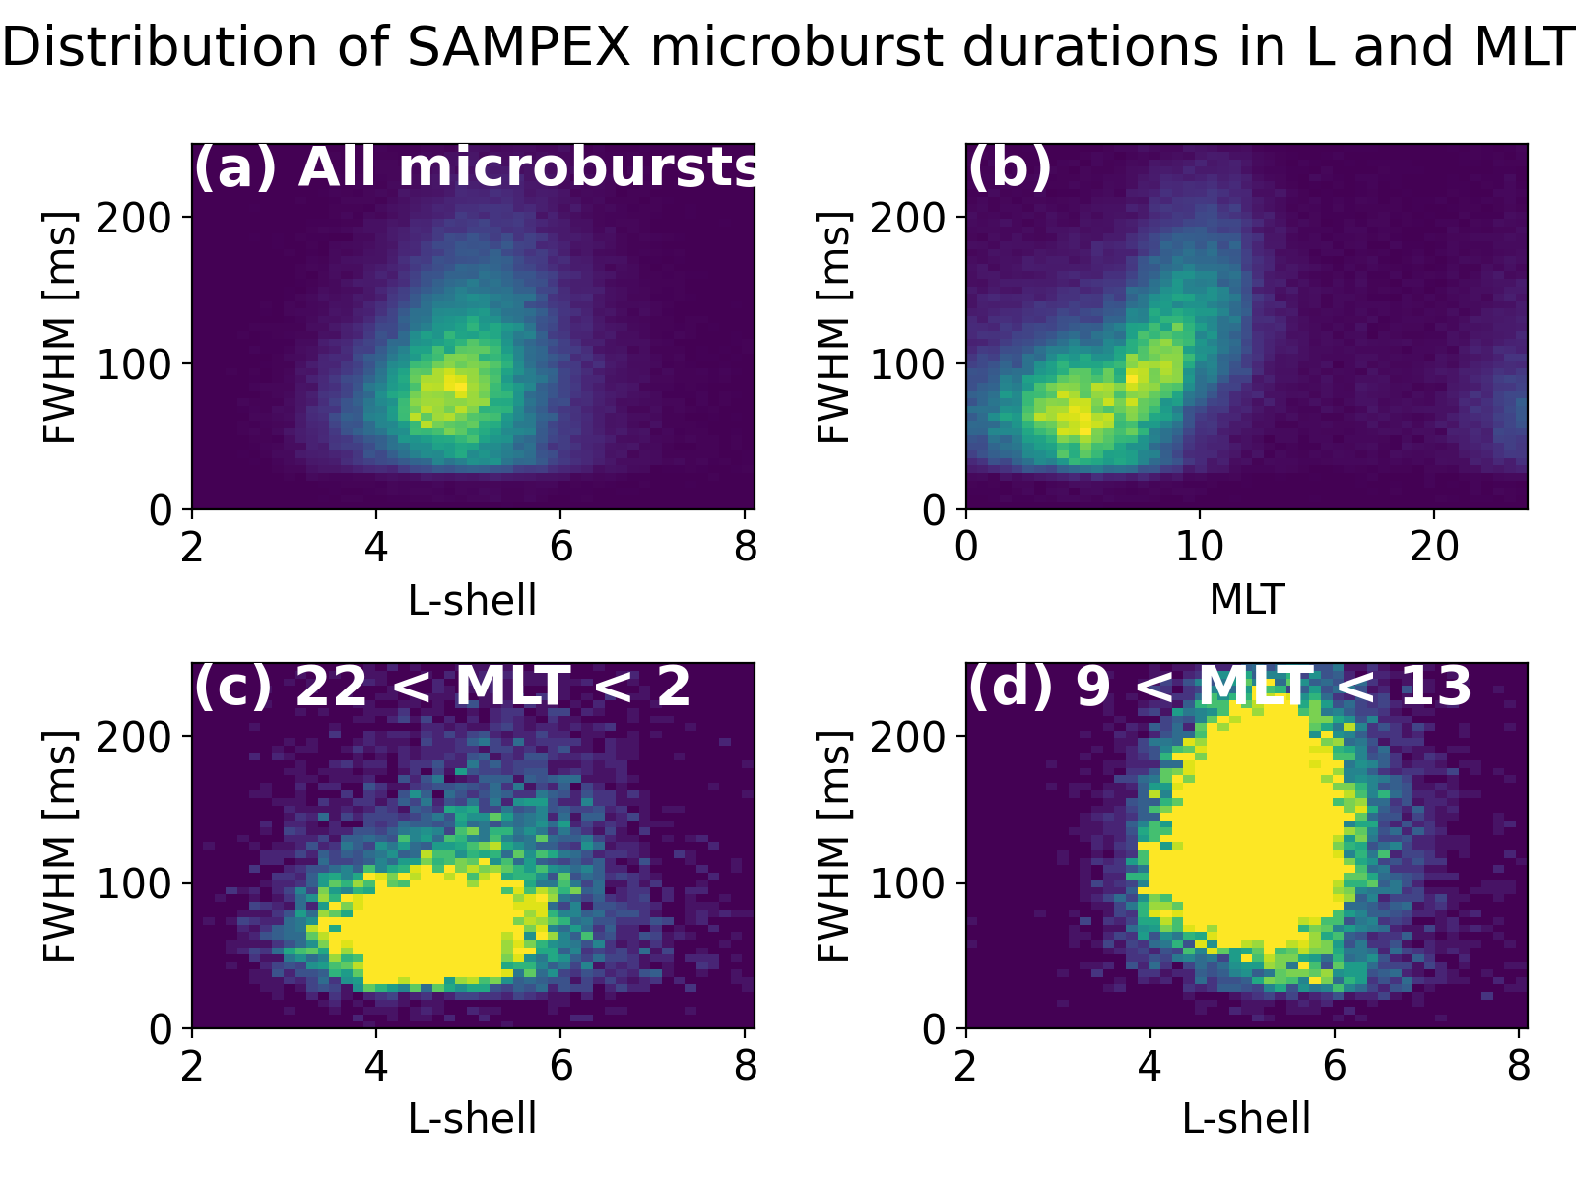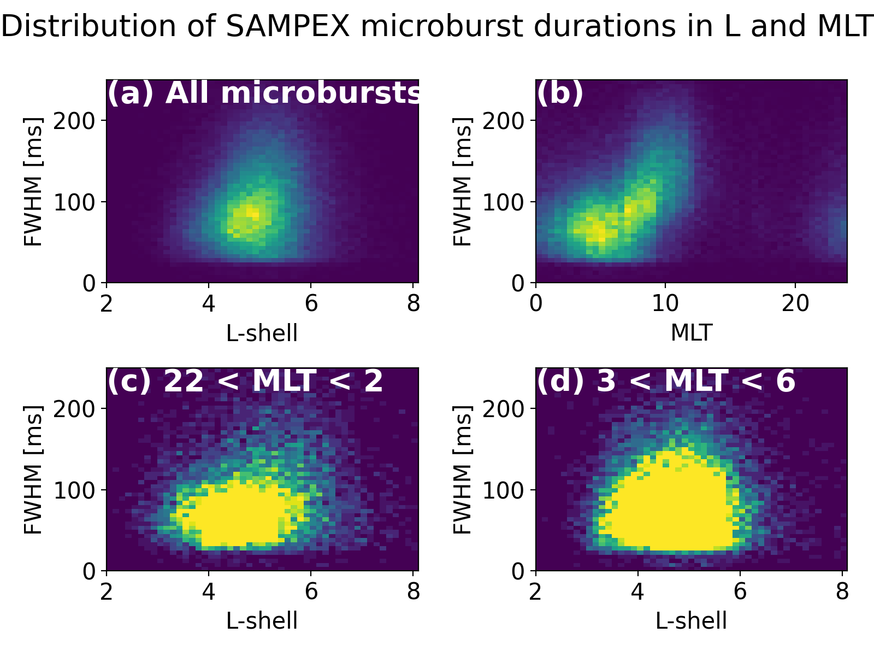  
  
Other comments:  
Title page: Dual affiliations should be listed with a separate number. Also affiliation 3 comes before 2. Done  
  
L46: Bonnell is incorrect reference - it's also missing from biblio. This appears to be a misunderstanding due to the pdf format. Bonnel is the 4th author of the Li et al., 2009 paper, and appears next to the year. This is due to AGU’s Latex formatting style that included the first 4 authors of that study.  
  
L51-53: Consider separating low and high altitude references. Done



L55: ; should be , Done

L75: remove comma Done

L76: remove "a" Done

L77: Breneman17 wasn't a direct (one-one) link. Rather, they associated a bunch of rising tone chorus to a bunch of microbursts during an extremely close conjunction showing that chorus (in general) causes microbursts.

You’re correct, we rewrote the sentence to convey that Breneman et al., 2017 “associated chorus rising tone elements to microbursts”.  
  
L81: Sentence should end with "?" Done  
  
L87: Suggest: "Therefore, we used SAMPEX data to quantify the distribution of relativistic microburst durations as a function of L-shell, MLT, and the Auroral Electrojet index"

Thank you for the suggestion. It is very concise, and we replaced two original sentences with your version.  
  
L93: No commas needed, I think. Would also suggest: For this study, we used... Done  
  
L106: I think this should be combined with the text in 3.1. Left to itself, it reads like a jotted-list. That was our intention with those two sentences: to provide a brief outline of the entire methodology. To be more concise, we decided to remove the sentences altogether and add “In the first/second step…” to the beginning of sections 3.1 and 3.2.  
  
"Straight line" is vague. Maybe "superposed with a linear fit"? Irrelevant due to the above comment.  
  
L127: Remove paragraph break We left the break as is because it introduces the topographic prominence method---described in the following paragraph, and the fit method---described right after the prominence method description. We think that this sentence eases the reader into the description of the two methods. Do you agree?  
  
L130: Confusing sentence b/c you start by defining duration and then switch to defining prominence. I’m sure that there are ways to clarify it, but I am out of ideas.  
  
L135-136: Not sure what you're saying here.  
  
L138: Maybe point out that Fig 1a is an example of this  
  
L139: I don't understand this. Do you mean "superposed with a straight line fit for the microburst base"? Or something like that?  
  
L145: To be clear, are these the initial parameter guesses?  
  
L156-159: A bit nit-picky, but is "perfect" fit the right way to say this for R^2=1? I think it's more of a statement that the data are such that you can have high confidence in your fit. i.e. all the data points fall directly on the mean line. Not a big deal, just maybe think about the exact wording...  
  
L167: these criteria  
  
L177: distribution  
  
L200: I think that "marginalized" isn't the right word to use here since all the usage I can find online has to do with marginalization of people or cultural groups. You could also consider adding this as two panels to Fig 3.

Also, since this requires an entire figure there should be a more nuanced explanation of it.  
  
L206: Need an intro sentence here that summarizes the main points, as well as a sentence that justifies the focus on the burst detection parameter discussed in the current first sentence.  
  
Is there some particular reason that the burst detection parameter would be less sensitive to abnormally long microbursts as opposed to abnormally short ones? --> you discuss this in the next sentences, but probably you should motivate the concern about long microbursts first.  
  
L214: change wording: "it longer overlaps with just the microburst"  
  
L225-229: I recall that chorus durations tend to be longer at higher L due to less magnetic field line curvature near the equator, allowing for cyclotron interaction to occur with a specific resonant population over a larger distance before the interacting electrons fall out of resonance.  
  
L227: Should reference Fig4b when discussing the MLT trend  
  
L237: I find this sentence confusing. Maybe: "These previous results on chorus durations combined with our results in microburst durations thus indicate that their durations roughly double from midnight to noon MLT. However, the chorus durations are about 3x longer than the microbursts..."  
  
L239: fix "Aa s"  
  
L243: Any guesses as to the duration discrepancy b/t chorus and microbursts?  
  
L243: Please comment on this. By scale factor do you mean 250ms/95ms ~ 3 for AE>300nT and 500ms/130ms > 3 for AE<100 nT?  
  
  
L248: Be clear that you are talking about the upper value of the absolute value of the magnetic latitude  
  
L250: Perhaps mention that the Saito results are simulations  
  
L251: probably should explain what you mean by "model configurations"  
  
L257: absolute value of latitude  
  
L271: duration  
  
L272: Be clear that previous work found that chorus durations double in MLT, not this paper.  
  
Figure 1: "lines" should probably be "curves"

Reviewer #2 Evaluations:  
Science Category (Required): Science Category 2  
Presentation Category: Presentation Category B  
Key Points (Required): Yes  
  
Reviewer #2 (Comments to Author (shown to authors):  
  
Shumko et al.  
"Duration of individual relativistic electron microbursts: A probe into their scattering mechanism"  
  
This paper investigates the duration of relativistic electron microbursts measured by the SAMPEX satellites. The authors found that the duration of the relativistic electron microbursts depends on the MLT. Comparing with the duration of chorus elements as shown in previous studies, they found that the rising tone element duration is roughly 3 times longer that the microbursts. The results of this paper are interesting and important to understand the origin of relativistic electron microbursts. However, before recommends the publication, I have a couple of comments which the authors may consider.  
  
Major Comments:  
Paragraph of Line 257  
In general, chorus waves are generated near the magnetic equator and then propagate to the higher latitudes, except for the minimum-B pockets at the dayside magnetosphere. If high-latitude chorus waves come from the equator, I suppose that duration of both low-latitude/high-latitude chorus waves are almost same. Are there any reason to consider different duration of low-latitude/high-latitude chorus waves?  
  
  
Paragraph of Line 251  
Recent simulation study by Miyoshi et al.[2020] showed that the duration of bursts depends on electron energy (Figure 2). Currently, the authors used SAMEX data to measure >1 MeV electrons. Does the SAMPEX observation show the duration of 1 MeV electrons or multiple energies? If multi-energy electrons contribute to the measured duration, the distribution of duration are not simply related to chorus element durations. Could you add this point in discussion?  
  
And Miyoshi et al.[2020] shows that multiple interactions with several elements of chorus bursts modifies duration of individual burs even if elements with same duration resonant with electrons, which means that the relationships between duration of chorus and microbursts are not simple. Results of this study show that durations of chorus elements are longer than microbursts elements, which is consistent with causal relationship between chorus and microbursts. I suggest that the authors include this point in discussions.