**What is cloud computing??**

It's the delivery of computing services over the internet, which is otherwise known as the cloud. These services include servers, storage, databases, networking, software, analytics, and intelligence. Cloud computing offers faster innovation, flexible resources, and economies of scale.

Cloud computing is the delivery of computing services over the internet by using a pay-as-you-go pricing model. You typically pay only for the cloud services you use, which helps you:

* Lower your operating costs.
* Run your infrastructure more efficiently.
* Scale as your business needs change.

**What is Azure??**

Azure is a continually expanding set of cloud services that help your organization meet your current and future business challenges. Azure gives you the freedom to build, manage, and deploy applications on a massive global network using your favorite tools and frameworks.

**Whats is Azure Portal?**  
The Azure portal is a web-based, unified console that provides an alternative to command-line tools. With the Azure portal, you can manage your Azure subscription by using a graphical user interface. You can:

* Build, manage, and monitor everything from simple web apps to complex cloud deployments.
* Create custom dashboards for an organized view of resources.
* Configure accessibility options for an optimal experience

***Azure overviews:***

To create and use Azure services, you need an Azure subscription. When you're working with your own applications and business needs, you need to create an Azure account, and a subscription will be created for you. After you've created an Azure account, you're free to create additional subscriptions. For example, your company might use a single Azure account for your business and separate subscriptions for development, marketing, and sales departments. After you've created an Azure subscription, you can start creating Azure resources within each subscription.

|  |  |
| --- | --- |
|  |  |

***Overview of Azure subscriptions, management groups, and resource***

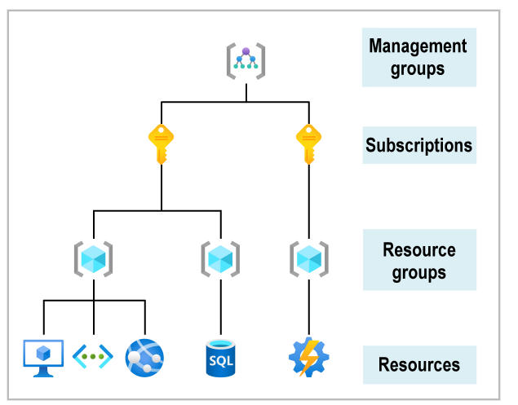

• **Resources**: Resources are instances of services that you create, like virtual machines, storage, or SQL databases.

• **Resource groups**: Resources are combined into resource groups, which act as a logical container into which Azure resources like web apps, databases, and storage accounts are deployed and managed.

• **Subscriptions**: A subscription groups together user accounts and the resources that have been created by those user accounts. For each subscription, there are limits or quotas on the amount of resources that you can create and use. Organizations can use subscriptions to manage costs and the resources that are created by users, teams, or projects.

• **Management groups**: These groups help you manage access, policy, and compliance for multiple subscriptions. All subscriptions in a management group automatically inherit the conditions applied to the management group.

***How to create a resource (VM) under a resource group:***

* First have to create a Resource Group

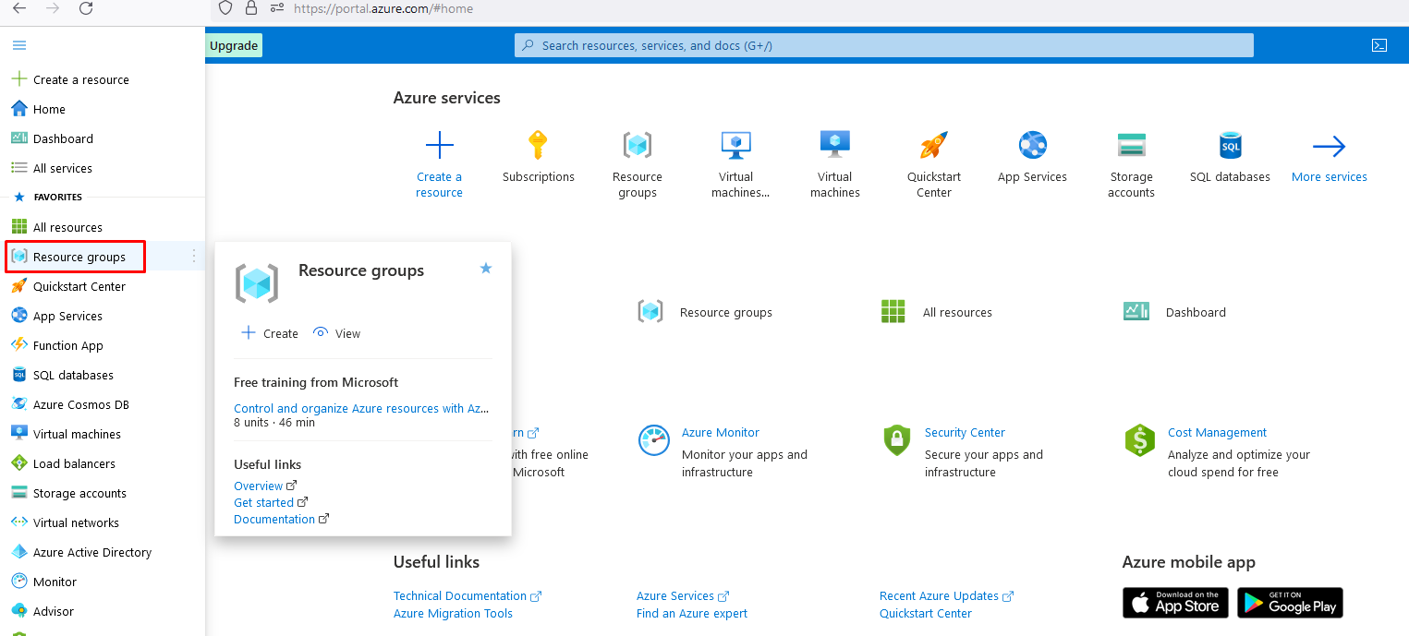

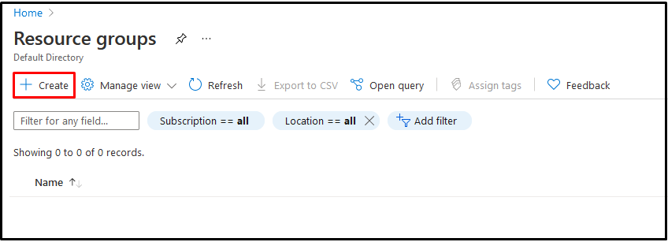

Select the Subscription, put the Resource group Name, Select the Region then **Next:Tag>**

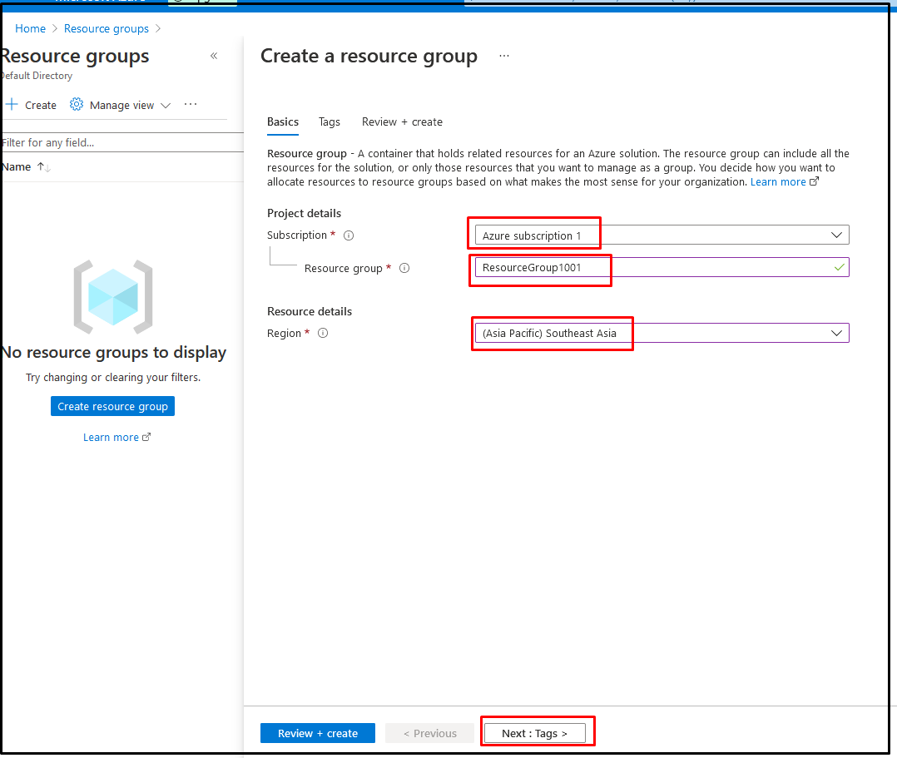

**Enter the Tag Name and Value: Then Review + Create**

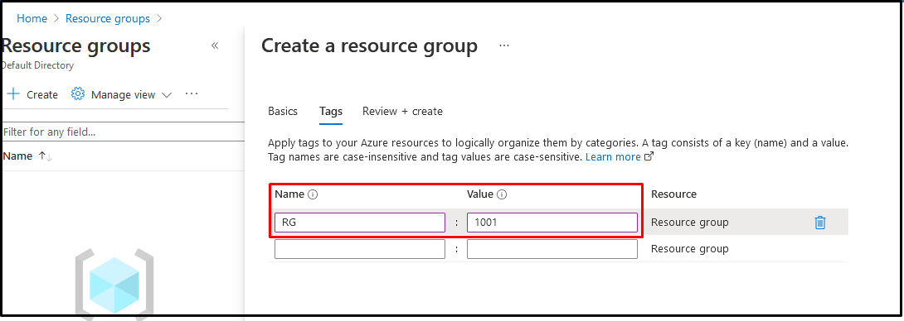

*Then click on* ***Create*** *button*

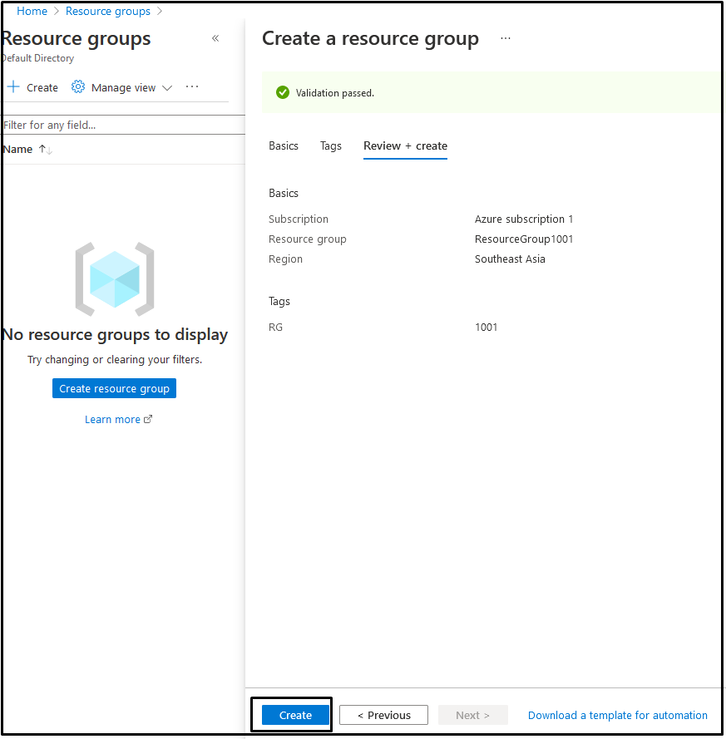

Resource Group created Successfully----------

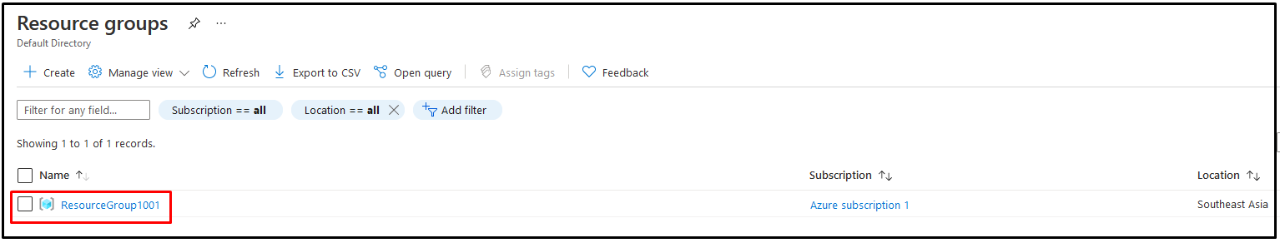

*Now we will create/add a resource (VM) under this resource group:*

*First, search virtual machine in search field. Then we will get a page like below:*

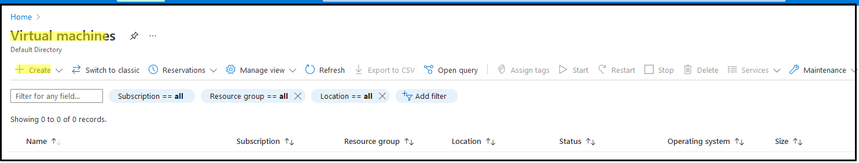

Then Create >> Create Virtual Machine. Fill-up the yellow marked field then **Next:Disk**

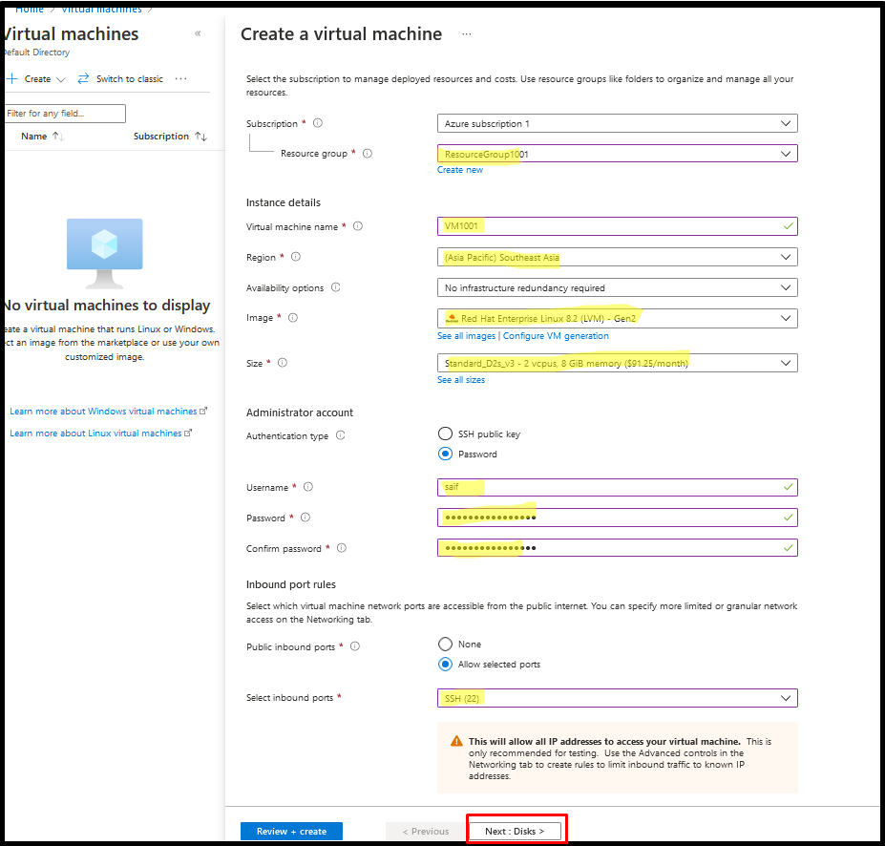

Fill-up the yellow marked field then **Next: Networking**

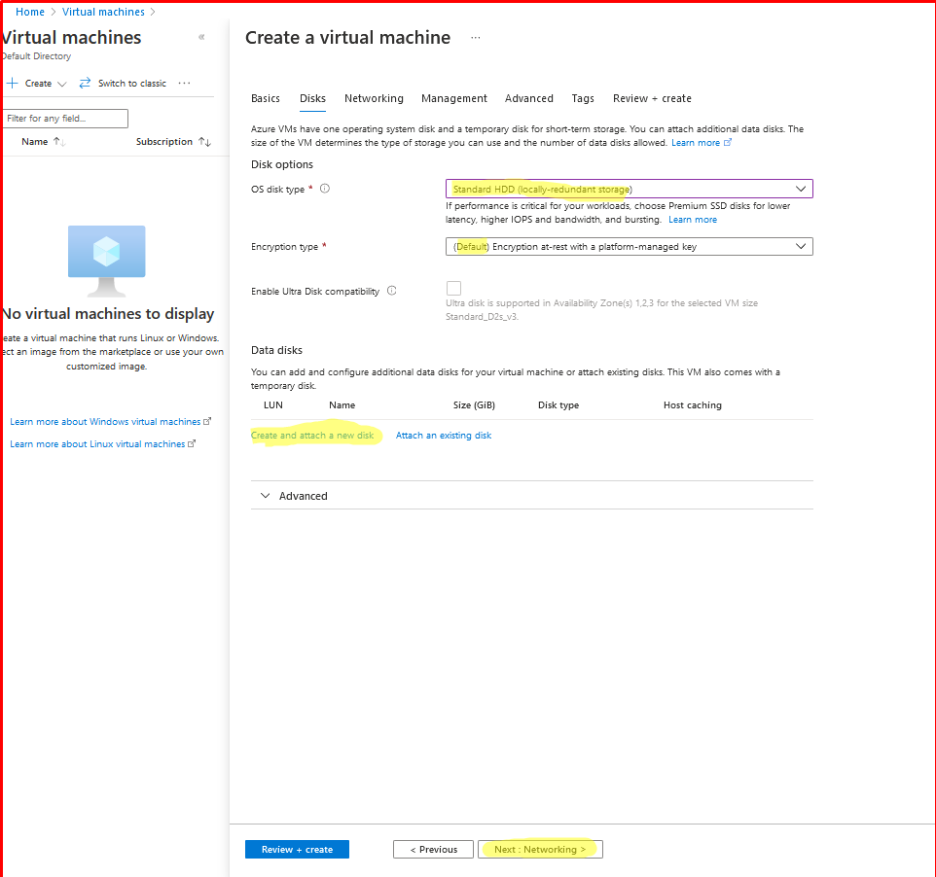

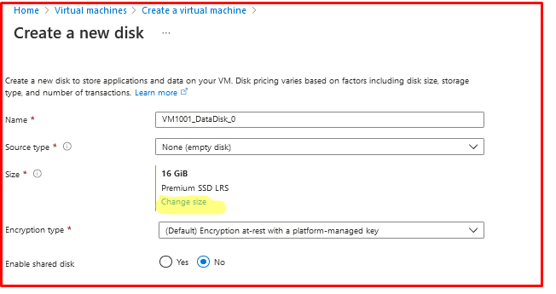

After this fill-up Network setting page and>>Management >>Tag. Then Review + Create >> Create..

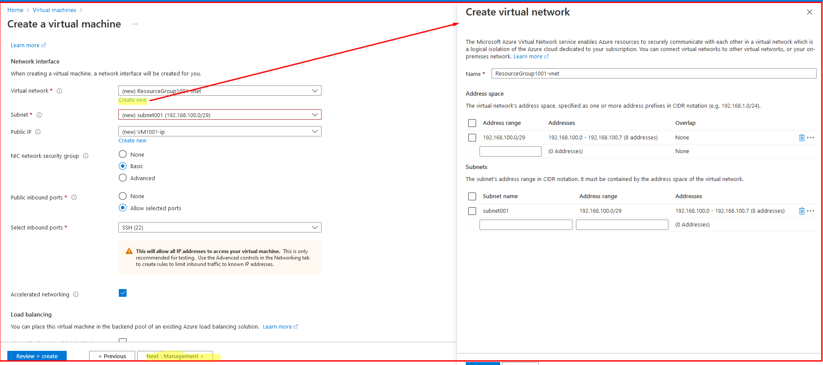

|  |
| --- |
|  |

**Deployment is complete, that’s mean VM is ready………….**

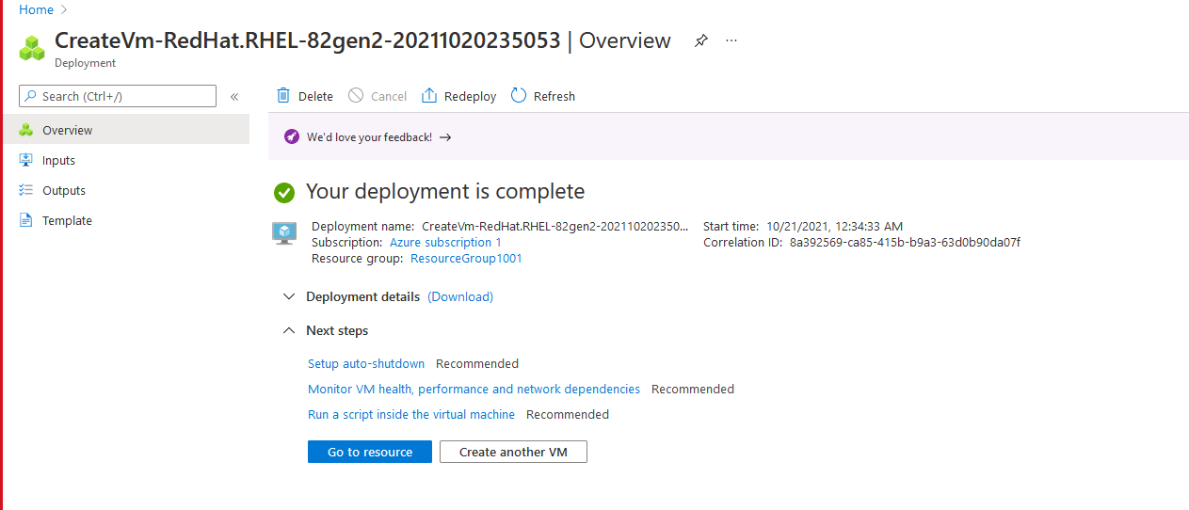

**Below is the Resource (VM) summary information**

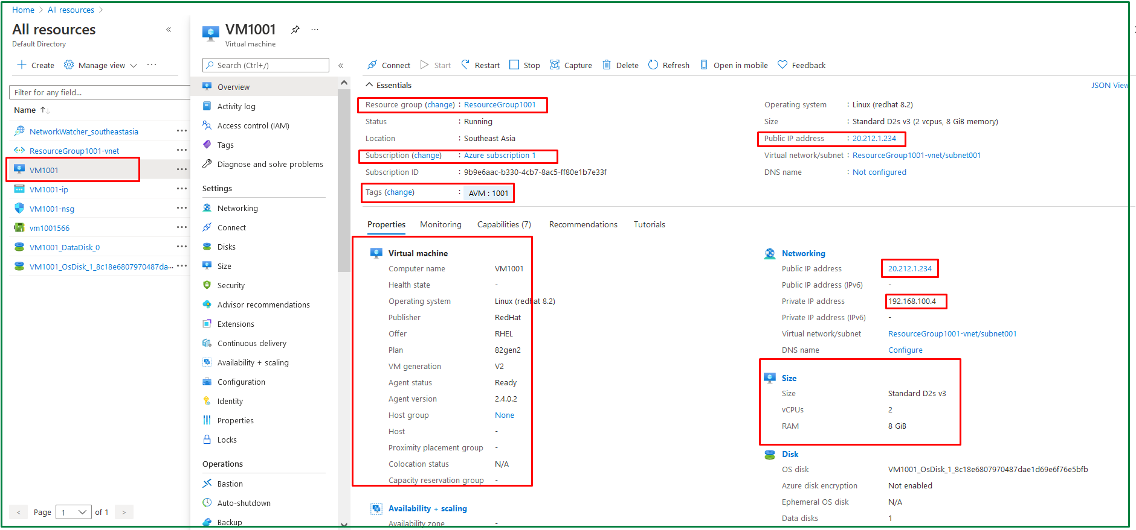

Reference:

<https://docs.microsoft.com/en-us/learn/azure/?mkt_tok=MTU3LUdRRS0zODIAAAGAG-9iiDoQQNTZB2uTedonDBJU5m3mZvrnEaIYl_Ga2sLqt7BPJsLHfyBGmqwejA33D3kRHWv1bzwUK8BO9OJqK--KpuwHkmKZ-jzr46cTNUw6zjfk9fPmqwH>