First login into server **192.168.0.12** with user **tecmint** and generate a pair of public keys using the following command

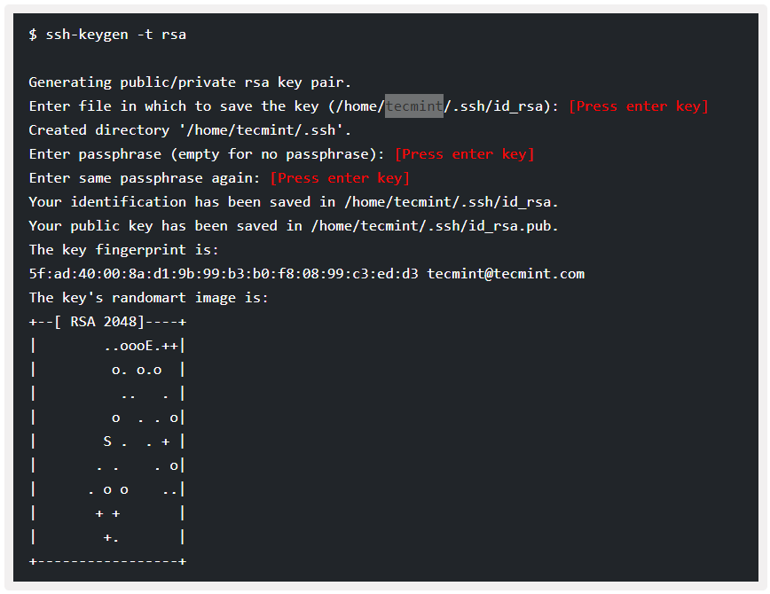

**Step 2: Upload SSH Key to – 192.168.0.11**

Use SSH from server **192.168.0.12** and upload a new generated public key (**id_rsa.pub**) on server **192.168.0.11** under **sheena**‘s **.ssh** directory as a file name **authorized_keys**.

Or push with below command

# ssh-copy-id [sheena@192.168.0.11](mailto:sheena@192.168.0.11)