A New Software User Interface for the Upgraded Haystack 37-meter Radio Telescope



Matthew Siebert

Abstract

Recently the 37m Haystack antenna has undergone major hardware upgrades that have significantly enhanced its capabilities for radio astronomy observations. A new software user interface was developed to accommodate the new antenna and radiometer capabilities. The UI was designed for both real-time data acquisition and post-processing data pipelines. The software includes three applications that facilitate astronomical observation. The main application is a sky map of radio sources that displays important antenna status information, as well as provides the user with telescope control capabilities. There is also a discrete source scan (DSS) plotting application, and an application to provide an astronomer with an idea of what is currently up in the sky. This manual is intended to provide the user with a means to use this interface effectively when operating and collecting data from the 37m telescope.

Table of Contents

1. Introduction

1.1 Previous User Interface

1.2 Getting Started

2. Software

2.1 Radio Source Sky Map Application

2.1.1 Radio Source Sky Map / Tool Bar
2.1.2 Source List Side Bar
2.1.3 Antenna Information Side Bar
2.1.4 Schedule Side Bar
2.1.5 Az-El Offset Strip Charts

2.2 Discrete Source Scan Application

2.2.1 Source Information Side Bar
2.2.2 DSS Plots
2.2.3 Fit Information Side Bar

2.3 UpNow Application

2.4 Integration with CLASS

3. Conclusions and Future

improved UI more user friendly
message based (zeromq)
program easily modified to accommodate this
remote observation

1. Introduction

1.1 Previous User Interface

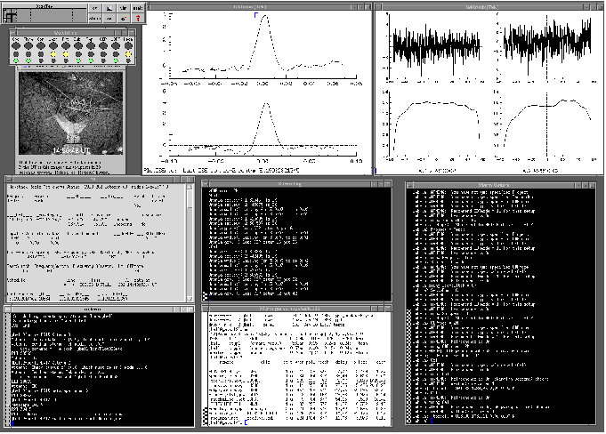

(Figure-1, Previous UI)

Figure-1 is a screenshot of the previous user interface that was used to monitor and control Haystack's 37m radio telescope. The interface was very reliant on text to convey information to the user. For this reason, the user had to be very familiar with the system in order to use the interface effectively. The new interface is well organized and has a better aesthetic. It also has several visual aids to convey information quickly and hopefully reduce the learning curve associated with using new software.

1.2 Getting Started

The new 37m telescope UI is a Python-based program that was designed to be used on Linux systems. It was developed with Python v. 2.7.10 in the Spyder Interactive Development Environment provided by Anaconda 2.2.0 (64-bit) on an Ubuntu 14.04 LTS system.

The python software consists of 6 .py files.

sourcemap.py DSSqt.py UpNow.py
GUI_Form.py DSS_Form.py
tail.py

It is important to also install PyQtGraph as well as PyNOVAS on the machine running the UI software. PyQtGraph is a scientific graphics and GUI library for Python. It provides plotting utilities that are optimized for speed and necessary for the main application in this UI. PyNOVAS offers a collection of functions and applications for calculating the positions of the solar system bodies and other celestial objects. This package should be installed along with the DE405 ephermeris data set provided by JPL.

2. Software

2.1 Radio Source Sky Map Application

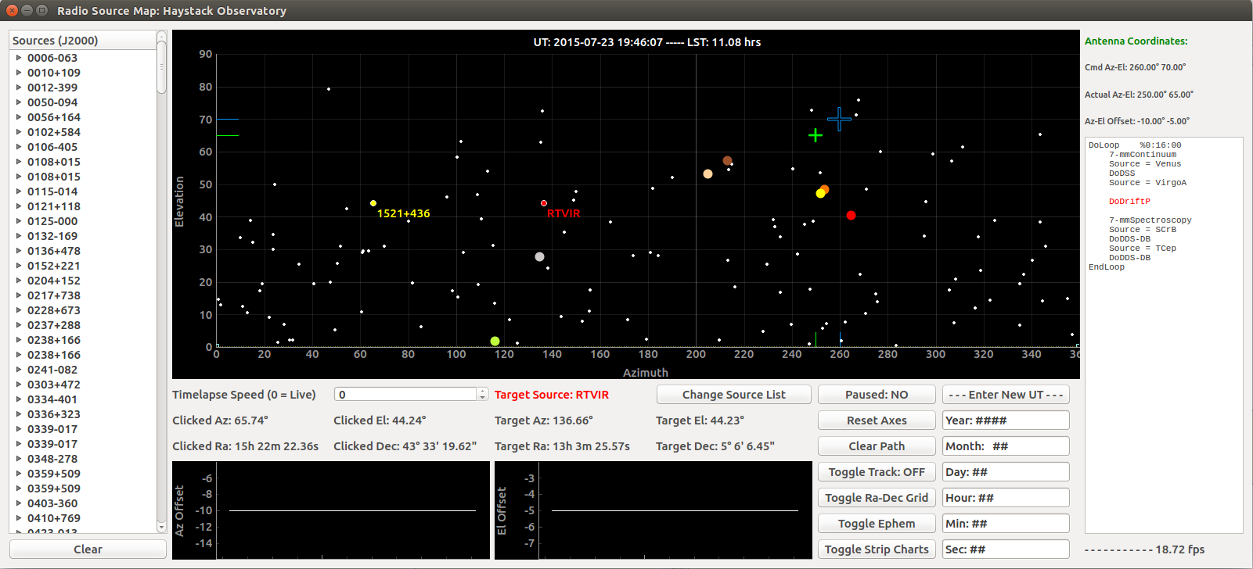
(Figure-2, Radio Source Map)

The main component of the UI to the 37m radio telescope is a Python generated interactive window. The window consists of a radio source sky map, a sky map tool bar, a source list side bar, an antenna information sidebar, a live schedule display, a frame rate display, and az-el offset strip charts. This section will describe each of these components in detail in order to allow the user to use them effectively.

2.1.1 Radio Source Sky Map / Tool bar

When the application is first launched, the user is prompted for a source list (must be a .lst file). The sources in the list must have the following format and be of the epoch J2000:

RTVIR 13 02 37.98 +05 11 08.38 2000 15.0

The first item is the name of the source, the next three items are the source's right ascension (hours, minutes, seconds), the following three items are the source's elevation (degrees, minutes, seconds), and the last two items are the epoch and line velocity respectively. Any information in the source list that is not in this format will be treated as other information and ignored.

The equatorial coordinates for each source are converted into horizontal coordinates for the current time and plotted on the sky map (white points). This map covers the entire sky in azimuth and elevation. The universal time and corresponding local sidereal time are displayed at the top of the map. The user may also use the mouse scroll wheel to zoom in and out in order to see the full range of elevation (-90 to +90 degrees). The yellow dashed line represents the horizon. The larger colored points displayed on the map are the solar system bodies' (sun, moon, planets) positions. The user can click on any source and the source will be labeled and highlighted yellow with a white outline (solar system bodies are only labeled and retain their color). The clicked source's horizontal and equatorial coordinates are displayed below the map. The current target source specified by the observer in Umbrella is highlighted red with a white outline. The target source horizontal and equatorial coordinates are also displayed below the map.

The green cross-hairs represent the antenna's current pointing position on the sky and the blue cross-hairs represent the antenna's commanded sky position. Both of these are accompanied by tick marks on the azimuth and elevation axes with the same respective colors. The green azimuth tick mark will turn yellow when the antenna leaves the main zone and enters a wrap zone (clockwise or counterclockwise).

Time-lapse speed – Below the map on the left is the time-lapse control spin-box. When the value is set to 0 and the map is not paused, the sky map is displaying the sources in live time. The value in the spin-box is a multiplier that determines how much time elapses between each successive frame (10s*multiplier). This can propagate the map forward and backward in time; however, antenna position and status are still displayed in live time. When live time is desired, simply change the value back to 0 and press enter.

Change Source List – Clicking this button will prompt the user to choose a .lst file and restart the application using that file as the source list.

Paused: YES/NO – Clicking this button will pause the sky map on the currently displayed time and update the status on the button to “YES”. Antenna position and status are still displayed in live time. Clicking the button again will unpause the sky map (status becomes “NO”) and return to plotting according to the current time-lapse settings. The default status is “NO”

Reset Axes – Clicking this button will return the axes ranges to their original states (0 to 360 degrees in azimuth, 0 to 90 degrees in elevation). This is useful after zooming in or out.

Toggle Track: ON/OFF – Clicking this button (status becomes “ON”) will begin displaying the clicked source's trajectory as a yellow line as the source moves on the sky map. Clicking the button again (status becomes “OFF”) will stop plotting the trajectory and leave the previous track displayed on the sky map. This function is useful in combination with increasing the time-lapse speed in order to follow a clicked source over longer periods of time. The default status is “OFF”.

Clear Path – Clicking this button will remove any yellow lines drawn on the map from when the “Toggle Track” button was in the “ON” state.

Toggle Ra-Dec Grid – Clicking this button will overlay a grid showing equatorial coordinates mapped on to the sky. The grid has 12 gray contours of constant right ascension (labeled from 0 to 22 hours), and 12 orange contours of constant declination (labeled from -90 to 75 degrees). The grid is intended to give the user a quick idea of how equatorial coordinates map on to the sky at the time displayed by the sky map. Clicking the button again will return the sky map to its original state.

Toggle Ephem – Clicking this button will remove the solar system bodies from the sky map and only plot the positions of the sources specified in the source list. If the current target source is a solar system body, this button will be grayed out so that the user cannot remove the solar system bodies from the map. Clicking this button again will return the solar system bodies to the map.

Toggle Strip Charts – Clicking this button will begin plotting the antenna azimuth and elevation offsets on the strip charts in real time. Clicking this button again will clear the plots leaving them blank.

Enter New UT – Clicking this button will open user input windows for a entry of a desired UT (year, month, day, hour, minute, sec). After the user specifies these fields, the sky map will display all source positions for this UT. The state of the map becomes paused after changing the UT this way. Time-lapse and other map functions will work in the same way as before, and antenna position and status are still displayed in live time. Keep in mind that unpausing the map will begin changing time according to the time-lapse spin-box. This means that if the value in the spin-box is set to 0, the map will revert to current real time.

Enter Command – Clicking this button will allow the user to input and execute an Umbrella command. This button is grayed out if there is currently an active Umbrella schedule.

Add Object – Clicking this button will open user input windows for entry of a desired celestial object to be displayed. The information needed is name, right ascension (J2000 and in the form: RAhh RAmm RAss) , and declination (J2000 and in the form: DECdd DECmm DECss). The object will be highlighted green with a white outline and displayed at its current sky position and labeled.

Remove Objects – Clicking this button will remove all celestial objects from the sky map that were added via the “Add Object” button.

2.1.2 Source List Side Bar
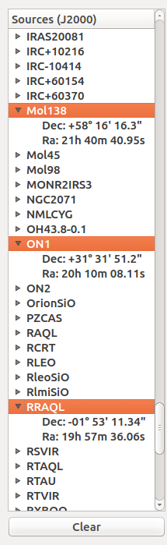
The left side of the sky map application is a sidebar that lists all of the specified sources in the selected source list. Clicking on the arrow next to a source name will display that sources equatorial coordinates (J2000) below its name. This can be done for multiple sources. The user can also click on any source name (highlighting the name in orange as in Figure-3) and the source will be highlighted blue with a white outline on the sky map. This can also be done for multiple sources. This is useful when the user has specific sources in mind, and wants to see where they are in the sky in real time or at a specific time.

Clear – Clicking this button will deselect any sources that are currently selected in the source list side bar.

(Figure-3, Source List Side Bar)

2.1.3 Antenna Information Side Bar

On the right side of the sky map application pertinent antenna pointing and status information is displayed. This data is currently read from an updating file and represents the real time state of the 37m antenna.

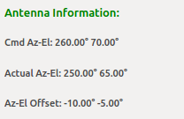
Cmd Az-El – The current computer commanded antenna azimuth and elevation in degrees.

Actual Az-El – The current actual antenna azimuth and elevation in degrees.

Az-El Offset – The current difference between the actual antenna sky position and commanded sky position in degrees.
(Figure-4, Antenna Information)
Other Info – Cable wrap , usroff, tsys, etc.

2.1.4 Schedule Side Bar
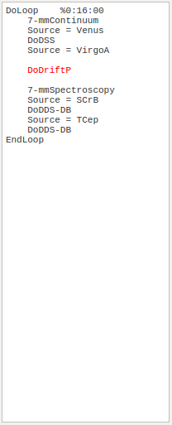
Below the antenna information on the right side of the application is a display of the current active Umbrella command schedule. The path to this .skd file is specified from the updating file along with the antenna information. This schedule tells the telescope when and how to perform various operations. The current operation being performed is highlighted red as shown in Figure-5. If no schedule file is specified, the display will show “No Active Schedule”.

When there is no active schedule, the user may use the “Enter Command” button described in section 2.1.1.

(Figure-5, Schedule Side Bar)

2.1.5 Az-El Offset Strip Charts

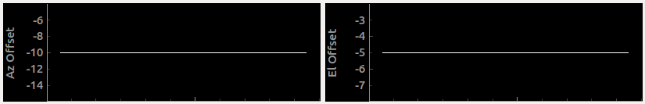
(Figure-6, Az-El Offset Strip Charts)

At the bottom of the application are two strip charts for plotting the difference between the actual and commanded antenna positions. These plots can be activated and deactivated by clicking the “Toggle Strip Charts” button as described in section 2.1.1. When activated, the plots show the real time offsets that are also displayed in text in the antenna information sidebar. The plots show a history of the offsets so that user can get a good idea of how the antenna is behaving.

2.2 Discrete Source Scan Application
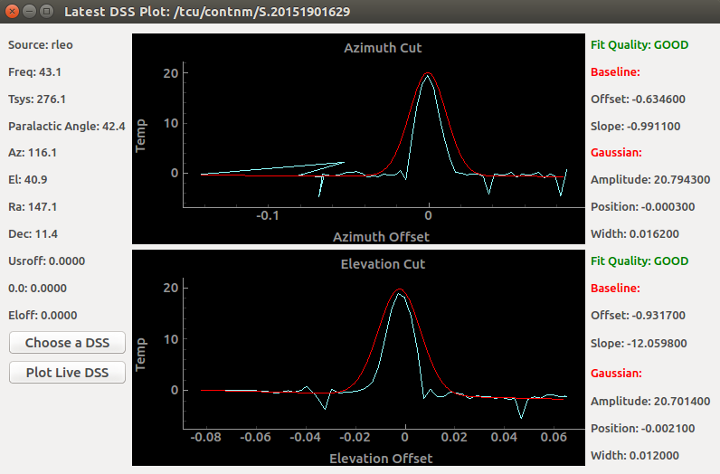

(Figure-7, DSS Application)

Another component of the UI to the 37m radio telescope is a Python generated window to display the results of discrete source scans (DSS). This application replaces the the plot window in the top-middle of the previous UI (Figure-1) as well as displays important information that was previously only provided in text. The new application consists of a source information side bar , two main DSS plots, and a fit information side bar.

Discrete source scans can be commanded in Umbrella and are useful for determining pointing offsets of the telescope before observing. In a DSS the antenna is first moved in a roughly 0.2 degree azimuth scan centered on the computer position of the selected source. As the telescope scans across the source, the radiometer records the increase in temperature as the source passes through the telescope beam. When the scan is complete, Umbrella reports parameters that specify a Gaussian fit for the scan. This process is then repeated for a scan in elevation.

When launched, this application automatically plots the latest DSS. If the latest DSS is incomplete, then the application obtains the available information and plots the scan in real time. When the DSS completes, the Gaussian fit is plotted and the fit parameters are displayed.

2.2.1 Source Information Side Bar

On the left side of the application there is a display of the important information regarding the target source and antenna status.

Source – The name of the target source

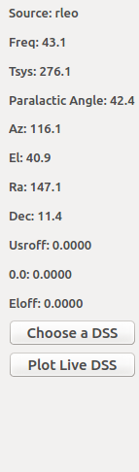
Freq – The current observing frequency in GHz

Parallactic Angle – The angle between the great circle through the source and the zenith, and the hour circle of the object.

Az – The azimuth of the target source in degrees

El – The elevation of the target source in degrees

Ra – The right ascension of the target source in degrees

Dec – The elevation of the target source in degrees

Usroff -

0.0 -

Eloff -

(Figure-8, Source Information Side Bar)

This side bar also includes two buttons to control the DSS display:

Choose a DSS – Clicking this button will prompt the user to choose a completed DSS file. Once the user chooses a file, it is plotted and the source and fit information are displayed. Choosing an invalid file will clear the current contents of both plots, and change the title of the plot to alert the user to make a different selection.

Plot Live DSS – Clicking this button will cause the program to obtain the most recent DSS file and plot its contents whether it is complete or incomplete. This button can be essentially used as a refresh button. Once the current scan is completed, the application leaves its contents displayed until this button is pressed. Then it looks for a newer file to plot.

2.2.2 DSS Plots

In the center of the application are two plots as shown in Figure-7. The top and bottom plots are the azimuth and elevation cuts respectively. The light blue curves represent the actual measured source temperature, and the red curves represent the Gaussian fits. If the plots are live, only the available temperature curves are shown, and the Gaussian fits are displayed when the scan is complete.

2.2.3 Fit Information Side Bar
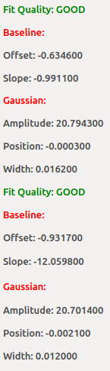
On the right side of the application there is a display of the important parameters of the Gaussian fits for each scan. These parameters are only displayed for completed scans.

Fit Quality – Quality of the Gaussian fit. Can be “GOOD”, “SO-SO”, or “REJECT”

Baseline – The baseline that was added to the Gaussian fit

Offset – The vertical offset of the baseline

Slope – The slope of the baseline

Gaussian – The Gaussian fit (form: y = a * exp( -(x - p)² / w²))

Amplitude – The amplitude of the fit (a)

Position – The position of the fit (p)

Width – The width of the fit (w)

(Figure-9, Fit Information Side Bar)

2.3 UpNow Application

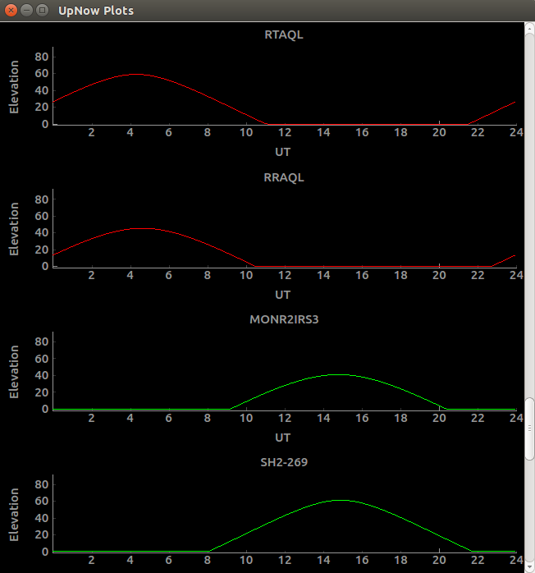

(Figure-10, UpNow Application)

A small and useful component of the new UI to the 37m radio telescope is called the UpNow application. When the program is launched, it prompts the user for a source list (.lst) just like the sky map application. This application then generates a plot for every source in the list and formats each of them into a a scrollable window. The plot represents the trajectory of the source in the sky over the course of the current day. When a source is below the horizon, the elevation is set to 0 so that the user can clearly see when the source will be up in the sky (the curved part of the trajectory). Sources that are currently up in the sky at the time of launching the application are indicated with green curves as shown in Figure-10. Sources below the horizon are indicated with red curves.

3. Conclusions and Future

The new user interface for the 37m radio telescope improves upon the previous interface and facilitates astronomical observation for both astronomers and engineers. The applications developed are user-friendly and provide several visual aids to help the user operate the antenna. The underlying python code is easy to modify and can be made to support better functionality in the future. For example, instead of processing a file, the code could be modified to process messages with antenna status information. This could eventually lead to remote control of the telescope. This new interface takes a step towards new functionalities like this, and allows the user to operate the telescope more efficiently.

4. Acknowledgments

5. References

Kraus, John Daniel. Radio Astronomy. 2nd ed. New York: McGraw-Hill, 1966. Print.

“PyNOVAS: Astronomical Functions and Appllications.” Retrieved from: http://pynovas.sourceforge.net/

Ball, John A. Charpentier, P.J. “Umbrella: A User-Interaction Language for Radio Astronomy at Haystack.” 17 Oct. 1998.

“PyQtGraphScientific Graphics and GUI Library for Python.” Retrieved from: http://www.pyqtgraph.org/

