**1.** Open terminal via **Ctrl+Alt+T** or by searching for “Terminal” from dash. When it opens, run command:

xrandr

It outputs current screen resolution as well as all available solutions. ALL I need here is the display device name, in my case, it’s **eDP-1**.

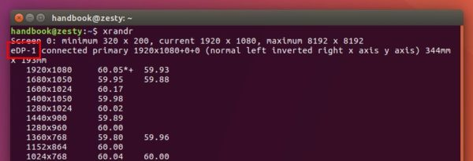

**2.** Run command to calculate VESA CVT mode lines by given resolution:

cvt 1600 900

Replace 1600 900 (1600X900 in my case) in the command to your desired screen resolution.

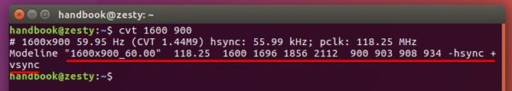

**3.** Copy the Modeline (words with red underline, see previous picture), and run command to add new mode:

sudo xrandr --newmode "1600x900_60.00" 118.25 1600 1696 1856 2112 900 903 908 934 -hsync +vsync

UPDATE: For Ubuntu 17.10 Wayland, run xhost si:localuser:root command first in the terminal window to avoid sudo failure “No protocol specified Can’t open display 0:”

NOTE the command section after --newmode are COPIED from previous step output.

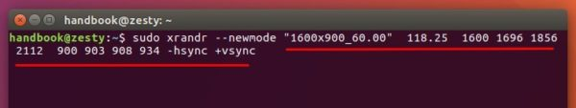

**4.** Now add the new created mode for your display device:

sudo xrandr --addmode eDP-1 **"1600x900_60.00"**

Replace **eDP-1** (see step1) and "1600x900_60.00" (Step 2 or 3) in the command.

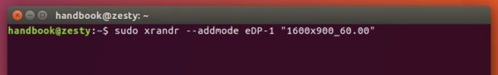

Finally Apply the new resolution in the Display settings:

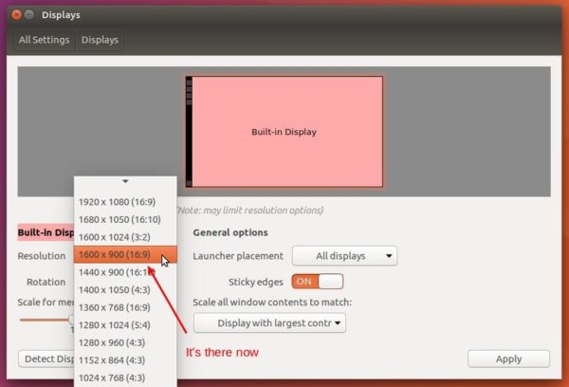

**IMPORTANT:** To make Ubuntu remember the new created screen resolution at next start, you have to edit the .profile via command:

gedit ~/.profile

add the last 2 commands to the end, commands in step 3 and 4, and save the file.

[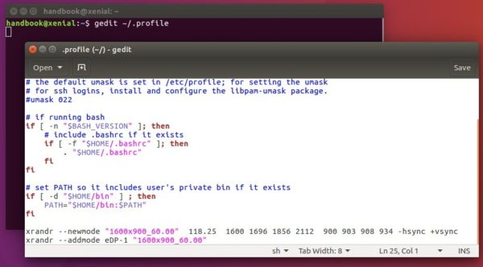](http://ubuntuhandbook.org/wp-content/uploads/2017/04/profile-new-resolution1.jpg)