Stock Market Portfolio Analysis

Group 5

Mohamed Sihly

CIS 3367

Professor Soniya A. Dsouza

After extensively researching the historical stock pricing data of Apple Inc. (AAPL), Advanced Micro Devices, Inc. (AMD), Intel Corporation (INTC), NVIDIA Corporation (NVDA), and QUALCOMM Incorporated (QCOM), I have concluded that AMD would be the best candidate for future investment. This analysis is based off of multiple factors, the first of which is seen in the table below, which compares the highest positive and negative percent changes in closing prices for each stock:

|  |  |  |  |
| --- | --- | --- | --- |
| Company Name | Symbol | Positive % Change | Negative % Change |
| Apple Inc. | AAPL | 12/26/2018  +7.04% | 01/03/2019  -9.96% |
| Advanced Micro Devices, Inc. | AMD | 01/30/2019  +19.95% | 10/25/2018  -15.45% |
| Intel Corporation | INTC | 01/04/2019  +6.14% | 07/27/2018  -8.59% |
| NVIDIA Corporation | NVDA | 10/30/2018  +9.36% | 11/16/2018  -18.76% |
| QUALCOMM Incorporated | QCOM | 07/26/2018  +7.00% | 11/08/2018  -8.16% |

As seen above, AMD has the highest positive day-to-day change in closing percentages at +19.95%, which is more than double the next highest positive change of +9.36% for NVIDIA. While AMD’s highest negative change in closing price is nearly as high at -15.45%, it is still only the second highest out of the selected stocks behind the -18.76% of NVIDIA. Additionally, it is the only stock out of the five where the highest positive change in percentage is greater than the highest negative change, and it is by a significant margin of 4.5% higher. This table, however, is a crude representation of the variance of the stocks, and it would be more suited for a more normal period, such as the prior year, instead of the selected time period where the technology sector of the stock market faced a sudden and tremendous crash as a result of the political climate and economic warfare. The following graph of monthly moving averages demonstrates the effects of the market crash on these stocks:

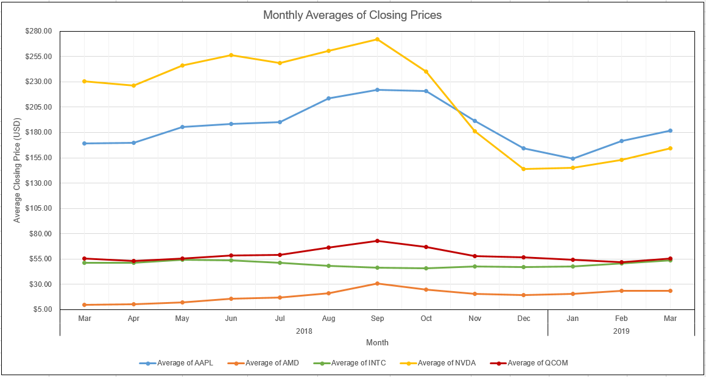

As seen in the graph, September of 2018 was the inflection point for all five stocks in the portfolio as the technology sector of the stock market began a period of shock recession that persisted for the following 4-5 months. NVIDIA suffered the greatest losses falling from a peak monthly average closing price (ACP) of $271.91 in September 2018 to a low of $143.66 in December 2018. The last time NVIDIA’s stock was at this price point was in May of 2017, 19 months earlier. By the conclusion of the selected historical period in March of 2019, the ACP was $164.37, which is $66.37 less than the ACP one year prior. The next highest losses are attributed to Apple, who fell from $222.07 in September 2018 to $154.17 in January 2019. However, unlike NVIDIA, Apple was able to recover to $181.66 by March 2019, which is $12.82 higher than the $168.84 from year one earlier. Similarly, Intel and Qualcomm were able to recover from the market crash in September and ended with slightly higher monthly ACPs in March 2019 than they began the selected period with in March 2018. Finally, AMD was able to not only recover from the crash, but to end the selected period at more than double the initial price. In March 2018, the ACP for AMD was $10.08; in September 2018, the ACP was $30.83; and in March 2019, the ACP was $23.89.

Knowledgeable investors who were conscientious of the political climate and the impending market changes likely would have pulled out sooner than later after the crash in September, and they still would have been slightly better off than they began or would have suffered only minor losses. However, there are many investors who tried to weather the storm without any idea of how bad the losses could get. For the purposes of simplicity and versatility in this project, an assumption is made that a diversified selection of stocks in the technology sector were purchased in a package and held onto for one year regardless of short-term fluctuations and individual stock performance. The table below represents a simplification of the core elements of this portfolio: the purchase price (opening price on the first day of the period), the sell price (closing price on the last day of the period), and the return on interest (the sell price divided by the purchase price).

|  |  |  |  |  |
| --- | --- | --- | --- | --- |
| Company Name | Symbol | Purchase Price  (03/26/2018) | Sell Price  (03/22/2019) | ROI (%) |
| Apple Inc. | AAPL | $168.07 | $191.05 | 13.67% |
| Advanced Micro Devices, Inc. | AMD | $10.71 | $26.37 | 146.22% |
| Intel Corporation | INTC | $50.74 | $53.26 | 4.97% |
| NVIDIA Corporation | NVDA | $238.00 | $177.50 | -25.42% |
| QUALCOMM Incorporated | QCOM | $54.58 | $56.82 | 4.10% |

While the graph of monthly moving averages discussed above gives a decent representation of how short-term investors would be affected, it does little to show the effects on long-term investors. This chart of ROIs gives a much more easily comprehensible and accurate representation of how each stock performed after one year. Despite the massive drop NVIDIA faced on the monthly moving averages graph, the overall ROI was only -25.42%. While this is a significant loss for any investor, it can be balanced out relatively easily in a diversified portfolio, which will be discussed shortly as I examine 5 different distributions for the portfolio that will demonstrate how little or large of an effect the individual ROIs have on the total ROI of the portfolio. Aside from NVIDIA, all of the stocks in the portfolio were able to recover from the market crash and end up slightly better than they started with. Intel and Qualcomm ended with ROIs of +4.97% and +4.10%, respectively, which likely would not be a worthwhile return for any shareholders on their own, but they do serve to marginally offset any losses in a portfolio, such as is the case with the NVIDIA losses in this portfolio. Apple was not only able to recover from a loss comparable to that of NVIDIAs (as seen in the graph above), but it ended with an ROI of +13.67%, which is a worthwhile investment on its own for practically any investor. Additionally, it holds the second highest return out of the selected stocks in the portfolio. And now finally, let us take the first real look at why AMD was selected as the best stock to invest in out of the entire portfolio. AMD had an absolutely outstanding year of explosive growth starting from a base of $10.71 per share on March 26, 2018; rising to a peak of $34.14 on September 13, 2018; and ending the period at $26.37 on March 22, 2019. Even with the losses incurred from September onwards, the final ROI after one year of investment comes out to +146.22%. There is no doubt that AMD is the best choice moving forward based on the historical data, however, knowledgeable investors would never place their investments into a single asset. Some package deals like mutual funds and index funds even have restrictions on them that guarantee a level of diversity and risk aversion. So, let us now take a look at different investment scenarios that could have happened at the start of the period.

In all of the following scenarios, the investment budget is set to $100,000 with an aim of using every possible dollar without going over the limit. Because of the amount of textual and visual data that is modified with each scenario, I will not be including figures in this analysis. As such, please follow along in the Portfolio Analysis worksheet by using the Select a Scenario dropdown to cycle between the different distributions. The first scenario is a manual distribution arbitrarily created based on my previous knowledge of the standings of the companies as well as my preferences for them. The result of this distribution is a meager +5.27% ROI, which demonstrates how the ROIs of the individual stocks in the portfolio have no practical meaning without analyzing the number of shares and initial amount invested alongside them.

By using the Solver add-on in Excel, I used a combination of constraints to create four related scenarios (all with a shared minimum of 50 shares per stock): maximizing total profit with a limit of $30,000 per stock, maximizing total profit with a limit of 1000 shares per stock, maximizing ROI with a limit of $30,000 per stock, and maximizing ROI with a limit of 1000 shares per stock. By maximizing total profit by initial amount invested, a total profit of $46,303.62 is made from an initial investment of $99,964.91 resulting in an ROI of +46.32%. AMD composes 78% of the portfolio by shares, but only 30% by dollars invested. Without the $30,000 limit, Solver would have invested everything into AMD to achieve the maximum possible ROI, which is exactly why I decided to establish this maximum limit. A constraint of this kind is much more realistic than the next one I will discuss, but it was worth exploring anyways. By limiting the shares to 1000 per stock, AMD hits the cap and causes the rest of the budget to be allocated to Apple. AMD’s percentage of the portfolio by shares only falls from 78% to 64%, but percentage of the portfolio by dollars invested falls from 30% to 11% and Apple drastically rises from 30% to 72%. The result of this method causes the total profit to drop to $22,731.42 made from an initial investment of $99,978.03 resulting in an ROI of +22.74%. This analysis provides initial evidence as to why limiting purchase orders by the number of shares is not a viable method as it results in half of the total profit and ROI that come from limiting the amount invested per stock instead.

While maximizing total profit may seem like the most logical way to distribute funds, maximizing the total ROI proves to be significantly better. With a limit of $30,000 again, Solver obtains a profit of $42,225.66, which is only approximately $4,000 less than what was obtained in the first Solver scenario aimed at maximizing profit instead of ROI; the interesting part about how this differs from the profit maximization scenario is the total amount of dollars invested only uses $55,568.21 out of the $100,000 budget resulting in a total ROI of +75.99%. This scenario represents just how much profit could be made in the best case scenario, but it is again the ultimate idealized scenario even with the $30,000 constraint as 93% of the portfolio by shares is AMD, which is an extremely risky position to be in and would never occur in managed funds like mutual or index funds. The final scenario tries to maximize ROI with the 1000 shares constraint, but it ultimately differs very little from the previous scenario. It simply invests the minimum of 50 shares in each of the 4 stocks aside from AMD and the maximum of 1000 shares in AMD for a total of $36,279.50 invested with a profit of $14,022.00 and an ROI of +38.65%. The only insight this scenario provides is confirmation that constraining the distribution by number of shares is not a viable method for lowering risk while maximizing profit or ROI.

As stated in the outset of this analysis, I have selected AMD as my recommendation for future investment. When drafting the basis of this project a few months ago, I had indicated I would include outside research and tie important incidents to the daily changes in the stocks to create a timeline of events that could explain any discrepancies between their performances. After finishing my analysis in Excel and beginning this paper, I decided that was unnecessary and that I would face severe issues with scope creep. Instead, I used only the knowledge I had of the market, specifically the technology sector as I am very involved with it, and put myself in the position of an investor with an equivalent amount of knowledge of the market and Excel. The results produced were interesting and, in my humble opinion, significant on their own without additional research. While I remain a highly risk-averse person and avoid anything resembling gambling, which I generally consider stock market trading to be (at least in the short term), I have gained an appreciation for how educated investing could be made by an amateur with enough knowledge of Excel and data manipulation. I am likely to even return to this project in the future to use it as a template and improve upon it as my proficiency with Excel and data visualization develops even further. I hope that you were able to gain some insights from this project as I was, and I thank you for your time.