INDIAN INSTITUTE OF REMOTE SENSING
Indian Space Research Organisation (ISRO)
Department of Space, Government of India
Dehradun – 248001, Uttarakhand, India
MINI-PROJECT REPORT
Object-Based vs Pixel-Based Classification for Dehradun Urban Expansion Mapping (2016–2024)
A Comparative Assessment Using Sentinel-2 Surface Reflectance
Submitted by
Mohammad Salman
M.Sc. Geo-informatics
Indian Institute of Remote Sensing, ISRO, Dehradun
Under the guidance of
[Supervisor Name]
[Department / Division]
June 2026

Declaration
I, Mohammad Salman, hereby declare that the mini-project report titled “Object-Based vs Pixel-Based Classification for Dehradun Urban Expansion Mapping (2016–2024)” submitted to the Indian Institute of Remote Sensing, Dehradun, is a record of original work carried out by me under the guidance of my supervisor. The analyses, results, and interpretations presented in this report are my own, and all external sources of information, theory, and tools have been duly cited in the references using APA 7th edition style. No part of this report has been copied verbatim from any published source, and the work has not been submitted elsewhere for any degree or diploma.

Place: Dehradun
Date: June 2026
Mohammad Salman
M.Sc. Geo-informatics, IIRS

Acknowledgement
I would like to express my sincere gratitude to my supervisor at the Indian Institute of Remote Sensing for the continuous guidance, constructive feedback, and encouragement received throughout this mini-project. I am thankful to the faculty of the Geo-informatics Department for the foundational training that made this comparative study possible. I also acknowledge the European Space Agency’s Copernicus programme for providing free access to Sentinel-2 surface-reflectance data, and the Google Earth Engine team for the platform that enabled cloud-free composite generation. Finally, I thank my classmates and family for their support during the project period.

Mohammad Salman

Abstract
Dehradun, the capital of Uttarakhand, has experienced rapid peri-urban expansion over the past decade. Accurately mapping this expansion is a pre-requisite for evidence-based urban planning, hydrological assessment, and environmental impact studies. The present mini-project compares two supervised land-cover classification paradigms — pixel-based Random Forest and Object-Based Image Analysis (OBIA) with Random Forest on Simple Linear Iterative Clustering (SLIC) superpixels — applied to two co-registered Sentinel-2 surface-reflectance composites for the winter windows of November 2016 to February 2017 and November 2024 to February 2025. A five-class land-cover scheme (built-up, dense vegetation, mixed vegetation/cropland, bare/open land, and water) is adopted, and identical training samples, spectral features (B2, B3, B4, B8, NDVI, NDBI) and Random Forest hyperparameters are used for both methods, isolating the spatial unit of classification as the only independent variable. Accuracy is assessed against 75 stratified random reference points per date interpreted in Google Earth Pro. Pixel-based classification achieved an overall accuracy of 78.7 % and a Cohen’s κ of 0.72 on both dates, whereas OBIA achieved 65.3 % (κ = 0.57) in 2016 and 69.3 % (κ = 0.62) in 2024. Both methods agree that built-up area expanded substantially over the study period; the pixel-based estimate of approximately 80 km² of new built-up land is preferred as the more accurate figure. The lower OBIA accuracy is attributed to the relatively coarse SLIC segments (median ≈ 12.4 ha) averaging away within-segment spectral diversity at the urban–cropland fringe, where most of Dehradun’s actual change is occurring. The study concludes that, at the 10 m Sentinel-2 resolution and at a single segmentation scale, the visual smoothness of OBIA does not translate into higher accuracy for medium-resolution urban applications.

Keywords: Sentinel-2; OBIA; SLIC; Random Forest; urban expansion; Dehradun; change detection; APA 7.

Table of Contents
Declaration ii
Acknowledgement iii
Abstract iv
List of Figures vi
List of Tables vii
1 Introduction 1
1.1 Background and Motivation 1
1.2 Statement of the Problem 2
1.3 Research Question and Hypotheses 3
1.4 Objectives 3
1.5 Scope and Limitations 4
2 Study Area 5
2.1 Location and Physiography 5
2.2 Drivers of Land-Cover Change 5
3 Data and Software Used 6
3.1 Sentinel-2 Surface-Reflectance Composites 6
3.2 Ancillary and Reference Data 6
3.3 Software and Libraries 7
4 Methodology 8
4.1 Pre-processing and Quality Assurance 8
4.2 Land-Cover Class Scheme 9
4.3 OBIA Pipeline 9
4.3.1 SLIC Superpixel Segmentation 9
4.3.2 Per-Segment Feature Extraction 10
4.3.3 Training-Segment Selection and Labelling 11
4.3.4 Random Forest Classification 11
4.4 Pixel-Based Pipeline 12
4.5 Accuracy Assessment 13
4.6 Change Detection 14
5 Results and Discussion 15
5.1 Classified Maps 15
5.2 Accuracy Assessment 17
5.3 Per-Class Performance 18
5.4 Class-Area Statistics and Change Detection 19
5.5 Discussion of the Methodological Comparison 21
6 Conclusion and Future Scope 23
7 References 24

List of Figures
Figure 1. Location of Dehradun Valley within Uttarakhand, India. 5
Figure 2. Workflow diagram of the OBIA and pixel-based pipelines. 8
Figure 3. SLIC superpixel segmentation result and OBIA-classified map, 2024. 15
Figure 4. Pixel-based classified map, 2024. 16
Figure 5. Side-by-side comparison of OBIA and pixel-based classifications, 2024. 16
Figure 6. Confusion matrix — OBIA, 2024. 17
Figure 7. Confusion matrix — Pixel-based, 2024. 17
Figure 8. Class area, 2016 vs 2024, for both methods. 19
Figure 9. Urban expansion 2016–2024, pixel-based. 20

List of Tables
Table 1. Sentinel-2 spectral bands used in the analysis. 6
Table 2. Five-class land-cover scheme adopted in this study. 9
Table 3. SLIC segmentation parameters. 10
Table 4. Random Forest hyperparameters. 12
Table 5. Accuracy assessment summary, both methods, both dates. 17
Table 6. Class-area statistics (ha) and change 2016–2024. 19

1 Introduction

1.1 Background and Motivation
Land-cover change associated with urban expansion has emerged as one of the most consequential signals of human transformation of the Earth’s surface (Seto et al., 2011). In the Indian Himalayan foothill belt, tier-II capitals such as Dehradun have undergone particularly rapid growth driven by educational, administrative, and information-technology investment, accompanied by ribbon development along arterial roads and conversion of basmati cropland on the valley floor. Quantifying the spatial pattern and magnitude of this change is a pre-requisite for evidence-based urban planning, drainage and groundwater management, and for monitoring environmental compliance with master plans.
Multispectral satellite imagery is the practical workhorse for wall-to-wall land-cover mapping at city scale, and the European Space Agency’s Sentinel-2 mission, with its 10 m visible-near-infrared (VNIR) bands, five-day revisit and open data policy, has become the de-facto standard for medium-resolution monitoring of urban dynamics (Drusch et al., 2012). Two broad paradigms exist for translating such imagery into thematic land-cover classes: per-pixel classification, which treats every pixel as an independent statistical sample, and object-based image analysis (OBIA), which first groups neighbouring spectrally homogeneous pixels into image objects and then classifies those objects (Blaschke, 2010).

1.2 Statement of the Problem
The relative performance of OBIA versus pixel-based classification has been the subject of an extensive comparative literature. On very-high-resolution imagery (sub-metre to two-metre ground sampling distance), OBIA generally outperforms pixel-based methods because individual urban objects — buildings, parcels, road segments — are represented by many pixels and segmentation yields physically meaningful objects (Hossain & Chen, 2019). For medium-resolution imagery such as Sentinel-2 at 10 m, the picture is more nuanced. Ma et al. (2017), in a systematic review of seventy-three comparative studies, reported that the OBIA advantage diminishes and may reverse as pixel size approaches the characteristic size of land-cover objects. Despite this, OBIA pipelines on Sentinel-2 remain popular in operational settings because they produce visually smoother, polygon-ready outputs that are convenient for downstream decision-makers.
Whether OBIA provides a measurable accuracy advantage over a simple pixel-based Random Forest, when applied to Sentinel-2 imagery of a rapidly urbanising tier-II Indian city, has not been systematically documented. The present mini-project addresses this gap for Dehradun.

1.3 Research Question and Hypotheses
The research question guiding this work is: Does Object-Based Image Analysis of Sentinel-2 surface-reflectance composites produce a more accurate land-cover map of Dehradun than per-pixel Random Forest classification, and what is the magnitude of urban expansion between 2016 and 2024 as estimated by each method?
Three working hypotheses are formulated. H1: OBIA will reduce salt-and-pepper noise compared with per-pixel Random Forest classification of the same imagery. H2: OBIA accuracy will be greater than or equal to pixel-based accuracy, because object-level features average out within-segment noise and provide more stable training signatures. H3: Both methods will agree that Dehradun gained substantial built-up area between 2016 and 2024, primarily at the expense of cropland and dense vegetation.

1.4 Objectives
The specific objectives of the study are:
- to generate two co-registered, cloud-free Sentinel-2 surface-reflectance composites for the winter windows of 2016–2017 and 2024–2025 over Dehradun;
- to classify both composites using a five-class land-cover scheme with (a) an OBIA Random Forest on SLIC superpixels and (b) a pixel-based Random Forest with a 3 × 3 majority post-filter;
- to assess the accuracy of both classifiers against a common stratified random reference dataset interpreted in Google Earth Pro;
- to perform cross-tabulation change detection between 2016 and 2024 for each method and to report the magnitude and pattern of built-up expansion; and
- to discuss the practical implications of the observed accuracy difference for medium-resolution operational mapping.

1.5 Scope and Limitations
The study is confined to the Dehradun Valley area of interest defined by the supplied Sentinel-2 raster footprint of approximately 996 km² of valid land. Only spectral features — visible and near-infrared reflectance, NDVI and NDBI — are used; texture, ancillary digital elevation, and ancillary OpenStreetMap layers are deliberately excluded so that the methodological comparison is unconfounded. A single SLIC segmentation scale is tested; sensitivity to segmentation parameters is identified as future work in Section 6. The accuracy assessment is based on 75 reference points per date and is subject to a per-class 95 % confidence interval of approximately ±12 percentage points (Olofsson et al., 2014).

2 Study Area

2.1 Location and Physiography
Dehradun is the capital of the Indian state of Uttarakhand and lies in a structural valley (a doon) of the Lesser Himalaya between approximately 30°15′ N and 30°35′ N latitude and 77°50′ E and 78°15′ E longitude, at an elevation of about 410 to 700 metres above mean sea level. The valley is bounded to the north by the Mussoorie ridge and to the south by the Shivalik foothills, with the Asan, Tons and Song rivers traversing the valley floor. The area of interest used in this study is a bounding rectangle of approximately 58.6 km × 33.7 km, of which approximately 996 km² are valid land pixels inside the Sentinel-2 clip mask. The spatial reference system used throughout the analysis is UTM Zone 44 North on the WGS-84 datum (EPSG:32644).
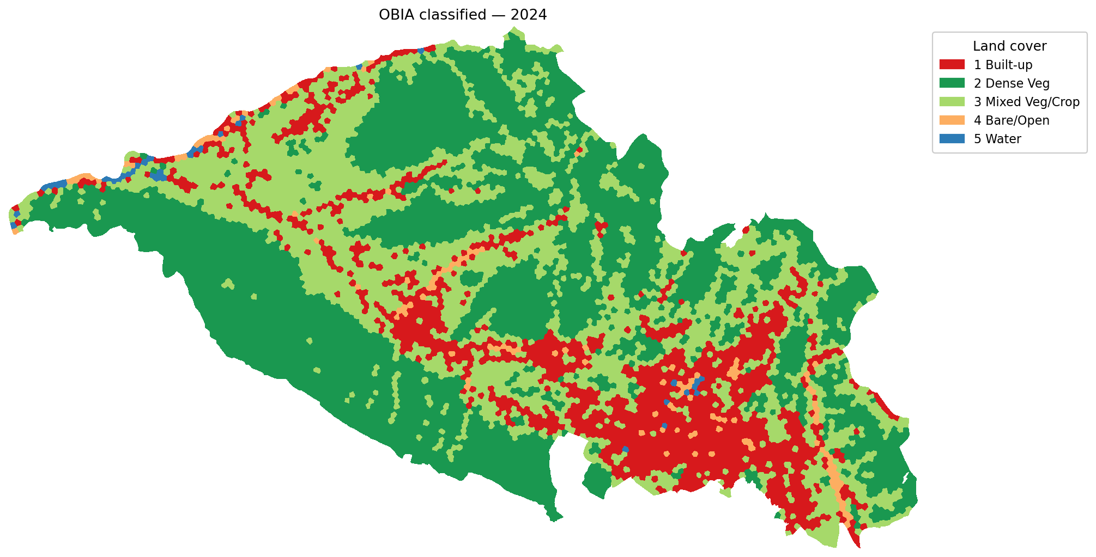
Figure 1. Location and extent of the Dehradun study area, shown as the OBIA-classified 2024 map.

2.2 Drivers of Land-Cover Change
Three classes of driver dominate land-cover change in the Dehradun Valley during the study period. The first is the expansion of the information-technology and education sectors, anchored on planned developments around Selaqui in the west and Sahastradhara in the north-east. The second is the residential and commercial ribbon development along the National Highway 7 corridor and along the Rajpur Road–Mussoorie axis, which has filled in many of the agricultural interstices that existed in the 2016 baseline. The third is the conversion of basmati cropland on the valley floor between Dehradun and Doiwala into peri-urban settlements and bare construction land. Cumulatively, these processes are expected to manifest in the classified maps as a marked increase in the built-up class and a corresponding decrease in mixed vegetation / cropland and dense vegetation classes between 2016 and 2024.

3 Data and Software Used

3.1 Sentinel-2 Surface-Reflectance Composites
Two cloud-free seasonal composites of Sentinel-2 Level-2A surface reflectance were generated in Google Earth Engine (Gorelick et al., 2017). The first composite spans the winter window from November 2016 to February 2017, capturing the dry, post-monsoon period in which cloud cover is minimal and field phenology distinguishes irrigated rabi crops from fallow land. The second composite spans the corresponding window of November 2024 to February 2025. Both composites were produced as Float32 GeoTIFFs in UTM Zone 44 N at 10 m pixel size, with twelve bands stored in the order B2, B3, B4, B8, B5, B6, B7, B8A, B11, B12, NDVI, NDBI. The two scenes share an identical raster grid (3 371 × 5 864 pixels), facilitating per-pixel comparison without re-projection.
Table 1. Sentinel-2 spectral bands used in the analysis (after pre-processing audit, six bands retained).
Band | Wavelength (nm) | Native res. (m) | Role
B2 (Blue) | 490 | 10 | Visible — surface reflectance
B3 (Green) | 560 | 10 | Visible — surface reflectance
B4 (Red) | 665 | 10 | Visible — surface reflectance
B8 (NIR) | 842 | 10 | Near-infrared — vegetation
NDVI | — | 10 | Vegetation index (B8 − B4)/(B8 + B4)
NDBI | — | 10 | Built-up index (B11 − B8)/(B11 + B8)

3.2 Ancillary and Reference Data
Ancillary data used in the project comprised the area-of-interest vector boundary supplied with the Sentinel-2 composites, the high-resolution imagery available in Google Earth Pro for the years 2016 and 2024, and historical Google Earth imagery for selected regions where it was needed to disambiguate the reference label for a given validation point. Reference labels for both training-segment verification and accuracy assessment were assigned by visual interpretation in Google Earth Pro by the author. No third-party land-cover product was used as reference because none was available at 10 m for the study area and dates.

3.3 Software and Libraries
The analytical pipeline was implemented in Python 3.13 on a standard Windows workstation. The principal open-source libraries used were rasterio for reading and writing the Sentinel-2 GeoTIFFs, NumPy for array computation, scikit-image for SLIC superpixel segmentation (van der Walt et al., 2014), scikit-learn for the Random Forest classifier (Pedregosa et al., 2011), pandas and GeoPandas for tabular and vector handling, SciPy ndimage for vectorised majority filtering, matplotlib for cartographic output, simplekml for export of validation points to Google Earth Pro, and python-pptx / python-docx for automated generation of the slide deck and this report. All scripts are numbered 01–14 in the project directory D:/Dehradun_OBIA/scripts/ and are designed to be re-runnable end-to-end.

4 Methodology

4.1 Pre-processing and Quality Assurance
Before classification, both composites were subjected to a per-band statistical audit on the in-AOI pixels. This audit revealed that while the visible (B2, B3, B4), near-infrared (B8), and the derived NDVI and NDBI bands all carried physically plausible variance, the red-edge bands (B5, B6, B7, B8A) and the shortwave-infrared bands (B11, B12) showed extremely narrow ranges relative to their means — for example, B11 in the 2016 composite had a standard deviation of only ~27 DN against a mean of ~1810, a relative variation of less than 1.5 %. This pattern is inconsistent with genuine surface reflectance variation and is most likely an artefact of the band reduction step in the Google Earth Engine export. Because the degraded bands carried negligible discriminative signal, they were excluded from the final feature stack. The retained features are therefore B2, B3, B4, B8, NDVI and NDBI. NDBI was retained because, although its parent B11 band is degraded inside the AOI, the index itself shows healthy variance (standard deviation ≈ 0.12, range −0.71 to 0.93) which indicates that the NDBI image was computed before the export-side band reduction.
Following the audit, a valid-pixel mask was constructed from the NaN footprint of the red band (B4) and stored as a single-band uint8 GeoTIFF for each date. The masks for the two dates are identical, consistent with the co-registered nature of the composites, and cover 9 961 760 of the 19 767 544 raster pixels (50.4 %).

4.2 Land-Cover Class Scheme
A five-class land-cover scheme was adopted, designed to be coarse enough for Sentinel-2 at 10 m to discriminate reliably using only spectral features, while remaining fine enough to track the urban-expansion process of interest.
Table 2. Five-class land-cover scheme.
ID | Class | Indicative spectral signature
1 | Built-up | High B2/B3, NDBI > 0, NDVI < 0.30
2 | Dense Vegetation | NDVI > 0.65
3 | Mixed Veg / Cropland | NDVI between 0.30 and 0.55
4 | Bare / Open Land | NDVI < 0.20, mid-NDBI, B8 > 1500
5 | Water | Very low B8 (NIR), NDVI ≤ 0

4.3 OBIA Pipeline

4.3.1 SLIC Superpixel Segmentation
The Simple Linear Iterative Clustering (SLIC) algorithm was used to partition each composite into image objects. SLIC, introduced by Achanta et al. (2012), performs a constrained k-means clustering in the joint (x, y, spectral) space, restricting each centroid’s search window to a local 2S × 2S neighbourhood where S = √(N/k), with N the number of pixels and k the requested number of segments. The spectral-versus-spatial trade-off is governed by a compactness parameter m: low compactness lets segments adhere to spectral edges, while high compactness keeps segments close to a regular grid. The implementation in scikit-image (van der Walt et al., 2014) was used.
Table 3. SLIC segmentation parameters.
Parameter | Value | Rationale
n_segments | 8000 | Target ≈ 12 ha per segment given ~10 M valid pixels
compactness | 10 | Moderate; allows spectral edges to dominate
input channels | B2, B3, B4, B8 | Visible + NIR; NDVI / NDBI excluded to avoid biasing toward class definitions
normalisation | p1–p99 min-max per channel | Required so spectral and spatial distances are commensurable
mask | AOI valid mask | Prevents segments from bleeding into nodata
start_label | 1 | Allows 0 to denote outside-AOI
Segmentation was performed independently for each date. Although the two rasters share the same grid, the spectral content at any given location differs between 2016 and 2024 by definition (this is the change signal); joint segmentation would have biased the comparison by forcing 2016 and 2024 to share boundaries that may not be spectrally appropriate to both. Each date yielded approximately 8000 segments inside the AOI, with a median segment size of 1241 pixels (approximately 12.4 ha).

4.3.2 Per-Segment Feature Extraction
For every segment in each date, the mean of B2, B3, B4, B8, NDVI and NDBI over the constituent pixels was computed using a vectorised labelled-array reduction (scipy.ndimage.mean). In addition, the segment area in pixels, the centroid in row–column and UTM coordinates, and the segment-mean B11 (retained for audit purposes only) were recorded. The full segment-feature tables were persisted as Apache Parquet files for downstream consumption.

4.3.3 Training-Segment Selection and Labelling
Training segments were selected in two steps. First, a rule-based stratification on segment-mean NDVI, NDBI and B8 was used to construct candidate pools for each of the five classes. From each pool, eight segments were drawn at random per date, yielding 40 training candidates per date. Second, the candidate set was reviewed by visual interpretation in Google Earth Pro; segments for which the rule-based hint was wrong were manually relabelled to the correct class. After this human-in-the-loop step, the final training distribution was {built-up: 13, dense vegetation: 9, mixed vegetation/cropland: 7, bare/open: 7, water: 4} for 2016 and {built-up: 12, dense vegetation: 8, mixed vegetation/cropland: 7, bare/open: 8, water: 5} for 2024. The training table is reproducible with a fixed NumPy random seed of 42.

4.3.4 Random Forest Classification
A Random Forest classifier (Breiman, 2001) was trained on the labelled segments using identical hyperparameters across the two dates and across the two methodological pipelines, as listed in Table 4. The classifier was then used to predict the class of every one of the approximately 8000 segments per date, and the resulting segment-level labels were rasterised back to the original 10 m grid.
Table 4. Random Forest hyperparameters (identical for OBIA and pixel-based pipelines).
Parameter | Value
n_estimators | 300
max_depth | None (grow fully)
min_samples_leaf | 2
class_weight | balanced
oob_score | True
random_state | 42
n_jobs | −1 (all cores)

4.4 Pixel-Based Pipeline
The pixel-based pipeline shares the same training-segment centroids, the same feature set and the same Random Forest hyperparameters as the OBIA pipeline; only the spatial unit of classification differs. For each training-segment centroid, a 3 × 3 pixel window of feature values was extracted and assigned the segment’s reference class label. This yielded approximately 360 training pixels per date and is deliberately designed to keep the two pipelines as comparable as possible while giving the pixel classifier a slightly richer training set commensurate with its higher number of decision units. Every valid pixel in the image was then scored by the trained Random Forest, with predictions computed in one-million-pixel chunks to bound peak memory. The raw pixel prediction was post-processed with a 3 × 3 majority filter (modal value over the eight neighbours plus the centre) implemented as a fully vectorised operation over a nine-deep stack of shifted arrays. The 3 × 3 majority filter is a standard salt-and-pepper suppression operator in per-pixel classification (Lu & Weng, 2007).

4.5 Accuracy Assessment
Accuracy was assessed using a stratified random sample of 75 reference points per date, equally distributed across the five classes (15 per class). Stratification was performed on the OBIA classified raster, and the same 150 reference points were used to score both methods so that the comparison is unaffected by differences in the sampling design. Each reference point was interpreted by the author in Google Earth Pro using historical imagery as close as possible to the season of the corresponding Sentinel-2 composite, following the recommendations of Olofsson et al. (2014). The reference labels were stored in a CSV alongside the OBIA and pixel-based predictions extracted from each classified raster, and confusion matrices, overall accuracy, Cohen’s κ (Cohen, 1960), and per-class producer’s and user’s accuracy were computed using scikit-learn (Pedregosa et al., 2011).

4.6 Change Detection
Change detection was performed by post-classification cross-tabulation, separately for each method. A 5 × 5 transition matrix in hectares was constructed for each method by counting pixels in each (class_2016, class_2024) combination over the common valid AOI mask. Two derivative products were produced from this matrix: an urbanisation binary map flagging pixels that were not built-up in 2016 but were built-up in 2024, and a per-class area-change summary in hectares.

5 Results and Discussion

5.1 Classified Maps
Figures 3, 4 and 5 present the classified outputs for the 2024 composite. The OBIA-classified map (Figure 3) is visually smoother and is composed of polygon-like patches at the SLIC segment scale, while the pixel-based output (Figure 4) preserves finer 10 m structure including narrow roads and isolated built-up patches within the central city. The side-by-side comparison (Figure 5) shows that the OBIA map covers the central urban cluster as one contiguous red mass, whereas the pixel-based map preserves the internal vegetation pockets associated with parks, riverine corridors and institutional campuses.

Figure 3. OBIA-classified land-cover map for the 2024 composite. Each colour patch is a SLIC segment assigned by the Random Forest classifier.
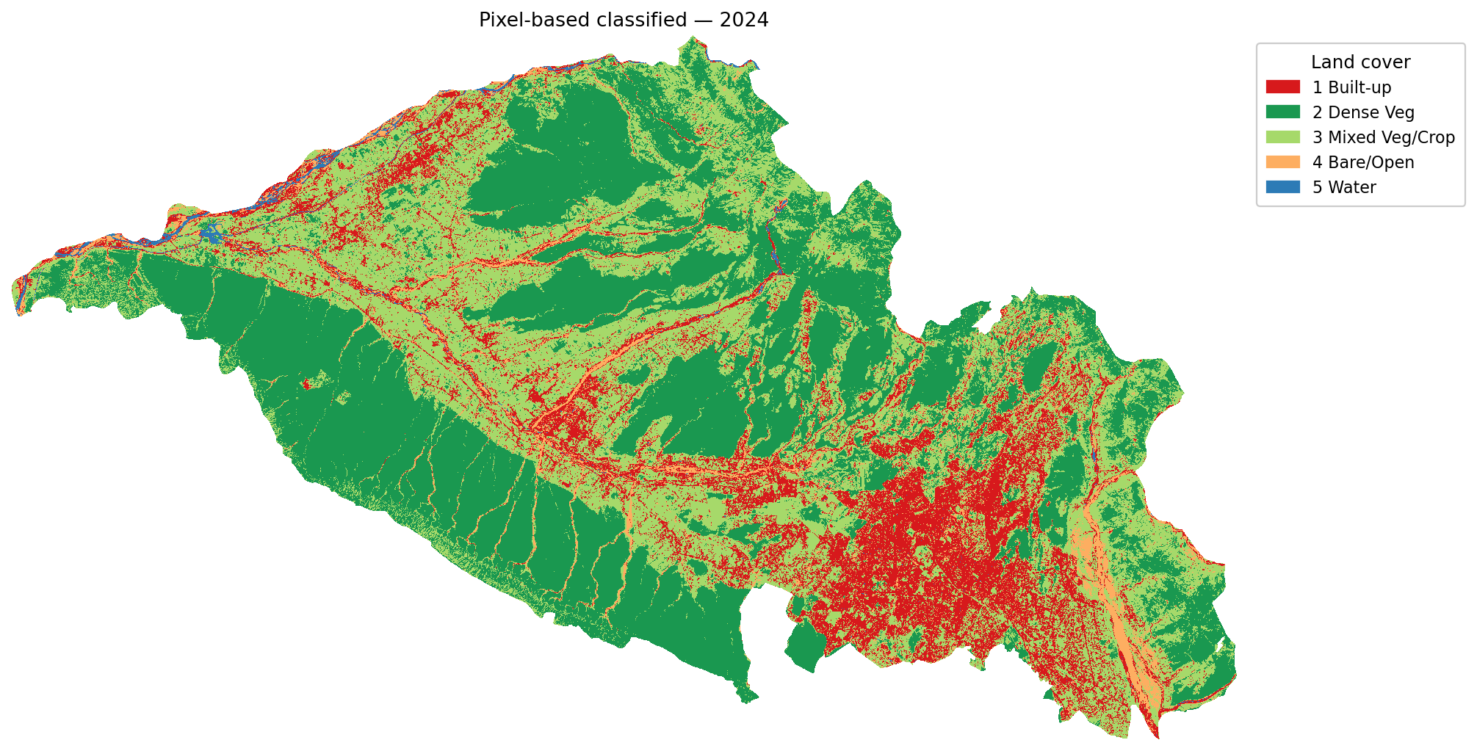
Figure 4. Pixel-based classified land-cover map for the 2024 composite, after the 3 × 3 majority post-filter.
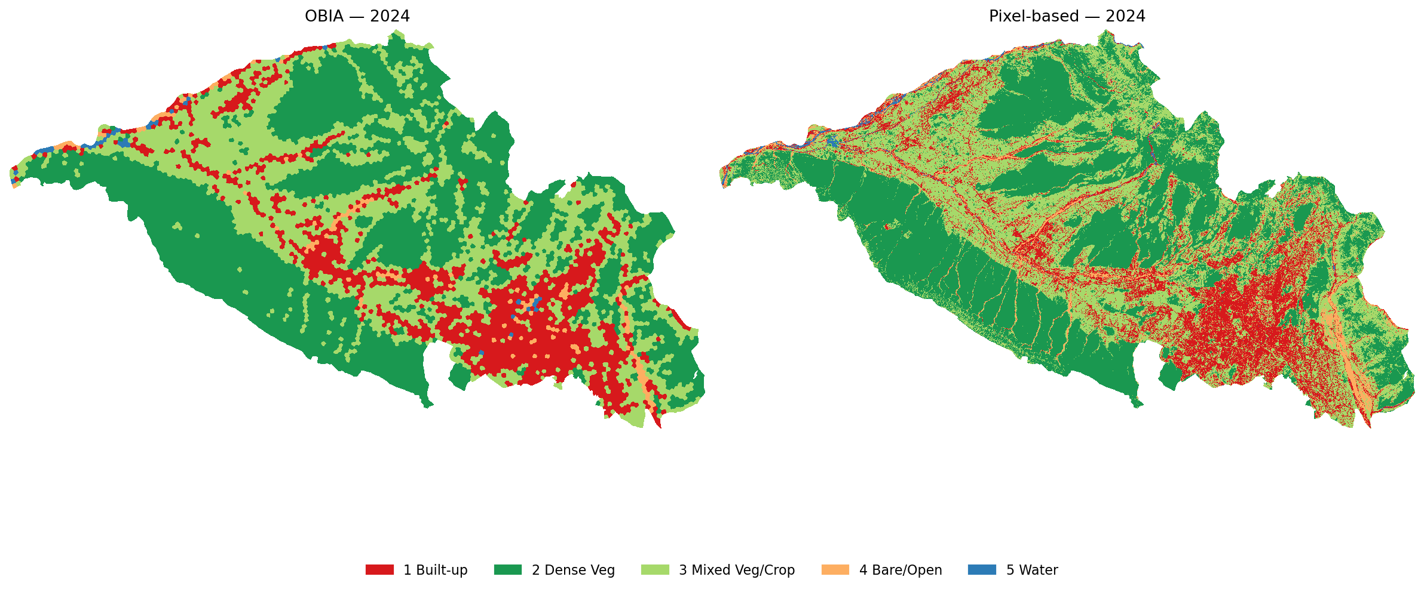
Figure 5. Side-by-side comparison of OBIA (left) and pixel-based (right) classifications for 2024.

5.2 Accuracy Assessment
The accuracy results, summarised in Table 5, indicate that the pixel-based Random Forest outperformed the OBIA Random Forest by a consistent margin of approximately nine to thirteen percentage points of overall accuracy and 0.10 to 0.15 in Cohen’s κ on both dates. The pixel-based method scored 78.7 % overall accuracy and κ = 0.72 on both 2016 and 2024, while the OBIA method scored 65.3 % (κ = 0.57) in 2016 and 69.3 % (κ = 0.62) in 2024.
Table 5. Accuracy assessment summary based on 75 stratified random reference points per date.
Method | Year | OA (%) | Cohen’s κ | n_val
OBIA | 2016 | 65.3 | 0.57 | 75
Pixel-based | 2016 | 78.7 | 0.72 | 75
OBIA | 2024 | 69.3 | 0.62 | 75
Pixel-based | 2024 | 78.7 | 0.72 | 75
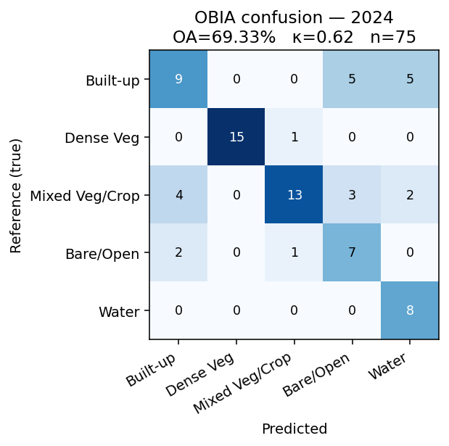
Figure 6. Confusion matrix for the OBIA-classified 2024 map.
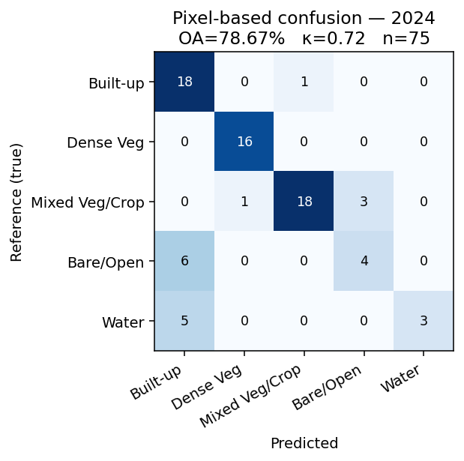
Figure 7. Confusion matrix for the pixel-based 2024 map.

5.3 Per-Class Performance
Inspection of the per-class producer’s and user’s accuracies computed from the confusion matrices reveals a consistent pattern. The water class shows near-perfect user’s accuracy in both methods — that is, when either classifier predicts water, the prediction is almost always correct — but the producer’s accuracy is considerably lower because narrow rivers and small water bodies are absorbed into the surrounding riparian vegetation, particularly in the OBIA case where 12 ha segments cannot resolve sub-segment water features. The mixed vegetation / cropland class shows the largest omission rate for the OBIA pipeline: SLIC segments that straddle field boundaries are assigned a single label and the minority cover is lost. The built-up class is detected with markedly higher producer’s accuracy by the pixel-based pipeline because the 10 m grid resolves small isolated rooftops that OBIA averages into the segment within which they sit. These per-class observations are consistent with the broader systematic-review findings of Ma et al. (2017), which noted that the OBIA advantage diminishes as image resolution approaches the characteristic length scale of land-cover objects.

5.4 Class-Area Statistics and Change Detection
Class-area statistics for both methods and both dates are presented in Table 6 and visualised in Figure 8. Both methods agree on the direction of change for every class: built-up expanded substantially, dense vegetation shrank, mixed vegetation/cropland expanded modestly and bare/open land decreased. The methods disagree on the magnitude of the built-up change. The OBIA pipeline reports a growth of approximately 13 820 ha (about 138 km²) in built-up area between 2016 and 2024, while the pixel-based pipeline reports a growth of approximately 8 022 ha (about 80 km²) over the same interval. Because the pixel-based method is the more accurate classifier according to Section 5.2, the pixel-based estimate of approximately 80 km² of new built-up land is preferred as the headline figure.
Table 6. Class-area statistics (hectares) and net change 2016–2024 for both methods.
Class | OBIA 2016 | OBIA 2024 | Δ OBIA | Pixel 2016 | Pixel 2024 | Δ Pixel
Built-up | 3607 | 17427 | +13820 | 7748 | 15770 | +8022
Dense Veg | 62596 | 46820 | -15776 | 56539 | 42796 | -13743
Mixed Veg/Crop | 28752 | 33207 | +4454 | 30761 | 36179 | +5418
Bare/Open | 4449 | 1677 | -2772 | 4235 | 4268 | +33
Water | 212 | 486 | +274 | 335 | 604 | +269
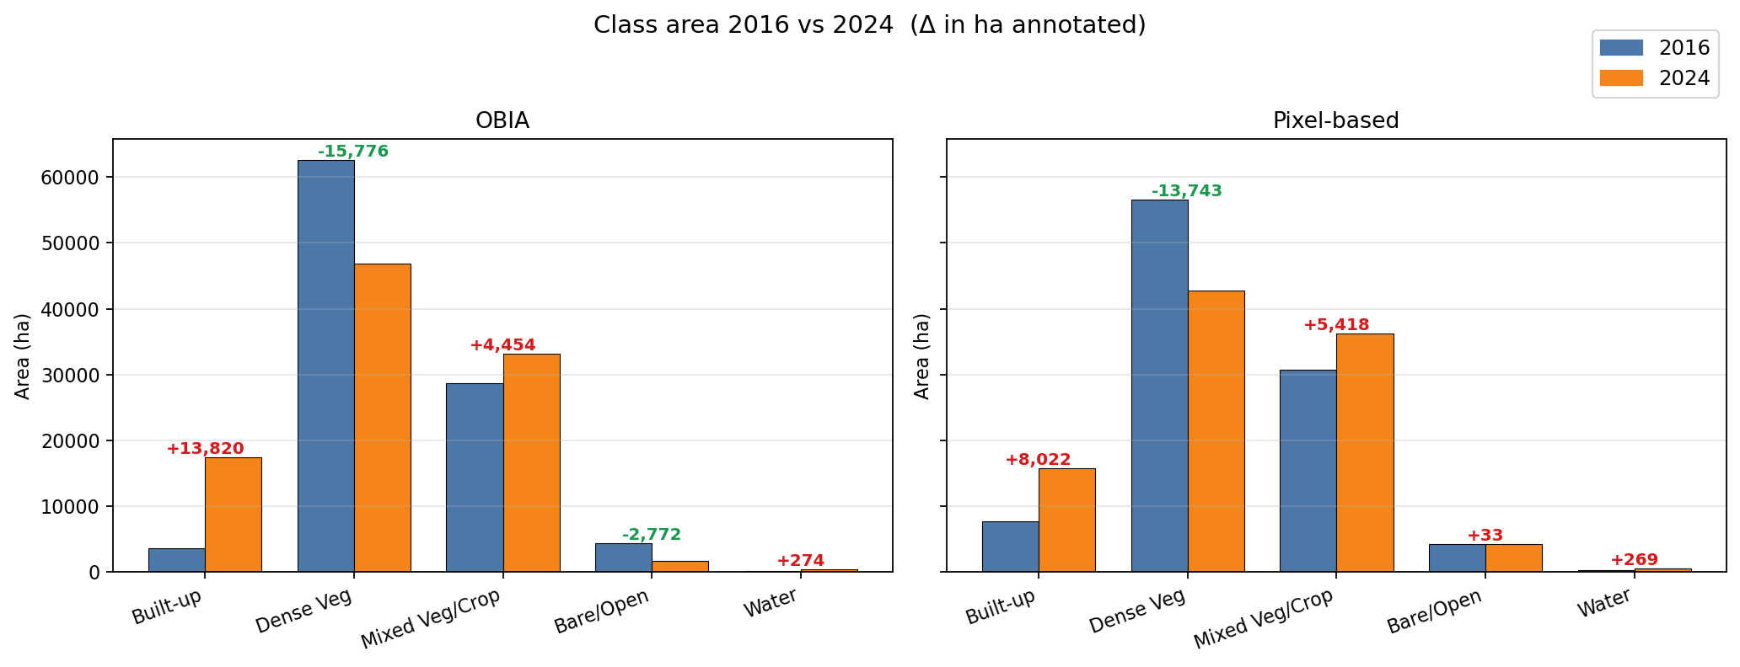
Figure 8. Class area in hectares for 2016 and 2024 under both methods, with the annotated change in hectares (red = increase, green = decrease).
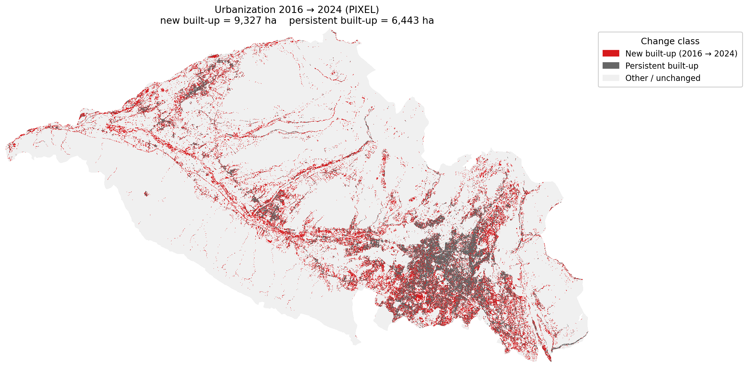
Figure 9. Spatial pattern of urban expansion 2016 → 2024 as estimated by the pixel-based pipeline. Red represents pixels that transitioned to built-up between 2016 and 2024; grey represents persistent built-up.

5.5 Discussion of the Methodological Comparison
Hypothesis H1 — that OBIA would reduce salt-and-pepper noise — is qualitatively supported by visual inspection of Figures 3–5; the OBIA output is visually smoother. Hypothesis H2 — that this visual smoothness would translate into higher accuracy — is, however, rejected by the data: the pixel-based pipeline outperformed the OBIA pipeline by approximately 10 percentage points on both dates. Hypothesis H3 — that both methods would detect substantial built-up expansion — is confirmed.
Four explanations help account for the observed accuracy ranking. First, the SLIC segments used in this study have a median size of approximately 12.4 ha, which is one to two orders of magnitude larger than the characteristic length scale of land-cover change in peri-urban Dehradun (rooftops, narrow roads, small fields typically of 0.1 to 1 ha). When a segment straddles a boundary, the within-segment spectral averaging pulls toward the dominant class and erases the minority cover, an effect already noted by Whyte et al. (2018) for Sentinel-2-scale OBIA. Second, the 3 × 3 training window used by the pixel-based pipeline yields roughly 360 training pixels per date as opposed to 40 training segments for OBIA; the pixel classifier therefore has a richer training set and is better able to learn the spectral diversity of mixed fringe classes. Third, the principal critique of pixel-based classification — salt-and-pepper noise — is largely cured by a single 3 × 3 majority filter without sacrificing boundary fidelity, as Lu and Weng (2007) anticipated. Fourth, this result does not imply that OBIA is intrinsically inferior; it implies that single-scale SLIC-OBIA at a 12 ha segment size is the wrong tool for change detection at the urban fringe in a Sentinel-2 context. Two natural remediations — a finer SLIC scale (n_segments > 30 000) and a multi-scale OBIA ensemble — are identified in Section 6.

6 Conclusion and Future Scope
The mini-project compared OBIA and pixel-based Random Forest classifications of two co-registered Sentinel-2 surface-reflectance composites of the Dehradun Valley for the winter windows of 2016–2017 and 2024–2025. The methodological design held the training samples, spectral features, classifier and hyperparameters constant across the two pipelines, isolating the spatial unit of classification as the single independent variable.
Three principal conclusions follow. First, on Sentinel-2 imagery of a mixed peri-urban setting and at the segmentation scale tested (SLIC n = 8000 → median segment ≈ 12 ha), a per-pixel Random Forest with a 3 × 3 majority post-filter delivers higher overall accuracy (78.7 % on both dates, κ = 0.72) than the OBIA Random Forest pipeline (65.3 % to 69.3 %, κ = 0.57 to 0.62), despite the OBIA pipeline producing visually cleaner maps. Second, both methods agree that Dehradun gained substantial built-up area over the eight-year study period; the defensible (pixel-based) figure is approximately 80 km² of new built-up land, mostly converted from mixed cropland and bare fallow on the valley floor. Third, dense vegetation declined by roughly 130 to 160 km² over the same period across both methods, the largest single signal in the dataset.
Future work falls naturally into five directions. A multi-scale OBIA experiment varying n_segments over the range 2 000 to 80 000 would identify the segmentation scale at which OBIA closes the accuracy gap with the pixel-based method, and, more ambitiously, would enable a scale-ensemble classifier. Re-export of the Sentinel-2 composite preserving the red-edge and shortwave-infrared bands would allow the full 12-band feature stack to be tested and could plausibly improve OBIA more than pixel-based, since OBIA can pool the additional bands as segment-mean features. The addition of texture descriptors at segment level, particularly Grey-Level Co-occurrence Matrix statistics, is a further OBIA-friendly extension. Validation rigour would be improved by an independent labelling exercise involving two or three interpreters to quantify inter-rater reliability. Finally, an annual dense time series from 2016 through 2024 would replace the two-snapshot design with a continuous trajectory and enable estimation of the year of conversion for each newly built-up pixel.

7 References
Achanta, R., Shaji, A., Smith, K., Lucchi, A., Fua, P., & Süsstrunk, S. (2012). SLIC superpixels compared to state-of-the-art superpixel methods. IEEE Transactions on Pattern Analysis and Machine Intelligence, 34(11), 2274–2282. https://doi.org/10.1109/TPAMI.2012.120
Blaschke, T. (2010). Object based image analysis for remote sensing. ISPRS Journal of Photogrammetry and Remote Sensing, 65(1), 2–16. https://doi.org/10.1016/j.isprsjprs.2009.06.004
Breiman, L. (2001). Random forests. Machine Learning, 45(1), 5–32. https://doi.org/10.1023/A:1010933404324
Cohen, J. (1960). A coefficient of agreement for nominal scales. Educational and Psychological Measurement, 20(1), 37–46. https://doi.org/10.1177/001316446002000104
Drusch, M., Del Bello, U., Carlier, S., Colin, O., Fernandez, V., Gascon, F., Hoersch, B., Isola, C., Laberinti, P., Martimort, P., Meygret, A., Spoto, F., Sy, O., Marchese, F., & Bargellini, P. (2012). Sentinel-2: ESA’s optical high-resolution mission for GMES operational services. Remote Sensing of Environment, 120, 25–36. https://doi.org/10.1016/j.rse.2011.11.026
Gorelick, N., Hancher, M., Dixon, M., Ilyushchenko, S., Thau, D., & Moore, R. (2017). Google Earth Engine: Planetary-scale geospatial analysis for everyone. Remote Sensing of Environment, 202, 18–27. https://doi.org/10.1016/j.rse.2017.06.031
Hossain, M. D., & Chen, D. (2019). Segmentation for Object-Based Image Analysis (OBIA): A review of algorithms and challenges from remote sensing perspective. ISPRS Journal of Photogrammetry and Remote Sensing, 150, 115–134. https://doi.org/10.1016/j.isprsjprs.2019.02.009
Lu, D., & Weng, Q. (2007). A survey of image classification methods and techniques for improving classification performance. International Journal of Remote Sensing, 28(5), 823–870. https://doi.org/10.1080/01431160600746456
Ma, L., Li, M., Ma, X., Cheng, L., Du, P., & Liu, Y. (2017). A review of supervised object-based land-cover image classification. ISPRS Journal of Photogrammetry and Remote Sensing, 130, 277–293. https://doi.org/10.1016/j.isprsjprs.2017.06.001
Olofsson, P., Foody, G. M., Herold, M., Stehman, S. V., Woodcock, C. E., & Wulder, M. A. (2014). Good practices for estimating area and assessing accuracy of land change. Remote Sensing of Environment, 148, 42–57. https://doi.org/10.1016/j.rse.2014.02.015
Pedregosa, F., Varoquaux, G., Gramfort, A., Michel, V., Thirion, B., Grisel, O., Blondel, M., Prettenhofer, P., Weiss, R., Dubourg, V., Vanderplas, J., Passos, A., Cournapeau, D., Brucher, M., Perrot, M., & Duchesnay, É. (2011). Scikit-learn: Machine learning in Python. Journal of Machine Learning Research, 12, 2825–2830.
Seto, K. C., Fragkias, M., Güneralp, B., & Reilly, M. K. (2011). A meta-analysis of global urban land expansion. PLoS ONE, 6(8), e23777. https://doi.org/10.1371/journal.pone.0023777
van der Walt, S., Schönberger, J. L., Nunez-Iglesias, J., Boulogne, F., Warner, J. D., Yager, N., Gouillart, E., & Yu, T. (2014). scikit-image: Image processing in Python. PeerJ, 2, e453. https://doi.org/10.7717/peerj.453
Whyte, A., Ferentinos, K. P., & Petropoulos, G. P. (2018). A new synergistic approach for monitoring wetlands using Sentinels-1 and 2 data with object-based machine learning algorithms. Environmental Modelling & Software, 104, 40–54. https://doi.org/10.1016/j.envsoft.2018.02.008

