A Comparative Approach to Solving Killer Sudoku
1. Introduction
Killer Sudoku is a challenging variation of the classic Sudoku puzzle. While standard Sudoku requires filling a 9x9 grid such that numbers 1 through 9 appear uniquely in each row, column, and 3x3 subgrid, Killer Sudoku introduces an additional layer of complexity: cages. These cages consist of groups of cells with a specific sum, further restricting valid configurations and amplifying the puzzle's difficulty.
This project implements an efficient backtracking algorithm to solve Killer Sudoku puzzles and evaluates its performance by solving multiple boards. By focusing on the backtracking approach, this project explores a widely applicable technique for constraint satisfaction problems (CSPs) and compares its effectiveness with insights from related research.
This project was inspired by the work of Inês Lynce and João Marques-Silva in "A Hybrid Approach for the Sudoku Problem: Using Constraint Programming in Iterated Local Search". Their study combined constraint programming (CP) with iterative local search (ILS), demonstrating the benefits of hybrid methods for solving highly constrained problems like Sudoku. While this project focuses solely on backtracking, it incorporates elements of CP, such as forward checking and constraint pruning, to enhance performance while solving a more advanced version of Sudoku.
2. Methods
To solve Killer Sudoku puzzles, I developed three main components: a puzzle generator, a backtracking solving algorithm, and an evaluation framework. These were designed to interact systematically, ensuring that the tests were consistent, and results were meaningful.
2.1 Puzzle Representation
Each puzzle was represented as:
- A 9x9 grid initialized with zeros, representing the empty board.
- A collection of cages, where each cage specified:
  - The cells it included (e.g., [(0, 0), (0, 1)]).
  - The target sum for those cells.
The board generator ensured valid Sudoku configurations, starting with a fully solved grid. Cages were created by grouping adjacent cells and calculating their target sums. To make the puzzles easier to solve, the generator pre-filled 20 cells in the grid and limited cages to a maximum size of 4 cells.
2.2 Puzzle Generator
To evaluate the algorithms systematically, I implemented a generator that created valid Killer Sudoku puzzles:
- Sudoku Grid Generation: A complete grid was created using backtracking to ensure it satisfied standard Sudoku rules.
- Cage Configuration: Cells were grouped into cages with randomized sums, ensuring that the resulting puzzle was solvable.
- Pre-Filled Numbers: Some puzzles included pre-filled cells to simulate starting boards commonly found in published puzzles.
This generator ensured that the puzzles tested a range of complexities, from simple grids with large cages to intricate setups requiring detailed reasoning.
2.3 Backtracking Algorithm
The backtracking solver works by systematically assigning values to cells and backtracking when conflicts arise. The approach incorporates:
- Constraint Validation:
  - Ensures numbers in each row, column, and sub-grid are unique.
  - Verifies that numbers in each cage adhere to their target sum and do not repeat.
- Forward Checking:
  - Updates the possible values for each unfilled cell after every assignment, pruning invalid options dynamically.
- Variable Selection:
  - Implements the Minimum Remaining Values (MRV) heuristic to prioritize cells with the fewest valid options.
The algorithm attempts to assign values recursively until the grid is fully solved. If no solution is found, the solver raises an exception indicating that the puzzle is unsolvable.
2.4 Performance Evaluation
The backtracking solver was evaluated by solving multiple boards and analyzing computational time. The evaluation process consisted of:
- Generating Killer Sudoku puzzles with simplified cages and pre-filled cells.
- Applying the solver to each board and recording the execution time.
- Plotting solving times for multiple boards to analyze performance trends.
3. Results
3.1 Solver Performance
The backtracking solver was tested on 10, 100, and 1,000 boards. The average solving time for each configuration was as follows:
- 10 Boards: 0.07 seconds per board on average. 0.73 seconds total.
- 100 Boards: 0.08 seconds per board on average. 7.86 seconds total.
- 1,000 Boards: 0.08 seconds per board on average. 76.95 seconds total.
The results indicate that the solver performs consistently well, with only a slight increase in solving time as the number of boards increases. We can see that on average, a board is solved in .08 seconds with the backtracking solver. The results suggest that the complexity of individual puzzles, rather than the number of puzzles, is the primary determinant of solving time.
3.2 Graphs of Solve Efficiencies
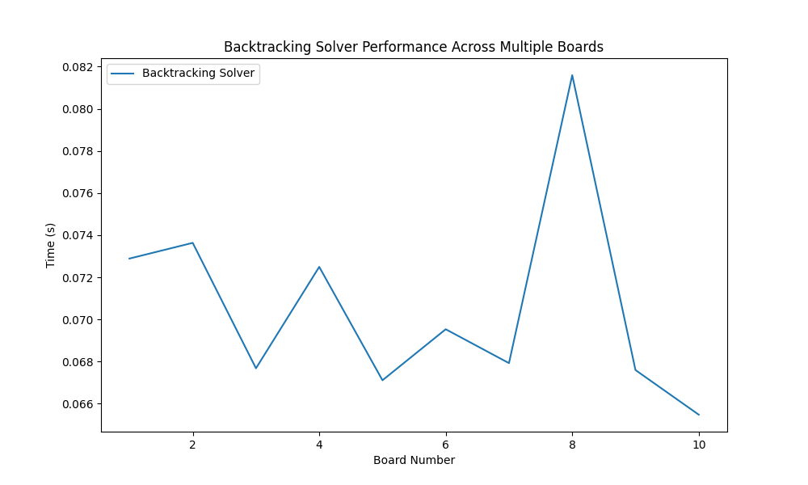
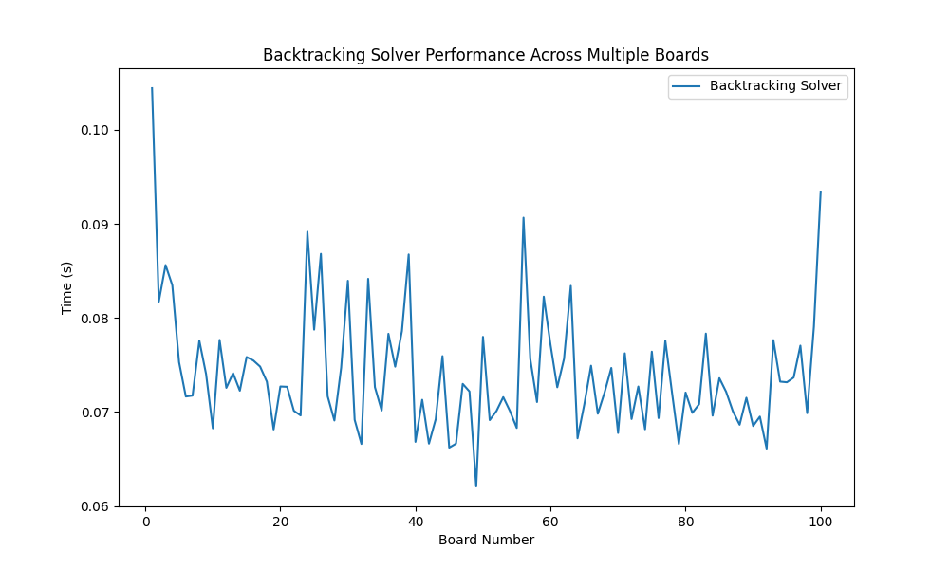
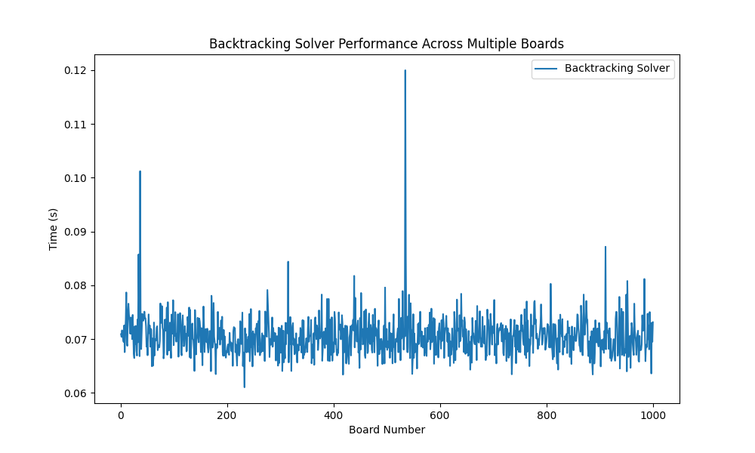
3.3 Sample Output
Below is an example of a generated puzzle and its solved grid:
Initial Puzzle:
[[0 0 1 3 0 0 0 0 7]
[0 0 0 0 0 0 0 0 0]
[0 0 4 0 0 0 3 8 6]
[0 0 0 0 0 0 0 0 9]
[0 0 6 0 0 0 0 0 8]
[0 0 3 5 0 0 7 0 0]
[0 0 0 0 0 0 1 0 0]
[0 6 0 0 0 1 0 0 3]
[0 1 0 9 0 0 0 0 4]]
Cages:
{'cells': [(3, 3), (4, 3), (4, 4), (3, 4)], 'sum': 19}
{'cells': [(5, 6), (6, 6), (7, 6), (5, 7)], 'sum': 18}
{'cells': [(1, 3), (1, 4)], 'sum': 12}
{'cells': [(4, 2), (4, 1), (4, 0), (5, 2)], 'sum': 12}
{'cells': [(6, 5), (6, 4), (5, 5)], 'sum': 21}
{'cells': [(6, 2), (6, 3)], 'sum': 11}
{'cells': [(6, 7), (6, 8), (5, 8)], 'sum': 12}
{'cells': [(3, 8), (4, 8)], 'sum': 17}
{'cells': [(2, 7), (2, 8), (1, 8)], 'sum': 19}
{'cells': [(7, 3), (7, 4), (8, 3)], 'sum': 18}
Backtracking Solved Puzzle:
[[6 2 1 3 8 0 4 5 7]
[8 3 7 6 4 5 0 1 2]
[5 0 4 1 7 2 3 8 6]
[2 4 0 7 1 6 5 3 9]
[1 0 6 4 0 3 2 0 8]
[0 8 3 5 2 0 7 4 1]
[4 5 8 2 3 0 1 7 0]
[7 6 2 0 5 1 0 0 3]
[0 1 0 9 0 7 6 2 4]]
4. Conclusions
The backtracking solver effectively solves Killer Sudoku puzzles with moderate complexity, as evidenced by its consistent performance across multiple test cases. The incorporation of forward checking and MRV significantly enhances the algorithm’s efficiency, reducing unnecessary recursive calls.
Strengths
- Simplicity: The solver is straightforward to implement and debug.
- Consistency: It reliably solves puzzles generated with the current parameters.
Weaknesses
- Scalability: For more complex puzzles with larger cages or fewer pre-filled cells, the solving time increases significantly.
- Lack of Hybrid Techniques: Unlike the approach in the referenced article, this project does not combine CP with optimization methods like ILS.
Future Improvements
- Incorporating Local Search:
  - Adding iterative improvement methods to enhance efficiency, inspired by Lynce and Marques-Silva.
- Dynamic Cage Generation:
  - Allow users to specify difficulty levels by adjusting cage complexity and pre-filled cells.
5. Works Cited
- N. Musliu and F. Winter, "A Hybrid Approach for the Sudoku Problem: Using Constraint Programming in Iterated Local Search," in IEEE Intelligent Systems, vol. 32, no. 2, pp. 52-62, Mar.-Apr. 2017, doi: 10.1109/MIS.2017.29.
- Python libraries:
  - Random
  - Numpy
  - Time
  - Matplotlib

