Setting up turtle3 instrunction:

https://medium.com/@nilutpolkashyap/setting-up-turtlebot3-simulation-in-ros-2-humble-hawksbill-70a6fcdaf5de

Navigation instruction:
https://roboticsbackend.com/ros2-nav2-tutorial/

custom world:
pkill -9 ros2
pkill -9 gzclient
pkill -9 gzserver
pkill -9 robot_state_pub
source /usr/share/gazebo/setup.sh
cd Documents/Robotics/Ex5/ros2_ws
source install/setup.bash
export TURTLEBOT3_MODEL=waffle
ros2 launch turtlebot3_gazebo turtlebot3_custom_map.launch.py
Operate robot:
source install/setup.bash
export TURTLEBOT3_MODEL=waffle
ros2 run turtlebot3_teleop teleop_keyboard

Question 4

Navigation:
(these are not necessary)
pkill -9 rvitz2
pkill -9 cartographer_no
pkill -9 cartographer_oc
pkill -9 ros2
pkill -9 gzclient
pkill -9 gzserver
pkill -9 robot_state_pub
source /usr/share/gazebo/setup.sh
cd Documents/Robotics/Ex5/ros2_ws
source install/setup.bash
export TURTLEBOT3_MODEL=burger
ros2 launch turtlebot3_gazebo turtlebot3_custom_map.launch.py

source install/setup.bash
export TURTLEBOT3_MODEL=waffle
ros2 launch turtlebot3_navigation2 navigation2.launch.py use_sim_time:=True map:=$HOME/Documents/Robotics/Ex5/map.yaml

After that estimate pose, click on robot position, teleoperate a bit.

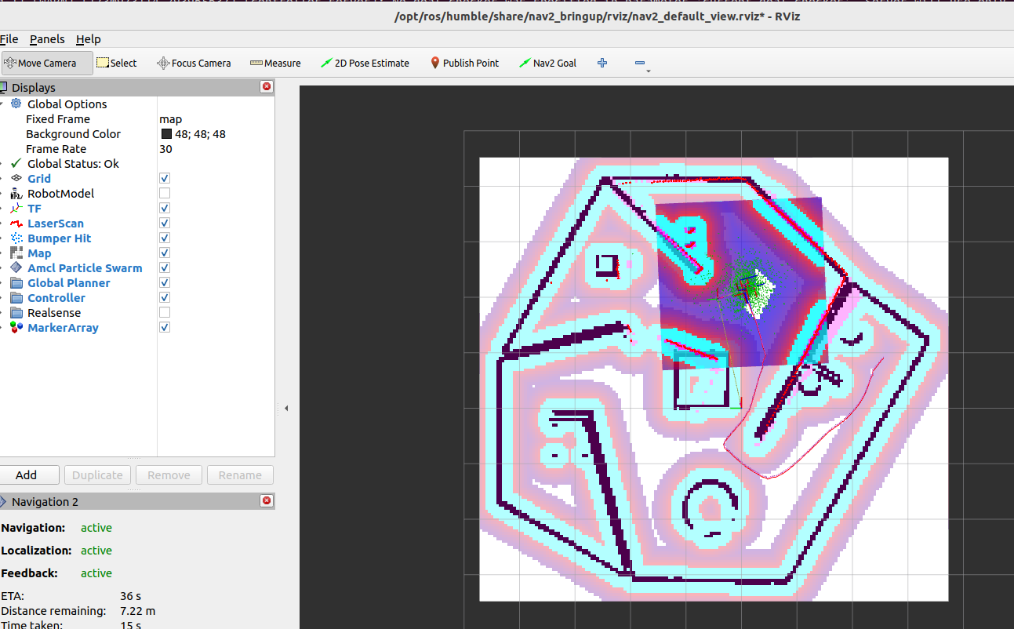

Question 5
Topics related to sensors:
LIDAR (LaserScan)/scan | sensor_msgs/msg/LaserScan
Camera (RGB): /camera/image_raw | sensor_msgs/msg/Image
Camera (Camera Info):  - /camera/camera_info | sensor_msgs/msg/CameraInfo
- IMU (Inertial Measurement Unit):  - /imu (orientation, linear vel, acceleration) | sensor_msgs/msg/Imu
- Odometry:  - /odom (position, orientaito, twist) | nav_msgs/msg/Odometry
- Bumper Sensor:  - /mobile_base/sensors/bumper_pointcloud (does not publish anything) | sensor_msgs/msg/PointCloud2

Sensor Topics:
- LIDAR (LaserScan):
  - /scan: LIDAR or laser scanner data and contains sensor_msgs/msg/LaserScan type messages.
- Camera (RGB):
  - /camera/image_raw: This topic contains raw image data from the robot's camera (likely an RGB camera), with the message type sensor_msgs/msg/Image.
- Camera (Camera Info):
  - /camera/camera_info: Contains the intrinsic calibration data of the camera, such as focal length, image size, and distortion coefficients.
- IMU (Inertial Measurement Unit):
  - /imu: Contains data from the IMU sensor, including orientation, angular velocity, and linear acceleration. It uses the sensor_msgs/msg/Imu message type.
- Odometry:
  - /odom: Contains the robot's odometry information, including position and velocity, often from wheel encoders or other odometry sensors. It uses the nav_msgs/msg/Odometry message type.
- Bumper Sensor:
  - /mobile_base/sensors/bumper_pointcloud: contains point cloud data from the robot's bumper sensors, which detect contact with objects.
It uses sensor_msgs/msg/PointCloud2 or similar message types.

Explanation of Other Relevant Topics:
- /tf and /tf_static: These topics contain transformation data between coordinate frames (tf2_msgs/TFMessage). These transformations are important for defining the relative positions of the robot's sensors (e.g., between base_link and odom frames).
- /joint_states: Contains information about the robot's joints (e.g., arm, wheel positions), typically from encoders. This isn't a sensor per se, but it is critical for navigation and movement.

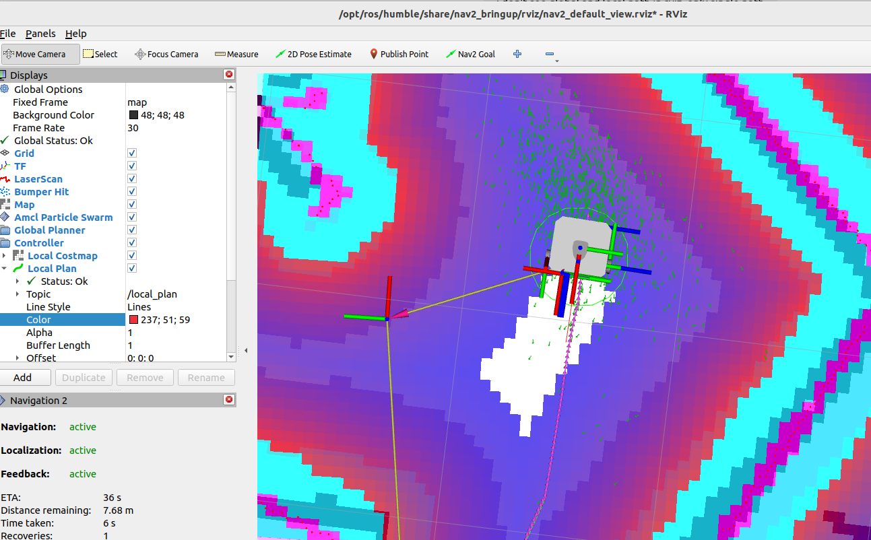
Question 6
Small red line in front of robot is local path, long line with magenta arrows is global path.

When the TurtleBot is navigating with the navigation stack running, you will often see several paths projected in RViz or on the map in different colors. These paths represent the planning and obstacle avoidance algorithms at work:
- Global Path:
  - This is the planned path that the robot should follow to reach its goal. It is typically generated by the global planner, which uses the map of the environment to find the shortest or most efficient route from the robot's current location to its goal.

- Local Path (Trajectory):
  - This path represents the robot’s immediate path, generated by the local planner. The local planner is responsible for making sure the robot avoids obstacles while following the global path.
  - It is a dynamically updated path that takes into account the robot’s surroundings (obstacles detected by sensors like LIDAR) and plans a path that avoids these obstacles.

- Costmap Layers (rectangle around robot, switch on in Controller tab):
  - This is a 2D grid that contains information about obstacles (high cost) and free spaces (low cost).
  - The global and local planners use the costmap to decide on valid paths. Obstacles detected by the sensors will appear in the costmap, and the path planners will avoid areas marked with high cost.
  - The local costmap is crucial for the local planner. It helps the robot avoid obstacles while following the global path by constantly updating the immediate area around the robot.
- As the robot moves, the local costmap shifts to maintain focus around the robot, adapting to newly detected obstacles or changes in the environment.

Question 7

/opt/ros/humble/share/turtlebot3_navigation2/param/burger.yaml

/opt/ros/humble/share/turtlebot3_navigation2/param/waffle.yaml

8. How do cost values (cost_scaling_factor) affect the shape of the path to navigate
9. How does the obstacle radius (inflation_radius) affect the (local and global) navigation?

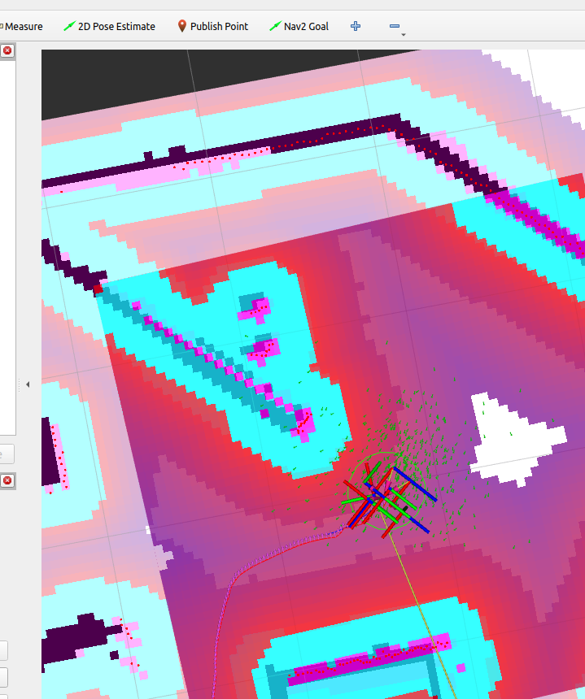
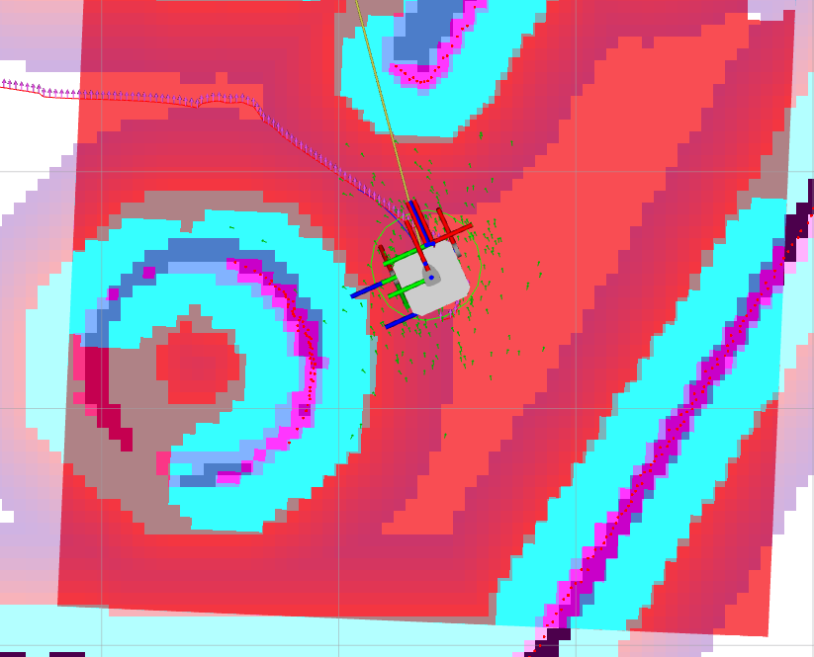

Tried to change cost_scaling_factor from 3 (right) to 1 (middle) and 0.01 (left) for waffle robot. No change in navigation is noted.

The cost_scaling_factor parameter affects the rate at which the cost increases near obstacles in the inflation layer of the costmap. It controls how steeply the cost rises from free space to fully occupied (obstacle) cells.
- Higher cost_scaling_factor: Increases the "penalty" for cells near obstacles, making the cost around obstacles rise sharply. This makes the planner avoid areas close to obstacles more aggressively, leading to more indirect paths that keep a larger distance from obstacles.
- Lower cost_scaling_factor: Reduces the rate of cost increase around obstacles, allowing the planner to take paths that might come closer to them. This can result in shorter paths but may increase the risk of getting too close to obstacles.

Effect on Path Shape:
- Higher scaling factors result in paths that take smoother curves around obstacles, maintaining a safer margin but potentially increasing travel distance.
- Lower scaling factors may lead to more direct paths, as the planner will be less penalized for approaching obstacles closely.

Obstacle Radius (inflation_radius)
- The inflation_radius parameter defines the area around obstacles that will have increased cost to create a buffer zone.
- Larger inflation_radius: Expands the high-cost zone around each obstacle, causing the robot to avoid obstacles with a larger safety margin. Both local and global planners will try to route paths that stay outside this buffer, which can help avoid collisions but might result in longer paths, especially in tighter spaces.
- Smaller inflation_radius: Reduces the buffer zone, allowing paths that pass closer to obstacles. This can be beneficial in confined environments but may increase the risk of the robot getting too close to obstacles.

Effect on Local and Global Navigation:
- Local Planner: With a larger inflation radius, the local planner will have less room to maneuver around obstacles, especially in tight spaces, potentially slowing down to avoid entering high-cost cells.
- Global Planner: A larger inflation radius affects the global path, leading it to avoid obstacles with a wider berth, which may result in a more circuitous route.
In summary:
- cost_scaling_factor controls how strongly the planner is influenced by nearby obstacles, impacting the "shape" of the path.
- inflation_radius determines the size of the buffer around obstacles, directly affecting the robot's clearance fro

Question 7,8,9
cost_scaling_factor=20  infl_radius = 0.2  moves ok | cost_scaling_factor=20  infl_radius = 2.2  stack | cost_scaling_factor=1  infl_radius = 0.1  stack

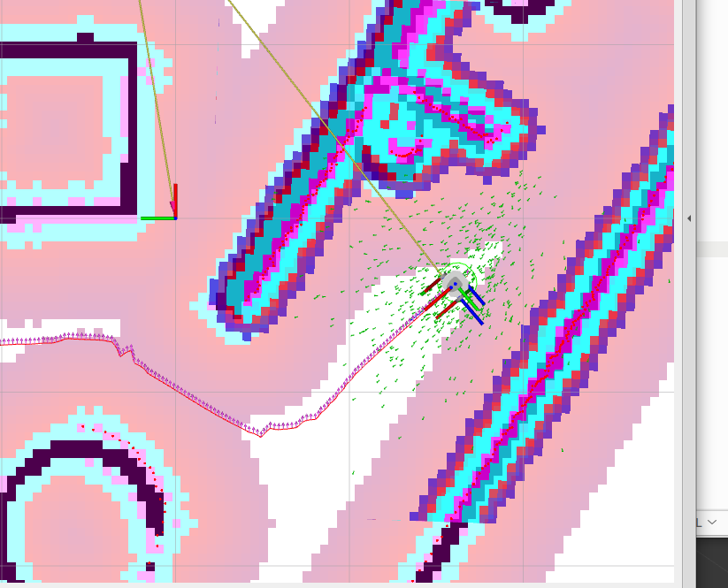
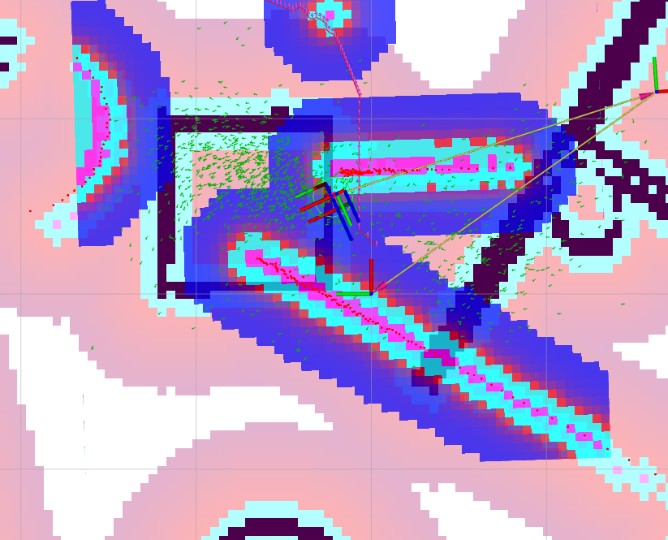
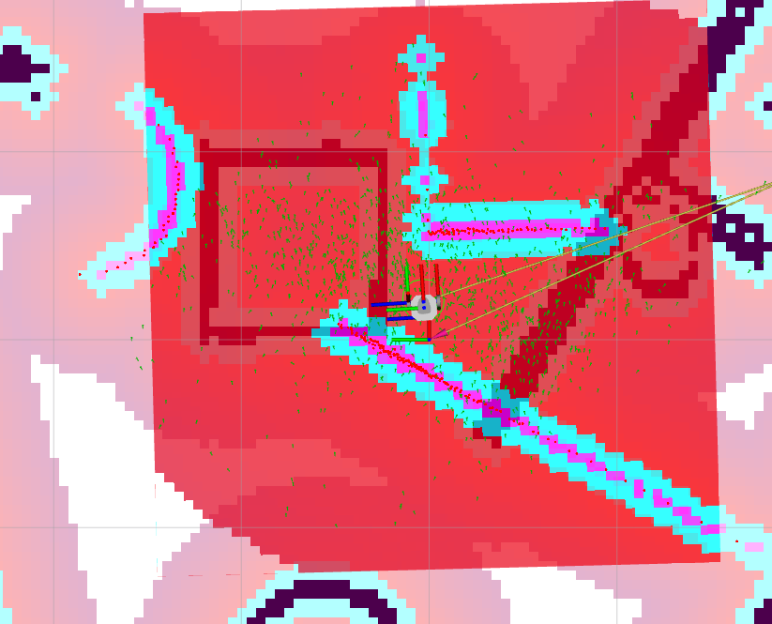

cost_scaling_factor=1
infl_radius = 3
moves ok, but another trak
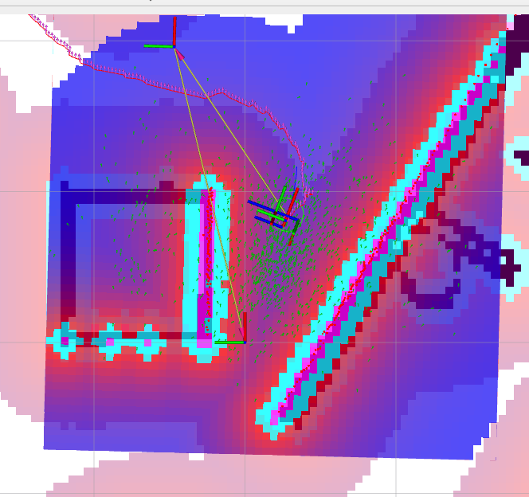

burger2.yaml is copied to /ros2_ws/src/turtlebot3/turtlebot3_navigation2/param

navigation2.launch2.py is copied to
ros2_ws/src/turtlebot3/turtlebot3_navigation2/launch/ navigation2new.launch.py
but this file contains errors. Instead use as below.

After change of paramters need
cd Documents/Robotics/Ex5/ros2_ws
colcon build
source install/setup.bash

custom world:
pkill -9 ros2
pkill -9 gzclient
pkill -9 gzserver
pkill -9 robot_state_pub
source /usr/share/gazebo/setup.sh
cd Documents/Robotics/Ex5/ros2_ws
source install/setup.bash
export TURTLEBOT3_MODEL=burger
ros2 launch turtlebot3_gazebo turtlebot3_custom_map.launch.py

navigate:

source install/setup.bash
export TURTLEBOT3_MODEL=burger2
ros2 launch turtlebot3_navigation2 navigation2.launch.py use_sim_time:=True map:=$HOME/Documents/Robotics/Ex5/map.yaml

Task 4 Automatic map exploration works good with gazebo_world, but custom map is too complicated.

pkill -9 ros2
pkill -9 gzclient
pkill -9 gzserver
pkill -9 robot_state_pub
pkill -9 lidarNode
source /usr/share/gazebo/setup.sh
cd Documents/Robotics/Ex5/ros2_ws
source install/setup.bash
export TURTLEBOT3_MODEL=waffle
ros2 launch turtlebot3_gazebo turtlebot3_world.launch.py

ros2 launch turtlebot3_gazebo turtlebot3_house.launch.py
ros2 launch turtlebot3_gazebo turtlebot3_custom_map.launch.py

####################
source /usr/share/gazebo/setup.sh
cd Documents/Robotics/Ex5/ros2_ws
source install/setup.bash
export TURTLEBOT3_MODEL=waffle
ros2 launch turtlebot3_cartographer cartographer.launch.py use_sim_time:=True

##################
source install/setup.bash
pkill -9 lidarNode
ros2 run lidar_avoidance lidarNode

###################
ros2 run nav2_map_server map_saver_cli -f ~/map

###### if robot is stack use teleop #################
source install/setup.bash
export TURTLEBOT3_MODEL=waffle
ros2 run turtlebot3_teleop teleop_keyboard

1. Automatic Exploration Strategy
To explore the environment autonomously, you can use several motion generation and exploration techniques:
- Frontier-based Exploration: This approach involves detecting the boundary between known (mapped) and unknown (unmapped) areas. The robot can then move toward frontiers to incrementally expand the map.
- Random Walk with Obstacle Avoidance: If a structured exploration strategy is unnecessary, the robot can follow a semi-random walk pattern, avoiding obstacles with lidar data and gradually covering the space.
- Wall-following or Coverage Pattern: For environments with walls and obstacles, the robot can follow walls or perform grid-like movements (e.g., lawn-mowing pattern) to ensure thorough area coverage.

2. Evaluating Mapping Progress (is not implemented here)
Mapping progress can be evaluated based on several key criteria:

a. Coverage Percentage
- Track the percentage of the environment that has been mapped. This can be calculated by checking the occupancy grid and seeing how much of it has been marked as known space.
- Set a target threshold (e.g., 95% coverage) as the completion criterion.

b. Frontier Detection
- Unmapped Frontiers: The robot should continuously search for frontiers, which are borders between known and unknown spaces. If no new frontiers are detected, it suggests that most of the environment has been mapped.
- Distance to Frontiers: If all frontiers are unreachable or lie outside the robot's safe range, this could indicate that mapping is complete.

c. Loop Closure
- If you’re using SLAM, loop closure helps correct drift by recognizing previously visited areas. Successful loop closures indicate consistent map quality.
- When the robot revisits known areas and matches them with the existing map, it shows that mapping is progressing correctly and could signal the end when all areas loop back consistently.

d. Positional Uncertainty or Map Consistency
- Check the SLAM algorithm’s positional uncertainty to evaluate map quality. Lower uncertainty values indicate a stable and reliable map.
- Map consistency can be evaluated by overlaying subsequent scans. If the scans consistently align with the map, mapping is likely complete.

e. Path Planning Success Rate
- Test path planning between mapped points. If the robot can consistently plan and execute paths across the map without discovering new obstacles, the map is likely complete.

3. Criteria for Map Completion
Based on the above, here are possible conditions to determine if mapping is complete:
- No New Frontiers: If there are no more frontiers or all frontiers are inaccessible, this indicates that mapping is complete.
- High Coverage Threshold Reached: Once a set coverage threshold (e.g., 95%) of the environment has been mapped, consider the map complete.
- Consistent Loop Closures and Path Planning: If loop closure has been achieved, and the robot can reliably navigate the map without encountering unmapped areas, then the map is consistent and complete.

4. Additional Considerations for Robust Mapping
- Redundant Scanning: Occasionally revisit areas to verify map accuracy and consistency, especially in dynamic environments.
- Efficient Battery Management: Since mapping can be resource-intensive, implement strategies for battery conservation or recharging, if possible.
- Obstacle Dynamics: If the environment has moving obstacles, ensure the robot can update its map dynamically when these are detected.

Example Implementation Outline
Here’s a high-level outline of the implementation steps:
- Initialize SLAM and Navigation Nodes: Start the SLAM process and enable navigation with a frontier-based exploration algorithm or similar.
- Move to Frontiers Automatically: Use the robot motion generation functions to move to detected frontiers, updating the map as the robot progresses.
- Monitor Mapping Progress:
  - Calculate coverage and check frontier availability after each scan.
  - Check for successful loop closures and path planning success.
- End Mapping:
  - Stop the mapping process when criteria (like coverage threshold or no frontiers) are met.
- Finalize and Save Map: Once mapping is complete, save the map to disk for future use.

Add ex5/turtlebot3_custom_map.launch.py into turtlebot3_ws/src/turtlebot3_simulations/turtlebot3_gazebo/launch
Add turtlebot3_custom_world.world into turtlebot3_ws/src/turtlebot3_simulations/turtlebot3_gazebo/worlds

cd Documents/Robotics/Ex5/ros2_ws
colcon build –symlink-install
source install/setup.bash
export TURTLEBOT3_MODEL= whatever model you wan
ros2 launch turtlebot3_gazebo turtlebot3_custom_map.launch.py

export TURTLEBOT3_MODEL= whatever model you want
ros2 launch turtlebot3_cartographer cartographer.launch.py use_sim_time:=True

----- Here would be the part where you open another terminal and start teleop --------

ros2 run nav2_map_server map_saver_cli -f ~/map

However, due to few errors[1][2] in the launch file and the configuration file of the ros package, changing these
parameters will not produce the expected outcomes. Use the configuration file (burger2.yaml) and launch
file (navigation2.launch2.py) provided with the handout instead.
10. Open a fresh terminal and run the below commands to copy the two files to respective directories.
Remember to replace {file_path} with correct path where you downloaded the two files.
$ sudo cp /{file_path}/burger2.yaml \
/opt/ros/foxy/share/turtlebot3_navigation2/param
$ sudo cp /{file_path}/navigation2.launch2.py \
/opt/ros/foxy/share/turtlebot3_navigation2/launch
11. Launch navigation again as in the step 6.3.2 of the tutorial
$ export TURTLEBOT3_MODEL=burger2
$ ros2 launch turtlebot3_navigation2 navigation2.launch2.py
\use_sim_time:=True map:=$HOME/map.yaml

cartographer:
pkill -9 rvitz2
pkill -9 cartographer_no
pkill -9 cartographer_oc
export TURTLEBOT3_MODEL=waffle
ros2 launch turtlebot3_cartographer cartographer.launch.py

slam:
ros2 launch turtlebot3_slam turtlebot3_slam.launch

