LED House — Electrical Shop
"Where every home finds its light."

Software Analysis & Design — System Documentation

Table of Contents
Sec. | Section Title
01 | Onion Diagram
02 | User Scenarios
03 | User Story Cards
04 | BPMN Process Diagrams

01 — Onion Diagram
The onion diagram represents the system architecture of LED House in concentric layers, moving from the most fundamental logic at the centre outward to external actors at the boundary.

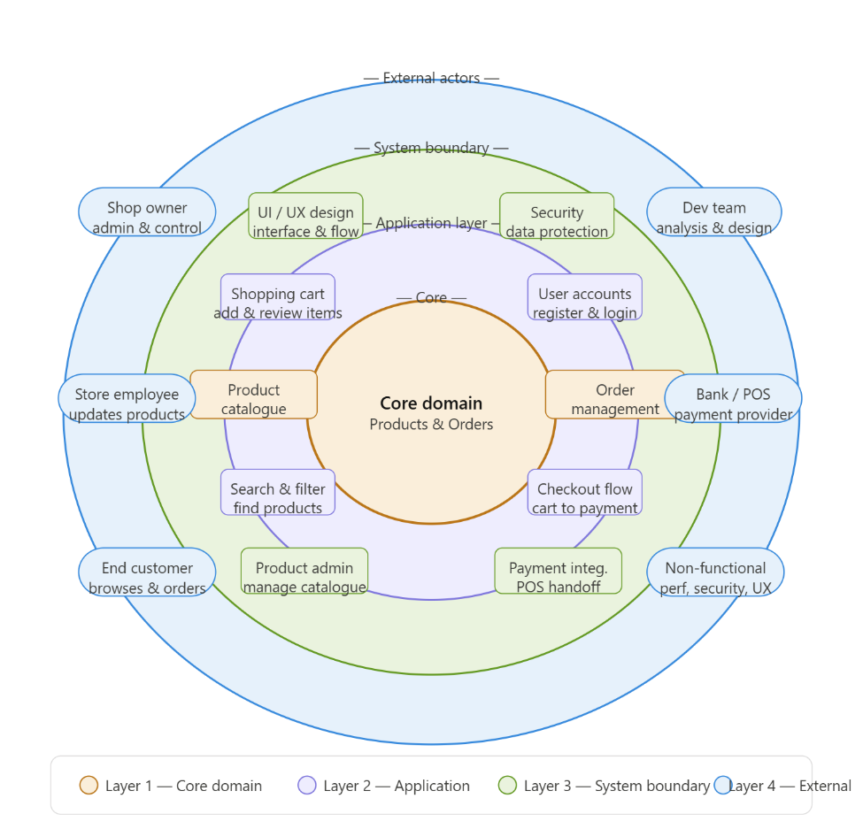
Layer 1 — Core Domain (innermost) This is the heart of the system. It contains the two fundamental business objects that the entire platform is built around: the Product Catalogue, which stores all product data including names, descriptions, prices, and categories; and Order Management, which handles the creation, tracking, and status of customer orders.

Layer 2 — Application Layer This layer contains the features that users directly interact with. It includes the Shopping Cart (allowing customers to add and review items before purchase), Search & Filter (enabling quick product discovery), User Accounts (customer registration and login), and the Checkout Flow (the journey from a filled cart to a completed order).

Layer 3 — System Boundary This layer defines how the system presents and protects itself. It includes the UI/UX Design layer (the interface and navigation structure), Security & Data Protection (handling safe storage of user data), the Product Admin Panel (allowing the owner and employee to add, edit, and remove products), and Payment Integration (the handoff point to the external bank POS system).
Layer 4 — External Actors (outermost) These are the stakeholders and external systems that interact with LED House from outside its boundary. They include the Shop Owner (high influence, responsible for admin and control), the Store Employee (assists with product updates), the End Customer (browses and places orders), the Bank/POS Provider (processes online payments), the Development Team (responsible for analysis and design), and Non-Functional Requirements (performance, security, and usability constraints that shape the whole system).

02 — User Scenarios
Narrative descriptions of how different stakeholders interact with the LED House system in real-world context. Each scenario anchors a cluster of system requirements and illustrates the value the system delivers.
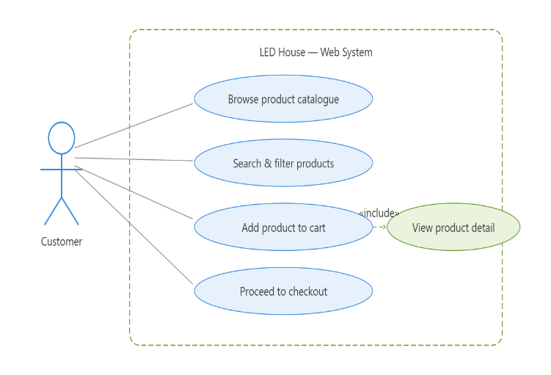

User Scenario 1 — Customer browses & buys a product Actor: End Customer. The customer opens the LED House website and browses the product catalogue. They use the search and filter functions to narrow down results by category or price. Once they find a product of interest, they view its detail page, then add it to the shopping cart and proceed to checkout.

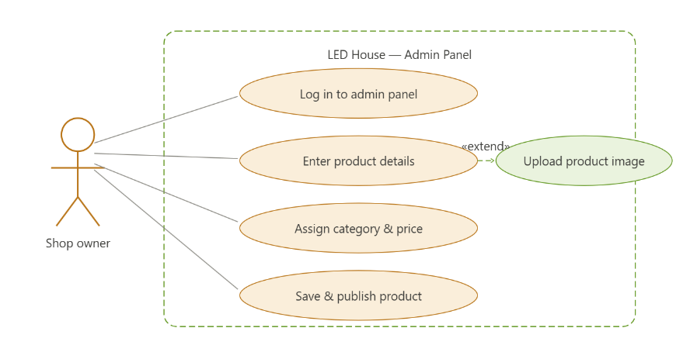
User Scenario 2 — Shop owner adds a new product Actor: Shop Owner. The shop owner logs in to the admin panel and navigates to the product management section. They enter the product name, description, price, and category. Optionally, they upload a product image (extend relationship). Once all details are confirmed, they save and publish the product, making it immediately visible in the customer-facing catalogue.

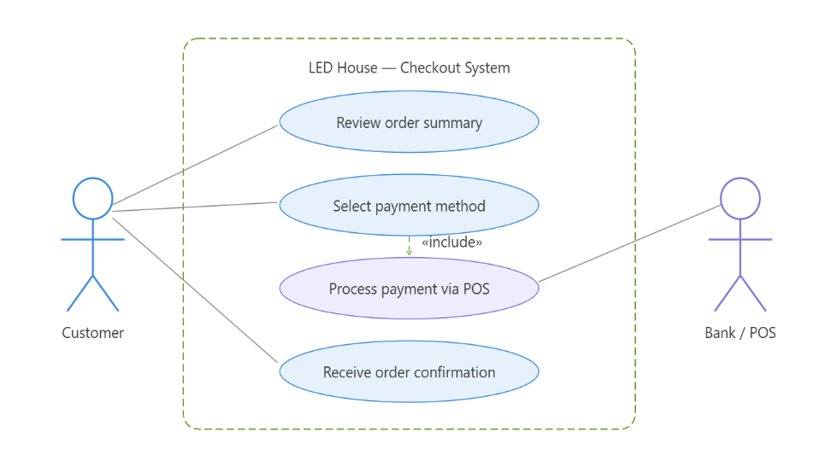

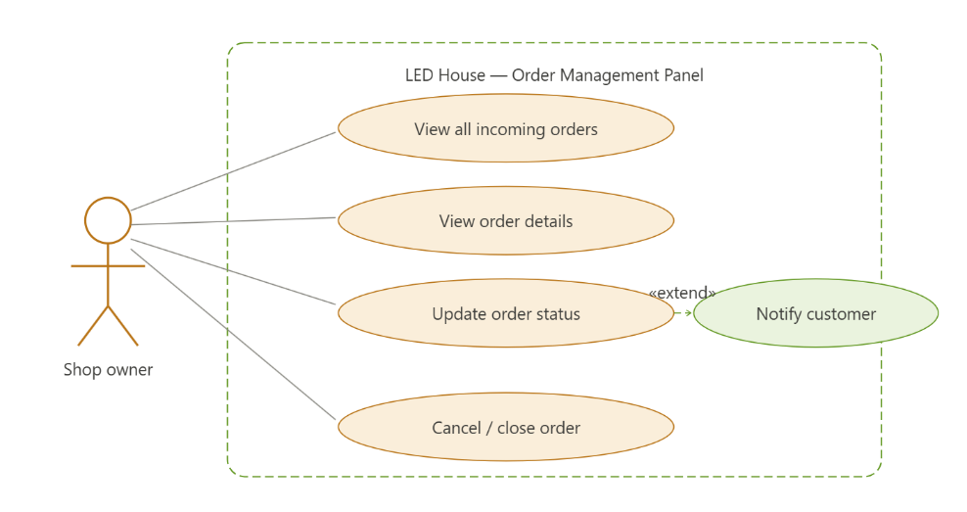
User Scenario 3 — Customer makes a payment via POS Actors: Customer, Bank / POS Provider. After completing the cart, the customer reviews their order summary and selects a payment method. The system hands off the transaction to the external bank POS service (include relationship), which processes the payment securely. Upon successful payment, the customer receives an order confirmation on screen.

User Scenario 4 — Shop owner views & manages orders Actor: Shop Owner. The shop owner logs in to the admin panel and views the list of all incoming orders. They can open any order to view its full details, including items, quantities, and customer information. They then update the order status (e.g. pending → processing → dispatched). Optionally, the system can notify the customer of the status change (extend relationship). The owner can also cancel or close an order if needed.

03 — User Story Cards
Formal user stories following the template: As a [role], I want [feature], so that [benefit]. Each card includes acceptance criteria and a priority level (HIGH / MEDIUM).

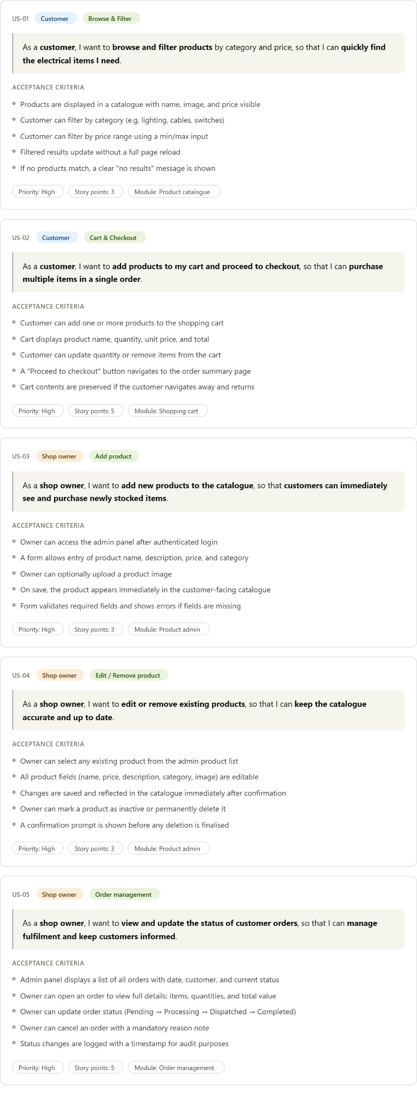
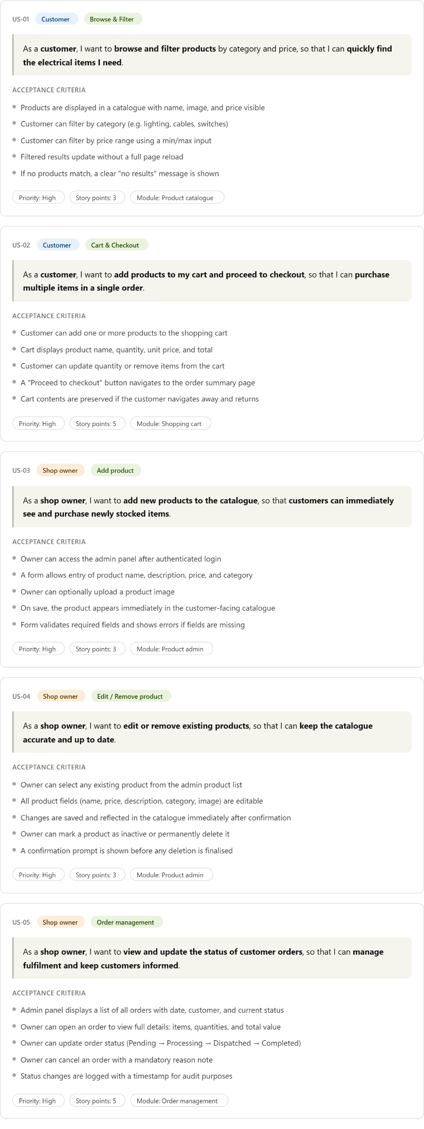

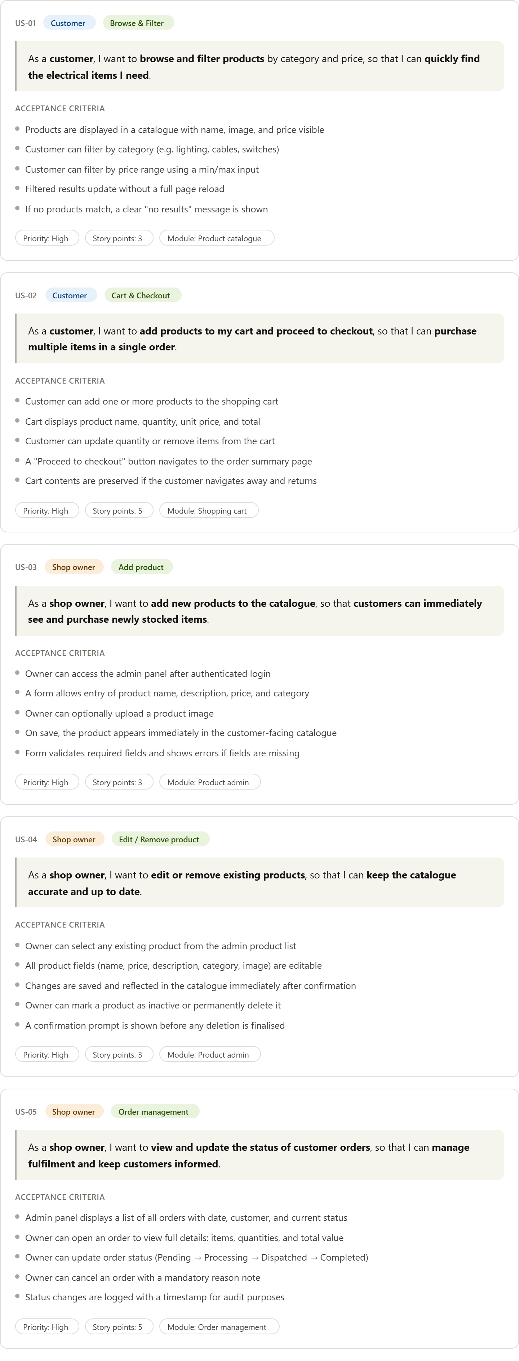

04 — BPMN Process Diagrams
Business Process Model and Notation (BPMN 2.0) diagrams for the five core workflows. Pools (labelled swimlanes on the left) represent organisational participants. Solid arrows show sequence flow within a pool; dashed purple arrows show message flow between pools.

BPMN 1 — Customer Purchase Flow: A browsing and filtering sequence leads the customer to checkout — the system validates stock and reduces inventory, a POS request is sent to the bank, and the returned payment status triggers either a confirmation email and new order alert to staff, who then prepare and hand over the order, or a failure notification ending the process.
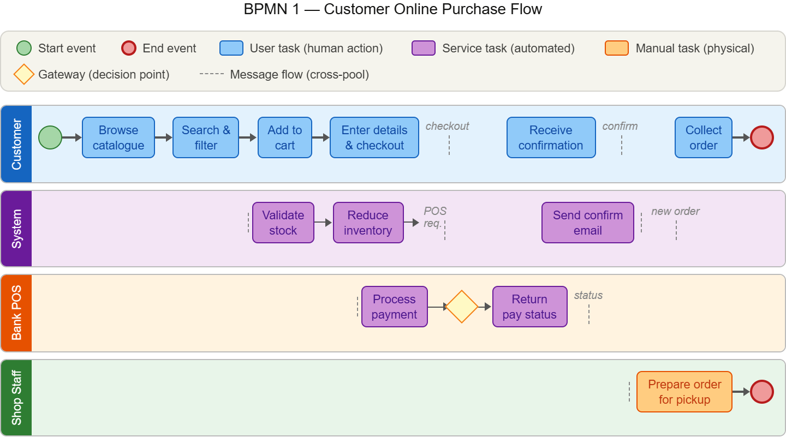
BPMN 2 — Product Management: Two paths split at a gateway (new vs update), both merge into submit → system validates → publishes to catalogue. Invalid submissions loop back to the owner.
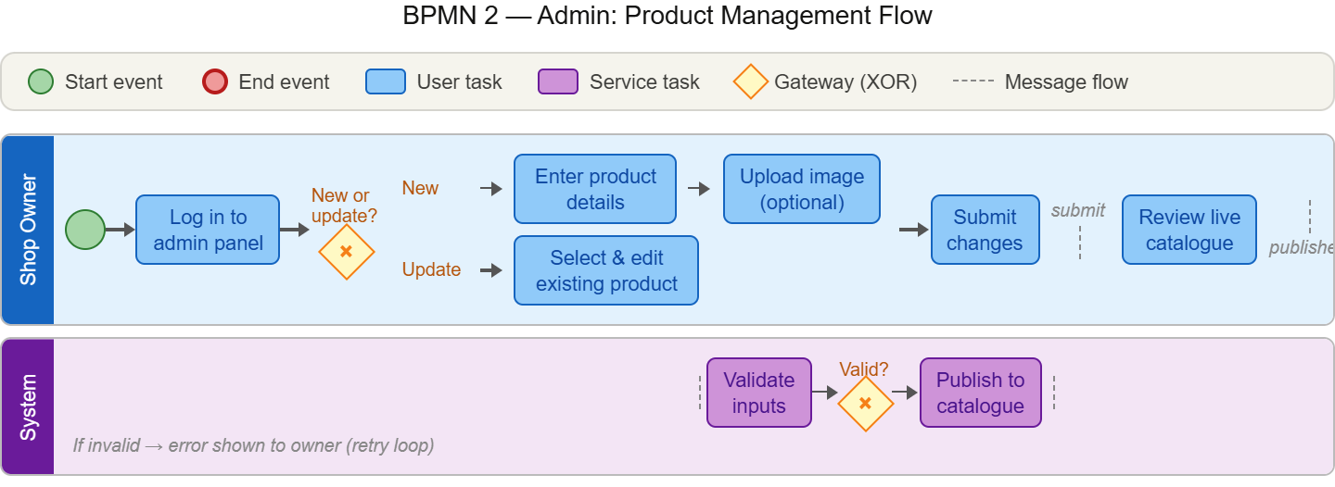

BPMN 3 — Order Fulfilment: The stock availability gateway is the key branch — "in stock" triggers pick & pack by staff and customer collection, while "out of stock" sends a notification and ends the process.

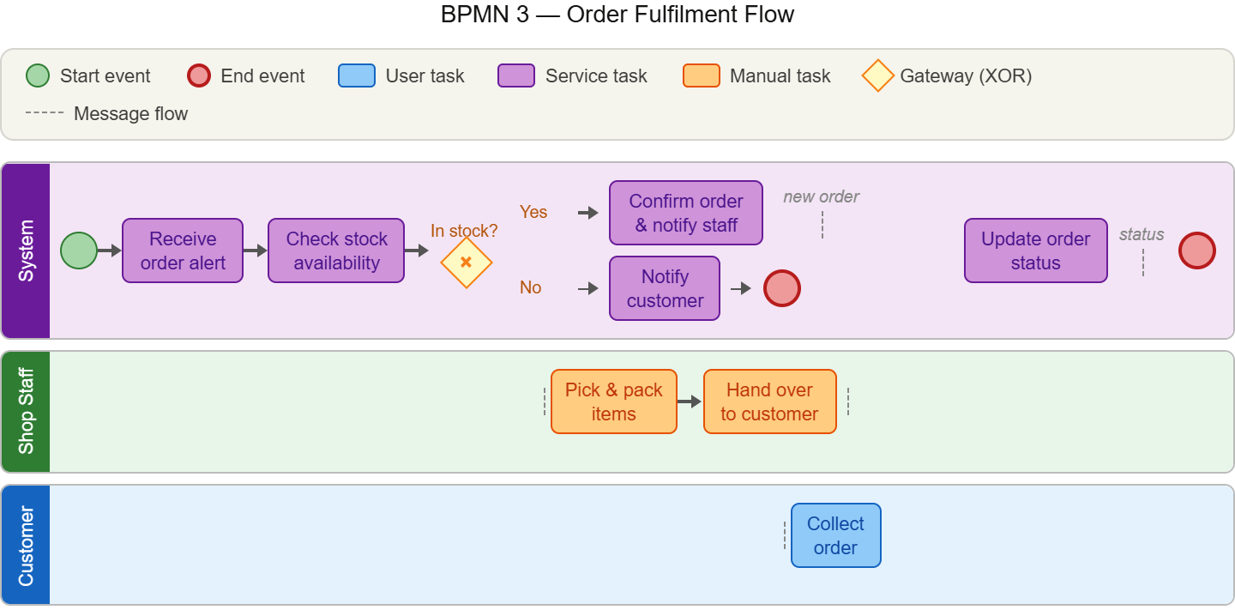

BPMN 4 — Payment Processing: The system redirects to the Bank POS lane, which processes and returns a status. A success/failure gateway then either confirms the order or notifies of failure.
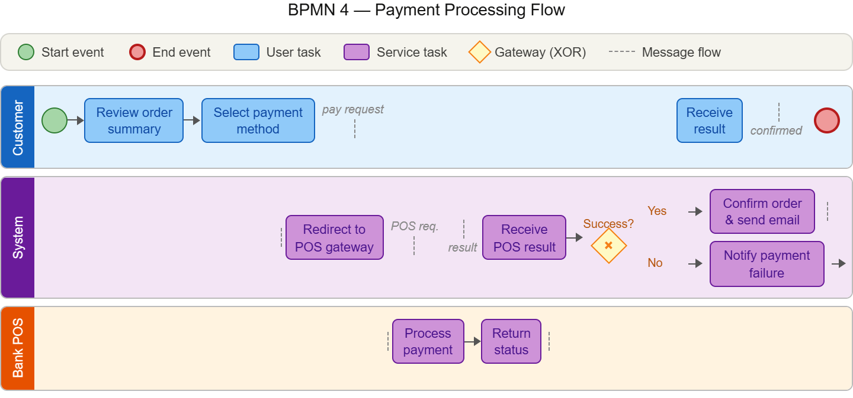

BPMN 5 — Registration & Login: A new/returning gateway splits the flow — new users fill a form and get an account created, returning users submit credentials which are validated. Invalid credentials trigger an error with a retry loop noted.
