Title Style
Abstract
The love of men is a frigid thing, a mountain stream only three steps from the ice. We are his. Oh Stormfather . . . we are his. It is but a thousand days, and the Everstorm comes.
Contents
1 Heading 1 1
1.1 Heading 2 1
1.1.1 Seed Heading 3 1

Heading 1
Szeth-son-son-Vallano, Truthless of Shinovar, wore white on the day he was to kill a king. The white clothing was a Parshendi tradition, foreign to him. But he did as his masters required and did not ask for an explanation.
He sat in a large stone room, baked by enormous firepits that cast a garish light upon the revelers, causing beads of sweat to form on their skin as they danced, and drank, and yelled, and sang, and clapped. Some fell to the ground red-faced, the revelry too much for them, their stomachs proving to be inferior wineskins. They looked as if they were dead, at least until their friends carried them out of the feast hall to waiting beds.

Heading 2
Szeth did not sway to the drums, drink the sapphire wine, or stand to dance. He sat on a bench at the back, a still servant in white robes. Few at the treaty-signing celebration noticed him. He was just a servant, and Shin were easy to ignore. Most out here in the East thought Szeth’s kind were docile and harmless. They were generally right.
The drummers began a new rhythm. The beats shook Szeth like a quartet of thumping hearts, pumping waves of invisible blood through the room. Szeth’s masters—who were dismissed as savages by those in more civilized kingdoms—sat at their own tables. They were men with skin of black marbled with red. Parshendi, they were named—cousins to the more docile servant peoples known as parshmen in most of the world. An oddity. They did not call themselves Parshendi; this was the Alethi name for them. It meant, roughly, “parshmen who can think.” Neither side seemed to see that as an insult.

Heading 3
The Parshendi had brought the musicians. At first, the Alethi lighteyes had been hesitant. To them, drums were base instruments of the common, darkeyed people. But wine was the great assassin of both tradition and propriety, and now the Alethi elite danced with abandon.
Szeth stood and began to pick his way through the room. The revelry had lasted long; even the king had retired hours ago. But many still celebrated. As he walked, Szeth was forced to step around Dalinar Kholin—the king’s own brother—who slumped drunken at a small table. The aging but powerfully built man kept waving away those who tried to encourage him to bed. Where was Jasnah, the king’s daughter? Elhokar, the king’s son and heir, sat at the high table, ruling the feast in his father’s absence. He was in conversation with two men, a dark-skinned Azish man who had an odd patch of pale skin on his cheek and a thinner, Alethi-looking man who kept glancing over his shoulder.

Heading 4
The heir’s feasting companions were unimportant. Szeth stayed far from the heir, skirting the sides of the room, passing the drummers. Musicspren zipped through the air around them, the tiny spirits taking the form of spinning translucent ribbons. As Szeth passed the drummers, they noted him. They would withdraw soon, along with all of the other Parshendi.
They did not seem offended. They did not seem angry. And yet they were going to break their treaty of only a few hours. It made no sense. But Szeth did not ask questions
$$w_{ij}=α⋅\cos\left(v_{i},v_{j}\right)+\left(1-α\right)⋅0.3$$
Table 1
Far-field control domain clusters
Domain | L1 cluster | Papers | Score
Quantum computing | L1=9 | 18,864 | 1
Synthetic chemistry | L1=19 | 12,414 | 1
Astrophysics | L1=11 | 17,562 | 1
Social Sciences/Economics | L1=13 | 16,372 | 1
Computer vision / ML | L1=17 | 13,738 | 1
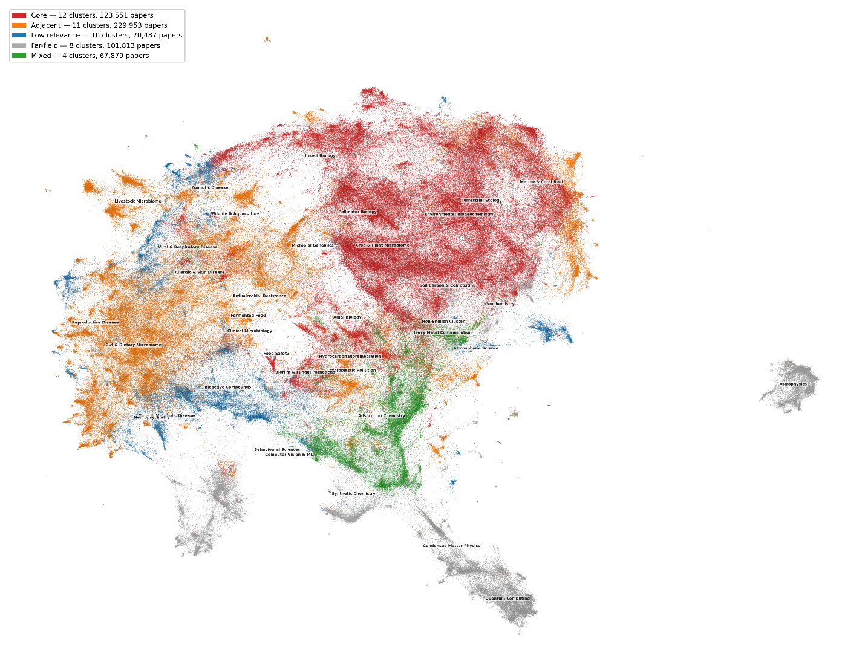
Figure 2 Semantic landscape of the soil microbiome literature: 45 major themes
Two-dimensional UMAP projection of 810,517 papers coloured by scoring tier: core (red, 12 clusters by pipeline scoring, 323,551 papers, >50% score 4–5), adjacent (orange, 11

