Title Style
Authors
Michael Sinclair
Charles Sturt University [ORCID]
Jian Liu, Yang Fong CSU
Abstract
Agricultural rhizosphere research informs decisions about inoculants, soil amendments, and crop rotation, yet operates almost entirely at the amplicon and isolate resolution. Genome-resolved approaches, metagenome-assembled genomes, genome-scale metabolic models, and community flux balance analysis are well established in non-agricultural soils but rare in agricultural soils. This review asks what the field stands to gain from adoption and why. A six-stage computational pipeline mapped ~810,000 soil microbiome papers using SPECTER2 embeddings, a hybrid citation–semantic graph comprising ~1.9 million papers and clustered them using Leiden community detection. Bridge signals between thematic clusters and genome-resolved methods clusters were quantified as method-transfer gaps. Signals between agricultural rhizosphere communities, metagenomic assembly (MAG), and genome-scale metabolic modelling (GSMM) clusters ranged from 0.749 to 0.94, indicating near-complete vocabulary divergence despite substantial citation traffic. A hub classification framework confirmed that the divergence reflects genuine non-adoption rather than disciplinary reframing of shared methods. Directed reading of over 90 papers across four functional dimensions, disease suppression, abiotic stress tolerance, nutrient cycling, and resistome dynamics converged on four findings. Functional attribution at amplicon resolution is unreliable, and its error rate can be measured against MAG-level data. Culture-dependent screening systematically excludes organisms that community-level analysis identifies as keystones. Community metabolic modelling leading to synthetic community transplantation has been demonstrated only once in an agricultural system. This review concludes that multifunctional organisms are the rule, not the exception, and strain selection for one function should not proceed without genome-level information about the others. Their shared trend is that amplicon resolution relates organism identity to function via databases of cultured isolates. However, these relationships fail whenever the organisms present lack close cultured relatives or carry traits beyond their database entries. Further research is required to report and analyse these limitations. Public data already exists, and many developing tools are open-source and validated. The biological questions, implications and limitations are presented here; what remains is to apply the methods to the agricultural systems where the questions are most pressing.

Table Style
Col1 | Col2
Value | Text
Value | Text
Value | Text

Contents
1 Introduction i
2 Methods i
2.1 Reference Database Retrieval i
2.1.1 Seed corpus and manual expansion i
2.1.2 Hybrid Graph Construction ii
2.2 Thematic landscape ii
3 References vi

Introduction
The ecological work done by soil microbial communities (nutrient cycling, decomposition, pathogen suppression, and the maintenance of soil structure) is heterogeneous in a specific way: the organisms and mechanisms involved change with soil type, land use, climate, and disturbance history, and findings from one system rarely transfer cleanly to another. The research literature responds to this by being similarly heterogeneous. It draws on molecular microbiology, agronomy, ecosystem ecology, remediation science, and applied biotechnology at once, and a reader trying to understand a particular process in a particular soil is usually reading across several of those fields rather than within any one of them. Conventional reading, one paper at a time, is a reasonable way to develop depth in a subfield. It is not a reliable way to see the field's overall structure.

Methods
The computational pipeline constructs a thematic map of the soil microbiome literature from the ground up, treating the corpus of retrieved papers as a network rather than a list. The pipeline proceeds in six stages, summarised in Figure 1 and described in the sections that follow.
References were retrieved from literature databases through systematic keyword searching, supplemented by citation graph expansion (Section 2.1). An iterative refinement loop ensured that each network analysis informed the next round of queries. SPECTER2 (Singh et al., 2022), a transformer model fine-tuned on citation triplets from the Semantic Scholar Academic Graph, generated semantic embeddings from paper titles and abstracts. These embeddings were combined with citation edges to produce a hybrid graph in which edge weights reflect both thematic similarity and scholarly citation structure (Section 2.2). Community detection via the Leiden algorithm (Traag et al., 2019) then organised the hybrid network into a recursive hierarchy of major themes, sub-topics, and bridge communities (Section 2.3).
The six-stage pipeline is summarised in Figure 1; stages 4–6 (topology analysis, relevance scoring, and cross-domain bridge detection) are detailed in Sections 2.4–2.6. In-text links direct the reader to technical documents about tools, algorithms, and method descriptions; see SI 23 for a complete list of terms.

Reference Database Retrieval
The corpus was assembled in three stages corresponding to the subsections below. An initial manually directed phase (Section 2.1.1) built a seed corpus through theme-based search and targeted iterative expansion to correct for citation bias. A validation-control phase (Section 2.1.2) added off-topic anchor papers to the corpus before any citation-based expansion was run. A citation-graph expansion (Section 2.1.3) then grew the combined pool into the final corpus used for network analysis.

Seed corpus and manual expansion
The review began with SciSpace, a GPT-powered literature search application, to identify an initial seed corpus of approximately 400 papers. References were managed in a shared Zotero library throughout (see SI 7 for the prompts used). TF-IDF (Salton & Buckley, 1988) generation and manual review identified five search themes that structured the initial retrieval: nitrogen cycling, disease suppression, pathogen dynamics, abiotic factors, and dysbiosis. Theme-based retrieval using SciSpace and Zotero expanded the initial set into a seed corpus of approximately 600 papers.

Hybrid Graph Construction
The citation backbone was taken from the expansion described in Section 2.1.3. Citation edges encode a factual relationship, one paper cites another, and were retained regardless of whether both endpoints possessed embeddings. All citation relationships were treated as undirected for graph fusion.
Semantic reweighting was then applied to adjust citation edge weights based on the thematic similarity between connected papers. For edges where both endpoints possessed SPECTER2 embeddings, the hybrid weight was computed as a linear blend of cosine similarity and a default prior:
$$w_{ij}=α⋅\cos\left(v_{i},v_{j}\right)+\left(1-α\right)⋅0.3$$
where $v_{i}$ and $v_{j}$ are the SPECTER2 embedding vectors of papers $i$ and $j$, and $α= 0.5$ assigns equal weight to the semantic and citation components. For edges where one or both endpoints lacked embeddings, a default weight of 0.3 was assigned. This default is a principled prior: the citation relationship is known to be real, but the degree of thematic proximity cannot be quantified from text alone.
Table 1
Far-field control domain clusters
Domain | L1 cluster | Papers | Score
Quantum computing | L1=9 | 18,864 | 1
Synthetic chemistry | L1=19 | 12,414 | 1
Astrophysics | L1=11 | 17,562 | 1
Social Sciences/Economics | L1=13 | 16,372 | 1
Computer vision / ML | L1=17 | 13,738 | 1
The validation prediction holds at both scales, between clusters (centroid similarity) and within clusters (spatial modes). Details on embedding geometry, dynamic range, and within-cluster spatial structure are reported in SI 18.

Thematic landscape
The Leiden algorithm (Traag et al., 2019) was applied to the full hybrid network at resolution γ = 1.0 (Section 2.3.1). Dissolution of clusters with fewer than 100 papers reduced the L1 partition to 45 real clusters plus one unassigned pseudo-cluster (L1 = −1, containing 16,834 isolated papers, 2.1% of the corpus). Members of dissolved clusters were reassigned to the nearest large cluster by total edge weight. Human-readable labels were generated for each cluster using TF-IDF contrastive analysis of paper titles. The full 45-cluster TF-IDF inventory is provided in Supplementary Table S1. The resulting thematic landscape is visualised in Figure 1.
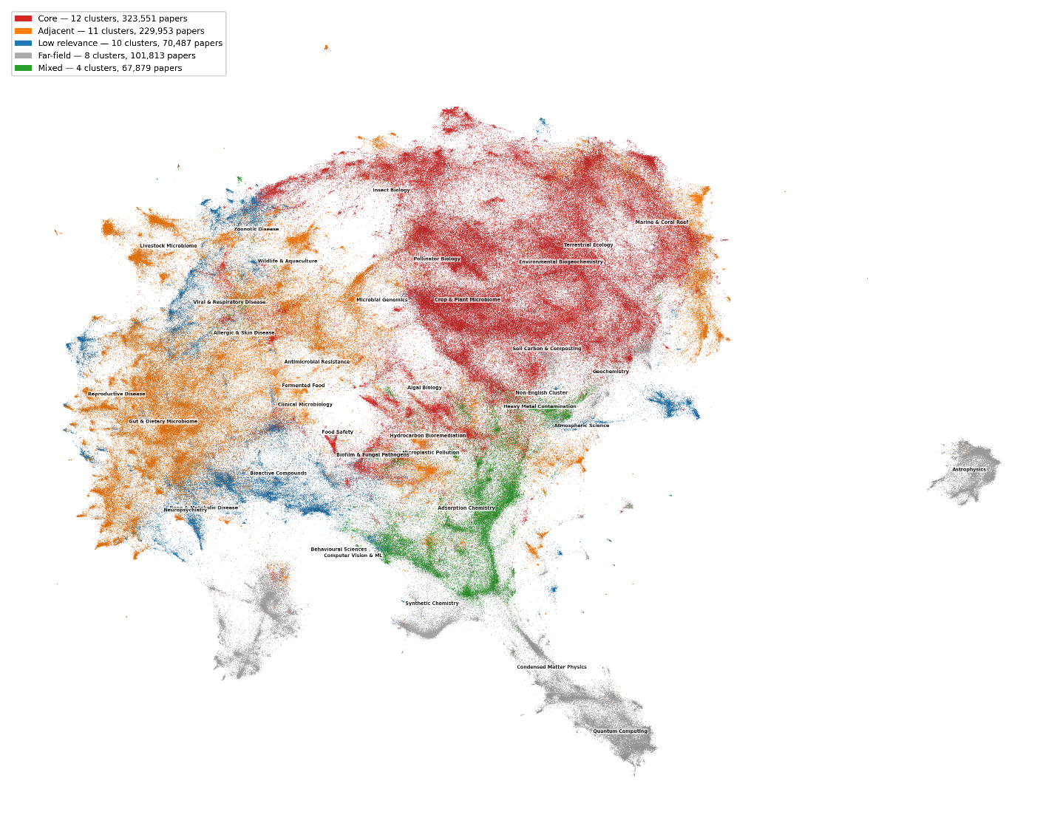
Figure 2 Semantic landscape of the soil microbiome literature: 45 major themes
Two-dimensional UMAP projection of 810,517 papers coloured by scoring tier: core (red, 12 clusters by pipeline scoring, 323,551 papers, >50% score 4–5), adjacent (orange, 11 clusters, 229,953 papers, >50% score 3), low relevance (blue, 10 clusters, 70,487 papers, >50% score 2), far-field (grey, 8 clusters, 101,813 papers, >50% score 1), and mixed (green, 4 clusters, 67,879 papers). A further 16,834 orphan papers (2.1%) are shown in light grey. Cluster display names positioned at centroids. Spatial proximity reflects semantic similarity in 768-dimensional SPECTER2 embedding space. Display names assigned by presenting top-8 TF-IDF contrastive labels to Claude Opus 4 (Anthropic, 2026) and reviewed by the author. One cluster (L1=15, COVID-19 & Respiratory Virology) exceeded the core scoring threshold on shared sequencing vocabulary rather than topical relevance and was reclassified as adjacent for thematic purposes (see Table 2).
The 45 L1 clusters resolved into four scoring tiers (Figure 1). The pipeline scoring classified 12 clusters as core (>50% of papers with scores 4–5), containing 323,551 papers. One of these, COVID-19 & Respiratory Virology (L1=15, 14,665 papers), exceeded the core threshold on shared sequencing and bioinformatics vocabulary rather than topical relevance; the split-score evidence from its L2 sub-clusters is reported in Table S 16. L1=15 was reclassified as adjacent for thematic interpretation, yielding 11 core clusters (308,886 papers) and 12 adjacent clusters (244,618 papers, including reclassified L1=15). Ten low-relevance clusters (>50% score 2) contained 70,487 papers. Eight far-field clusters (>50% score 1) contained 101,813 papers, including the five named controls and three citation-drift clusters described in Section 3.1. Four clusters with mixed score distributions contained 67,879 papers.
Table 2
Core and adjacent research domains. 11 core and 12 adjacent clusters by research domain, with human-readable names assigned from TF-IDF labels and representative paper titles
The core domain was organised around four broad functional areas, visible as spatial groupings in Figure 1 and confirmed by L2 sub-cluster analysis. Crop & Plant Microbiome (L1=1) was the largest core cluster and the most internally diverse: its 101,165 papers spanned plant growth promotion, disease suppression, abiotic stress tolerance, and nutrient management as distinct L2 sub-communities. Environmental Biogeochemistry (L1=4) overlapped spatially with L1=1 (Figure 2), reflecting shared methodological vocabulary between soil ecology and agricultural microbiome research. Terrestrial Ecology (L1=2) occupied a broader spatial footprint, connecting community ecology and biodiversity research to the soil microbiome core through shared diversity metrics and sequencing methods.
The two largest adjacent clusters occupied structurally central positions despite scoring below the core threshold. Gut & Dietary Microbiome (L1=0, 102,598 papers) was the single largest cluster in the corpus and shared extensive citation traffic with the core soil clusters. Microbial Genomics & Metagenomics (L1=5, 51,414 papers) contained the analytical method clusters genome assembly, MAG recovery, metabolic modelling, and virome analysis that the core research communities cite but have not uniformly adopted. The method-adoption gradient within L1=5 is reported in Section 3.4.
Livestock & Poultry Microbiome (L1=12) was connected to the core domain through two pathways: direct citation traffic to agricultural soil research and shared analytical methods with gut microbiome research. Antimicrobial Resistance (L1=25) bridged between clinical and environmental microbiology, with sub-clusters spanning hospital-acquired resistance, environmental ARG surveillance, and resistance gene transfer in agricultural systems.
The spotlight projections in Figure 2 and Figure 3 show the spatial footprints of selected core, adjacent, and far-field clusters.
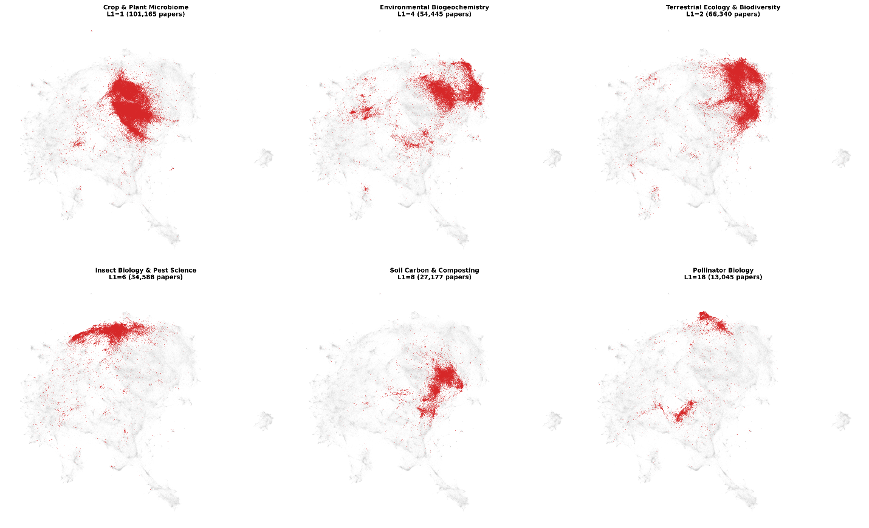
Figure 3 Spatial footprint of six core-domain clusters
Each sub-panel highlights one L1 cluster (red) against the full corpus (grey). Clusters shown: Crop & Plant Microbiome (L1=1, 101,165 papers), Environmental Biogeochemistry (L1=4, 54,445 papers), Terrestrial Ecology & Biodiversity (L1=2, 66,340 papers), Insect Biology & Pest Science (L1=6, 34,588 papers), Soil Carbon & Composting (L1=8, 27,177 papers), and Pollinator Biology (L1=18, 13,045 papers). All six clusters have >50% of papers with scores of 4–5. Spatial overlap between Crop & Plant and Environmental Biogeochemistry reflects shared methodological vocabulary.
The full 45-cluster TF-IDF inventory (Supplementary Table S1), within-cluster spatial-structure analysis, network-topology metrics, and the relevance-scoring workflow output are reported in SI Sections SI 3 through SI 6.

References
Aasfar, A., Bargaz, A., Yaakoubi, K., Hilali, A., Bennis, I., Zeroual, Y., & Kadmiri, I. M. (2021). Nitrogen-fixing Azotobacter species as potential soil biological enhancers for crop nutrition and yield stability. Frontiers in Microbiology, 12, 628379. https://doi.org/10.3389/fmicb.2021.628379

Supplementary Information
Supplementary Table S1 [STAND-IN — awaiting data]. 45-cluster TF-IDF inventory: human-readable display name and top contrastive terms for each L1 cluster.
L1 | Display name | Top TF-IDF terms
0 | [TBD] | [TBD]
1 | [TBD] | [TBD]
2 | [TBD] | [TBD]

- Within-Cluster Spatial Structure: Worked Examples
Three clusters illustrate the range of multimodal patterns observed among the 25 multimodal L1 clusters identified in 3.3.
Supplementary Figure S1. Within-cluster spatial modes in three multi-modal L1 clusters. Left column: full corpus UMAP (grey) with target L1 cluster highlighted. Right column: same view with papers coloured by spatial mode (histogram-based density peak detection, 100×100 grid, σ=2.0). (A–B) Environmental Biogeochemistry (L1=4, 54,445 papers): four modes separating the ecological core (34,621 papers), eDNA methodology (10,926), infrastructure hubs (6,122), and applied water ecology (2,472). The infrastructure mode sits 6.51 UMAP units from the ecological core. (C–D) Microbial Genomics (L1=5, 51,414 papers): two modes of near-equal size separating computational/analytical methods (25,843) from organismal/biological genomics (24,937), separated by 4.62 UMAP units. (E–F) Pollinator Biology (L1=18, 13,045 papers): three modes separating field ecology (7,342), pollinator gut microbiome research (3,072), and an intermediate interface community (2,597). The ecology–microbiome separation (8.40 UMAP units) is the largest intra-cluster distance in the corpus.
- Scoring Validation
  - Relevance Scoring Rubric
Relevance was assessed on a 1–5 integer scale. Scores were assigned to clusters (not individual papers) at each depth of the recursive hierarchy and propagated to paper-level scores through the score-resolution algorithm described in Methods Error! Reference source not found.. The rubric levels are defined as follows.
Score 5
Core interest. The cluster's thematic focus coincides with one of the review's primary research questions: soil microbiome community structure, plant–microbe interactions under agricultural management, biogeochemical cycling in terrestrial systems, or genome-resolved methodology applied to soil. TF-IDF labels and representative paper titles both reflect this focus without competing signals from non-target content. Entry into the reading pool was automatic for papers assigned to a score-5 cluster, subject to downstream filtering by publication type and abstract quality.
Score 4
Strong alignment with partial overlap. The cluster addresses content substantially relevant to the review but with a notable non-core component: adjacent systems (e.g. aquatic or marine microbial ecology with transferable methods), shared methodology with a different system (e.g. gut microbiome sequencing papers contributing amplicon-pipeline content), or a core theme studied at a resolution lower than the review focuses on. Papers entered the reading pool contingent on additional screening; score-4 clusters contributed the majority of papers advancing to full-text review.
Score 3
Adjacent domain. The cluster shares vocabulary or methods with the review target but studies a distinct system. Typical examples: analytical chemistry applied to environmental samples, ecological statistics without a microbial focus, plant physiology without a microbiome component. Score-3 clusters did not advance into deeper scoring rounds and contributed to reading only when a bridge community connection pulled specific sub-clusters back into scope.
Score 2
Methodologically related, thematically unrelated. The cluster shares analytical or statistical infrastructure with the review (e.g. network analysis, dimensionality reduction, machine learning), but its substantive content is outside the review's scope. Score-2 clusters served as calibration material for the embedding space and the hub-classification framework; they did not contribute to reading.
Score 1
Far-field. The cluster occupies a region of the corpus with no shared vocabulary, concepts, or methods relevant to the review. Score-1 assignments include the five deliberately seeded far-field controls (quantum computing, astrophysics, synthetic chemistry, behavioural economics, computer vision/ML) and three clusters that entered the corpus through citation-chain drift (condensed matter physics, non-English-language artefact cluster, battery/energy). Score-1 clusters were retained in the analysis as validation anchors (Section SI 2.3) but were excluded from all reading.
A cluster's score is a statement about the cluster's typical content, not a guarantee that every paper it contains conforms to that level. Cross-dataset re-scoring (Section SI 2.2) quantifies the within-cluster heterogeneity: the majority of score-5 cluster papers moved downward during independent re-clustering (Supplementary Table S 1 ), confirming that the score-5 category at L1 resolution aggregated genuinely core papers together with adjacent content that finer clustering could separate.

