Michael Sindle
Module 9.2 Assignment
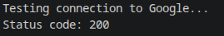

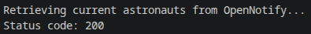

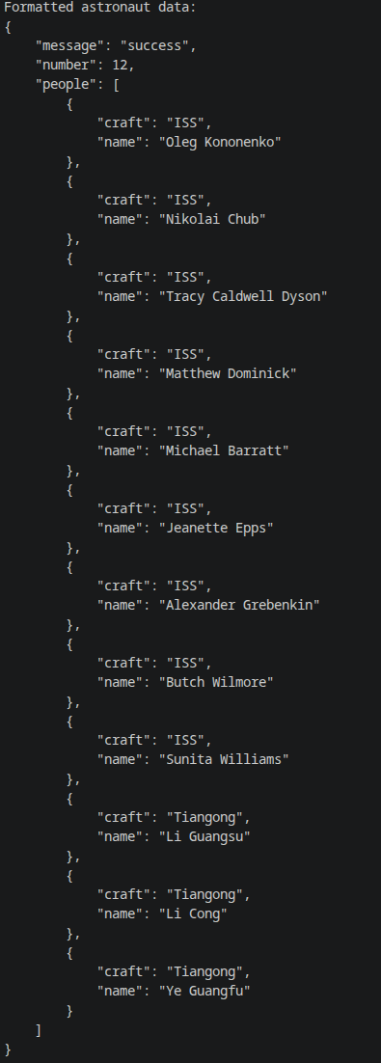

Part 2

