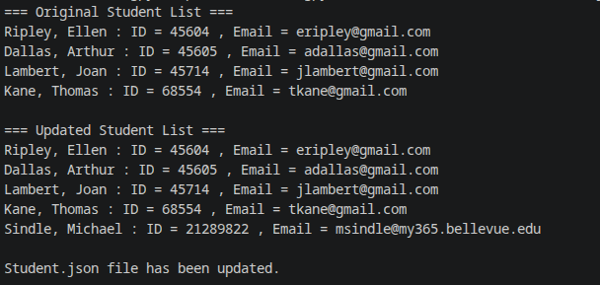

I had to do the message saying this file was modified a bit differently. I think part of the reason is im on an Arch Linux distro.

