**Part 1: Requirements and Specifications**

1. **Group Name:** GitHub Group
2. **Project Title:** Product Sales and Customer Reporting
3. **Business or Organization Summary:**

The organization is a Communications and Media Company and one of the largest cable provider in the U.S. that provides high-speed Internet, digital TV, pay TV products and voice services plus advanced home security to approximately 4.9 million residential and business customers in 21 US states. The main objective of this project is to provide daily, weekly, and monthly sales and customers reports to the Sales Management team on the customers who are subscribed to cable, internet, home security or phone services provided by the organization. The reports generated will also provide insights on the competitors available in customer region which will help the management in either providing offers/discounts to the existing customers who have a tendency to churn or cross sell other products which are offered thereby improving sales effectiveness. MicroStrategy and Tableau will be leveraged as the reporting interface for users.

1. **Customers: Who are the customers or end-users of the database system data?**

The direct users of the database system data are - Data Analysts, Business Analysts and Developers. Data Analysts will retrieve, gather and analyze data about the customers and competitors in a region. They will organize it and use it to build reports, charts and visual presentations on past customer patterns, new trends, subscription purchases, and regions to create models for predicting future customers or subscription purchases.

Business Analysts use data to help the organization to make more effective business decisions and plans. They can query the database as part of analysis to get information to help management with best plan to increase sales, customer use, subscription purchases etc. as well as using the data to identify problems and solutions. They will also create and execute SQL test scripts as part of the solution built by the developers.

Developers will work directly with business analysts and build scalable data visualizations in Tableau and/or MicroStrategy which connects to the SQL database, and perform ad-hoc analysis on business problems that provide actionable insights on the customers. They will also write complex SQL and Custom SQL queries to support the business requirements.

The Indirect Users of the database system are Project Managers and Business Users. These users will be using the dashboards and presentation provided by the Data Analysts, Business Analysts and Developers to build business plans for the company to bring in possible higher revenue, more customers compared to competitors, possible areas they should focus more on, along with areas of the company that have succeeded the most and possible marketing campaigns (target audience, region, etc.).

1. **What are the entities? Please list at least 5 tables or entities.**

Five entities for this database system are:

1. Customer

2. Subscription

3. Plan

4. Billing

5. Region

1. **What are the attributes? Please list at least 3 attributes for each table.**

1. Customer –

* 1. customer_ID - Unique number used to identify the customer
  2. last_name - Customer last name
  3. first_name - Customer first name
  4. user_name - an identification used by a customer to access online service

2. Subscription –

* 1. subscription_ID - Unique number used to identify the Subscription
  2. offer_code - Any specific offer the customer has signed (like new customer offer)
  3. start_date - Subscription start date

3. Plan –

* 1. plan_ID - Unique number used to identify the plan
  2. plan - Plan code to identify the type of plan (Internet, TV, Voice, Home Security)
  3. description - Plan description

4. Billing –

* 1. account_number - Unique number that identifies the customer account for billing
  2. account_type - Identify whether the account is Residential or Business
  3. bill_amount - The total amount billed to the customer
  4. balance_due - Balance that has not been paid in full for a given month

5. Region –

* 1. headend - Unique code to identify the cable head-end region
  2. state - State, the head-end belongs to
  3. city - City, the head-end belongs to
  4. zip_code - Zip Code, the head-end belongs to
  5. comp_code1 - Competitor Code in the head-end region, if any

**Part 2: Design**

**Part 2.1: Draw a complete E-R diagram for your project. You need to have and draw entities, attributes, and cardinalities using the MySQL Workbench or tools such as lucidchart.com or MS Visio.**

**Part 2.2: Please design a relational database schema for part 1. Make sure you identify your primary key.**

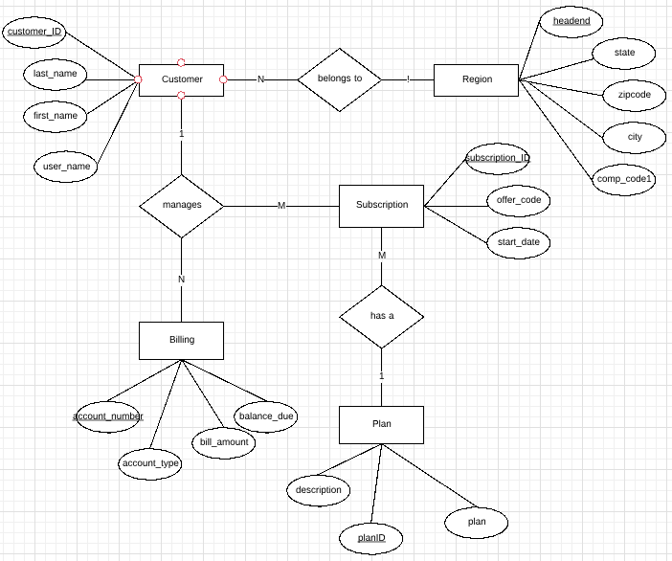

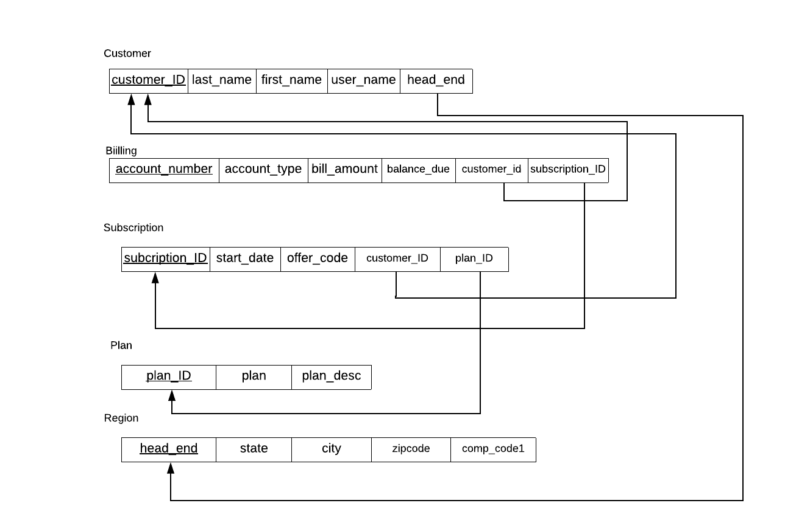

**Part 2.3: Provide at least 3 examples to show how the relations between tables can help users for their queries. These examples should cover at least three of the relations between tables.**

1. To get the list of competitors in a particular region and the customers who are likely to change their provider, we will connect customer, region and subscription tables. (Assuming that a customer may churn at the end of the new customer signup offer)
2. To find the balance due for the customer for a particular month who is subscribed to a particular plan, we will connect customer, billing and subscription tables.
3. To find what plans are subscribed by most users, and to see which subscriptions may need to be advertised more, we will connect customer, subscription and plan tables.