Range Free Localization of Sensor Node using Mobile Beacon

Summer Project Report

**ACKNOWLEGEMENT**

I would like to express my sincere gratitude to my supervisors, Dr. Dinesh Dash for providing his invaluable guidance, comments and suggestions throughout the course of the project.

This project helped me gain insights on the various localization methods, various sensors and their applications and other trivial details.

I would specially thank Naveen Sir for constantly motivating me to work harder.

**Introduction**

**Our project deals with and explains the localization method (range free) for wireless sensor networks using a Mobile Beacon.**

Wireless sensor networks consist of many wireless sensor nodes that enable the collection of sensor data from the physical world. A key requirement to interpreting the data is to determine the locations of the sensor nodes. The localization techniques developed can be divided into two categories: range-free and range-based.

They differ in the information used for localization. Range-based methods use range measurements, while range-free techniques only use the content of the messages.

Localization is the process of finding the spatial location of nodes in a wireless network. In a wireless network, nodes can be classified into three categories**, anchor, unlocalized and localized**.

In the first category a group of node, namely anchor nodes, know their position.

Nodes in the second group do not know their position and are called unlocalized.

The third group of node contains those nodes which were in the second group but subsequently have their position estimated, and thus are called localized.

However in our project, we consider a network area that has unlocalized nodes in it and we find their position.

The existing mobile beacon based range free localization method has two basic problems:

* The accuracy of position estimation depends on closer beacon broadcasting intervals.
* Varying radio propagation irregularity has a major impact on the localization accuracy.

We overcome the above two problems by proposing **a mobile beacon (MOB) based range free localization method for wireless sensor networks, which is based on analytical geometry of an arc.**

In this scheme, **Cramer’s rule** is used, **where the intersection point of two perpendicular bisectors of the chords is taken as the estimated position of the sensor node**. Simulation results show that our proposed scheme performs better than the existing range free localization algorithms.

Wireless sensor networks (WSNs) consist of large variety of inexpensive sensors, deployed to monitor the actuating response from the environment such as humidity, temperature, pressure, pollutant, vibration, etc. Due to its low cost, small size, and low power consumption, it is an idle choice to deploy large number of sensors into a sensing ﬁeld.

Most of the localization algorithms use ﬁxed infrastructure, where the sensor nodes along with few anchor nodes are randomly deployed into the sensing ﬁeld. However, the ﬁxed infrastructure requires higher density of anchor deployment to gain an acceptable accuracy of position estimation. Therefore, to overcome the limitation (density dependent accuracy) of the ﬁxed infrastructure, we utilize GPS enabled mobile beacon, which navigates the sensing ﬁeld and periodically broadcast the beacon messages, including its current location coordinate. From the collected beacon information, sensor node selects two distant beacon points based on the minimal received signal strength indicator (RSSI). Sensor node also takes care that the selected beacon points should have a maximum distance from each other. Using the selected beacon points, the sensor node creates its residence area under the intersection of their communication range. After creating the residence area, the sensor node requires two individual chords, which are later used to ﬁnd the position of the sensor node using the geometry conjecture (perpendicular bisector of the chord).

In this project, we estimate the position of the sensor node using: -

* Perpendicular bisectors of the chords.
* According to geometry, the perpendicular bisectors of any two chords on the circle must pass through the centre of the circle.
* Consider the communication range of a sensor node as a circle and its centre determines its position. If any two chords on the circle are obtained, then we can easily determine the position of the sensor node.

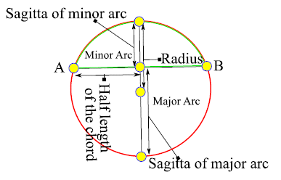However, to draw the two individual chords we require at least three points on the circumference of the circle.

* To determine the three beacon points, sensor node assumes a circle, which passes through a beacon point that is farthest among the others (differentiated using RSSI).

The rest of the two beacon points are formulated using the geometry of an arc. An arc has its height (Sagitta), length, and radius. If we approximate any two of these parameters, we can easily approximate the two points on the circumference of the assumed circle.

**Assumptions**

**Following assumption is taken for implementation:-**

* The mobile beacon traverses the sensing ﬁeld and periodically broadcast its current location coordinate. We assume that the sensor node listen to the beacon messages, once the mobile beacon enters the communication range of the sensor node.
* The path of mobile beacon is not straight .It follows certain trajectory.
* The mobile beacon travel with constant velocity.

We are estimating position of sensor node using geometry (Cramer rule) i.e. the perpendicular bisector of two chords intersects at centre of the circle.

We also deﬁne the transitions from the above two states as follows:

* Arrival: Once the sensor node receives the beacon messages from the mobile beacon.
* Departure Once the mobile beacon departs the communication range of the sensor node

**Problem Statement**

The existing mobile beacon based range free localization method has two basic problems:

1. The accuracy of the position estimation depends on closer beacon broadcasting intervals.
2. Varying radio propagation irregularity has a major impact on the localization accuracy.,

**Steps**

1. B and C are taken as arrival and departure points respectively.

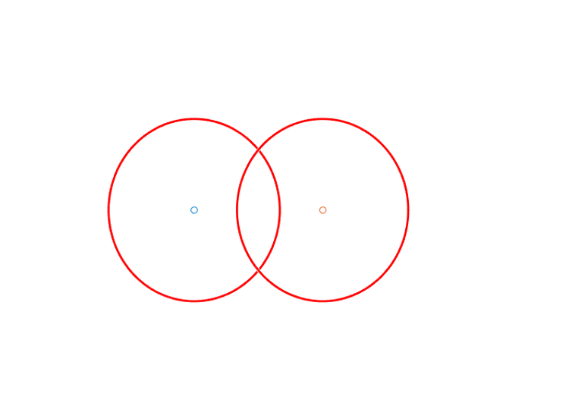

1. The sensor node must lie in the intersection area of these circle with centre B and C.
2. The Intersection point of circle B and C is joined (marked as J and K)

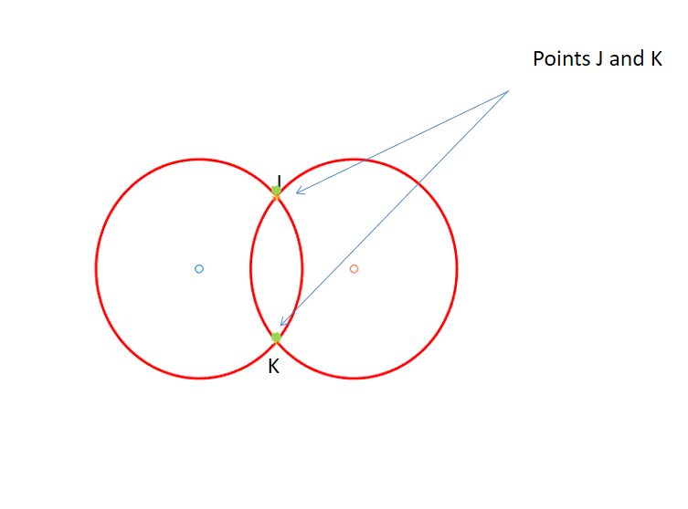

1. J and k are joined and RSSI value of B and C is calculated from sensor to find the sensor approximate half.
2. B and C are also joined and the intersection of line BC with JK is marked as P.

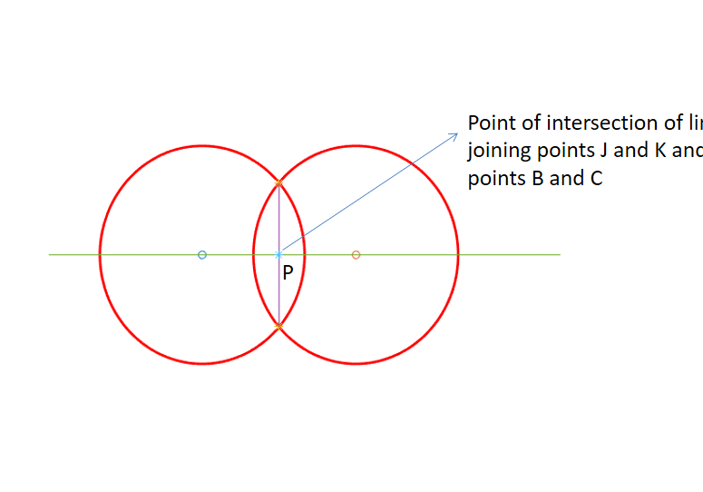

1. Mark the intersection of circle B with line BC .This will give us two points, the one with higher RSSI value from Sensor is marked as I.
2. Mid-point of points P and I is calculated and marked as Z.

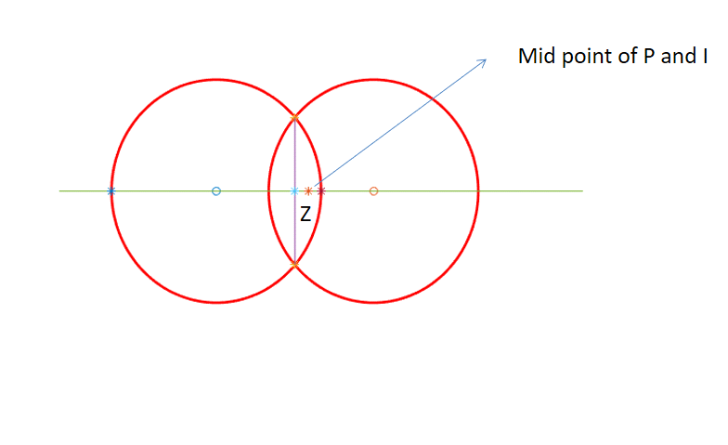

1. Now, we derive the Euclidean distances EPI, EPZ, and EBZ respectively. Estimated Euclidean distances EPI, EPZ, and EBZ are used to set the random approximation range for the radius and half length of the chord.
2. The relation given below, randomly approximate the radius within the range speciﬁed as follows:
3. r1 = EAZ + EPI
4. r2 = EAZ - EPZ
5. R = (r2 - r1)*rand(k,1) + r1 ; k = 1,2,...,kn
6. Each random value R (R1, R2, R3,...,Rn) within the range r1 and r2 are considered as the radius

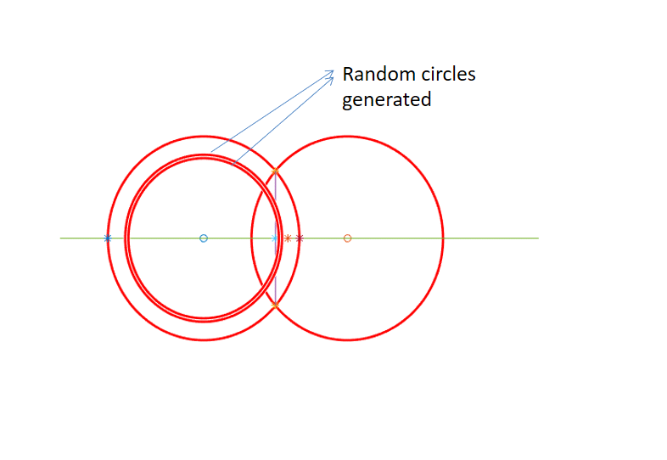

1. Each circle drawn against the radius r (corresponding to R) with centre B, intersects the lines BC and JK. Then the corresponding intersection coordinates of the circle with lines BC and JK are designated as Q and F respectively.
2. To choose the valid root for Q Euclidean distance of Q is calculated from P and the one with lesser distance is selected.
3. The mid-point of the line segment between Q and F(x,y) and Q(x,y) and F(-x,-y) are L(x ,y) and M(x, y).
4. The midpoint of L and M is marked as T(x,y) which is the centre of chord passing through B and C.
5. Euclidean Distance E is calculated from B to T which is half length of chord.

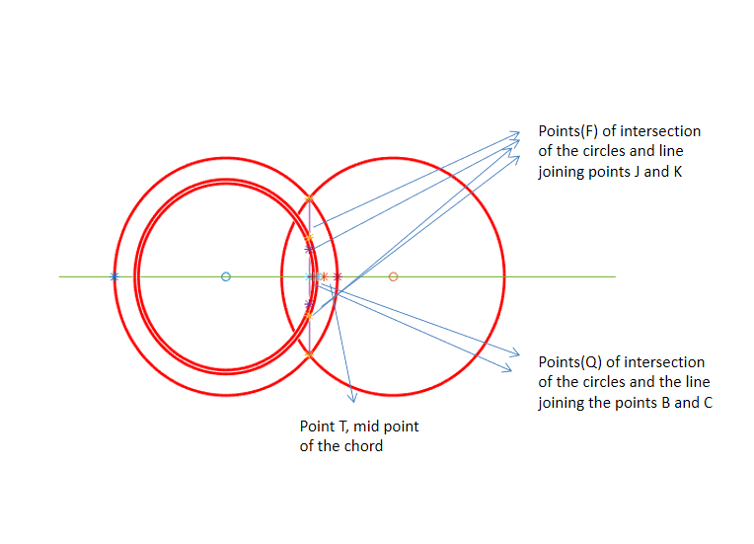

1. Using all the estimated parameters, the sensor node estimates the Sagitta of an arc. The Sagitta is the vertical line from the midpoint of the chord to the arc itself. The half-length of the chord, sagitta, and radius of the arc are inter-related and if we know any two of them, then we can calculate the third.
2. Each generated random values of R and measured half-length of the chord E are used to calculate the sagitta of an arc as follows:
   * 1. H=R+ sqrt(R^2 +E^2) or H=R- sqrt(R^2 +E^2)
3. We approximate the points on the circumference of the assumed circle corresponding to each sagitta H (major and minor) of an arc. Using the quadratic equation, we generate the points N(+x,+y), N(-x,-y) on the circumference of the assumed circle, when sagitta of major arc (+H) is considered. The other point is V(+x,+y), V(-x,-y) generated on the circumference of the assumed circle, when sagitta of minor arc (-H) is considered.

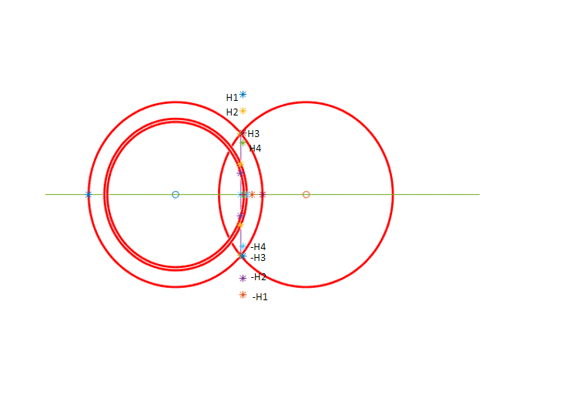

1. Each combination of beacon points B(x,y), N(x,y) and V(x,y) generates two different chords BN and BV. Consider the lines LBN and LBV as the corresponding perpendicular bisectors of the chords BN and BV respectively.

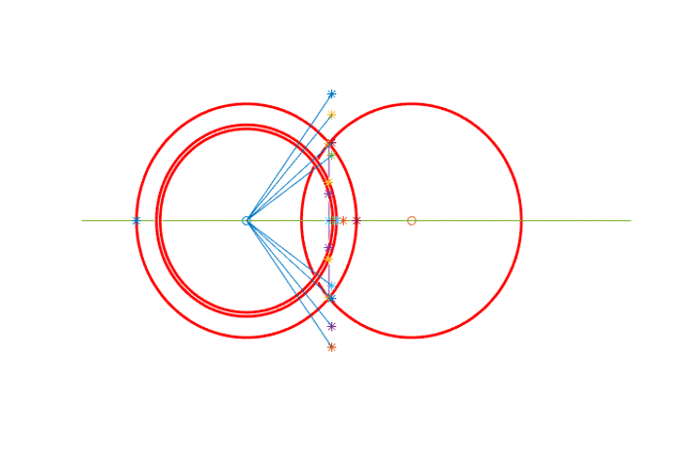

1. Based on the Cramer’s rule, the intersection point of the perpendicular bisectors LBN and LBV of the chords BN and BV generates four candidate positions of the sensor node.(P1,P2,P3,P4)

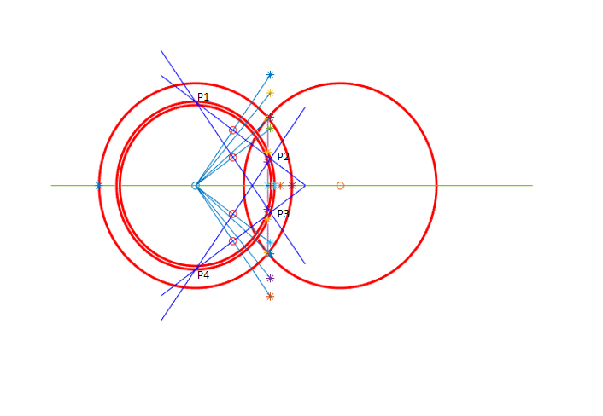

1. Out of four estimated positions (P1, P2, P3, and P4), two of them resides within the residence area of sensor node i.e. P2 and P3.However, to differentiate the valid candidate position of the sensor node within the residence area, sensor node applies the path-loss model.

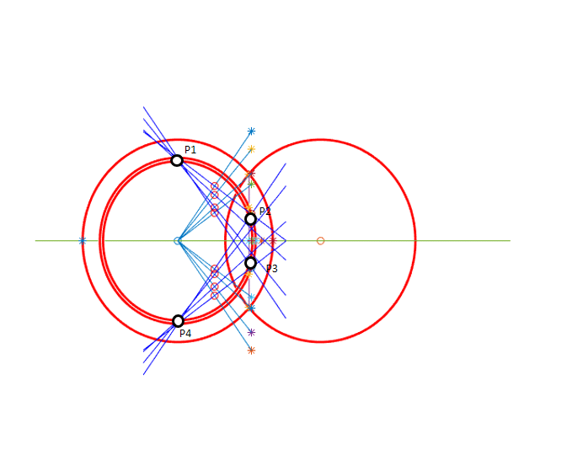

1. To differentiate the position of the sensor node within the residence area, sensor node has the RSSI received from the mobile beacon. Sensor node selects that beacon point through which it receives maximum RSSI. Now, sensor node calculates the Euclidean distance EP2 and EP3 between the selected beacon point and the estimated positions P2 and P3 respectively.
2. Sensor node estimates the received power RSSI(P2) and RSSI(P3) corresponding to the Euclidean distances EP2 and EP3. Based on the comparison between the received RSSI from the selected beacon point and estimated RSSI.

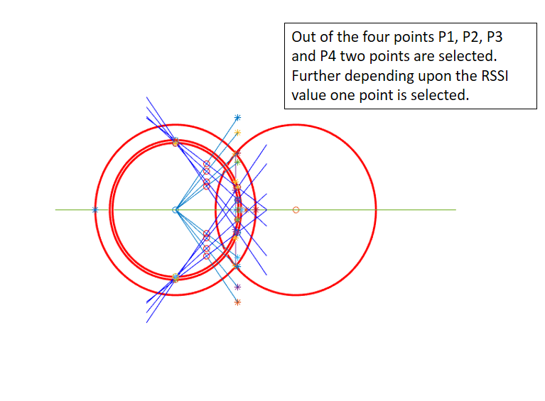

1. The ﬁnal position of the sensor node is taken as the average of all the positions generated corresponding to the each random value of R.

**Experimental Analysis**

For implementing this technique of finding sensor node location following input are taken:

|  |  |
| --- | --- |
| Parameter | Values |
| Network size | 10x20 |
| Number of nodes(for purpose of simplicity) | 1 |
| Number of the mobile beacon | 1 |

**The mobile beacon moves with constant speed and in a straight line.

**CONCLUSION**

In this paper, we have proposed a range free localization method based on the mobile beacon point, where sensor node estimate its location using the perpendicular bisectors of the two chords. The chord is approximated on the assumed circle of the sensor node using the analytical geometry of an arc.

Unlike most of the localization algorithms use fixed infrastructure, where the sensor nodes along with few anchor nodes are randomly deployed into the sensing field, proposed algorithm utilizes GPS enabled mobile beacon, which navigates the sensing field and periodically broadcasts the beacon messages, including its current location coordinate.

The main contributions of this paper are as follows:

* The proposed scheme is simple, where the candidate positions of the sensor node are generated using the perpendicular bisectors of the two chords, and to differentiate the valid candidate position, sensor node uses RSSI.
* The proposed method shows less position estimation error. It also investigates the radio propagation irregularity impact on the localization accuracy.
* The proposed method sustains less estimation error even without taking closer broadcasting intervals.
* The proposed method does not require any speciﬁc movement trajectory or enhanced beacon point selection mechanism.

For the aforementioned paper we have successfully implemented the algorithm according to which the sensor node can locate its position based on the signals sent by the mobile beacon.