**SIMULATION RESULTS**

In this section we study the performance of the proposed algorithms through experimental simulation. We also investigate the impact of parameters: the network size i.e. the number of sensor nodes, the number of timeslots in which the entire tour is divided and the maximum number of timeslots in which one sensor can send data.

**ENVIRONMENT**

We consider a network of 100 to 500 sensor nodes deployed along the path of a mobile sink. The entire path is divided into 100 to 500 timeslots. Hence each value of number of nodes is paired with each value of number of timeslots and checked in a test set. N is the number of sensor node and T is the number o timeslots for each test set. The data matrix is a N x T matrix, for each test run, where a data in i,j cell of the matrix denotes that ith sensor can send this much of units of data in the jth timeslot. A value of zero indicated no transfer of data due to energy or range reasons. For each pair of number of nodes and number of timeslots, we record the variance (taken average over a number of iterations) among the amount of data collected by each sensor node and compare it with the old algorithm proposed in the 2013 reference paper.

Each pair is then run for each value of the maximum number of timeslots for which a sensor can send its data to the mobile sink (called max duration); this is taken 2, 5, 10, 15 and 20.

The final results are two plots for each value of max duration; one between number of nodes and the variance of the amount of data collected from each node and the other between number of time slots and the variance of data collected from each node. For the first plot, the variance for a particular value of number of nodes is taken as an average over the different values of number of time-slots and for the second plot, the variance for a particular value of number of time slots is taken as an average over the different values of number of nodes.

**RESULTS**

The plots obtained are shown below.

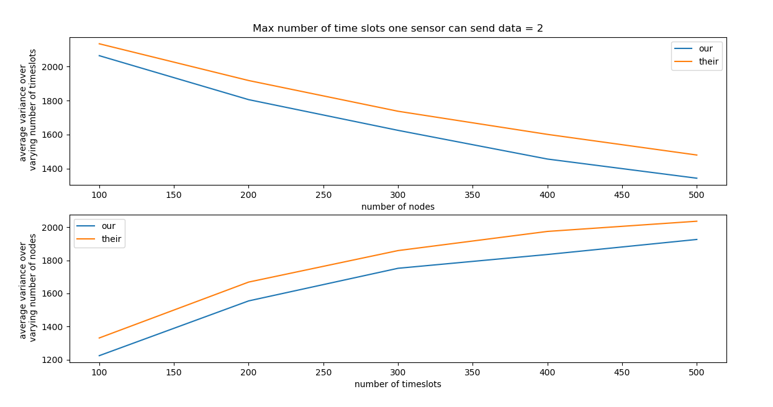

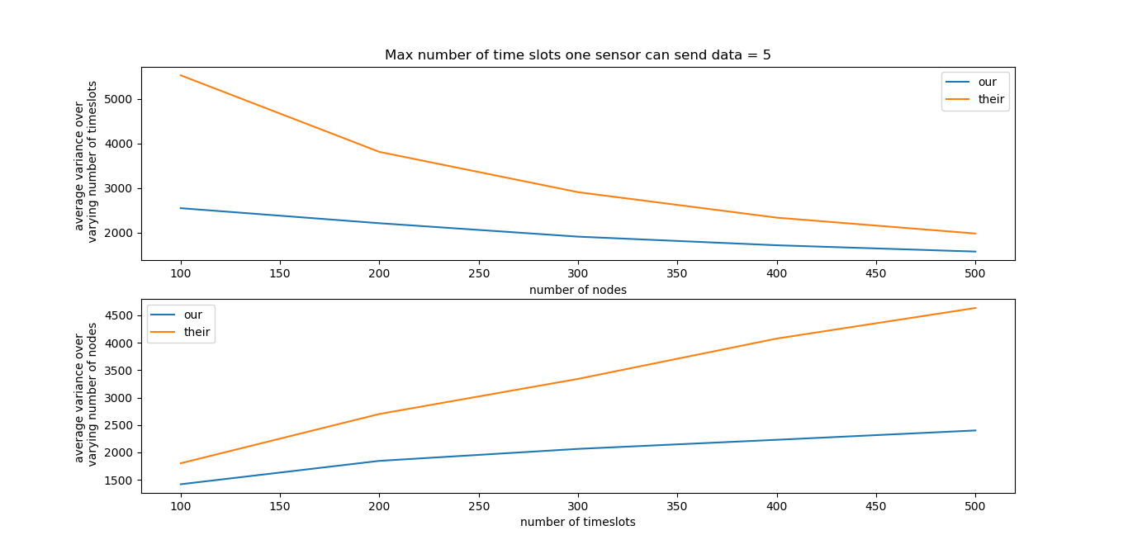

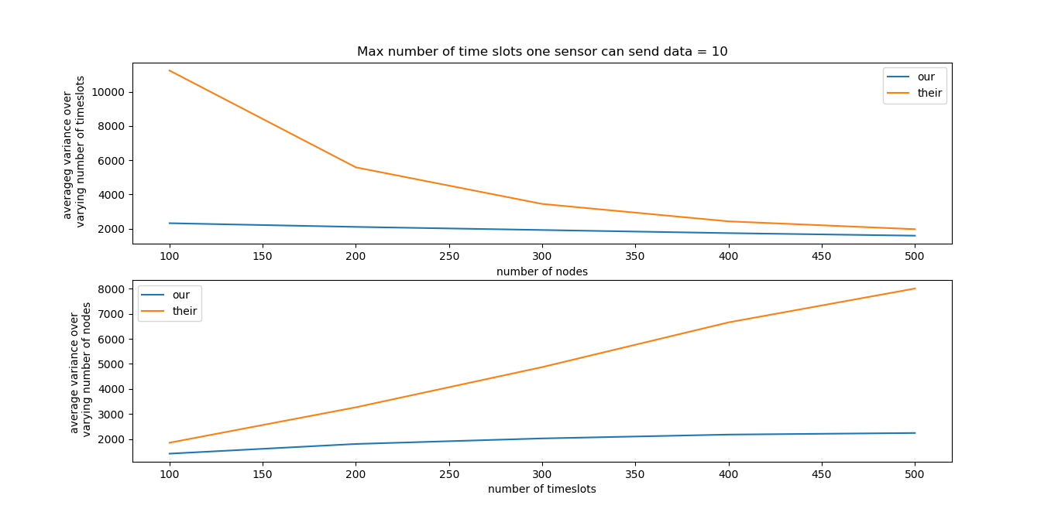

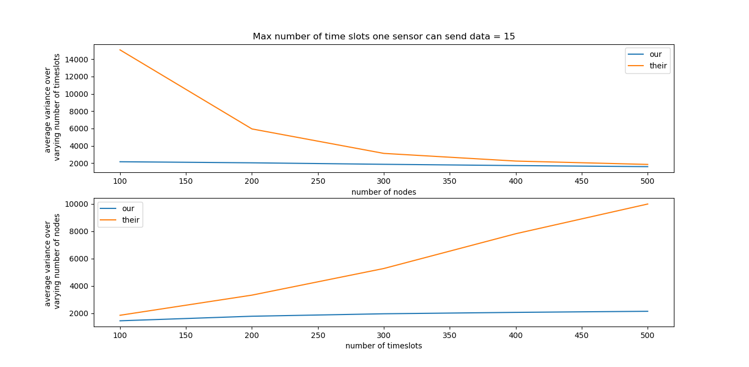

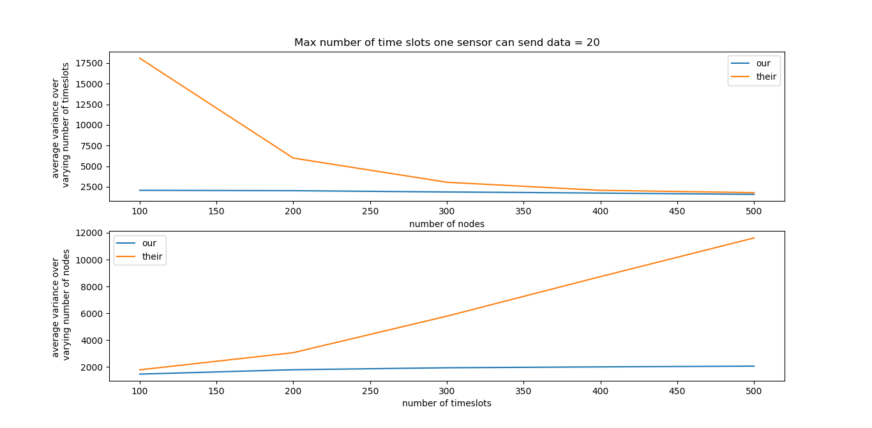

From the plots, it is clear that our algorithm performs better than the 2013 paper algorithm called C-schedule. The amount of data collected by each sensor is much less varied (shows low variance) in the new algorithm.

**Effect of increase in number of nodes**

The algorithm performs better than the 2013 paper algorithm but the difference in performance is more for lesser number of nodes.

**Effect of increase in number of time-slots**

The proposed algorithm performs better than the 2013 paper algorithm and the difference in performance is even better when we increase the number of timeslots.

**Effect of increase in max duration**

The proposed algorithm performs better than the 2013 paper algorithm but for a higher value of max duration (i.e. the maximum number of timeslots a sensor can send the data), the variance in general increases and the amount of change in the performance of the algorithm with varying number of nodes and number of times slots also increases. This may be attributed to the fact that the new proposed algorithm takes into account all the future timeslots and more number of future timeslots increase the effect of the future and past and current contributions become minor factors in calculating the utility gain.