Behavioral segmentation of customers of Gstore

Based on Browsers –

1. The most used browser for purchase is the chrome then comes Safari, then Firefox, IE, Edge.
2. But when it comes to revenue of purchases the leading offender is the Chrome, then Safari, followed by Safari, Explorer, edge.
3. The most used device for purchasing is Desktop, then mobile then tablet. The mean revenue generated by these devices remains in the same order.
4. In terms of OS the most use platform is the Windows, then Mac, followed by Android, iOS, Linux, while Chrome OS stands the last. The highest revenue generated is by Mac, then windows, then Chrome OS, Linus, ios , and android

Based on Location-

1. Continent wise - The highest number of the users who gives the traffic are from Americas region. Also the revenue generated too is from the same continent. Then they are followed by Asia then Europe.
2. Subcontinent wise – Most of the users who visits Gstore are from North America, then it is followed by southern Asia, then western and eastern Europe. But when it comes to revenue its only the North America where people buy the stuffs while the Asia and Europe region the contribution is extremely low comparatively.

Based on pageview-

1. Most of us think that the page views effects a lot when it comes to the revenue. But this data shows something opposite. The graph show the pageviews contribution to revenue. Which is almost flat.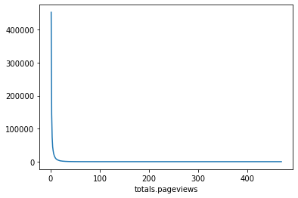

Based on months:

1. Trend shows that between Oct to Dec the transactions revenue was on the peak. And Jan has the lowest sudden trend.

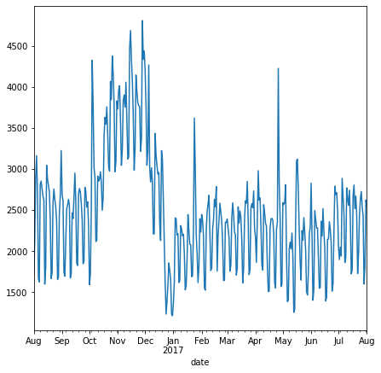

Based on weeks:

1. This is pretty easy to guess. And the data too shows the same trend. The first week has a decent transaction and the 3rd week too shows similar trend. Though the trend doest has too much fluctuation until it reaches the end of the month.

