DBSE & DBD
Name- M. Siri Chandana
Roll No- 2520030603
ACID PROPERTIES & ISOLATION
STEP 1 — DATABASE
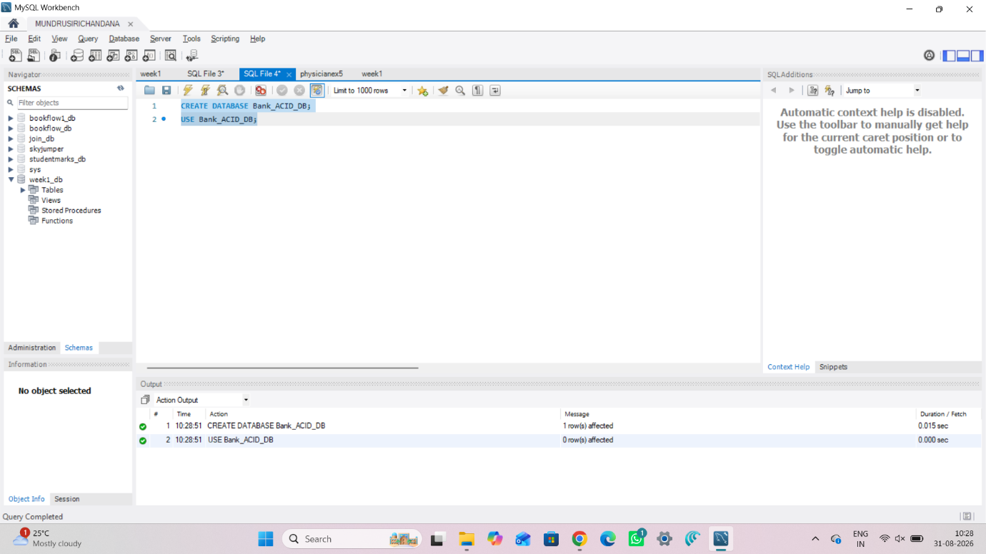
STEP 2 — CREATE TABLES
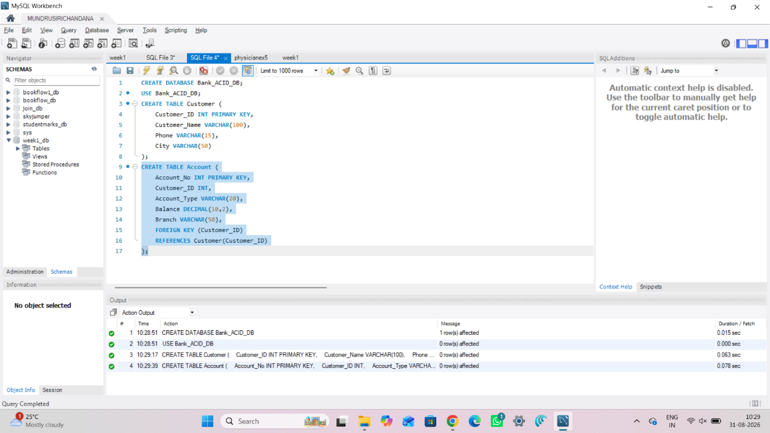
Bank Transaction
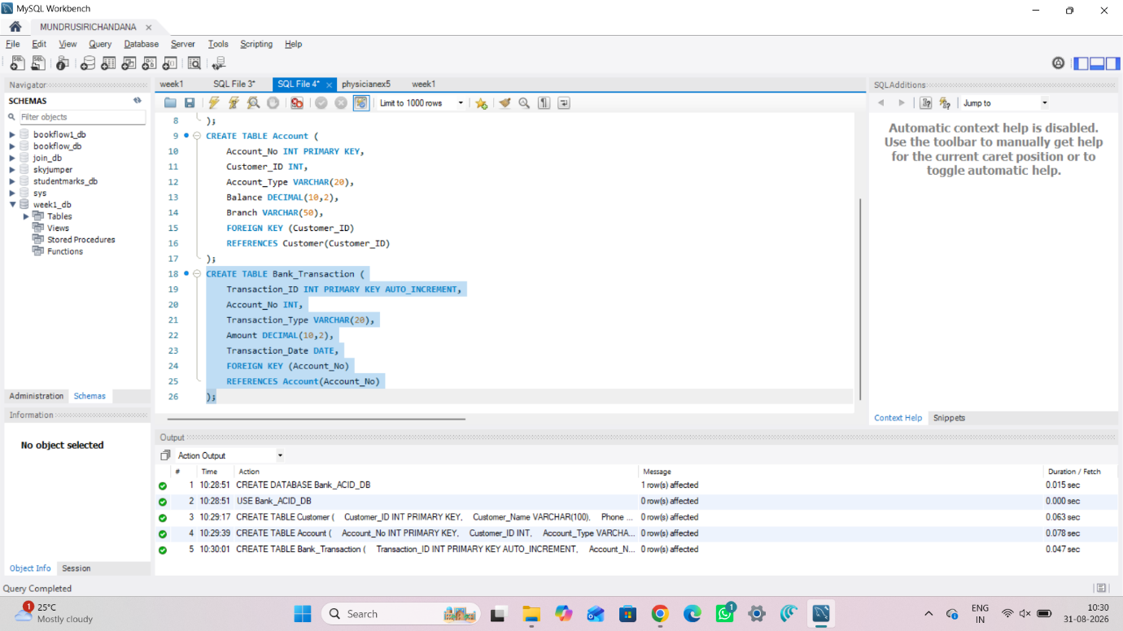
STEP 3 — INSERT INTO TABLES
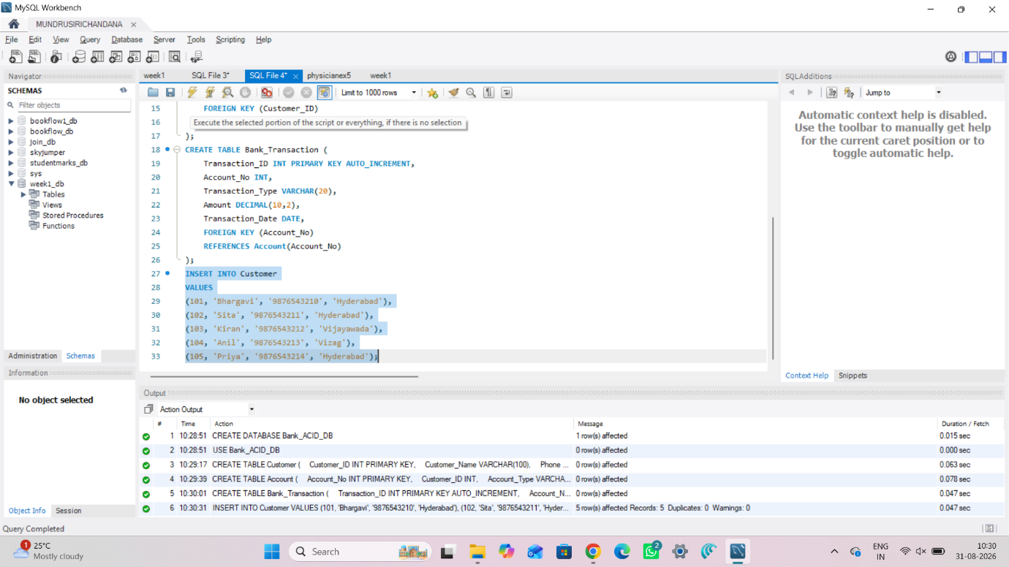
STEP 4 — DISPLAY TABLES
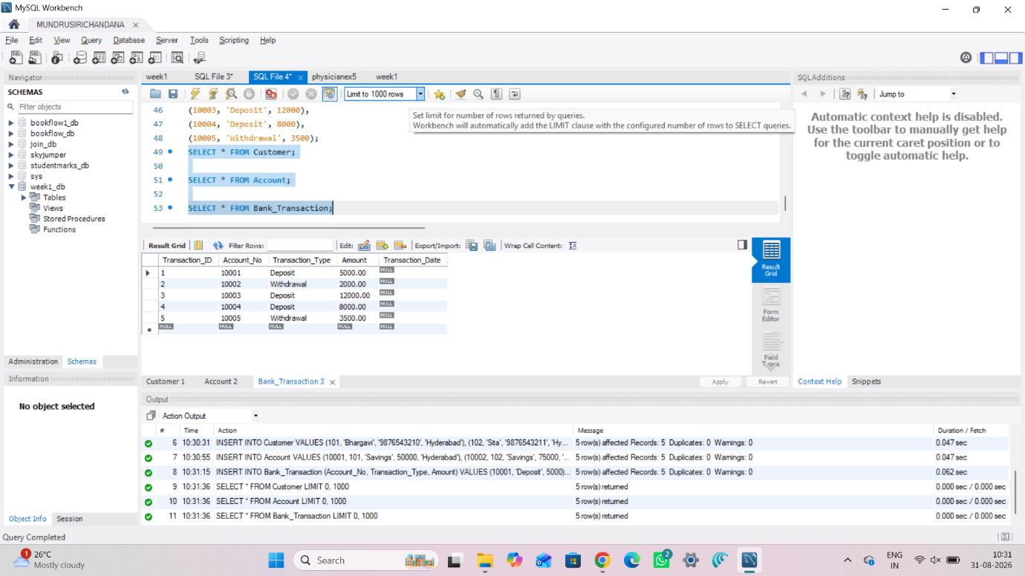
STEP 5 — COMMIT
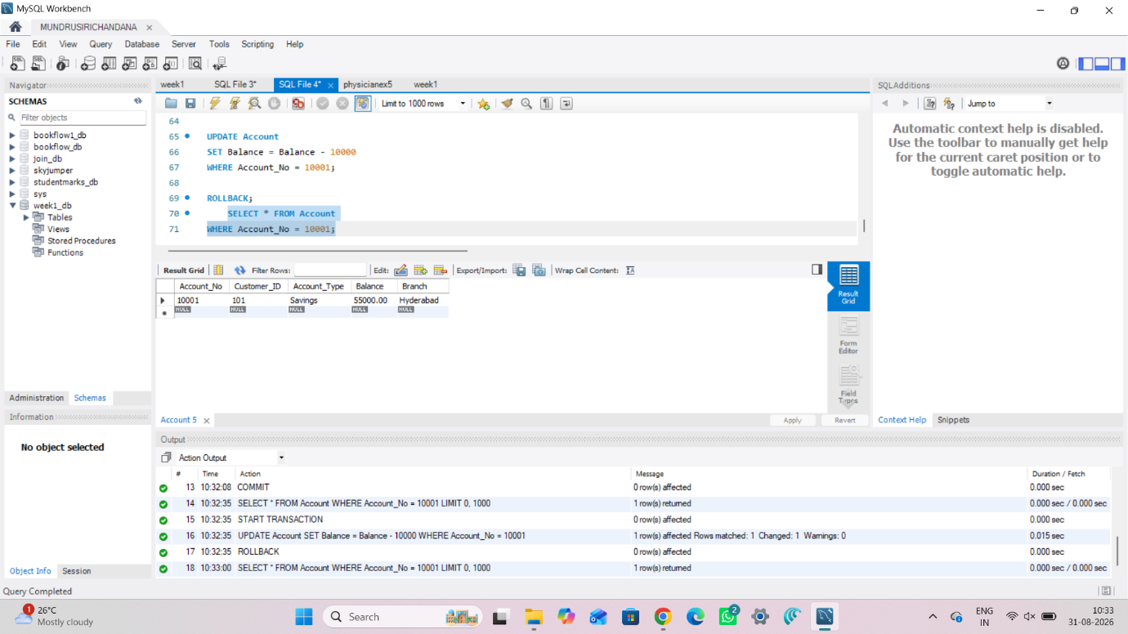
STEP 6 — ROLLBACK
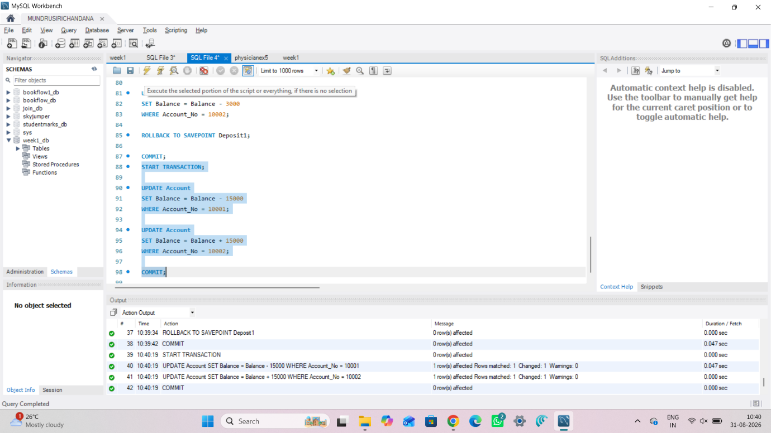
STEP 7 — BANK TRANSFER
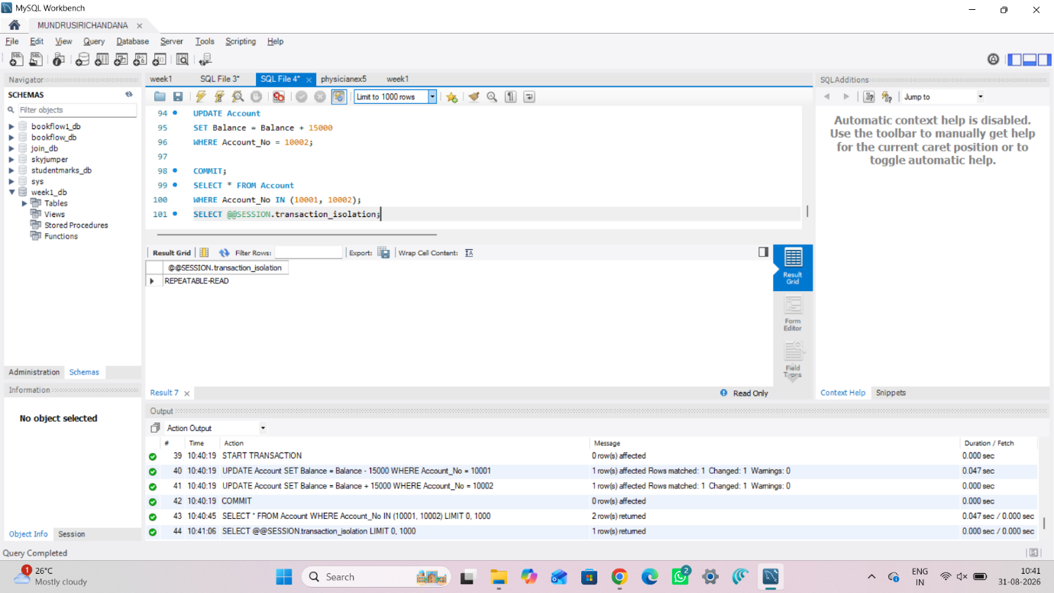
STEP 8 — READ COMMITTED
