DBSE & DBD
Name – M. Siri Chandana
Roll no-2520030603
DDL, DML, DCL & TCL
STEP 1 — DATABASE + TABLE
STEP 2 — ALTER TABLE ADD COLUMN
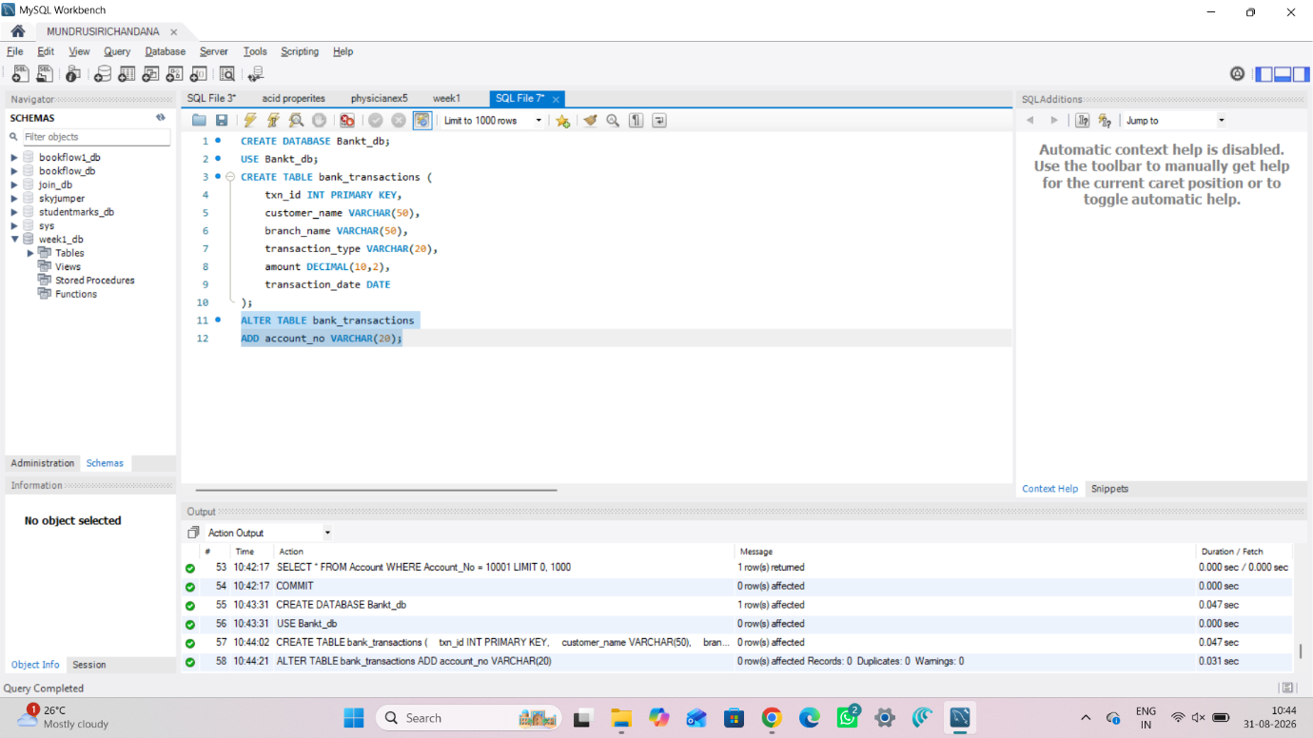
STEP 3 — ALTER TABLE MODIFY COLUMN
STEP 4 — RENAME TABLE
STEP 5 — TRUNCATE TABLE
STEP 6 — DROP TABLE
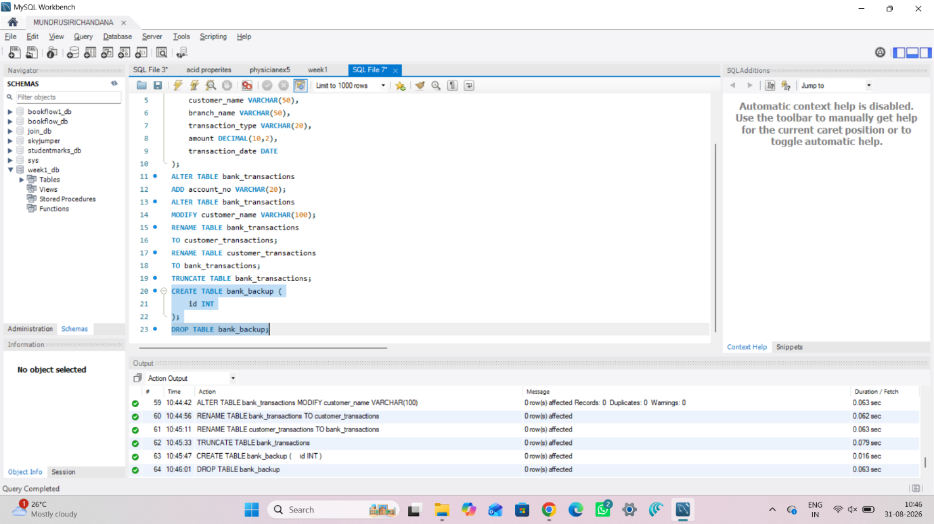
STEP 7 — INSERT SAMPLE DATA
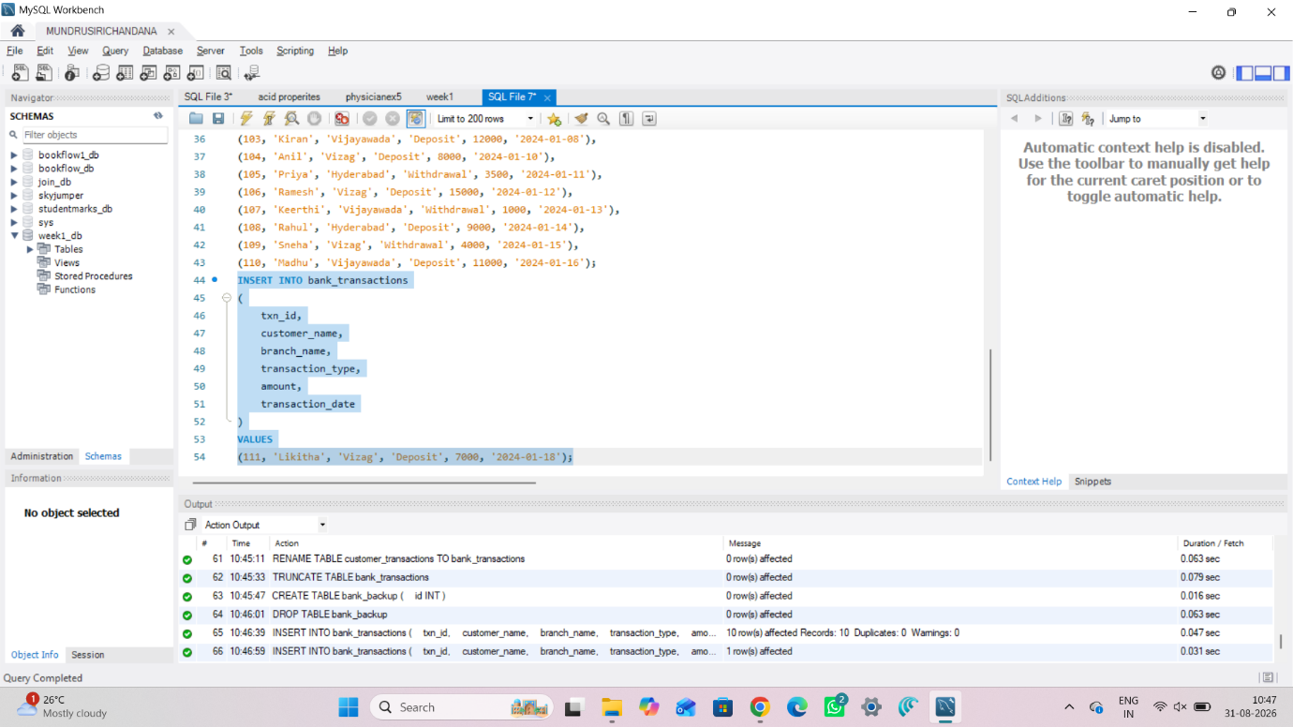
STEP 8 — INSERT
STEP 9 — UPDATE
STEP 10 — DELETE

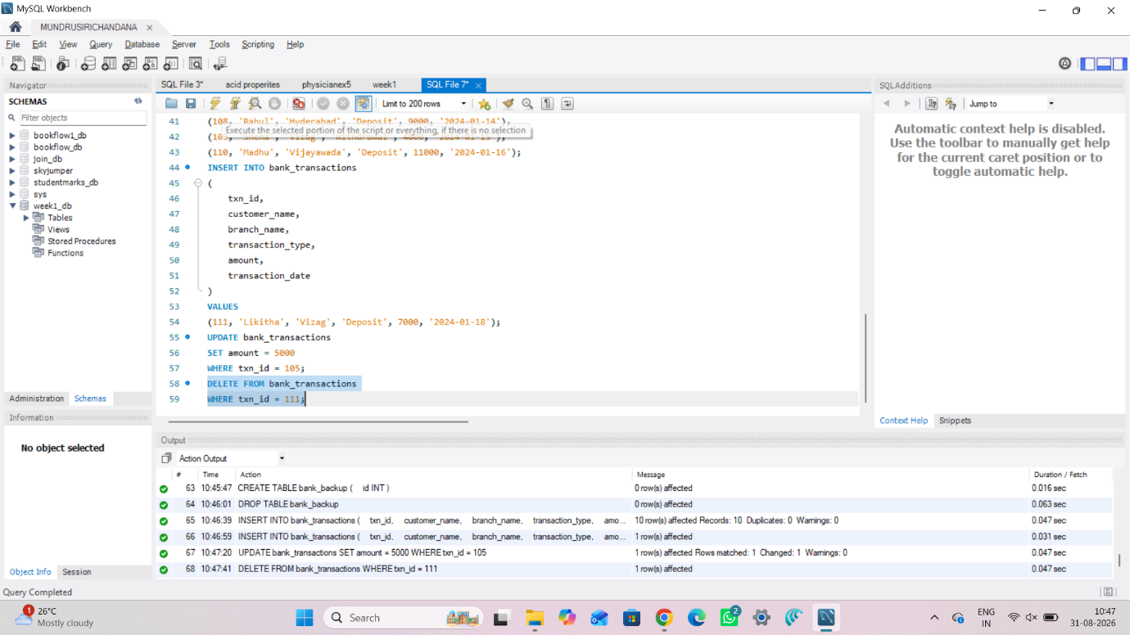
STEP 11 — SELECT
STEP 12 — SELECT WITH WHERE
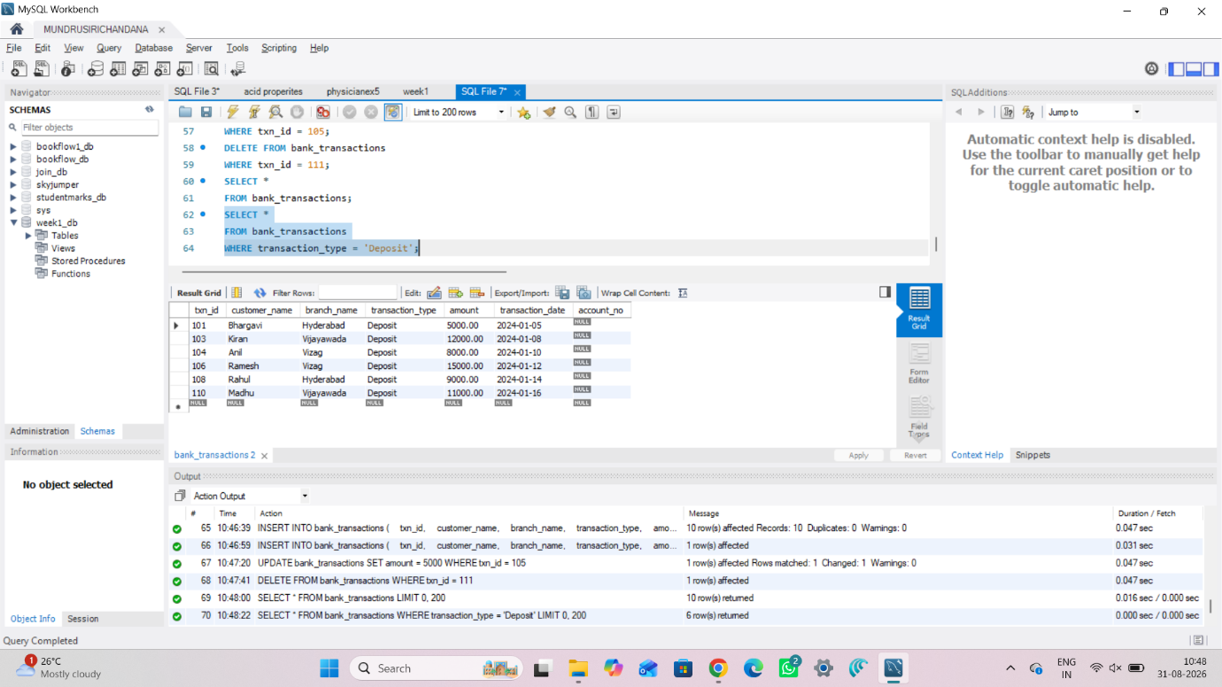
STEP 14 — GRANT SELECT
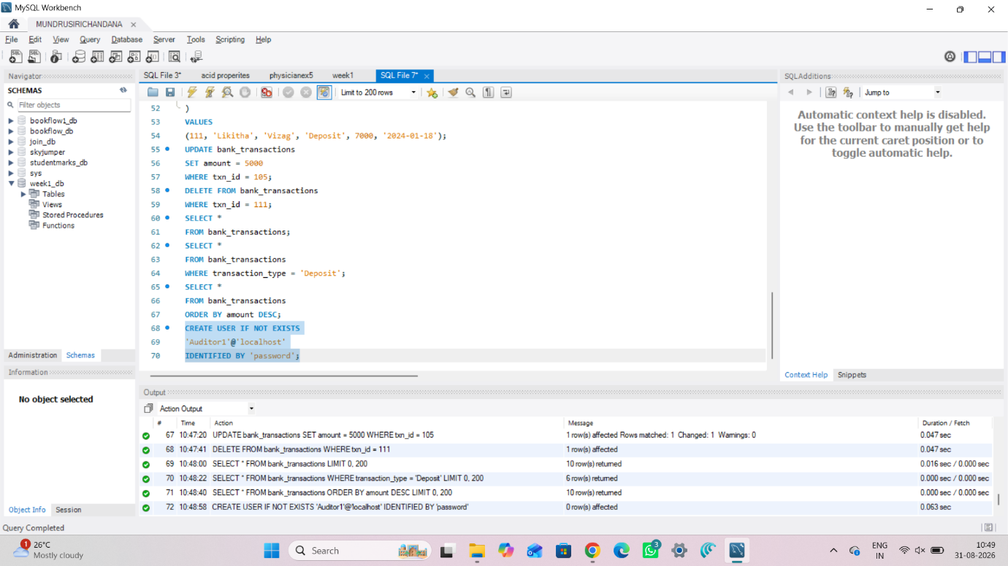
STEP 15 — GRANT ALL PRIVILEGES
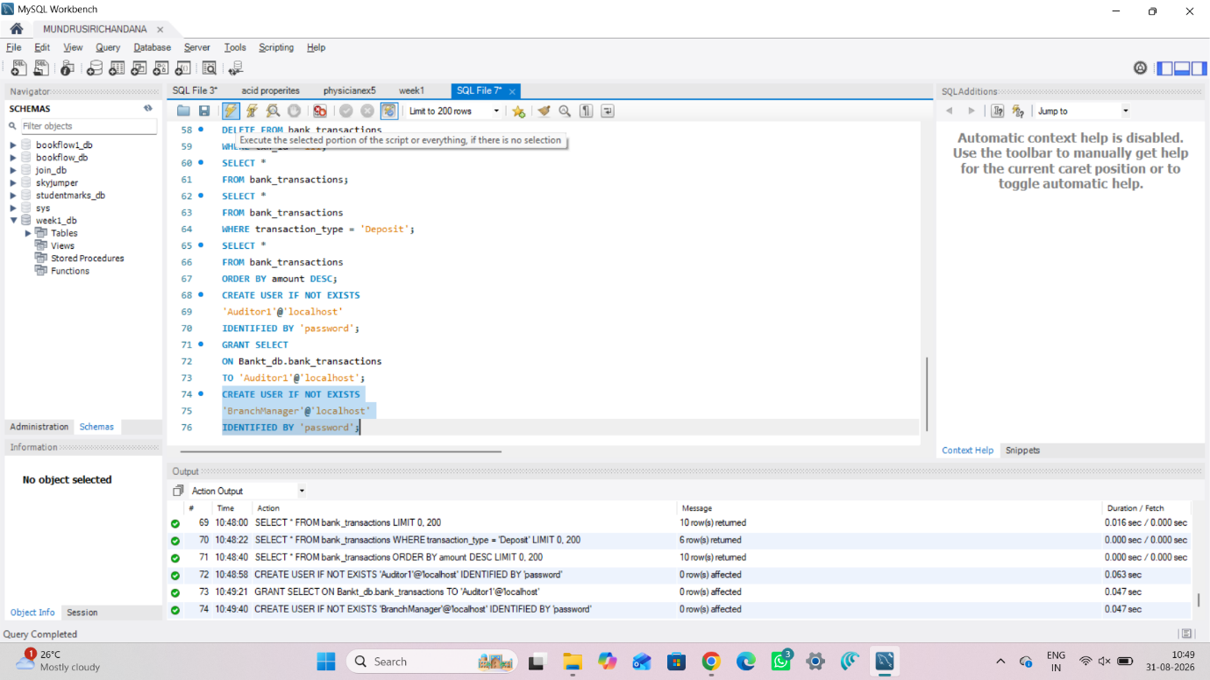
STEP 16 — REVOKE SELECT
STEP 17 — REVOKE ALL
STEP 18 — COMMIT
