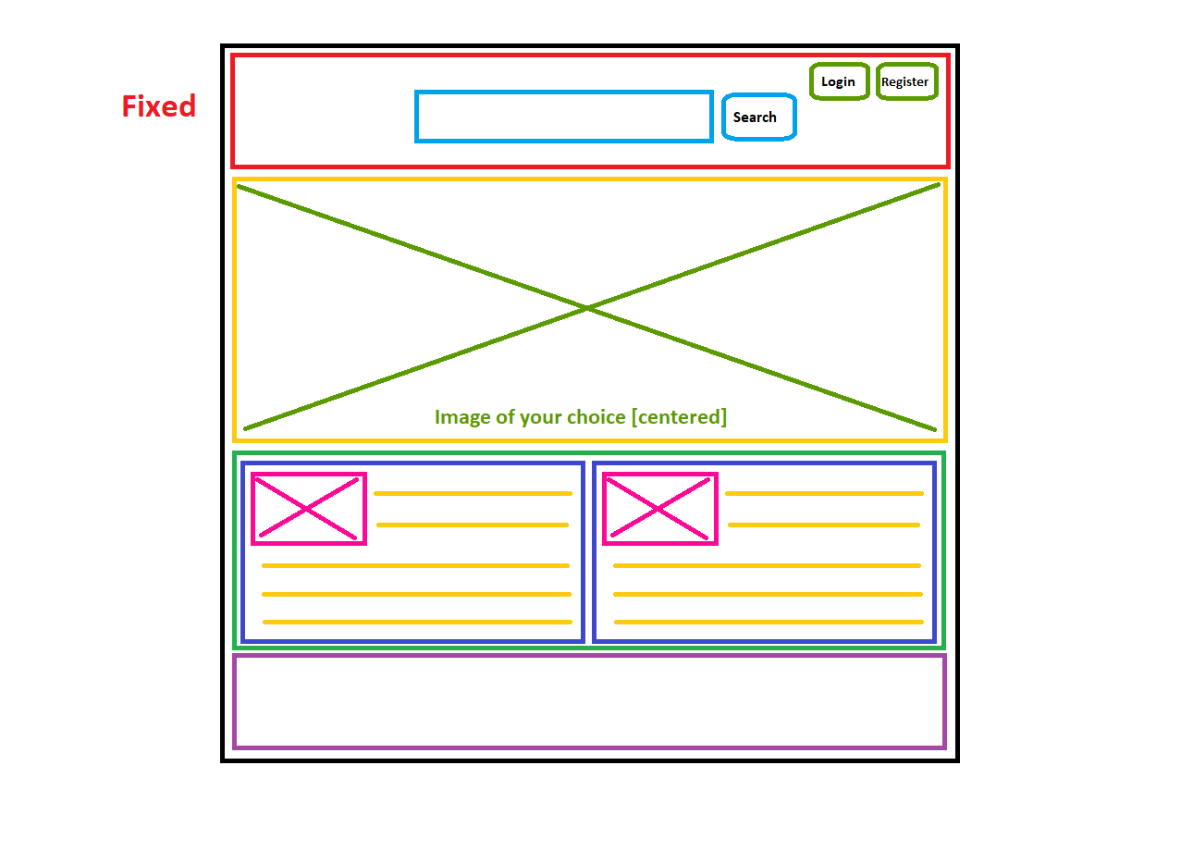
Goal:
- Implement a page that resembles the above wireframe
- Start with the overall structure, and focus on the details (buttons, search bar, images and text) last
- The images are represented by boxes with an 'X' inside - you can choose what images to include

