**AWS Lambda**

AWS Lambda is a serverless compute service that runs your code in response to events and automatically manages the underlying compute resources for you.

These events may include changes in state or an update, such as a user placing an item in a shopping cart on an ecommerce website.

Creation of the sample code and create a lambda function using terraform

Suppose we can take any code like python,java ;etc make the file into zip file & create a function in the lambda

Below is the image process of the terraform Aws Lambda

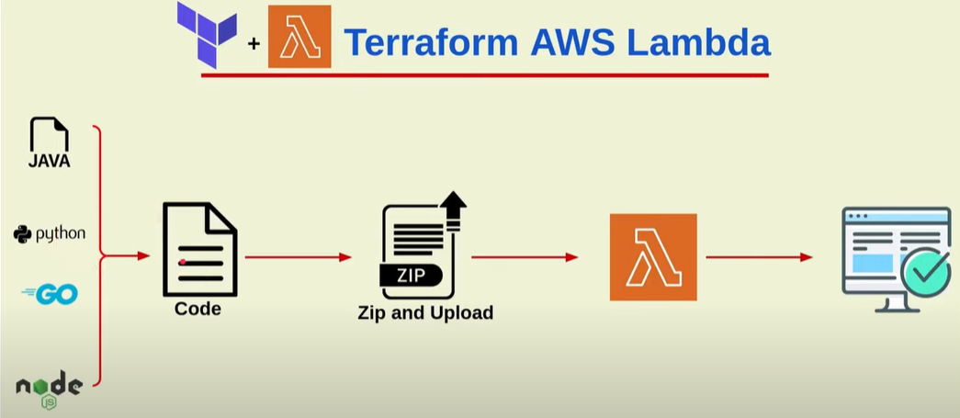

In the creation of the Terraform file we need to create a Iam-Role , Iam-policy ,Attach of the Iamrole and Iam policy .

Create a data file to create a Zip file of the python file.

The structure of the creation is Create a folder Aws-Lambda In the folder create Main.tf and create a Python folder in the folder create hello.python.py file in it .

Below is the image of the list of the resources created in main.tf

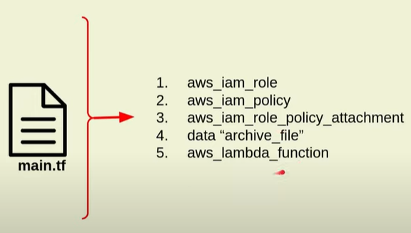

Below image is the Python file added in the file

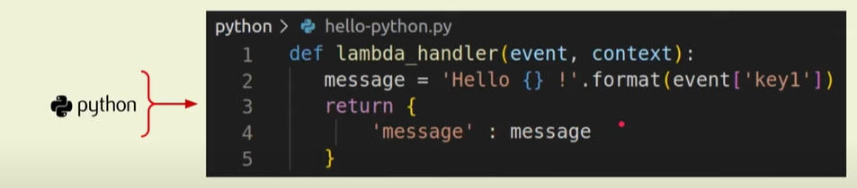

After the creation of the Terraform script We can run Terraform init ; Terraform Plan ; Terraform apply .

Below is the image after running of the terraform script go to the Aws console --- go to lambda service we can see the below image as per code

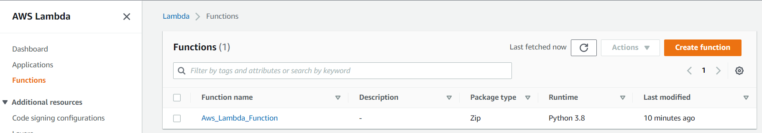

Below is the image of the Python-code :

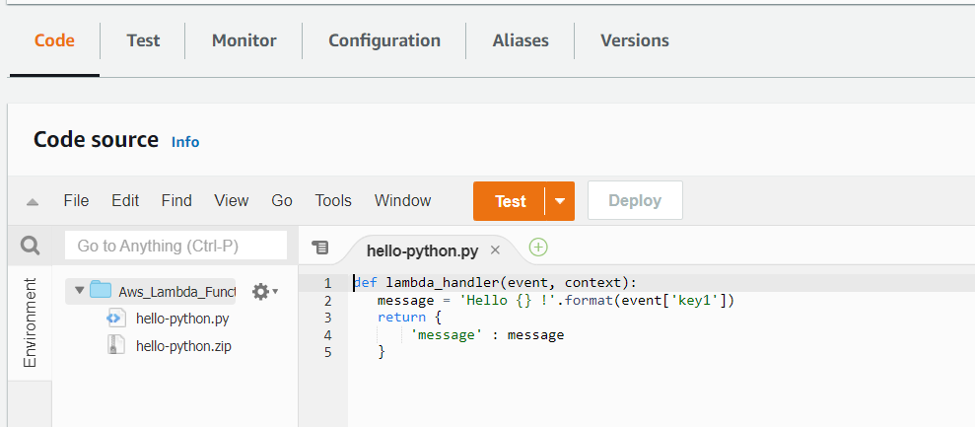

Create the test configuration for creation of the name and create run enter the

Key name : “ Hello world to aws lambda “

After that run the test Function we can see the below

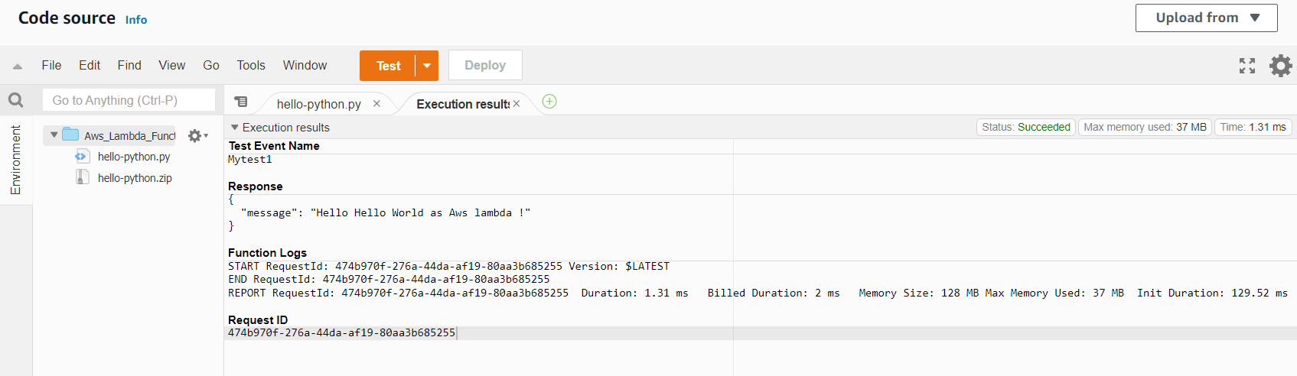

By reffering the doc below doc Creation of the Aws lambda

<https://spacelift.io/blog/terraform-aws-lambda>

Similar documents

<https://hands-on.cloud/how-to-manage-aws-lambda-using-terraform/>

<https://hevodata.com/learn/terraform-lambda/>