**How to Create a User Login Web System in Python**

Created the html code in Vs-code create separate logg_in ,logg_out, html files are created

After that install the python in the system

python3 -m http.server by excuting the command we can see the on what port python is running .

On the web browser enter Localhost :8000 we can see the login page like below

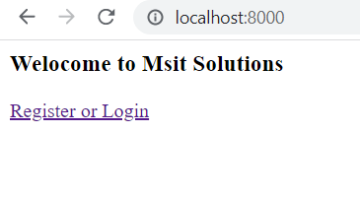

We can not login from click on the login so we are linking it with the Aws coginito.

Amazon Cognito lets you easily add user sign-up and authentication to your mobile and web apps. Amazon Cognito also enables you to authenticate users through an external identity provider and provides temporary security credentials to access your app's backend resources in AWS or any service behind Amazon API Gateway.

* Login to the Aws console
* Go to the Aws cognito.
* Click on Manage user pools.
* Create a user pool
* Create a Pool name : Ex:demo-app-user click on step through settings
* Add attributes like email,name etc
* add policies as custom password like have Capital ,small letter , One number etc.
* create the user pool
* Next create app-client name
* next edit the app-client settings
* click on the callback urls http://localhost:8000/logged_in.html
* click on the Sign out urls http://localhost:8000/logged_out.html
* In the OAuth 2.0 section
* Allowed OAuth Flows click on Authorization code grant
* Allowed OAuth Scopes click on email Openid
* create a domain Name as Msit solution and save
* Go to app-client settings and click on the Hosted Ui and Launch Hosted Ui
* Copy paste the UI link I had
* Now we have clear information on the connection of the local app to aws coginto
* Go to local code index.html and paste the Ui link in the Pragrap section and also in Logged_in.html ,Logged_out.html
* Do the changes in the link for the logged in html.

After the completed the procees we can see the window

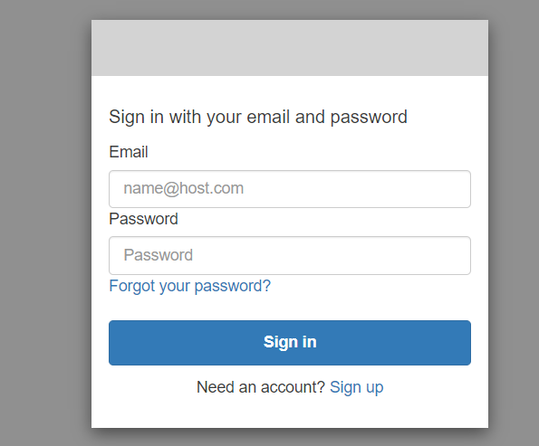

After login we can see the window and we can also logout from the window also

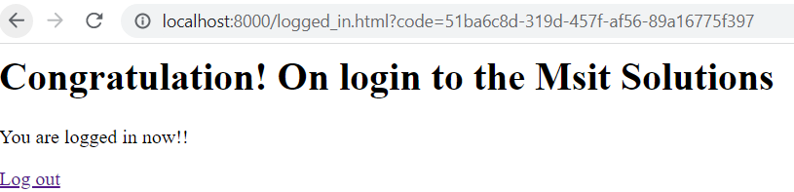

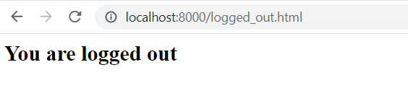

Aws coginto window look like after ever login we can see the who are the user logged in 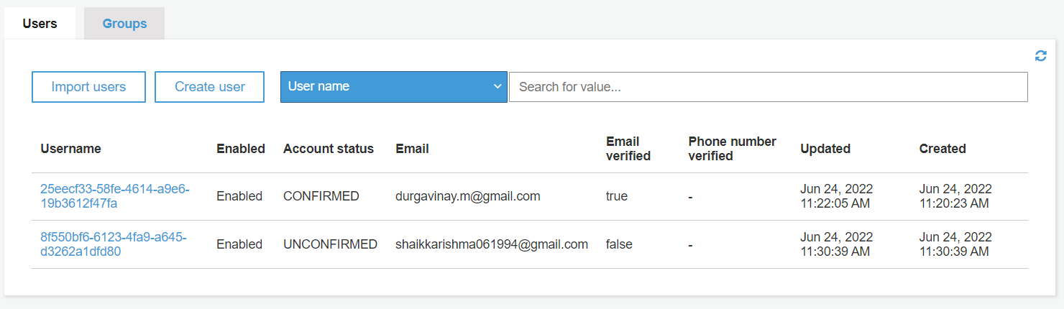

<https://msit-solutions.auth.us-east-2.amazoncognito.com/login?client_id=45316q3qv14kofgddnf0pkjd8q&response_type=code&scope=email+openid&redirect_uri=http://localhost:8000/logged_in.html>

This is the link that use can logged in

But the code has been placed in my local loggin has been not working .

<https://www.c-sharpcorner.com/article/creating-a-simple-login-page-using-html-and-css/>

<https://www.section.io/engineering-education/user-login-web-system/>