LABORATORY RECORD
Course: Full Stack Web Development
Course Code: 23CM4121
Experiment No.: 2
Student Name: M.Siva ganesh
Roll No.: A24126552093
Date: 11-08-2026

1. TITLE
Design a Webpage Using HTML5 and CSS3

2. AIM
To design and develop a webpage using HTML5 and CSS3, demonstrating semantic structural elements, internal CSS styling, a card-based section layout, in-page navigation with hover effects, ordered and unordered lists, and a styled footer.

3. OBJECTIVE
The objectives of this experiment are:
- To understand the use of semantic HTML5 elements such as <header>, <nav>, <main>, <section>, and <footer>.
- To apply internal CSS using the <style> element within <head> for layout and visual design.
- To implement in-page navigation using anchor tags with href="#id" and matching section id attributes.
- To style each section as a card using CSS background-color, border-radius, and box-shadow.
- To use CSS pseudo-class :hover to apply interactive link styling on the navigation bar.
- To use ordered and unordered lists to display structured content within sections.
- To create a visually cohesive footer using CSS background-color and color properties.

4. THEORY
Internal CSS — styles written inside a <style> block in the <head> element. Rules take the form selector { property: value; } and apply to all matching elements in the document.
CSS Box Model — every element is a rectangular box whose dimensions are determined by content, padding, border, and margin. Setting box-sizing: border-box makes width and height include padding and border.
Semantic Elements — <header> wraps the page title and branding, <nav> wraps navigation links, <main> marks the primary content, <section> groups related content, and <footer> closes the page.
In-Page Navigation — an anchor tag with href="#id" scrolls the browser to the element whose id attribute matches the fragment, allowing a navigation bar to link to sections on the same page.
CSS Pseudo-classes — the :hover pseudo-class applies styles only when the pointer is positioned over the element, enabling interactive feedback such as a colour change on navigation links.
CSS Box Shadow and Border Radius — box-shadow adds a depth effect behind an element; border-radius rounds its corners. Together they give each section a card-like visual appearance.

5. ALGORITHM / PROCEDURE
- Create an HTML file named HTML&CSS.html.
- Inside <head>, add charset and viewport meta tags, a <title>, and an internal <style> block.
- In the <style> block, write a universal CSS reset: * { margin: 0; padding: 0; box-sizing: border-box; }.
- Style the <body> with a sans-serif font, a light blue-grey background colour (#f0f4f8), and line-height: 1.6.
- Add a <header> with background-color: #4a90d9 containing an <h1> title centred in white text.
- Add a <nav> below the header with four anchor links — About Me, Subjects, Hobbies, Contact — styled in white on a darker blue bar.
- Style nav a with no underline and add a nav a:hover rule that applies a darker background and border-radius.
- Add a <main> element with max-width: 800px and margin: auto to centre the content column.
- Inside <main>, add four <section> elements with ids about, subjects, hobbies, and contact.
- Style each section as a white card with padding: 25px, border-radius: 8px, and box-shadow.
- Populate sections: About Me with a greeting paragraph; Subjects with an <ol>; Hobbies with a <ul>; Contact with an email address.
- Add a <footer> with background-color: #333, light-coloured text, and a centred credit paragraph.
- Open the file in a web browser and verify the header colour, navigation bar, card sections, hover effect, and footer.
- Record expected vs. actual output for each test case.

6. PROGRAM
HTML&CSS.html
<!DOCTYPE html>
<html lang="en">
<head>
<meta charset="UTF-8">
<meta name="viewport" content="width=device-width, initial-scale=1.0">
<title>My Student Webpage - Alex</title>
<style>
/* Basic reset */
* {
margin: 0;
padding: 0;
box-sizing: border-box;
}
body {
font-family: Arial, Helvetica, sans-serif;
background-color: #f0f4f8;
color: #333;
line-height: 1.6;
}
/* Header */
header {
background-color: #4a90d9;
color: white;
text-align: center;
padding: 5px 10px;
}
header h1 { font-size: 36px; margin-bottom: 5px; }
header p { font-size: 18px; opacity: 0.9; }
/* Navigation */
nav {
background-color: #357abd;
padding: 12px 0;
text-align: center;
}
nav a {
color: white;
text-decoration: none;
margin: 0 18px;
font-size: 16px;
padding: 5px 10px;
}
nav a:hover {
background-color: #2a5f9e;
border-radius: 4px;
}
main { max-width: 800px; margin: 30px auto; padding: 0 20px; }
section {
background-color: white;
padding: 25px;
margin-bottom: 25px;
border-radius: 8px;
box-shadow: 0 2px 5px rgba(0,0,0,0.1);
}
section h2 {
color: #4a90d9;
margin-bottom: 15px;
border-bottom: 2px solid #e0e0e0;
padding-bottom: 8px;
}
section p { margin-bottom: 12px; }
ol, ul { margin-left: 25px; margin-bottom: 10px; }
li { margin-bottom: 6px; }
/* Footer */
footer {
background-color: #333;
color: #ccc;
text-align: center;
padding: 20px;
margin-top: 40px;
font-size: 15px;
}
footer a { color: #4a90d9; }
</style>
</head>
<body>
<header>
<h1>HTML5 &amp; CSS3</h1>
</header>
<nav>
<a href="#about">About Me</a>
<a href="#subjects">Subjects</a>
<a href="#hobbies">Hobbies</a>
<a href="#contact">Contact</a>
</nav>
<main>
<section id="about">
<h2>About Me</h2>
<p>Hello! , I am Student at ANITS</p>
</section>
<section id="subjects">
<h2>My Favorite Subjects</h2>
<ol>
<li>Computer Science - I want to learn more about programming</li>
<li>Mathematics - especially algebra and geometry</li>
</ol>
</section>
<section id="hobbies">
<h2>Hobbies</h2>
<ul>
<li>Play basketball with my friends</li>
<li>Watch coding tutorials on YouTube</li>
</ul>
</section>
<section id="contact">
<h2>Contact</h2>
<p>If you want to say hi or give feedback on my page, you can email me:</p>
<p><strong>Email:</strong> example@email.com</p>
</section>
</main>
<footer>
<p>This webpage was created using HTML5 and CSS3.</p>
</footer>
</body>
</html>

7. CODE EXPLANATION
Code | Explanation
* { box-sizing: border-box; } | CSS reset that ensures padding and border are included in element width and height, preventing unexpected overflow.
body { font-family: Arial; background-color: #f0f4f8; } | Sets a sans-serif font, a light blue-grey page background, and a readable line-height for all body text.
header { background-color: #4a90d9; } | Applies a blue background to the page header and centres its text content.
nav { background-color: #357abd; } | Styles the navigation bar with a slightly darker blue background and centres the navigation links.
nav a { color: white; text-decoration: none; } | Removes underlines from navigation links and colours them white with horizontal margin and padding.
nav a:hover { background-color: #2a5f9e; border-radius: 4px; } | Changes the link background to a darker blue with rounded corners when the pointer hovers over it.
main { max-width: 800px; margin: 30px auto; } | Constrains the main content area to 800 px and centres it horizontally on the page.
section { border-radius: 8px; box-shadow: 0 2px 5px rgba(0,0,0,0.1); } | Wraps each content block in a white card with rounded corners and a subtle drop shadow.
section h2 { border-bottom: 2px solid #e0e0e0; } | Adds a light grey underline rule beneath each section heading for visual separation.
<nav> with <a href="#about"> | Creates in-page navigation links that scroll the browser to the matching section id on the same page.
<ol> / <ul> | Ordered list used for Favourite Subjects; unordered bulleted list used for Hobbies.
footer { background-color: #333; color: #ccc; } | Dark grey footer bar with light-coloured text that anchors the bottom of the page with a credit line.
footer a { color: #4a90d9; } | Colours footer hyperlinks in the same blue used in the header, keeping the colour scheme consistent.

8. TEST CASES AND EXECUTION DATA
Test Case | Input / Action | Expected Result | Actual Result | Status
TC-01 | Load the page in a browser | Blue header with title "HTML5 & CSS3" appears at the top | Header rendered with correct title and background colour | Pass
TC-02 | Inspect the navigation bar | Four links — About Me, Subjects, Hobbies, Contact — centred on a darker blue bar | Navigation bar rendered with all four links correctly | Pass
TC-03 | Click the About Me link | Browser scrolls to the About Me section | Page scrolled to the About Me section | Pass
TC-04 | Click the Subjects link | Browser scrolls to the Subjects section | Page scrolled to the Subjects section | Pass
TC-05 | Click the Hobbies link | Browser scrolls to the Hobbies section | Page scrolled to the Hobbies section | Pass
TC-06 | Click the Contact link | Browser scrolls to the Contact section | Page scrolled to the Contact section | Pass
TC-07 | Inspect the Subjects section | Ordered list with two items about Computer Science and Mathematics | Both list items rendered in an ordered list | Pass
TC-08 | Inspect the Hobbies section | Unordered bulleted list with two hobby items | Both hobby items rendered as bullets | Pass
TC-09 | Hover over a navigation link | Link background changes to a darker blue with rounded corners | Hover state applied correctly | Pass
TC-10 | Inspect the footer | Dark grey footer with light-coloured text centred | Footer rendered with correct colours and credit text | Pass

9. OUTPUT

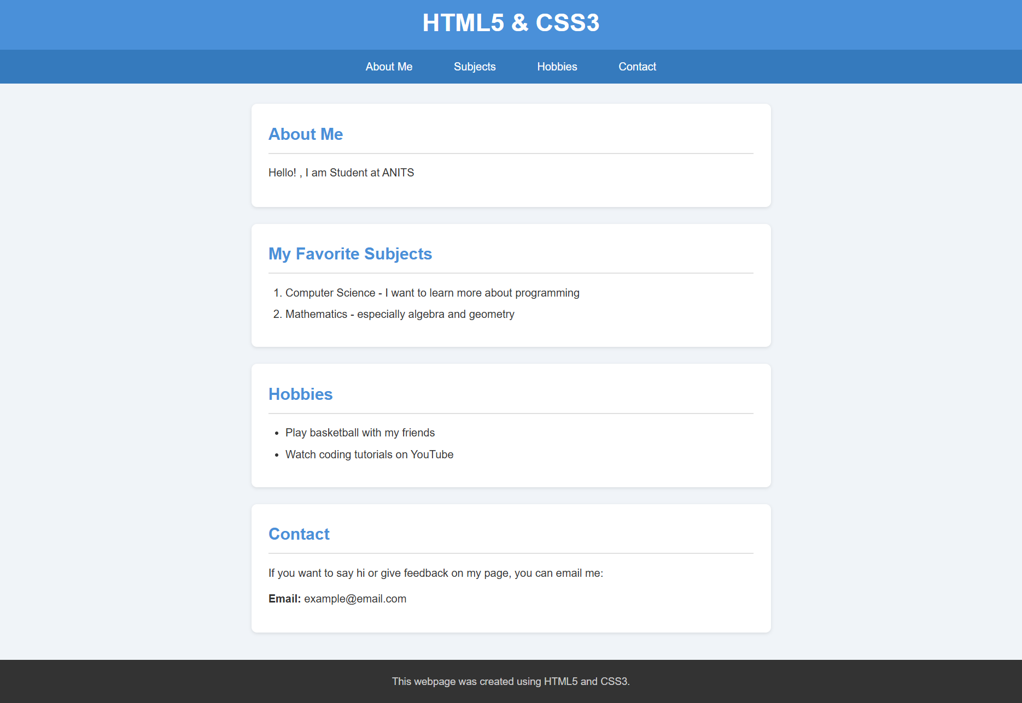

10. RESULT
Thus, a styled static webpage was successfully designed and developed using HTML5 and CSS3. The page demonstrates semantic structural elements, internal CSS styling, a card-based section layout, in-page navigation with hover effects, ordered and unordered lists, and a styled footer. All ten test cases passed successfully, confirming correct layout, navigation, hover behaviour, and visual styling.

