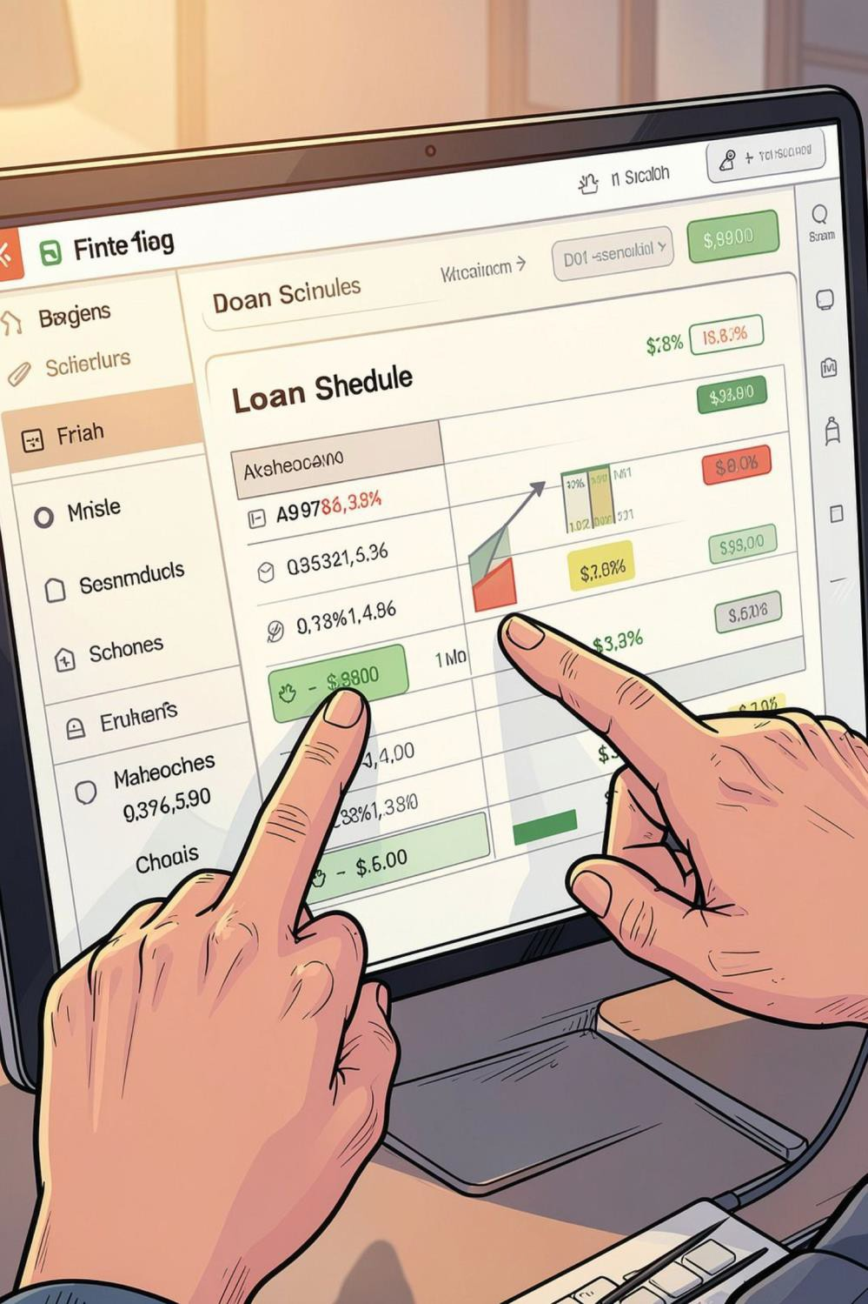

Loan EMI Schedule Generator — Project Overview
A compact tool for NBFCs to generate accurate reducing-balance amortisation schedules, export borrower-wise repayment PDFs, and handle real-world loan servicing edge cases. Designed for technical stakeholders, product owners, and fintech students.



Objectives & Domain

 Primary Objective
Produce precise EMI schedules using reducing-balance calculations; support exports per borrower as PDF.

Domain
Retail lending and NBFC loan servicing: monthly EMIs, floating-rate loans, prepayments, closures, and regulatory reporting.
 Quality Goals
Accuracy to the paisa, auditable schedules, deterministic rounding, and reproducible exports for compliance.

Existing System & Proposed Solution

Current Pain Points
- Manual schedule generation from spreadsheets — error
prone
- Inconsistent rounding leaving residual paisa on closure
- Poor support for mid-tenure floating-rate resets and re- amortisation

Proposed Solution

A rule-driven generator that ingests a loan master CSV and produces: reducing-balance amortisation schedules, borrower-level PDFs, and a configurable rules-engine for rate resets, rounding, and prepayments — all auditable and testable.

Input Data & Project Modules

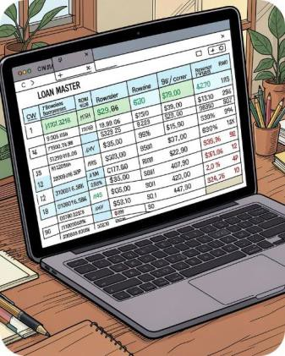
Inputs
Loan master CSV: borrower ID, principal, tenor (months), start date, annual rate(s), interest type (fixed/floating), EMI frequency, prepayment events, and rounding policy.

Modules
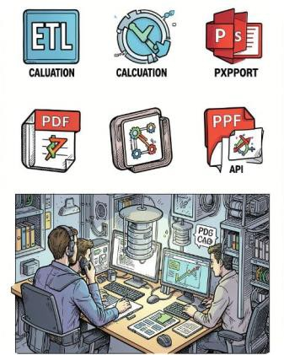
1) CSV Parser & Validator 2) Rate Engine & Reset Handler 3) Amortisation Calculator 4) Rounding & Residual Manager 5) PDF Exporter & Batch Scheduler 6) Test Harness & Audit Logger

System Architecture & Workflow

Validation
Workflow summary:

- Upload loan master CSV → schema validation
- Normalize rates; apply scheduled floating-rate resets
- 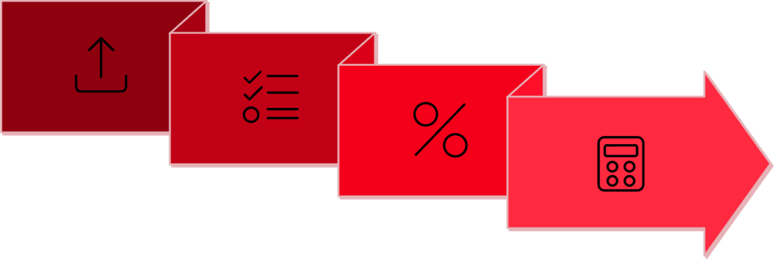Compute per-period principal & interest (reducing-
Amortisation
CSV Ingest
balance)
- Apply rounding policy and allocate residual paisa
- Produce borrower-wise PDF and batch export

Rate Engine

Architecture supports replayable calculations for
audits and reconciliations.

Core Concepts, Algorithms & Processing


1

Reducing-Balance Formula
2
Floating-Rate Resets
On reset dates, update periodic r and either keep EMI constant (adjust tenor) or re- amortise EMI using
remaining tenor.
3
Rounding & Residual Handling
Round each EMI component to nearest paisa; track cumulative rounding delta and assign final residual to last payment or an explicit closure
adjustment rule.
4
Prepayments & Partial Closures
Apply prepayment to principal on event date, recalculate remaining schedule; support optional prepayment penalties and interest
accrual adjustments.
EMI = P * r * (1 + r)^n / ((1
+ r)^n - 1) where r = periodic rate.
Recompute outstanding
principal each period.

Special Features & Implementation Challenges

Borrower-wise PDF Export
Styled, paginated PDFs with amortisation table, payment calendar, and audit footer (calculation seed & timestamp).

Floating-rate Scheduler
Support scheduled and ad-hoc rate updates; rules for EMI vs tenor
adjustment selectable per product.

Key Challenges
- Correctly handling mid-tenure resets without introducing rounding drift
- Deterministic residual paisa allocation acceptable to auditors
- Performance for large batch runs (tens of thousands of loans)

- Edge cases: very short tenors, negative amortisation, multi-frequency payments

Class Design & OOP Concepts Used

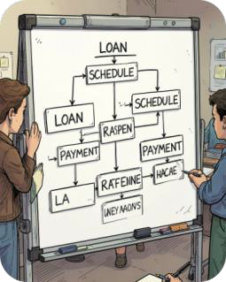
Core Classes
Loan (immutable master data), ScheduleGenerator, PaymentPeriod, RateEngine, CSVParser, PDFExporter, AuditLogger.

OOP Principles

Single Responsibility (each module focused), Dependency Injection (pluggable rate and rounding strategies), Strategy Pattern (rounding & re-amortisation policies), Factory for PDF templates, and robust unit- testable interfaces.

Implementation, Output & Testing

Implementation Notes
- Stack: Python service with libraries like pandas, reportlab, and APScheduler; CSV ingest, scheduled workers, PDF microservice.
- Config-driven: loan product templates define rounding, reset rules, and default behaviours.
- Idempotency: calculations keyed by loan-id + seed to allow replay.

Output & Testing
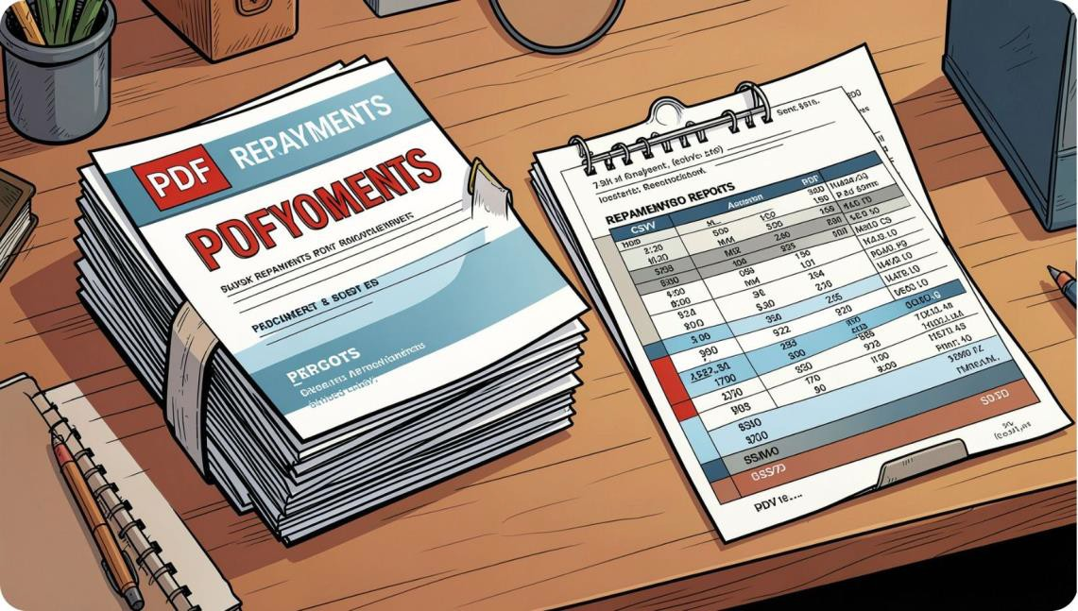
Outputs: per-borrower PDF, batch CSV of payment entries, audit logs. Tests include unit tests for math, integration tests for CSV → PDF, and reconciliation tests to ensure no paisa drift at closure.

Thank You
2500520001 — TALABATTULA SRI KRISHNA VARDHAN

2500520002 — MAMIDI SIVANI

2500520003 — CHIKKAM RAMA SURYA

