Flow of Funds
Updated for Ozow integration — v2.0
Prepared for | Ozow (Pty) Ltd — Integrations & Risk
Prepared by | Flamingo Pay (Pty) Ltd
Contact | Msizi Mtolo — CEO & Founder
Email | msizi@brocabs.co.za
Document | Flow of Funds v2.0 (supersedes v1.0)
Rails covered | PayShap • Instant EFT
Date | 15 April 2026
Classification | Commercial — Confidential

Purpose. This document supersedes any previously circulated Flow of Funds and reflects the split-payment settlement model agreed on our most recent call. Flamingo Pay operates as a technology platform on top of Ozow's licensed rails. Flamingo does not hold, aggregate, or comingle buyer or merchant funds at any point.
Summary. Funds move directly from the buyer's bank to the merchant's bank via Ozow, with Ozow performing a split at settlement so that the platform fee is credited to Flamingo's FNB account and the net amount is credited to the merchant. Two rails are supported: PayShap (real-time, T+0) and Ozow Instant EFT (same-day, T+0/T+1).

1. Parties and regulatory posture
Each party in the flow has a defined role and regulatory status. Flamingo's position is that of a payment platform / technology provider — not a payment service provider in its own right. All regulated payment activity is performed by Ozow and the participating banks under their respective authorisations.
Party | Role | Regulatory status
Buyer | Payer — scans QR, authenticates on own bank app | Consumer under NCA; authenticated by own bank
Buyer's Bank | Debits buyer account; authenticates payer | SARB-licensed bank; PASA participant
Ozow | PSP / System Operator; initiates and splits settlement | SARB-authorised System Operator; PCI-DSS Level 1
Merchant's Bank | Credits merchant account | SARB-licensed bank; PASA participant
Merchant | Receives net amount; accepts payment for goods/services | Small business / informal trader; KYC'd at onboarding
Flamingo Pay (Pty) Ltd | Platform; issues QR, routes buyer, receives platform fee only | Technology platform; not an FSP; POPIA-compliant
FNB (Flamingo's bank) | Holds Flamingo operating account for platform fees | SARB-licensed bank

2. Settlement architecture (both rails)
Regardless of rail, Ozow settles the transaction using a split instruction issued by Flamingo at payment initiation. Ozow debits the buyer once, then credits two beneficiary accounts at settlement: the merchant's nominated bank account (net amount) and Flamingo's FNB account (platform fee). Flamingo never receives the gross amount and never issues a payout instruction to the merchant.
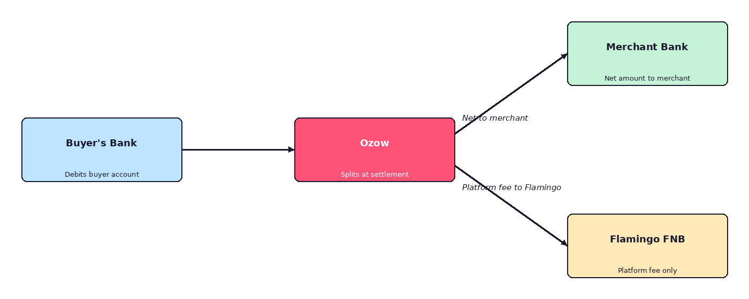
Figure 1 — Split settlement model. Ozow performs the split at point of settlement; Flamingo receives only its platform fee.

3. Rail A — PayShap (real-time)
PayShap is BankservAfrica's real-time low-value credit rail. The buyer authenticates inside their own bank app and the credit is posted to the beneficiary account within seconds.
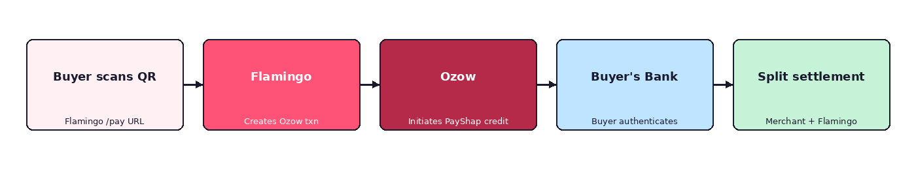
Figure 2 — PayShap flow

Step-by-step
1. QR scan. Buyer scans the Flamingo-branded QR at the merchant. The QR encodes https://flamingopay.co.za/pay/{merchantId}. No banking data leaves the buyer's phone.
2. Amount capture. The Flamingo web page (hosted on Vercel) asks the buyer to enter the amount and pick a rail. The buyer selects PayShap.
3. Session creation (server-to-server). Flamingo's backend calls Ozow's API with: merchant bank details (fetched from Flamingo's merchant record), amount, transaction reference, and a split instruction listing Flamingo's FNB account as the second beneficiary for the fee amount. Ozow returns a hosted payment URL.
4. Redirect to bank. The buyer is redirected to Ozow's hosted page, then on to their own bank's authentication flow (app push, OTP, or biometrics). Flamingo never sees credentials.
5. Debit & clearing. On buyer authentication, the buyer's bank debits the buyer in real time and a PayShap credit is initiated through BankservAfrica.
6. Split settlement. Ozow receives the funds and, using the split instruction, credits the merchant's bank account with the net amount and Flamingo's FNB account with the platform fee. Both credits clear within seconds.
7. Webhook & receipt. Ozow posts a signed webhook to Flamingo (HMAC-SHA512 with shared secret). Flamingo verifies the signature, updates the transaction, and shows the buyer a success receipt.

Metric | Value
Buyer-facing latency | ≈ 10–30 seconds end-to-end
Merchant credit time | T+0 (seconds after authentication)
Flamingo fee credit time | T+0 (same settlement batch as merchant)
Authentication owner | Buyer's bank (app push / biometric / OTP)
Funds held by Flamingo | None — zero float at any point
Reversibility | Irrevocable post-authentication (push payment)

4. Rail B — Ozow Instant EFT
For buyers on banks that do not yet support PayShap interoperable QR scanning, Flamingo falls back to Ozow's Instant EFT rail. The commercial split model is identical to PayShap; only the underlying rail and settlement timing differ.
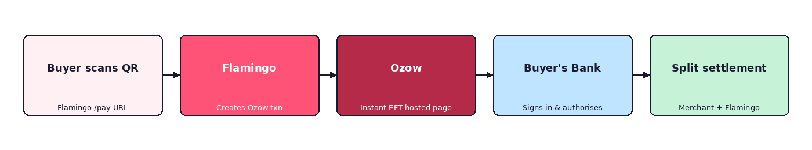
Figure 3 — Instant EFT flow

Step-by-step
1. QR scan. Identical to PayShap — the buyer scans the Flamingo QR and lands on the Flamingo /pay page.
2. Rail selection. If the buyer's bank does not support PayShap QR, they select Instant EFT. Flamingo calls the Ozow API with the same split-payment instruction.
3. Ozow hosted page. The buyer is redirected to Ozow's hosted Instant EFT page, chooses their bank, and authenticates with their online banking credentials on Ozow's page. Flamingo has no sight of these credentials.
4. Payment authorisation. Ozow uses its authorised Instant EFT mechanism to authorise the debit against the buyer's account. Ozow provides a payment confirmation to Flamingo and to the merchant.
5. Split settlement. Ozow settles to the merchant's bank and to Flamingo's FNB account using the same split instruction submitted at transaction initiation. Settlement typically occurs same-day (T+0) or by the next business day (T+1), per Ozow's published settlement windows.
6. Webhook & receipt. Same as PayShap — Ozow posts a signed webhook, Flamingo verifies the signature and marks the transaction complete.

Metric | Value
Buyer-facing latency | ≈ 30–60 seconds end-to-end
Merchant credit time | T+0 same-day or T+1 (per Ozow schedule)
Flamingo fee credit time | Same settlement window as merchant
Authentication owner | Ozow-hosted Instant EFT flow
Funds held by Flamingo | None — zero float at any point
Reversibility | Bank-dependent; handled via Ozow dispute process

5. Fee structure
Fees are extracted at the split moment inside Ozow's settlement process. The buyer always pays the face value of the transaction. The merchant receives the face value less Flamingo's platform fee and Ozow's transaction fee. No invoicing takes place between Flamingo and the merchant — the merchant simply sees a net credit.
Party | Fee charged | Extracted at | Paid to
Buyer | R 0.00 (pays face value) | Time of payment | —
Merchant | Flamingo platform fee (target 1.0 – 1.5%) | Ozow settlement split | Flamingo FNB account
Merchant | Ozow transaction fee (per Ozow agreement) | Ozow settlement | Ozow
Flamingo | Ozow technology / integration fee (if applicable) | Monthly invoice | Ozow

Worked example — R 100 transaction
Line item | Amount
Buyer pays | R 100.00
— Ozow transaction fee | (as per Ozow agreement)
— Flamingo platform fee (1.5%) | R 1.50
Merchant receives (net) | R 98.50 − Ozow fee
Flamingo FNB receives | R 1.50

6. Compliance, controls and safeguards

6.1 Funds handling
- Flamingo Pay never receives, holds, aggregates, or transmits buyer funds or merchant funds. The only credit Flamingo receives is the platform fee, posted directly by Ozow at settlement.
- Flamingo holds no trust account, client money account, or suspense account for third-party funds.
- There is no float, no end-of-day sweep, and no payout instruction issued by Flamingo to any merchant.

6.2 Authentication and credentials
- Buyer authentication is performed entirely on the buyer's own bank app (PayShap) or on Ozow's hosted page (Instant EFT).
- Flamingo has no access to buyer banking credentials, card data, PINs, OTPs, or biometric factors.
- Flamingo's backend communicates with Ozow over TLS 1.2+ using API keys held in a secrets manager; webhooks are verified using HMAC-SHA512 with Ozow's private key.

6.3 KYC / AML allocation
- Merchant KYC is performed by Flamingo at onboarding (ID, proof of address, business verification, bank account verification via AVS) and the outputs are shared with Ozow as required by Ozow's merchant due diligence process.
- Ongoing transaction monitoring is performed by Ozow on the rail itself. Flamingo performs platform-level monitoring (unusual patterns, velocity, chargeback ratios) and reports suspicious activity to Ozow and, where required, to the FIC.
- Sanction screening is performed at merchant onboarding and refreshed periodically.

6.4 Data protection (POPIA)
- Flamingo is the responsible party for merchant personal information and a sub-processor for buyer transaction metadata received via Ozow.
- No card PANs, CVVs, or full bank account numbers are stored on Flamingo systems — only tokenised references returned by Ozow.
- Data residency: primary storage in South Africa; backups encrypted at rest.

6.5 Refunds, disputes and chargebacks
- Refunds are initiated by the merchant via the Flamingo merchant dashboard, which calls Ozow's refund API. Refund funds are debited from the merchant's account via Ozow, not from Flamingo.
- PayShap credits are irrevocable post-authentication; refunds are processed as a fresh credit back to the buyer.
- Instant EFT disputes follow Ozow's dispute resolution process; Flamingo assists the merchant with evidence collation but is not a party to the dispute.
- Platform fees on refunded transactions are reversed to the merchant in line with Flamingo's merchant agreement.

6.6 Business continuity
- Rail fallback: if PayShap is unavailable for a given bank or transaction, the buyer is offered Instant EFT without leaving the Flamingo payment page.
- If Ozow is unavailable, transactions are rejected at the payment page — Flamingo does not queue or hold unsettled transactions.

7. Integration checklist and open items for Ozow
The following items are required from Ozow to complete the integration and go live:
# | Item | Owner | Status
1 | Production API credentials (SiteCode, PrivateKey, APIKey) | Ozow | Requested
2 | Enablement of split-payment / beneficiary routing on Flamingo site code | Ozow | Requested
3 | Confirmed Ozow merchant fee schedule for PayShap and Instant EFT | Ozow | Awaiting
4 | Webhook endpoint whitelisted (https://api.flamingopay.co.za/webhooks/ozow) | Flamingo | Done
5 | Sandbox smoke test of R 1.00 transaction across both rails with split | Joint | Pending
6 | Sign-off on this Flow of Funds by Ozow Risk & Compliance | Ozow | This document
7 | Merchant onboarding pack (KYC evidence share protocol) | Joint | Drafting
8 | Go-live date + commercial agreement execution | Joint | TBC

8. Sign-off
Flamingo Pay (Pty) Ltd | Ozow (Pty) Ltd
Name: Msizi Mtolo | Name:
Role: CEO & Founder | Role:
Signature: ____________________ | Signature: ____________________
Date: | Date:

Confidential — Prepared for Ozow integrations & risk review. Not to be distributed outside of the Ozow review team without Flamingo Pay's written consent.

