# Corona Buddy

**A Project Report**

***Submitted by***

## Akshat Sahu

## Tarun Surani

**Malhar Trivedi**

***Under the Guidance of***

Prof. Vijayetha Thoday

***in partial fulfillment for the award of the degree of***

## B. Tech (Computer Engineering)

At



**MPSTME, Mumbai**

**Nov, 2020**

## DECLARATION

We, Akshat Sahu, Tarun Surani, Malhar Trivedi Roll Nos. E020, E045, E051 B. Tech (Computer Engineering), V semester understand that plagiarism is defined as anyone or combination of the following:

1. Un-credited verbatim copying of individual sentences, paragraphs or illustration (such as graphs, diagrams, etc.) from any source, published or unpublished, including the internet.
2. Un-credited improper paraphrasing of pages paragraphs (changing a few words phrases, or rearranging the original sentence order)
3. Credited verbatim copying of a major portion of a paper (or thesis chapter) without clear delineation of who did wrote what. ( Source: IEEE, The institute, Dec. 2004)
4. I have made sure that all the ideas, expressions, graphs, diagrams, etc., that are not a result of my work, are properly credited. Long phrases or sentences that had to be used verbatim from published literature have been clearly identified using quotation marks.
5. I affirm that no portion of my work can be considered as plagiarism and I take full responsibility if such a complaint occurs. I understand fully well that the guide of the seminar/ project report may not be in a position to check for the possibility of such incidences of plagiarism in this body of work.

Names: Akshat Sahu, Tarun Surani, Malhar Trivedi

Roll Nos.: E020, E045, E051

Place: Mumbai

Date: 3/11/2020

## CERTIFICATE

This is to certify that the project entitled “___________________________” is the bonafide work carried out by ________________ of BTech, MPSTME (NMIMS), Mumbai, during the IV semester of the academic year__________, in partial fulfillment of the requirements for the Course Programming Language.

___________________

Prof. Vijayetha Thoday

Internal Mentor

_______________________ ________________________

Examiner 1 Examiner 2

## Table of contents

**CHAPTER NO. TITLE PAGE NO.**

1. PROJECT INTRODUCTION
2. MODULES IMPLEMENTED
3. SCREENSHOTS
4. CONCLUSION & FUTURE SCOPE
5. SOCIETAL APPLICATION (If any)

1. **Introduction**

**Front-end:**

We have made a project on covid-19. Our project firstly consists of a login page. There are total 7 html pages. In the login page the user enters username and password, if the username does not exist in the database the user goes to the signup page where he has to enter email, username and a new password then his username would be registered in the database and he is again redirected to the login page. Once the user logs in with the new username he comes to the overview page which gives us valuable information like how coronavirus spreads, when to seek medical attention, what are the symptoms and then we made a nav bar for the user to navigate to different pages. Then we have the prevention page which comes second in the nav bar. This page tells us about the basic protective measures against the virus like washing hands regularly, maintaining social distance and avoid touching eyes, nose and mouth. There is also a youtube video regarding that which has been embedded in the page. Then comes the statistics page which has the information of deaths, total cases, total recovered and recovery rate in the major states of the country. The fourth page in our nav bar is the news and article page. This is divided into 2 parts on the left we have videos related to coronavirus which has valuable Q&A videos, on the right we have news related videos like there is an economist video which tells how bad will be the economy due to covid-19 etc. Then the last page of our project is the helpdesk page here we have made a huge banner it consists of a number which we can call anytime for medical help.

**Backend:**

For the backend we have made 2 databases on xampp server. One database stores username and password to check if the user correctly enters the login credentials. Everytime the user enters a new username via the signup page it is been added to the database. The second database consists of states, their death toll, total cases, total recovered and recovery rate we have linked it to our statistics page.

1. **Modules Implemented**

login.php database.php eader.php footer.php signup.php statistics.php prevention.php overview.php newsarticle.php helpdesk.php

1. **Screenshots**

**Login page:**

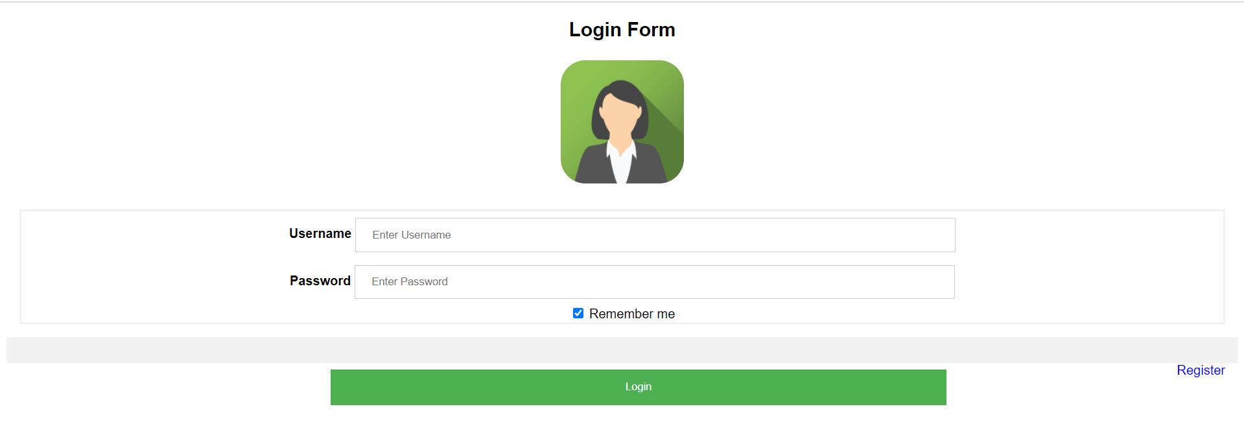

**Signup page:**

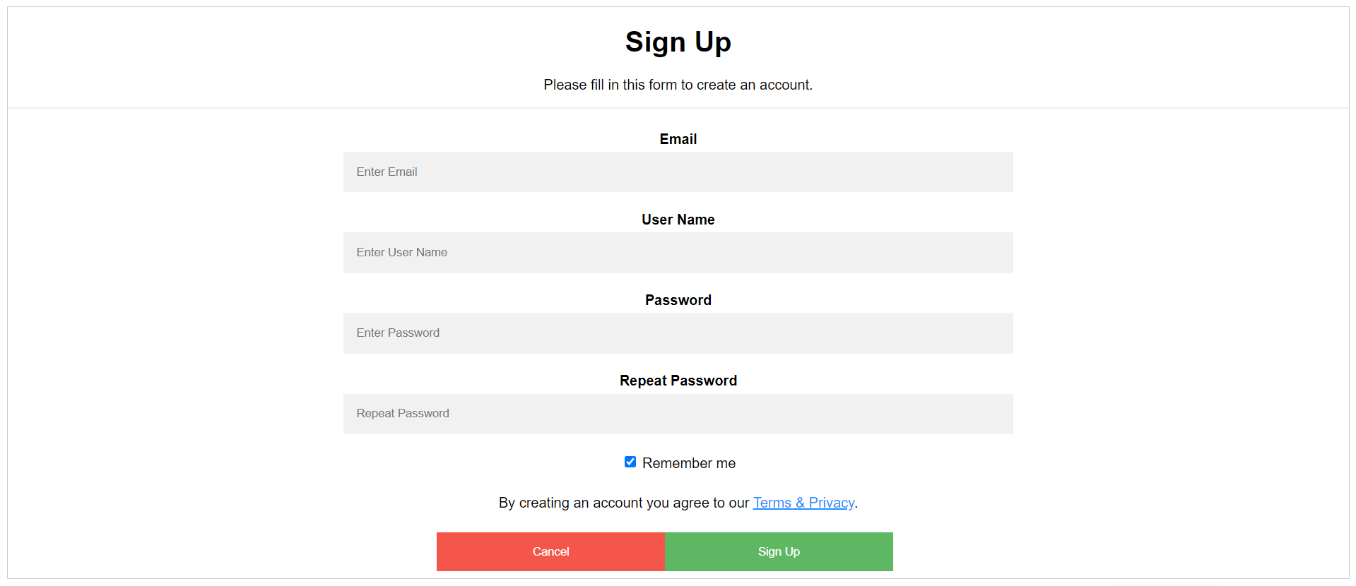

**Overview page:**

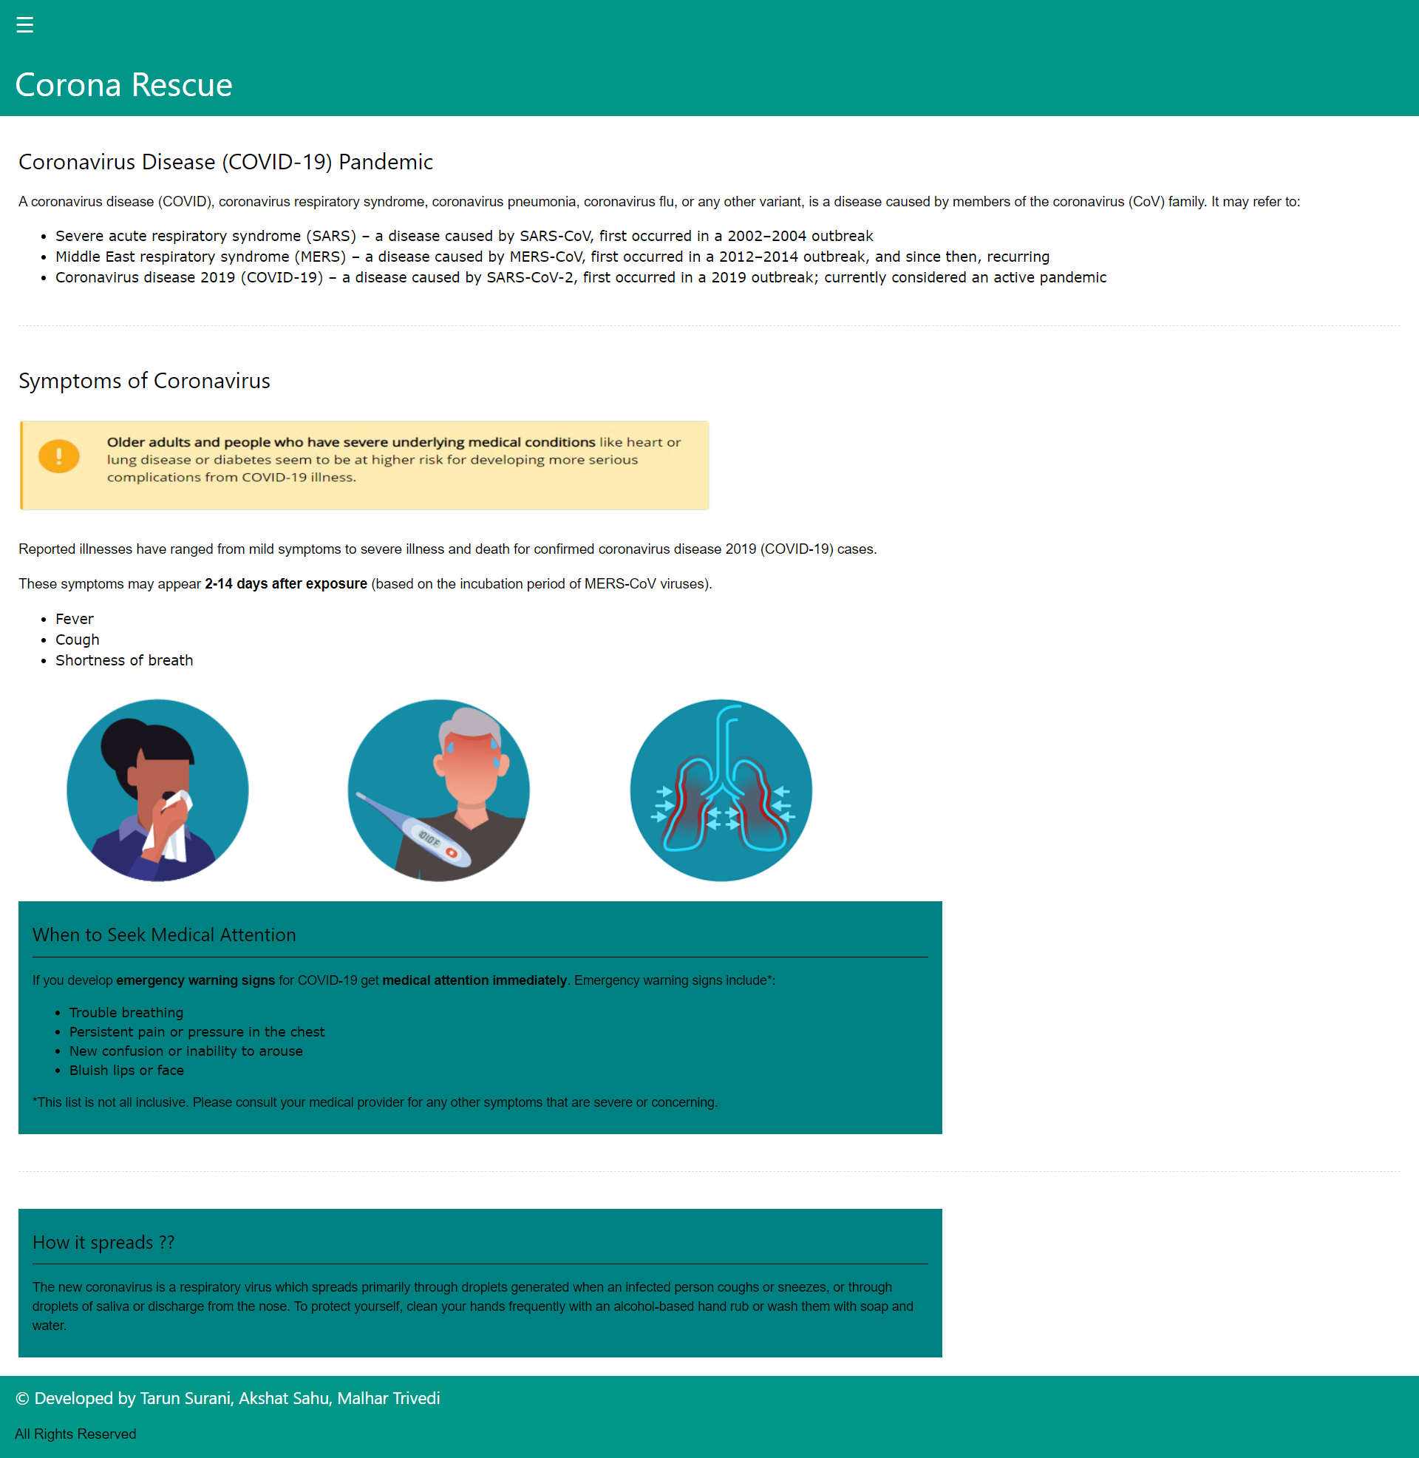

**Prevention page:**

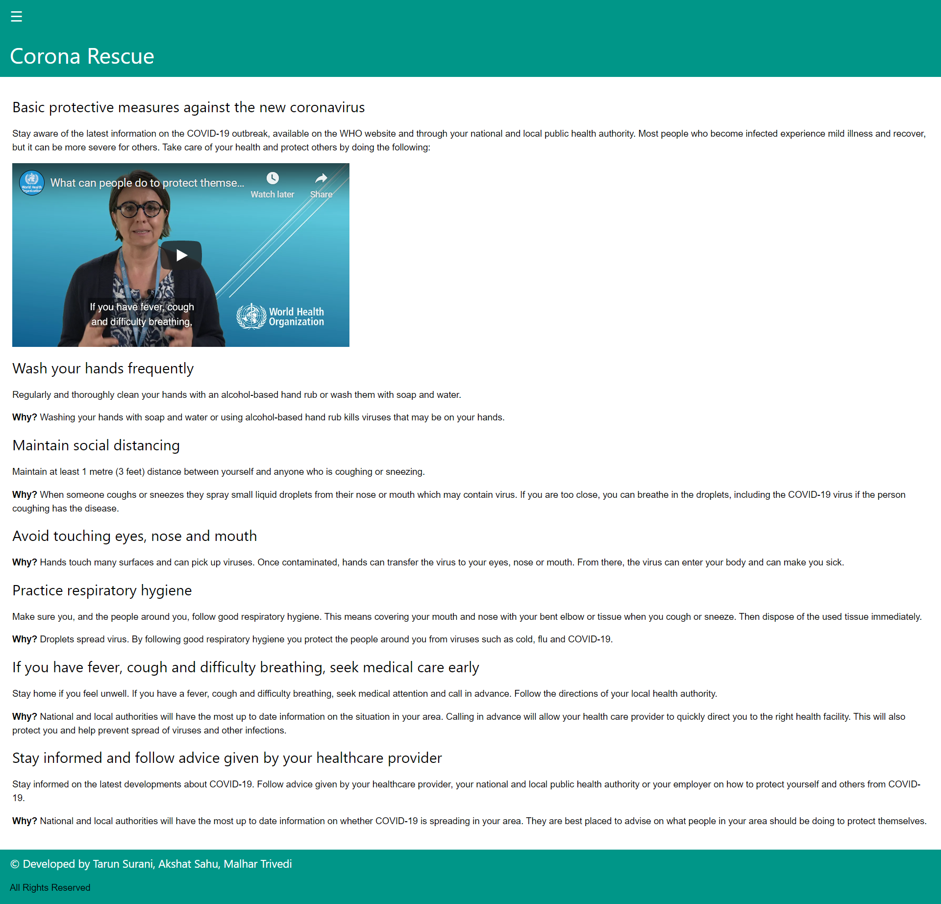

**Statistics page:**

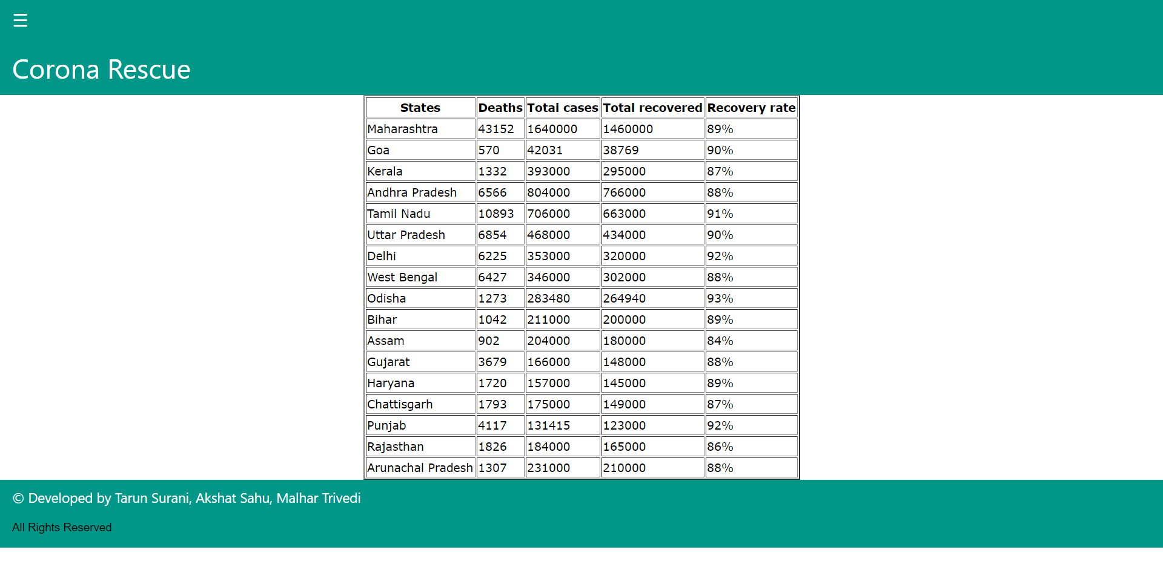

**News and articles page:**

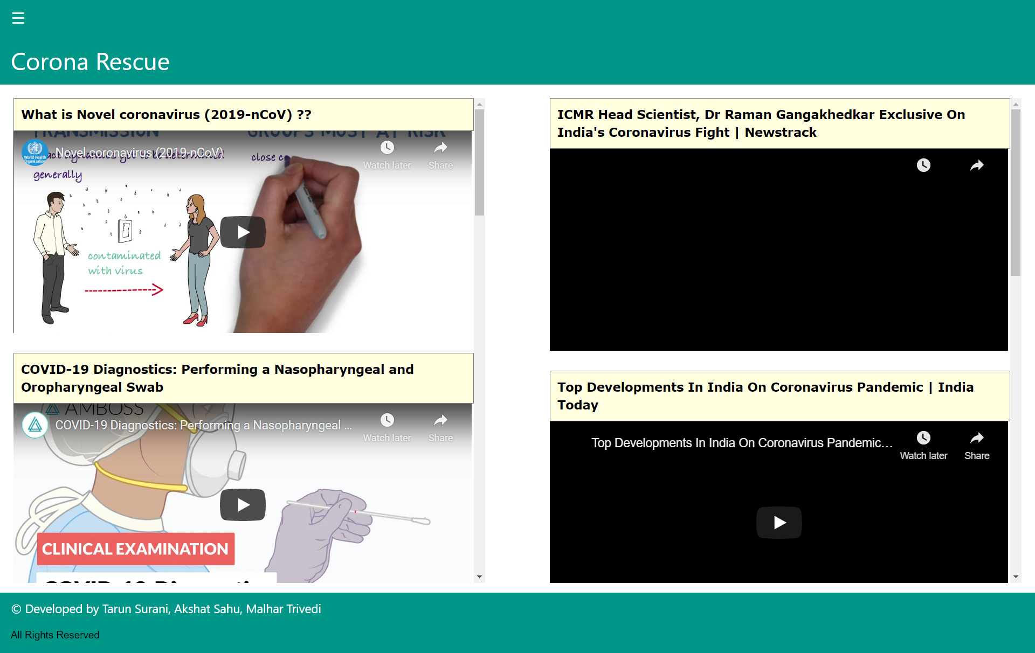

**Helpdesk page:**

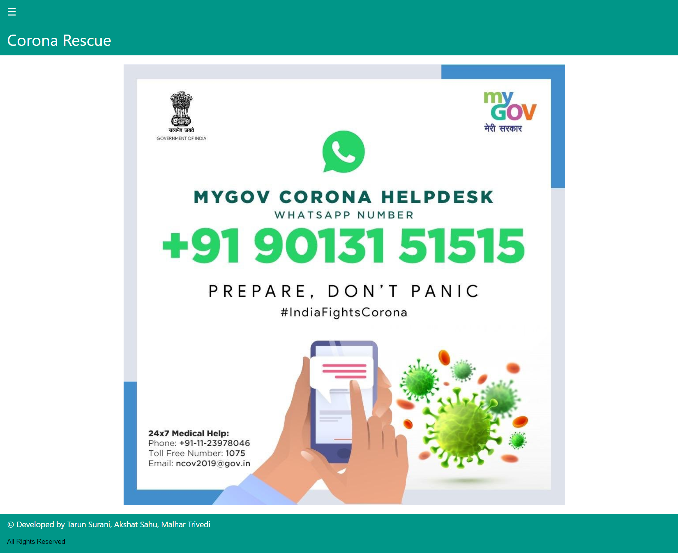

**Username database:**

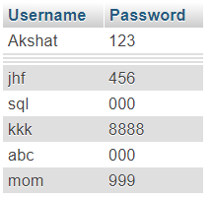

**States database:**

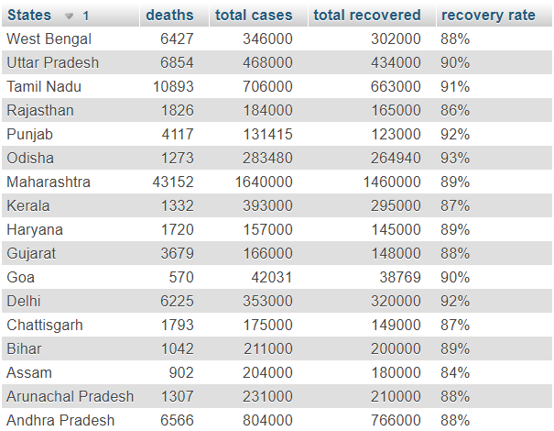

1. **Conclusion and future scope**

While working for this project we learnt new things and it improved our knowledge of web programming. We learnt things like retrieving data from database and upgrading values in database. We applied a lot of CSS and html also. This covid-19 related project is quite trending nowadays. There is plenty of future scope for this project for example we can add a map of the world or the country indicating users the no of cases and we can keep updating our website. Also, we can add some newly discovered facts about the virus. Overall we gained a lot of insight through this project.

1. **Societal Application**

This pandemic has caused a lot deaths and affected a lot of lives. People will keep searching things regarding the virus for example I myself browse worldometer website to keep a track of the total cases all round the globe from time to time. There are so many countries that are trying to make a vaccine for the virus and people will be updated with this news also. People will be updated with what their goverments are doing.