**Documentation**

Fruit Machine Slot

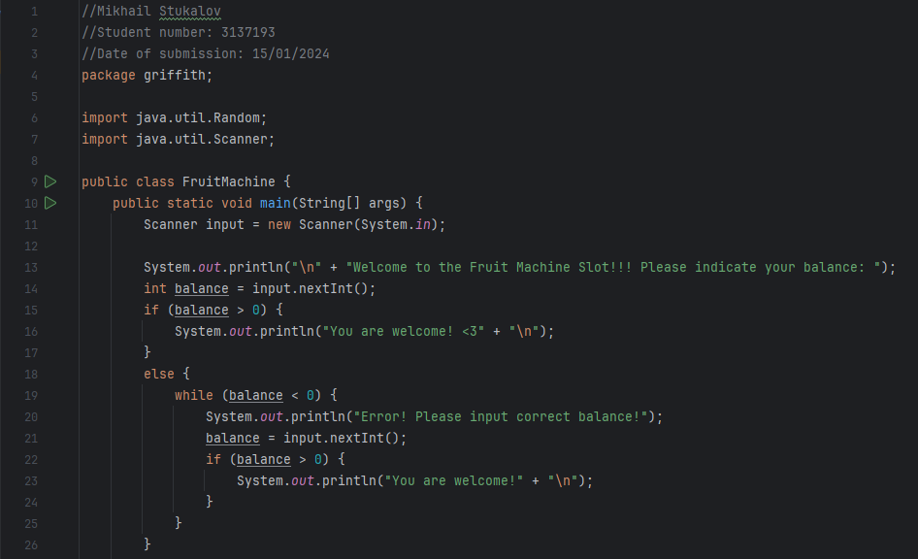

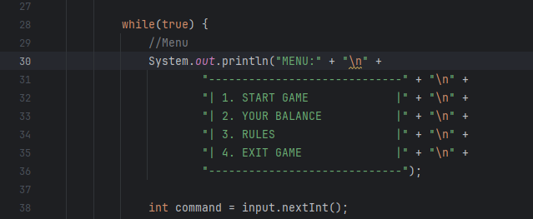

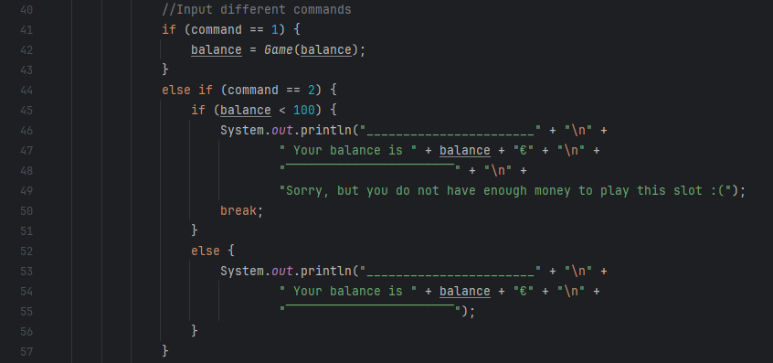

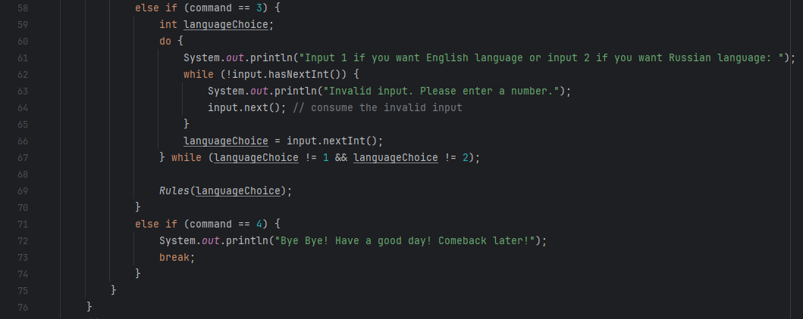

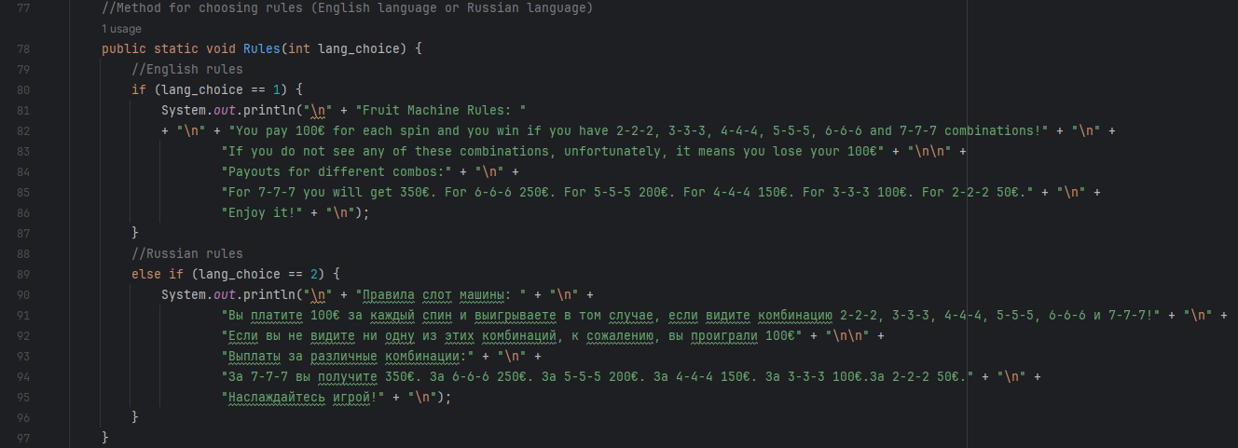

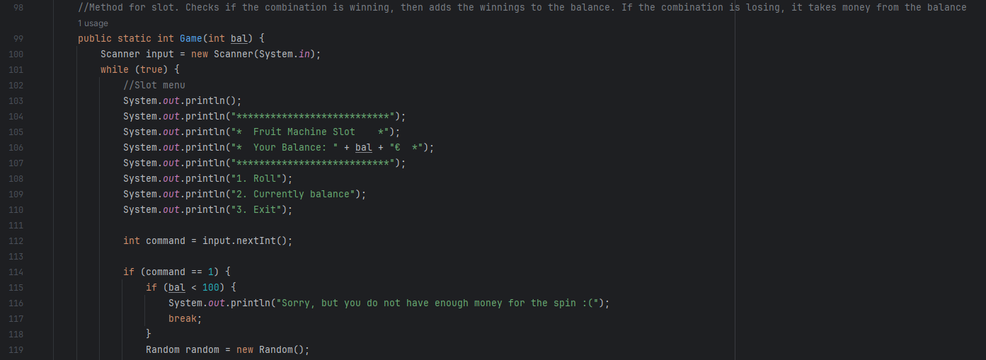

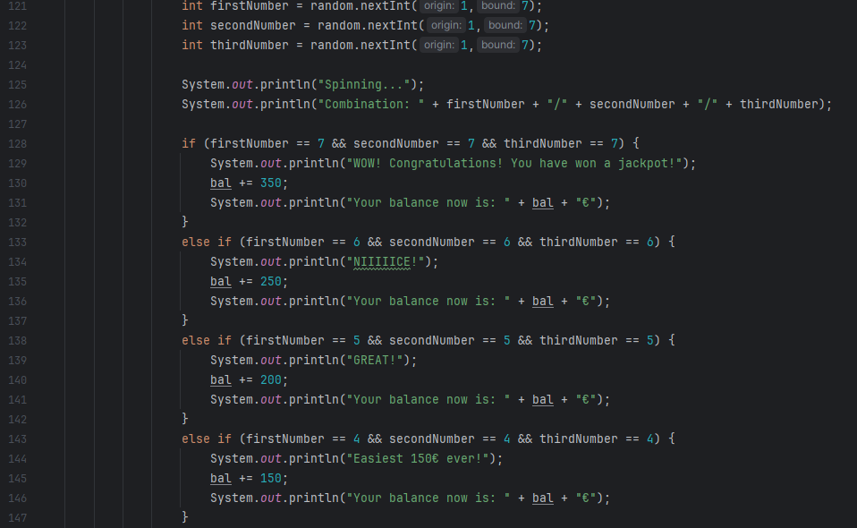

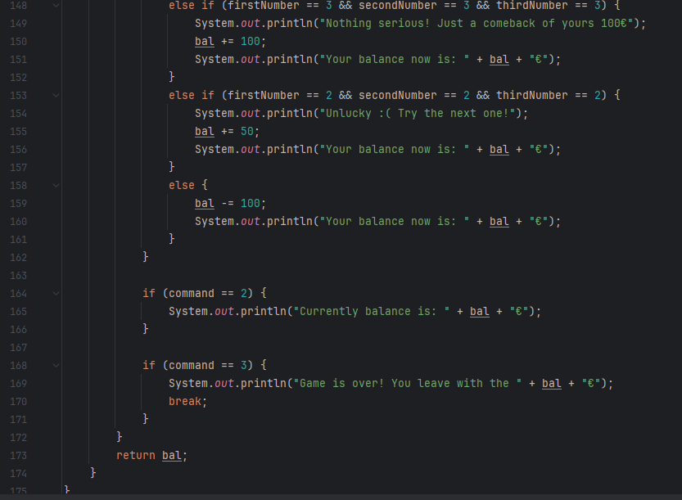

**Instruction**

To run this code press Shift + F10

When you run the code, first thing you see is the welcoming message, which asking user to input his balance 

When user inputs his balance, (For example, I entered 550), user will see the menu: 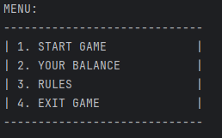

User needs to choose what he/she wants. For example, I would like to choose second command to check my balance:

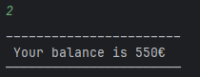

After that, user can read the rules of this Fruit Machine Slot. By the way, there are rules in 2 languages: English and Russian 

If user presses 1, rules will be in English. If user presses 2, rules will be in Russian language. If user presses other symbols, error will appear:

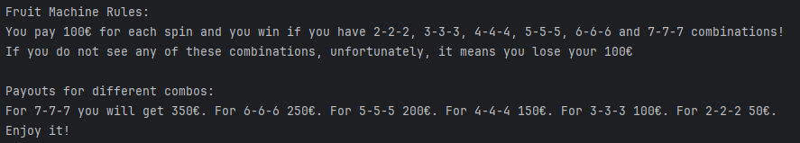



If user chooses 4th command, code will end.



To start game, user needs to press “1” (“START GAME” command):

Once user pressed “1”, a slot appeared:

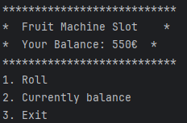

To start spinning this slot, user should press “1” (“Roll” command).

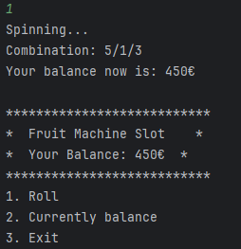

To check user`s balance press “2” (“Currently balance” command).



To come back to the previous menu just press “3” (“Exit” command).

